Gerhard Richter, Yoko Ono
and other foremost artists support human rights movement in DOX

→ Prague DOX Center for Contemporary Art launches the exhibition Art 19 – Art in the Light of Conscience. Eleven internationally renowned artists will be presented there.
→ Gerhard Richter, Yoko Ono, William Kentridge, Emilia & Ilya Kabakov, Chiaru Shiota, Shilpa Gupta, Kiki Smith, Shirin Neshat, Ayse Erkmen, and Rosemarie Trockel responded to the Art 19 initiative to create unique works to promote human rights activities of Amnesty International.
→ The Art 19 project, whose name stems from ‘Article 19’ of the Universal Declaration of Human Rights, is drawing together art and human rights – or more accurately art for human rights.
→ The public can see those works in four world capitals, Berlin, Geneva, Paris, and at the Czech premiere of the DOX Center for Contemporary Art from 13 December. →

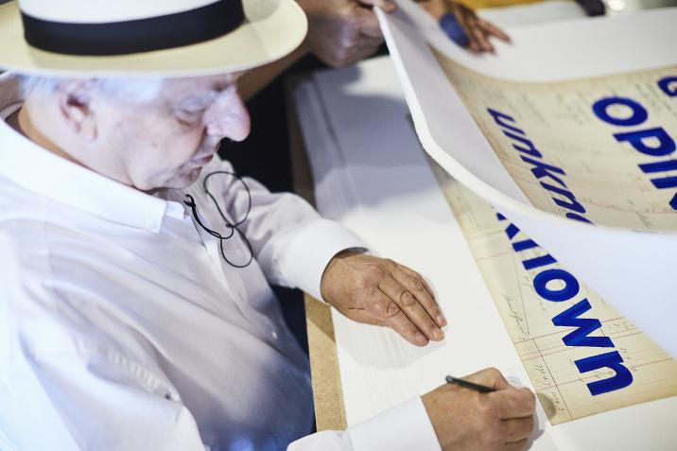
↑ Art 19 – Box One / making of: William Kentridge: God’s Opinion is Unknown, 2019, © Art 19 GmbH

The Art 19 project, whose name stems from ‘Article 19’ of the Universal Declaration of Human Rights, is drawing together art and human rights – or more accurately art for human rights. On behalf of Amnesty International Art 19 brings “Art 19 Box One” a unique collection of ten fine art prints by eleven of the leading contemporary artists in the world: Gerhard Richter, Yoko Ono, William Kentridge, Emilia & Ilya Kabakov, Chiaru Shiota, Shilpa Gupta, Kiki Smith, Shirin Neshat, Ayse Erkmen, and Rosemarie Trockel.

Art 19 is an initiative founded by four friends with lifetimes of experience in the worlds of art and human rights – Mike Karstens (gallerist and master printer from Muenster), Burkhard Richter (retired commercial lawyer, art advisor and curator from Düsseldorf), Bill Shipsey (Art for Amnesty founder and retired barrister from Dublin) and Jochen M. Wilms (entrepreneur and art project producer from Berlin).

The ambition of Art 19 through Box One is to raise money to support Amnesty International’s human rights work. The initial idea grew out of the work that Shipsey and Wilms had done together in Art for Amnesty, Amnesty International’s global artist engagement programme. They then approached Karstens and Richter who brought their vast experience and contacts at the highest level in the world of contemporary art to the initiative. Karstens has worked with the leading artists in the world for decades. His editions have been acquired by major museums around the world. Among his projects are the development of the Cologne Cathedral Window and the monumental work „Strontium“ both by Gerhard Richter.

“For 30 years now, I produce and publish fine art prints. Within my work for this project for the benefit of Amnesty International, it’s a real pleasure to see, that the artists are so diverse concerning their contributions. The technical requirements are quite challenging – and that’s great!”
– Mike Karstens Co-Founder and Managing Director Art 19

Since its founding in 1961 Amnesty International has enjoyed the support of the world’s leading artists of all disciplines. Amnesty International was launched in May 1961 with an article in the Observer newspaper entitled ‘The Forgotten Prisoners’ in which Peter Benenson, an English barrister, asked the readers of the newspaper to write letters to the governments of six named prisoners whom he called ‘prisoners of conscience’. Prisoners of Conscience were defined as those imprisoned for the non-violent expression of their opinions or beliefs. Within a year the organisation which became Amnesty International had been formed in countries around the world. It has since grown into a global movement of more than seven million members and supporters. It campaigns for a world where human rights are enjoyed by all. It is funded by members and supporters and is independent of any political ideology, economic interest or religion.

From the beginning artists of all disciplines were drawn to Amnesty. Artists have always appreciated and understood the close connection between the work that Amnesty does and their own freedom to express themselves through their art. The first artist to join Amnesty was the sculptor Henry Moore. Over the following decades hundreds more artists joined Amnesty and contributed their art in support of its work including visual artists Pablo Picasso, Joan Miro, Francis Bacon, Alexander Calder & David Hockney.Musicians began to support Amnesty in the 1970’s. U2, Sting, Joan Baez, Peter Gabriel, Bruce Springsteen, Adele, Ed Sheeran and Madonna are among the most prominent of the internationally recognised musicians to support Amnesty. Down the years actors including Julie Christie, Meryl Streep, Glen Close, Robin Williams, George Clooney, Emma Thompson, Don Cheadle, Ewan McGregor and Keira Knightley have rallied to Amnesty’s cause. Several artists including Fernando Botero, Sophia Vari and Peter Sís have contributed art to the making of monumental Aubusson tapestries which have been placed in major airports around the world honouring deceased human rights icons and in support of human rights.
The late Nobel Laureate in Literature Seamus Heaney was a life-long supporter of Amnesty. His poem From The Republic of Conscience written for Amnesty in 1985 became the inspiration for Amnesty’s most prestigious human rights award, The Ambassador of Conscience Award.

Now Art 19 is extremely grateful to artists Gerhard Richter, Yoko Ono, William Kentridge, Emilia and Ilya Kabakov, Chiaru Shiota, Shilpa Gupta, Kiki Smith, Shirin Neshat, Ayse Erkmen, and Rosemarie Trockel. who are continuing in the long and proud tradition of artists who support the cause of universal human rights. Art appeals to our senses in ways more powerful than the intellectual appeal of words, Conventions or Declarations. Art that is fully alive to reality and fully autonomous is exactly what the famous Russian poet Marina Tsvetaeyva once called it, namely, ‘art in the light of conscience’. ←

↑ Yoko Ono: A Piece of Sky, 2019, © Art 19 GmbH
Art 19
Art in the Light of Conscience
13 | 12 | 2019 – 3 | 2 | 2020

Organised by Amnesty International Czech republic, Art 19, and DOX Center for Contemporary Art
For more information visit art-19.com, www.dox.cz

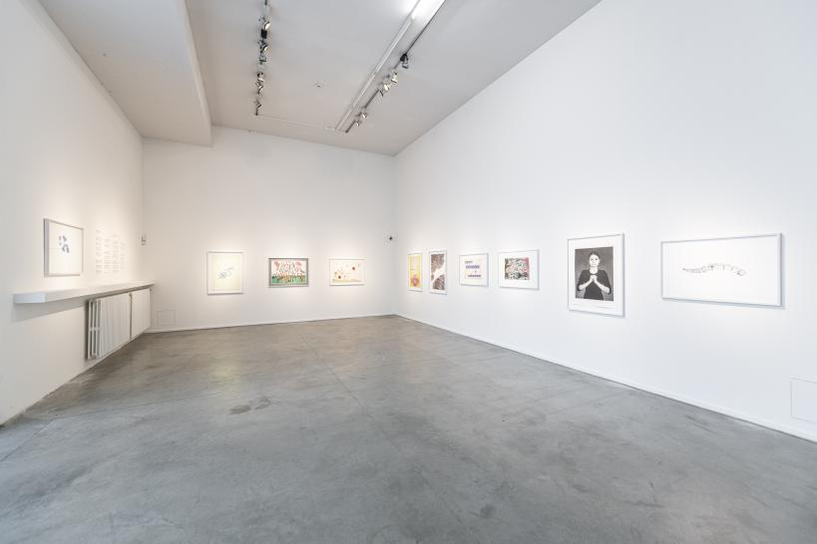
↑ exhibition view, © DOX, Jan Slavík

DOX Centre for Contemporary Art
The DOX Centre for Contemporary Art is a multi-functional space created thanks to a private initiative through the reconstruction of a former factory in Prague’s Holešovice district. The name DOX is derived on the Greek word doxa, which among other things means a way of perceiving things, an opinion, a conviction. DOX’s programme differs from other similar exhibition institutions (the combination of a “kunsthalle” with a multifunctional cultural centre) primarily through art projects incorporating critical reflection on current social topics and issues overlapping with other “non-artistic” areas and disciplines such as psychology, philosophy, history, sociology, political science, etc.

Where we are
Poupětova 1
Praha 7, 170 00

DOX partners
Hlavní město Praha
Nadační fond Avast
Metrostav
Ministerstvo kultury ČR

DOX media partners
Hospodářské noviny
Respekt
Xantypa
Art & Antiques

Print-quality photos can be downloaded from: www.dox.cz/cs/press

Contact
Michaela Šilpochová
DOX Centre for Contemporary Art
T +420 774 222 355
E michaela@dox.cz

