The world of words through the eyes of art in the exhibition Beyond Words

Picture and word. Art and literature. They have their own territories, their own maps and cartography. Nevertheless, as Virginia Woolf once remarked: “Though they must part in the end… they have much to tell each other.” The new exhibition at the DOX Centre for Contemporary Art, Beyond Words, explores the ways in which literary culture finds resonance in the work of contemporary visual artists.

↑ Brian Dettmer, Universal Ruins, 2016 ©DOX

“The intention was to present interesting and less common examples of artistic thinking about literary culture, works that indirectly lead us to reflect on the way we read and understand the world, on the importance of stories in our lives, on the relationship between author and reader, or on the possibilities and limits of new technologies or the future of the book in our digital age,” says Michaela Šilpochová, curator of the exhibition and artistic director of the DOX Centre for Contemporary Art.

A painting is a silent poem, a poem is a speaking painting.
Simonides

The relationship between verbal and visual expression has stimulated human interest and imagination since ancient times. The relationship between the art of painting and poetry was described as early as the 1st century BC by the poet Horatius with his famous statement ut pictura poesis. The opinion that “painting is silent poetry and poetry is a speaking picture” (attributed to Simonides a few centuries earlier) appeared in various forms throughout the centuries and became topical, for example, in the Renaissance paragone, a debate about the superiority of different art forms.

In the 18th century, the German Enlightenment scholar G. E. Lessing attempted to define the possibilities and limits of both genres, and almost two centuries later, the structuralist Jan Mukařovský, for example, drew on his theses.

In the last century, the European avant-gardes in particular continued to explore the relationship between art and literature, and in many ways foreshadowed the development of the connection between painting and the visual arts in the second half of the 20th century. In the Czech context, one cannot fail to mention, for example, the works of visual poetry of the 1960s. A historical mapping of the imaginary border between word and image would be a long, intricate, and fascinating journey in itself.

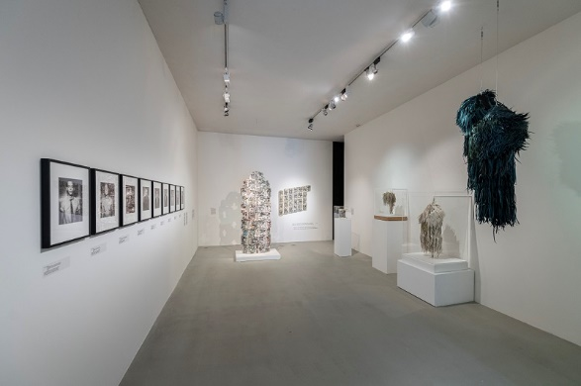
↑ A view into the exhibition Beyond Words, photo: Jan Slavík

Contemporary art and literature continue their dialogue and their encounters lead to surprising places and landscapes. The exhibition Beyond Words explores some of these inspirations on three floors of the tower of the DOX Centre for Contemporary Art.

The group exhibition project, involving 12 artists, deliberately does not venture into the vast territories of classic book illustration and comics - the two genres we perhaps most often associate with the world of words. Nor does it aim to capture the full breadth of the many different approaches contemporary artists take to reflecting the world of the written word.

The works on display thus speak primarily to the ability of the image and the imagination to capture that hard-to-grasp, ineffable something that lies beyond words.

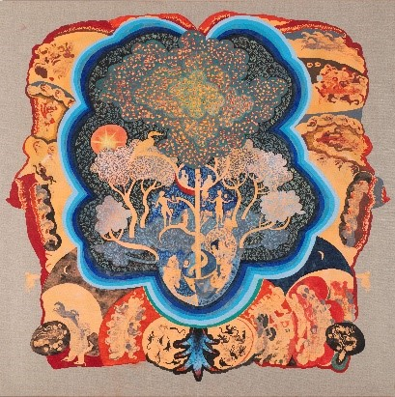
“How then to ‘read’ them? According to Marcel Proust, the only truly revelatory way lies not in going to distant places, but in seeing the world through different eyes, through someone else’s eyes. This exhibition is an invitation to such a journey and an opportunity to look at the world of words through the eyes of art,” concludes Michaela Šilpochová

Exhibiting artists: Brian Dettmer, Georgia Russell, Ivan Pinkava, William Kentridge, Douglas Coupland, Radka Bodzewicz, Matej Krén, Vladimír Doležal, Millicent Young, Krištof Kintera, Anna Beata Háblová, Volker März
↑ Radka Bodzewicz, Garden of Eden, 2023 ©DOX

Curator: Michaela Šilpochová

Beyond Words
14. 9. – 11. 2. 2023
DOX Centre for Contemporary Art
Poupětova 1, Prague 7

Press release and photographs can be downloaded after registration in the Press section.

Contact:
Karolína Kočí
E karolina.koci@dox.cz
T +420 777 870 219

