“Where punk ends, we begin.” DOX presents the work of Genesis Breyer P-Orridge, a striking figure in the music and art scene, in the exhibition IT IS A PAINTFUL THING TO BE ALONE: WE ARE BUT ONE

They were a striking figure who not only greatly influenced the alternative subculture of the last 50 years, but also someone who was able to change identities and break free from gender boxes. You can explore this unique mission to liberate the body, individuality, and artistic creation now at DOX.

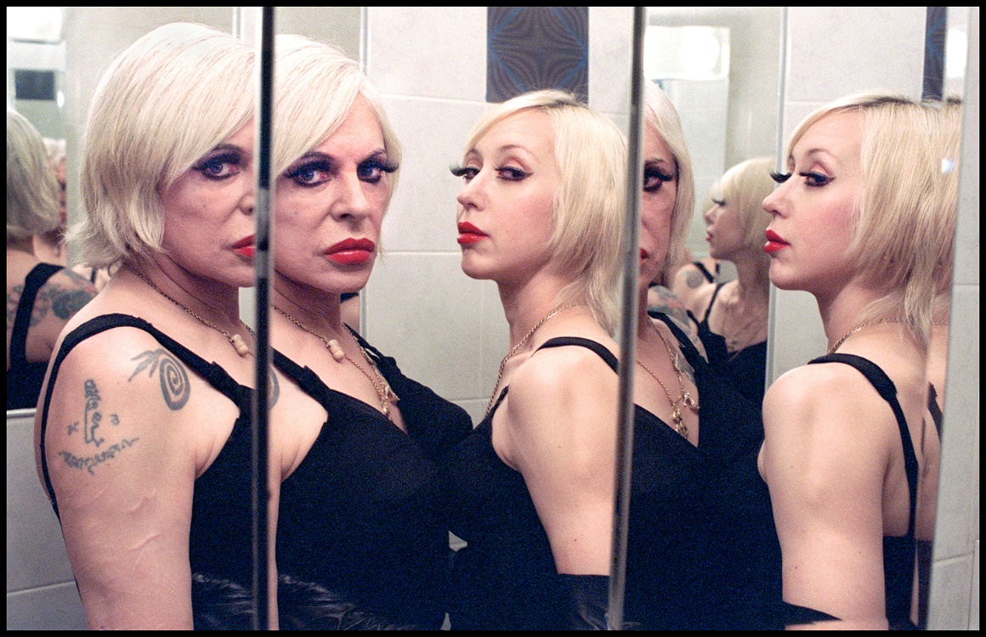
IT IS A PAINFUL THING TO BE ALONE: WE ARE BUT ONE presents the artwork of British artist, musician, occultist, and sound magician Genesis Breyer P-Orridge (1950-2020), who, together with their wife Lady Jaye Breyer (1967-2007), decided to change the concept of their own identity, gender, and physical body. Through surgical and aesthetic alterations, they merged their bodily features to create a new entity, Breyer P-Orridge, known artistically as the Pandrogeny Project.
↑ Untitled, Pandrogeny Project, 2006, photo: Laure A. Leber

“My father was a forward-thinking philosopher, and their ideas on things like gender non-conformity, individualistic self-expression, and creative autonomy are just a few examples of how valuable their influence is to any modern audience looking for inspiration.”
– Genesis’ daughter Genesse P-Orridge

The exhibition of Genesis Breyer P-Orridge, the first of its kind in Europe and organized by the DOX Centre for Contemporary Art in Prague in collaboration with New Discretions (New York). Pioneer Works is a partner of the exhibition.

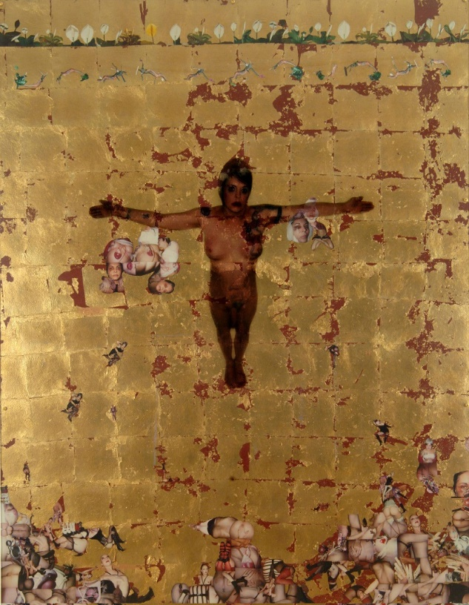
“Genesis Breyer P-Orridge’s activities were reflected in both music and visual arts, and they participated in films and wrote books and poems. Unfortunately, at the time those works were produced, they met with some misunderstanding, but they went in their given direction regardless of success. And in hindsight, we can see that they were at the birth of several genres of music and overall influenced what alternative culture means today,” says DOX curator Otto M. Urban of Genesis Breyer P-Orridge.

The exhibition at DOX is a follow-up to BREYER P-ORRIDGE: We Are But One, developed by Pioneer Works at Red Hook Labs in Brooklyn in 2022. The works presented then now form the core of the new project and will offer an intimate look at the Pandrogeny Project (Genesis Breyer P-Orridge with Lady Jaye Breyer P-Orridge), a nearly two-decade-long effort to liberate love and pure consciousness from the confines of the gender-conforming body.

↑ Breyer P-Orridge, In the Shape of a Cross 2005, ©Estate of GBPO

According to curator Otta M. Urban, Genesis Breyer P-Orridge thought about their work in such a complex way that it was only a matter of time before they themselves entered into its complexity. “It started gradually, growing out of activities related to performance and body art. At first they followed the Actionists and then, thanks to a very solid spiritual concept, the creative material became their own body. They reasoned that one should be aware of human individuality, one should realize that there is no predefined formula according to which life must unfold, but that there is freedom in life to actively enter into and transform the formula. Plus, they chose to document their physical transformation at the same time.”

Benjamin Tischer, who has worked with Genesis for more than twenty years and has been their gallerist for the last decade, came from New York to prepare the exhibition at DOX. “Genesis, whether through bodily modifications, musical innovations, the adoption of occult strategies, or the questioning of gender, has often been ahead of the curve. And they were never afraid to lead by example, to be open and generous in their intentions. One of their enduring messages is that we as a species must change and evolve, hopefully into a more humane version.”

The exhibition is divided into five parts. Historical materials, flyers, album covers, and photographs from their previous collaborations, including COUM Transmissions, Throbbing Gristle and Psychic TV complement Genesis Breyer P-Orridge’s works.

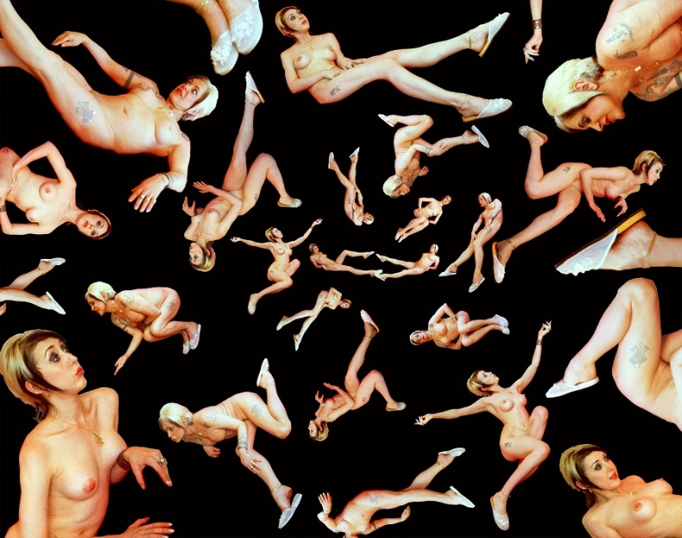
Other materials include contextual works by Daniel Albrigo, Hans Bellmer, William S. Burroughs, Cerith Wyn Evans, Val Denham, Scott Ewalt, H. R. Giger, Brion Gysin, Michelle Handelman, Eric Heist, Lucie Hošková, Peter Christopherson, Derek Jarman, Nicolas Jenkins, Marie Losier & Bernard Yenelouis, Pierre Molinier, Fakir Musafar, Hermann Nitsche, Genesse P-Orridge, Sandie Shaw, Vladimír Skrepl, Scott Treleaven, Pauline Smith, Annie Sprinkle, Carl van Vechten and Sam Zimmerman.
↑ Breyer P-Orridge, Snoflakes DNA, 2004, ©Estate of GBPO

The exhibition also includes a sculptural installation commemorating the shrine, created by Genesse P-Orridge, Genesis’s daughter. She herself came to DOX and participated in the preparation of the exhibition. “My intention was to create a space in this shrine for reverence and contemplation around the inspiring life my father led. The shrine includes relics and sacred objects from my father’s personal altar, which they collected on their travels to spiritual regions such as Benin and Nepal. There will also be pieces of materials from their own sculptures and gold leaf, a favorite material in their practice that we often used together when I was growing up to work on artwork.”

VYSVĚTLIVKY
Genesis P-Orridge
Genesis P-Orridge was a British musician, artist, and poet who played a pivotal role in experimental music and avant-garde art from the 1960s until their death in 2020. P-Orridge was also famous as a founder and principal member of the industrial music groups Throbbing Gristle and Psychic TV. They were a prominent figure in the COUM Transmissions movement, which was concerned with performance, conceptual art, and controversial content. Their work was characterized by provocation and significant experimentation with identity and gender. P-Orridge has greatly influenced alternative culture and art.

BREYER P-ORRIDGE
Breyer was the last name of Lady Jaye, Genesis’ wife, partner, and collaborator, who died in 2007. Genesis and Lady Jaye went by the combined pandrogyn name BREYER P-ORRIDGE. Their own choice was to always capitalize this name.

After Lady Jaye’s death, Genesis continued to label the artwork as BREYER P-ORRIDGE to pay tribute to their collaboration and to acknowledge that the creative process always included input from their shared angelic being. For Genesis, loyalty did not end with death, and their deep connection, as well as a lifelong commitment to belief in spiritual practices and magic, meant that separation from the physical world did not alter the unified power of their inspiration.

Their relationship and art project was a critique of the traditional view of gender and identity. Genesis P-Orridge and Lady Jaye became a symbol of a return to the idea that gender is fluid and can be shaped and changed. Their work has been highly controversial but also inspiring to many artists and activists interested in gender identity issues.

ZÁJMENA
Genesis used the pronoun he/him until he and Lady Jaye embarked on the Pandrogeny Project. At that time, Genesis started using the pronoun she/her. These pronouns evolved into the pronouns s/he and he/r, which the artist used until their death in 2020. After Lady Jaye’s death, Genesis began using the pronoun we (replacing “I”). Posthumously, the consistent pronouns they/them are thus often used.

The exhibition IT IS A PAINFUL THING TO BE ALONE: WE ARE BUT ONE presents the artistic work of Genesis Breyer P-Orridge, one of the most influential figures of alternative culture of the last half century. They were one of the initiators of a broader artistic movement, the so-called Industrial Culture, which has manifested itself in all areas of contemporary culture and art, not only in the visual arts, but also strongly in music, film, and literature. The movement has its roots in the UK but over time has found international resonance. During their long artistic career, the GBPO has been involved in a number of seminal projects that continue to inspire new audiences or listeners today. Their artworks have appeared in a number of group and solo exhibitions, most recently at Pioneer Works in New York in 2022. In the early 1970s, they were a member of the legendary COUM Transmissions art collective, which is now regarded as a major artistic achievement in opening up new themes and different aesthetic concepts. Thematically, COUM is close to the work of the Viennese Actionists. The influence of the American writer William Burroughs and his friend Brion Gysin was also strong, as was that of Marcel Duchamp. COUM Transmissions was also one of the initiators of the later DIY movement. In 1975, Genesis Breyer P-Orridge co-founded a group called Throbbing Gristle, whose interest in sound experimentation and new technologies foreshadowed a number of new musical directions (industrial, noise, electronic, etc.). Subsequently, they collaborated with a number of other projects, most notably Psychic TV. Their artistic work thus coexisted with that of a musician and writer. Since the 1990s, they lived in New York with their second wife, Lady Jaye. Together they realized The Pandrogeny Project, the idea of which was to create an identical, unified being through plastic surgery. The exhibition presents the work of Genesis P-Orridge in a broader cultural context. Attention is thus also paid to the work of artists who have directly influenced or referenced their artistic work.

Curators: Benjamin Tischer (New Discretions) and Otto M. Urban (DOX) with Genesse P-Orridge (GBPO Estate).

Main Exhibition Partners: HateFree Culture, New Discretions, GBPO Estate

Exhibition Partners: Pioneer Works, Norway grants, The Ministry for Regional Development of the Czech Republic

IT IS A PAINFUL THING TO BE ALONE: WE ARE BUT ONE
26 October 2023 – 3 March 2024
DOX Centre for Contemporary Art
Poupětova 1, Prague 7

Press release and photos can be downloaded in the Press section after registration.

Contact:
Karolína Kočí
E karolina.koci@dox.cz
T +420 777 870 219
www.dox.cz

