Themes of the child in the exhibition Great Expectations in Prague’s DOX

In November, the DOX Centre for Contemporary Art opens an extensive exhibition dedicated to the themes of birth and the beginning of life. The group exhibition, entitled Great Expectations, features nearly forty contemporary Czech artists under the direction of curator Otto M. Urban. The exhibition will be on view until 24 April 2022.

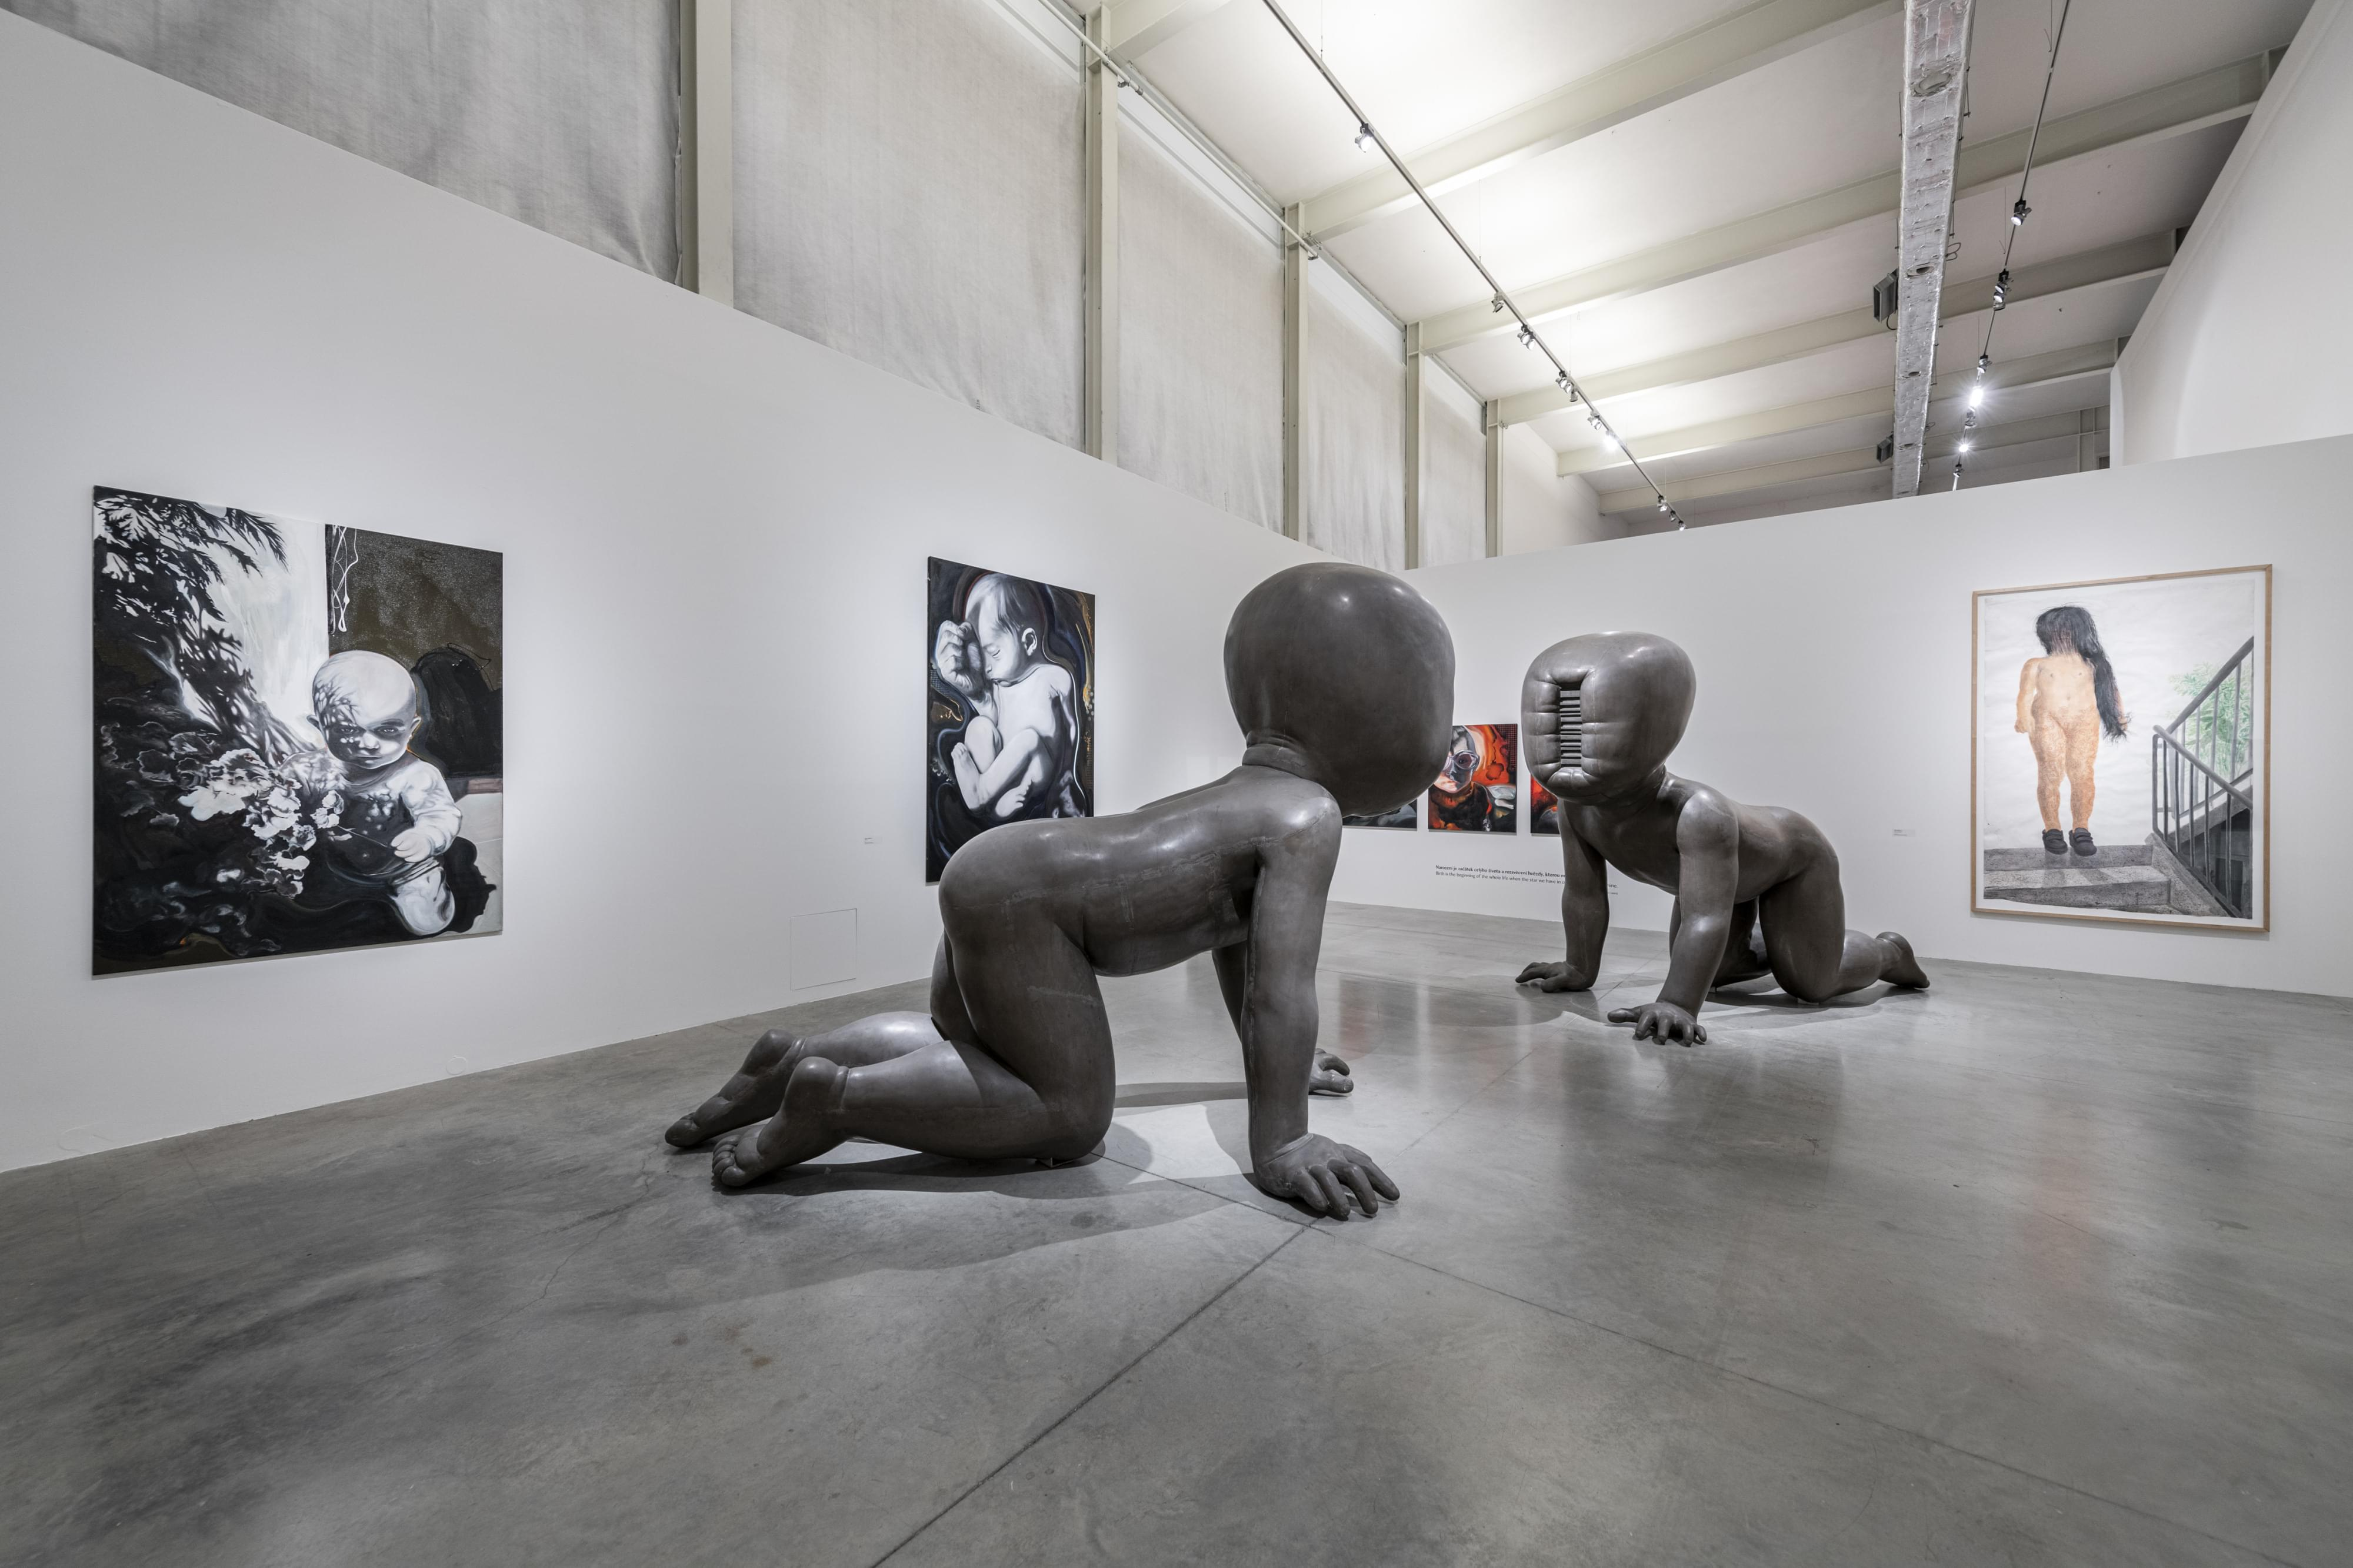

↑ A view into the Great Expectations exhibition. Photo by Jan Slavík, © DOX

The exhibition Great Expectations, subtitled The Child in Contemporary Czech Art, is a loose continuation of the so-called pandemic trilogy that began with the project Vanitas in Contemporary Czech Art (DOX, 2020–2021). In this case, too, it is a group exhibition that presents a wide range of artists of different generations and artistic expressions. After the themes of death, dying and impermanence, Great Expectations deals with the themes of birth and the beginning of life, a period that is full of twists and turns and expectations, seeming innocence and cruelty. The exhibition deliberately does not deal, for example, with themes of puberty or parenthood, which are specific and broad enough in themselves. Nor does it reflect the work aimed directly at children.

“The perception of childhood changes with age and is subject to forgetting; it is an idealized time. The child has become not only an object of scientific research, but also a powerful business. Novels and poems are written about the child and childhood, films are made, and music is composed, with some works lasting for generations and becoming a firm part of the wider cultural canon. I often see children's work as simplistic, copying the repeated clichés of an ideal paradise bathed in warm sunshine. However, flashes of sadness, pain and anxiety also appear in the memories,” says Otto M. Urban, the exhibition curator and chief curator of the DOX Centre.

The child has appeared in the history of art since time immemorial and has always been an important part of the spiritual history of humanity. In contemporary art, the motif of the child is richly represented, perhaps even more strongly than in earlier times. However, visions and images of childhood are often unpleasant, they do not represent a radiant idyll, but melancholy prevails with all its mysteries and anxieties. Naturalism (Magdaléna Rajchlová, Lubomír Typlt) is replaced by caricature (Marek Meduna), exaggeration (Veronika Bromová, Jan Vytiska), in some cases childishness becomes almost monstrous (Andros Foros). A child can also be a symbol or allegory (Ivan Pinkava) or represent more general themes and issues (Zdena Kolečková).

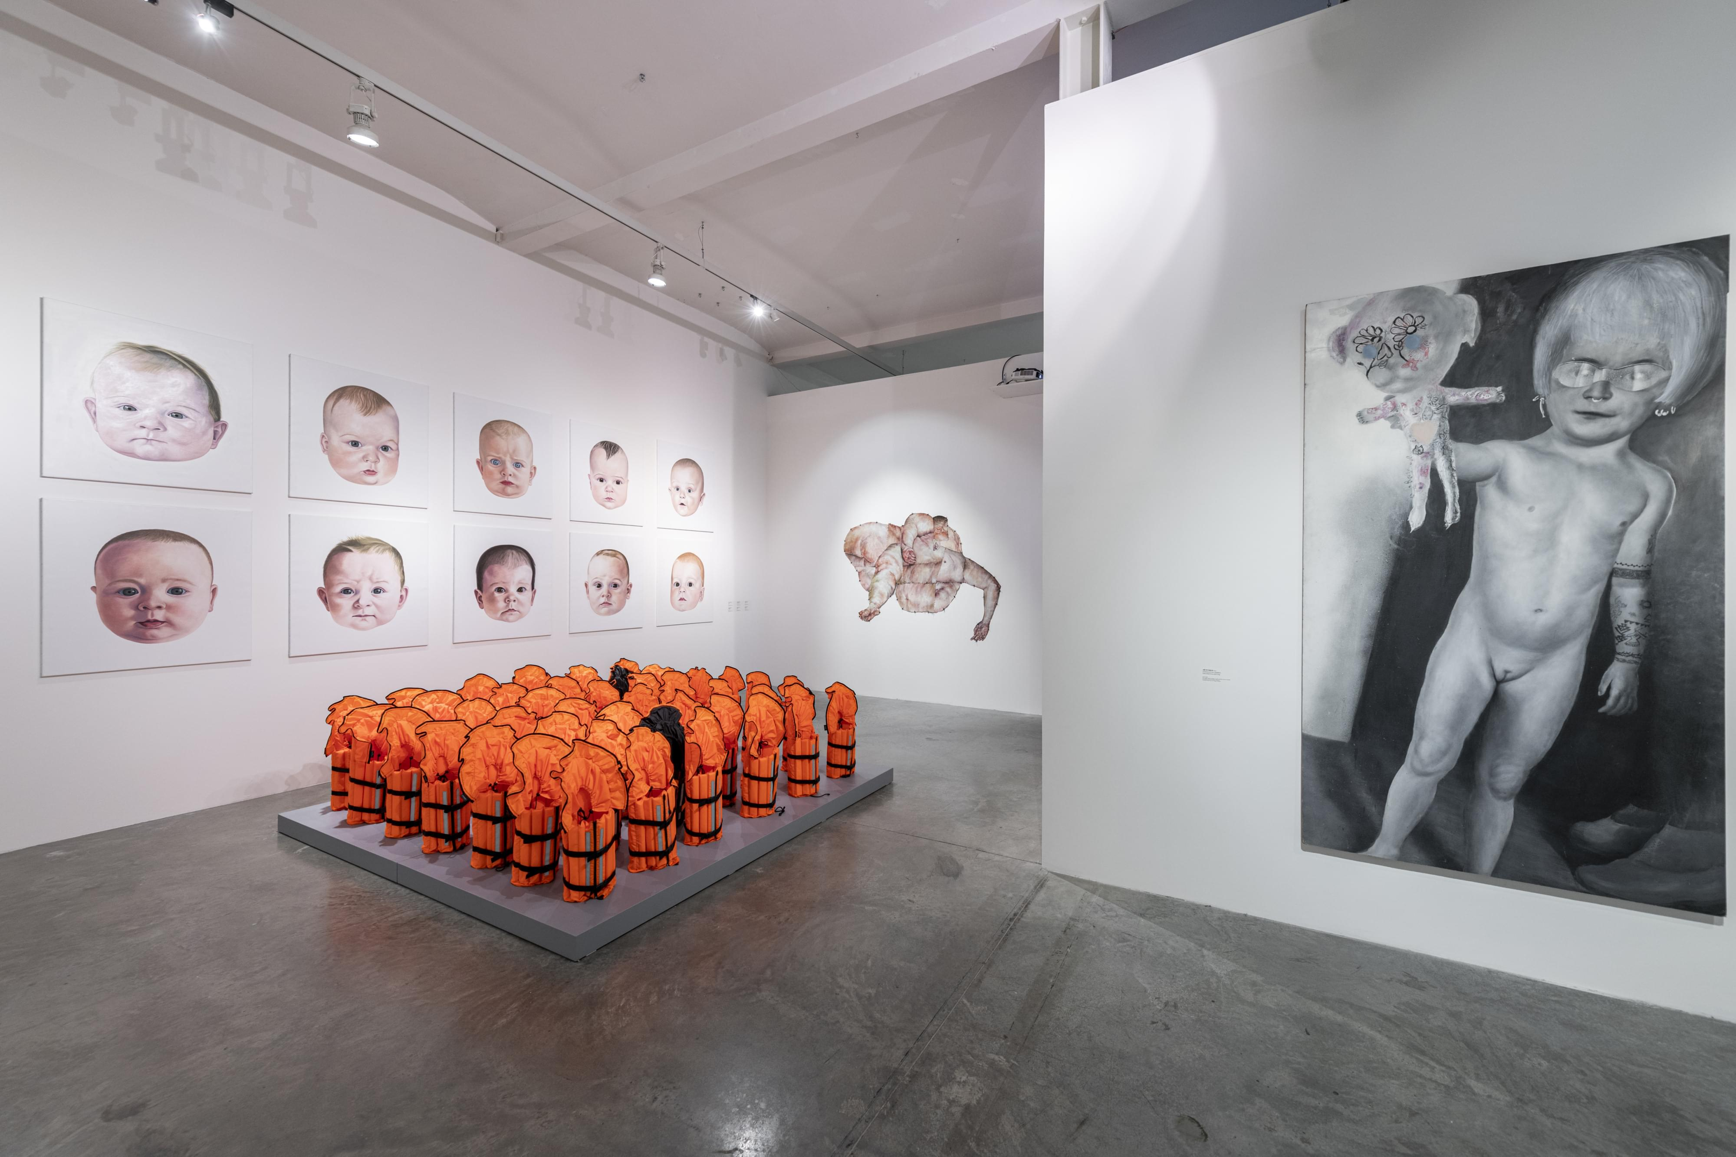

↑ A view into the Great Expectations exhibition. Photo by Jan Slavík, © DOX

Great Expectations represents the work of nearly forty artists, some of whom have been working on the subject of the child for a long time. The spectrum of forms of the exhibited works is rich: from painting (Adam Štech) and collage (Jana Vojnárová) to sculptures (Barbora Balek, Martin Žák) and installations (Kateřina Šedá) to videos (Mark Ther, Martin Zet) and photography (Jiří David, Václav Jirásek). The oldest works date back to the 1990s (Milan Knížák, Petr Nikl), and new works are constantly being created (installations of drawings by Josef Bolf, sculptures by Matouš Háša, paintings by Ivana Lomová).

The exhibition is accompanied by quotes from children who participate in the educational programs that form one of the main lines of activity of the DOX Centre, as well as a video from the Commander project focused on the online radicalisation of children and young people. The broader Commander project by Viliam Dočolomanský and the Farm in the Cave theatre studio was inspired by the recent capture of the leader of an international online extremist organisation, a 13-year-old boy from Estonia whose profile name was the Commander. The upcoming project includes an art film featuring child actors, a theater production and a series of educational videos and workshops for children and parents to draw attention to this current and dangerous phenomenon.

It is not only the exhibition studio that is dedicated to children – there is a space in the immediate vicinity of the exhibition where visitors can not only experience or recall various perspectives and scales of life, but also draw from them, write them out, and, as the creators of the studio, Jiří Raiterman and Lucie Laitlová, say, “display their childhood on the fridge”.

A comprehensive catalogue with philosophical and sociological texts (planned for February 2022) will be published to accompany the Great Expectations exhibition. The exhibition will also be complemented by a full range of public and school programs – from literary events to film screenings to panel discussions reflecting current issues related to childhood, education and upbringing, such as media education or children's mental health in the pandemic era. ←

Great Expectations
The Child in Contemporary Czech Art
10. 11. 2021 – 24. 4. 2022

Curator Otto M. Urban
Architectural design of the exhibition Otto M. Urban, Michaela Šilpochová, Leoš Válka
Graphic design Daniel Korčák
Studio concept Jiří Raiterman, Lucie Laitlová

Exhibiting artists

Barbora Balek
Josef Bolf
Veronika Bromová
David Černý
Jiří David
Viliam Dočolomanský
& Farm in the Cave
Pavel Forman
Andros Foros
Viktor Frešo
Matouš Háša
Siegfried Herz
Jakub Janovský
Václav Jirásek
Krištof Kintera
Ester Knapová
Milan Knížák
Zdena Kolečková
Eva Koťátková
Ivana Lomová
František Matoušek
Marek Meduna
Barbora Myslikovjanová
Petr Nikl
Daniel Pešta
Jiří Petrbok
Ivan Pinkava
Magdaléna Rajchlová
Michal Rapant
Jaroslav Róna
Nikola Emma Ryšavá
Kateřina Šedá
Adam Štech
Jan Švankmajer
Mark Ther
Lubomír Typlt
Jana Vojnárová
Jan Vytiska
Martin Zet
Martin Žák

DOX Centre for Contemporary Art
Poupětova 1, Prague 7
opening hours: Wednesday to Sunday 12pm–6pm

The press release and photos can be downloaded after registration in the Press section

Contact

Hana Janišová
DOX Centre for Contemporary Art
E hana.janisova@dox.cz

