**HOW CAN I HELP YOU? Krištof Kintera asks in his apothecary of virtues and vices.**

**No ink drawings on paper, no pencil lines, or reproductions of sketchbooks. Yet Krištof Kintera, one of the most respected artists on the Czech art scene today, claims that he is exhibiting DRAWINGS. Over 300 works in a uniform format are presented in a site-specific installation on three floors of the tower of Prague’s DOX Centre. Together, they form a personal confession of the artist, who records what interests, frustrates, and frightens him on individual pages of an imaginary diary. At the same time, he touches on our own innermost feelings, desires, pains, and fears.**

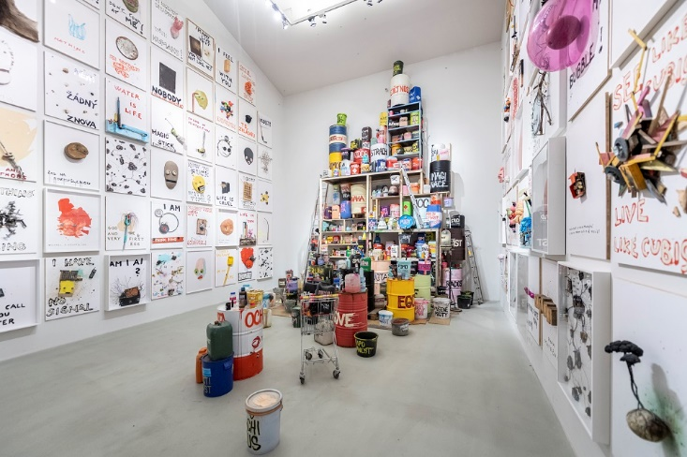

The Czech and international audience knows Krištof Kintera’s work primarily thanks to his sophisticated kinetic sculptures and monumental, technically demanding installations in galleries and public spaces. It is difficult to imagine more classical artistic methods, such as drawing, in the context of his complex projects. Nevertheless, the artist describes a significant part of his work, which he has been continuously engaged in for almost two decades, as “drawings”. In many cases, these are almost three-dimensional works in a uniform format that most people would consider more like collages or assemblages. For Kristof Kintera, however, they are clearly drawings. Above all because of the way they are created - spontaneously, quickly, and with ease.

*“My drawings are the result of rare moments when I manage to investigate time. They are not made in some ordered state of calm, but mostly on the spur of the moment. I enjoy this diaristic work immensely, but in the traffic of all the things I do, I find it very difficult to get to it. It’s kind of a parallel line for me, because even though I’m working on a lot of other projects - various sculptural things and reinstallations that are technically very demanding and take years to complete – it’s the drawing that frees me from being a sculptor, a worker, and a craftsman. In the case of this work, I have an “instant” and quick result that makes me feel like an artist,”* says artist Krištof Kintera.

Kintera creates these straightforward compositions of drawings with a limited amount of resources - the found and “consumed” objects and materials of our everyday existence. Text often plays an important role in them. An old pillow with eyes made of burnt-out light bulbs doubts its “contribution to evolution”, a crumpled tin can sadly explains that it is trying to get itself into shape every day, a broken TV screen announces with a disappointed expression that “Everything is different”. The words “No One Has Anything” carved into a sign have literally been struck with an axe. Simple yet visually striking arrangements, short punchy texts, playfulness, irony, hyperbole.

The way Krištof Kintera composes the individual objects and texts into the final form is reminiscent of the process of drawing itself. They are quick sketches, visual records of thoughts, of what he stores, as if unconsciously, somewhere in the back of his mind during the day - a fragment of a sentence, a visual perception, a song lyric, a phrase, a piece of an advertising slogan - to pull them out at the first possible opportunity, when he is back in his studio, and quickly get them onto paper or, in this case, onto a board.

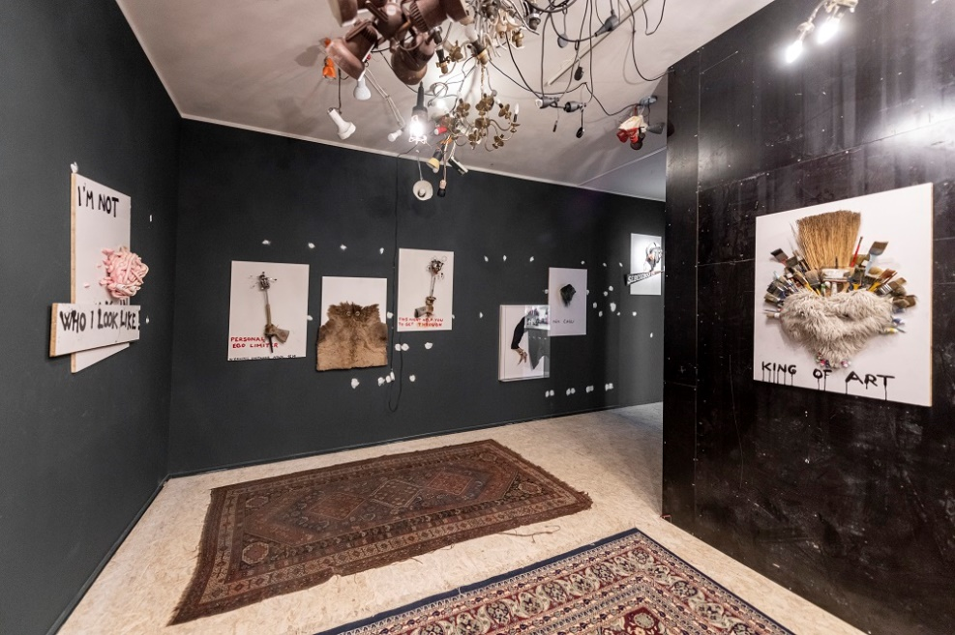

*“In this way, a kind of diary is created - a personal confession of the artist, where on individual pages he records his own feelings, emotions, and thoughts, but at the same time comments on our own doubts, fears, and frustrations with irony, perspective, and insight. The artist thus finds himself in the role of therapist, alchemist, and healer. He x-rays the tiny fractures of our relationships, listens to the beating of our thoughts with a stethoscope and pricks our egos with a scalpel,”* says Michaela Šilpochová, the exhibition curator and artistic director of the DOX Centre.

Hundreds of drawings have been created over the years and the diary continues to grow. At the same time, its pages never stay in one place for long. They find themselves in collectors’ salons, law offices, doctors’ offices and living rooms, where they begin to live a second life. However, the number of lenders of works to the exhibition, the vast majority of whom are private collectors, has also exceeded 100.

**Now, for the first time - and perhaps for the last time for a long time – Kintera’s drawings are gathered at the DOX Centre**, which the artist himself considers a small miracle. “*In the time I’ve been making them, we’re talking about some 500 or even 600 drawings. Many of them are abroad, we had to make very complicated arrangements to bring them back. But what is extremely interesting for me is the synergy with the lenders. I am happy that my drawings have become a kind of common thing for all the people who have acquired them. And not only that they have acquired them, but that they surround themselves with them in their homes and that they interfere with their lives. Now they’ve loaned the works for an exhibition and they’re calling me all unhappy about how long the exhibition is going to be and how long they’re going to have to live without their drawing at home. So, the emotional ties, the intertwining of the relationships with the owners of the works, and the unique logistical operation, all of it together is touching for me. And when I get up to the top, to the tower of the DOX Centre, and I see the installation in full swing, I am overjoyed.”*

In addition to the mentioned drawings, which could perhaps be described as classical, DOX is also exhibiting a number of new works by the artist with floral motifs. Krištof Kintera creates them using a unique technique of electric discharge burning. “*It’s a fresh thing, even though I have been intermittently burning for several years. However, I am exhibiting flowers for the first time at the DOX Centre, and in the process of creating them I have managed to master the high-voltage burning technique more and gain confidence in it. The parallels between the flow and the voltage, between what’s going through the machine and also the energies that flow through nature and the actual flowers, are all extremely interesting connections. For example, any flower root looks exactly the same as the imprint of that discharge. I now see a lot of parallels and things to think about in this work.”*

*“The fact that a large number of drawings could be collected created a unique opportunity where Krištof Kintera could elaborate on the motifs of some of the drawings in the exhibition space or develop them with authorial interventions. Each of the three floors was conceived in a completely different way. Together they form a large installation, a kind of laboratory, a book of wisdom, a wailing wall, and an apothecary of virtues and vices. And how can the diary of drawings by Kristof Kintera help you? See for yourself.”* concludes Michaela Šilpochová, the curator of the exhibition*.*

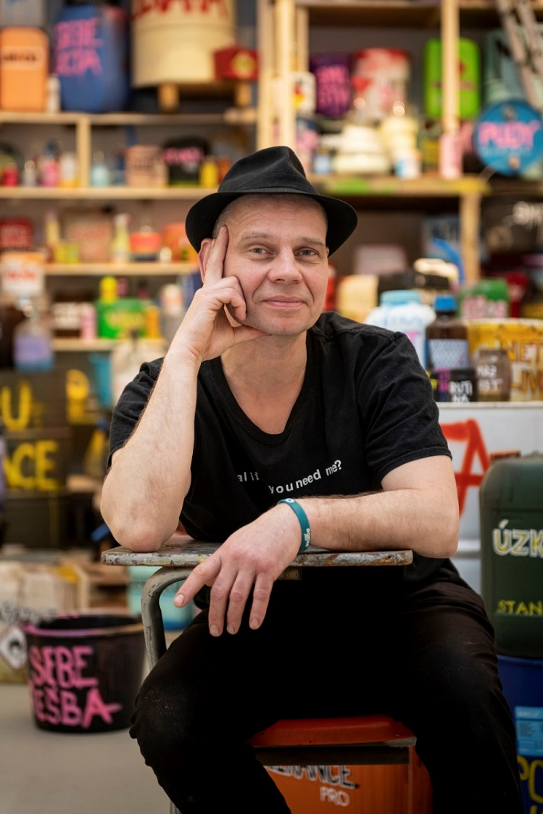**Krištof Kintera** (* 1973) studied at the Academy of Fine Arts in Prague in the studios of Milan Knížák, Michael Bielický, Aleš Veselý, and Jiří Lindovský. He subsequently joined the Rijksakademie van Beeldende Kunsten in Amsterdam. He also completed scholarships at Ohio State University in the USA and at the Künstlerhaus Villa Waldbert in Feldafing, Germany. He creates often technically demanding, well-planned and witty kinetic or luminal sculptures, installations, or videos. He uses a variety of materials to create them - often electrical appliances or other discarded or found devices and objects. In many of them he alludes to the nature of today’s consumer society or creates a kind of fictional “person” out of them. In this way, he often asks questions that are easily understandable to himself and the viewer, and that relate to social or political issues. Another aspect of his work is his distinctive sense of humour, which he brings to his drawings and collages through puns on words, materials, and other forms. Krištof Kintera is one of the most active artists on the Czech and international scene, regularly exhibiting at renowned European institutions, most recently at Kunsthalle Rotterdam, D+T Brussels and others. His exhibition Nervous Trees (2017) at the Rudolfinum Gallery was one of the most successful exhibitions in recent years in the Czech Republic. (Source: Czech Television)

**Curator:** **Michaela Šilpochová**

**HOW CAN I HELP YOU?**

**10. 3. 2023 – 20. 8. 2023**

DOX Centre for Contemporary Art

Poupětova 1, Prague 7

## Press release and photographs can be downloaded after registration in the [Press](https://www.dox.cz/users_area/register) section.

## Author of photography: Jan Slavík, ©DOX

## 

Contact:

**Karolína Kočí**  
E [karolina.koci@dox.cz](mailto:karolina.koci@dox.cz)

T +420 777 870 219

**www.dox.cz**