A crucifix submerged in urine, torture chambers, or followers of the Ku Klux Klan: DOX launches the exhibition Infamous Beauty - a cross-section of the work of controversial American photographer Andres Serrano. An artist who has been searching for beauty all his life and is not afraid of taboo subjects.

In Infamous Beauty, the DOX Centre for Contemporary Art unveils 120 large-format photographs by the artist who rewrote the history of the American cultural scene. The work of New Yorker Andres Serrano (72) conveys strong emotions, contrasts, and the exposure of half-truths. For 40 years, his work has dealt with social issues, sexuality, racial intolerance, and the darker aspects of the human condition.
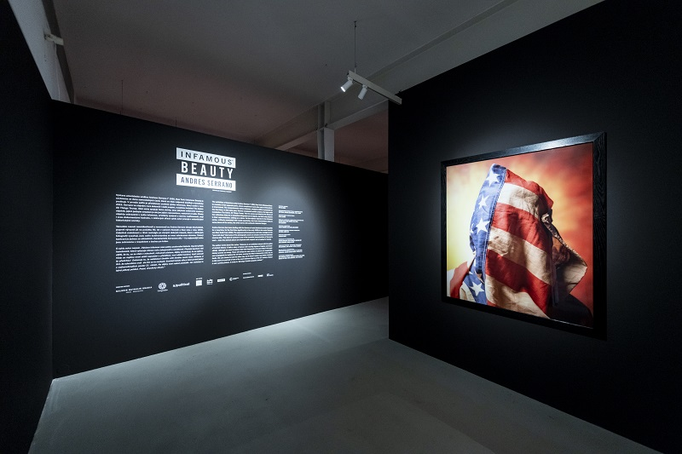
Serrano has photographed various sensitive subjects, including Ku Klux Klan members, the dead in a morgue, close-ups of firearms, and burned people. He also went into the New York subway system and made portraits of the homeless. He has devoted a significant part of his work to human sexuality, attempting to transcend taboos and introduce viewers to different forms of sexual identity, whether homosexual or other orientation, or fetishes. In his early works, he even made use of bodily fluids (urine, blood, breast milk, etc.). One of his latest series attempts to point out how creepily Donald Trump is trying to manipulate the USA.
Andres Serrano chooses his topics not according to whether they are taboo for society, but according to what interests him personally: “I choose the subjects from my head. They may relate to people, places, issues, and ideas around me, but things usually start in my mind and then I go about seeing how I could make them happen. These are not things that are taboo to me, more like unexplored. The best way to describe what I do is that I materialize the pictures in my head. And when I take the pictures, they usually look even better than what I imagined! How do I get close to people and get them to do what I want? I ask them.”

According to the curator of Infamous Beauty, Otto M. Urban, the unconventionality of Serrano’s works also lies in the fact that he points out problems in the form of references to the old masters: “As an art historian, I like it when you can find a reference to art history in the works, which Serrano makes. He refers to himself as an artist who uses the medium of photography with a painterly perception of the image. References can be seen, for example, in the geometry of his photographs; there is an allusion to Piet Mondriani or Kazimir Malevich. In some of his portraits, one can see the famous 19th century American photographer Edward S. Curtis, and he also mentions Caravaggio and Baroque painting. That is why I was immediately attracted by how he works with references and how he transforms the works of older artists.”
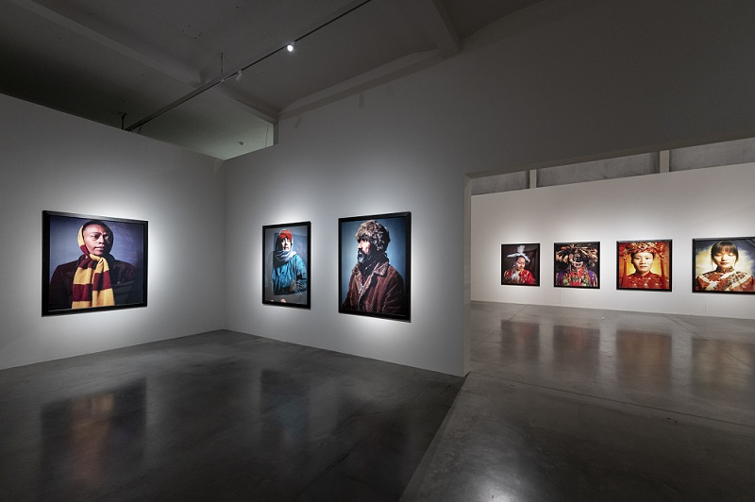
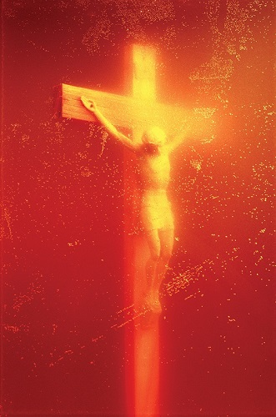
Serrano’s 1987 photograph Piss Christ, which shows the crucifix immersed in the artist’s urine, has sparked national outrage and protests several times over the years, and the image has even been debated by the United States Senate. Piss Christ started the so-called culture wars in the US and caused a split in federal funding for the arts, an ideological battle that continued in the US throughout the 1990s. It is this iconic work (in the form of NFT) that greets visitors as they enter the Infamous Beauty exhibition.

“What it symbolizes is the way Christ died: the blood came out of him but so did the piss and the shit. Maybe if Piss Christ upsets you, it’s because it gives some sense of what the crucifixion actually was like... I was born and raised a Catholic and I’ve been a Christian all my life.”
(Andres Serrano for The Guardian, 2016)
↑ Andres Serrano, Piss Christ, 1987 ©Andres Serrano

The Prague exhibition is composed of two separate parts, which complement each other and are thematically intertwined. In the exhibition hall, under the title Beauty, a collection of more than sixty works is presented, a selection from the artist’s long artistic career. Andres Serrano’s work is presented at DOX in a dialogue of recent photographs with older works from a total of 18 series, including: Bodily Fluids (1986-1990), Immersions (1987-1990), Nomads (1990), The Morgue (1992), Objects of Desire (1992), America (2001-2004), Holy Works (2011), Torture (2015), Made in China (2017), Infamous (2019), Robots (2022), and more.

The DOX first floor then presents the complete Infamous series from 2019. The third space is dedicated to Serrano’s latest series, Confessions. The latest works were created as oil pastel drawings by Serrano over black and white photographs of sculptures by Michelangelo.

According to exhibition curator Otto M. Urban, the juxtaposition of the newer works with works more than three decades older yields surprising and powerful connections. “We wanted to present Serrano’s entire broad spectrum, from the oldest works to the most recent ones. Our aim was to show the coherence and consistency of his artistic opinion. That’s why works are placed next to each other that have, say, a twenty-year gap between them but are surprisingly in a kind of harmony in that opinion. It is a lifelong search for beauty, truth, or goodness. But one line runs through his work constantly, and that is religious motifs and references to Christian iconography.”
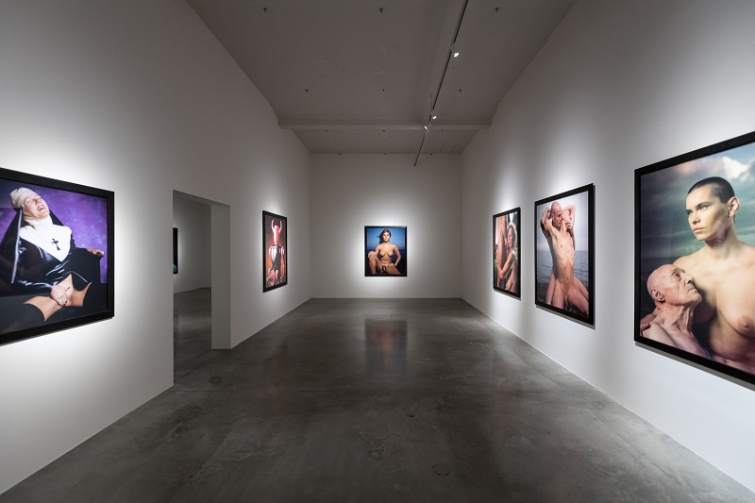
One of the most important aspects of Serrano’s work is his ability to spark public debate on controversial topics. In his photographs, he often uses stark, explicit, and even shocking images that aim to provoke a strong emotional reaction. These works are not absent from the DOX exhibition either, as the artist himself acknowledges: “My work is fluid and transitional, that is to say it’s an organic process. One picture leads to another, one idea, one series transitions into the next one. It’s a thread that links everything I do from one day to the next, one month, one year, one decade to the other. Otto Urban, who curated this exhibition, understood that for my first ever exhibition in Prague, the exhibition had to be a bang up show with no holds barred. He picked some of my best work from different series coming from many places, Fotografiska in Sweden, a/political in London, Nathalie Obadia Gallery in France and Belgium.”

Contrast is one of the fundamental characteristics of Serrano’s work - even the darkest places are depicted with respect and a desire for beauty, according to curator Otto M. Urban. “In many interviews, Andres Serrano talks about how his main concern is capturing beauty. He often chooses motifs that are generally perceived as ugly - for example, death or the nudity of old people. Thus, one of the points of his artistic mission is to find beauty even in such subjects. Which is actually a concept in art theory today that almost nobody uses, because beauty seems to have disappeared. It’s as if Serrano is one of the few who is not afraid to talk about beauty as a term. For a thousand years, beauty has been one of the key terms of any artistic expression. That’s why I appreciate Serrano’s openly bringing the subject of beauty back into the wider discussion.”

Andres Serrano
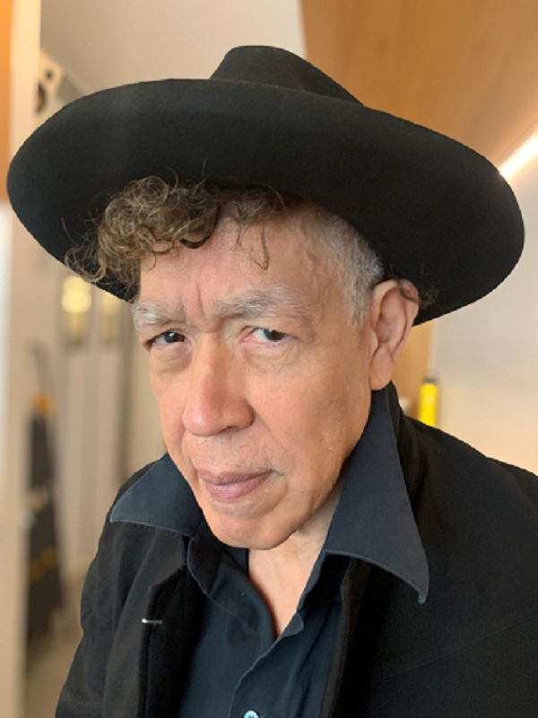
Andres Serrano was born in 1950 in New York to a family with Hispanic roots (his mother was from Cuba, his father from Honduras). He grew up in the Bronx, attended public schools and was raised in the Christian faith. After high school, he joined the US Army and served in Vietnam. After returning from the war, he enrolled at the Brooklyn Museum Art School, where he studied painting from 1967-1969.
He is considered self-taught in photography.
Before creating his first works in 1983, Serrano worked as an assistant art director at an advertising agency.
He also worked as a drug dealer. His work was first exhibited by photographer Alex Harsley at his Fourth Street Photo Gallery in New York.
His work has often focused on controversial and taboo subjects, earning him both widespread recognition and plenty of criticism. Andres Serrano rose to prominence in the late 1980s when American conservatives found his work offensive, leading to a debate over federal support for the arts in the United States.
He has photographed many figures from the world’s cultural and political scene, such as Snoop Dogg, B. B. King, Yoko Ono, Arthur Miller, Robert Altman, and others.
He lives with artist Irina Movmyga.

Serrano’s Blood and Semen III was used by heavy metal band Metallica for the cover of their album Load. A photograph of Piss and Blood was chosen by the band a few years later for the cover of the album Reload. Andres Serrano himself directed the music video Crush My Soul for the metal band Godflesh.

Themes/Series
Among the most well-known series of photographs is Infamous (2019), in which the artist explores the tainted history of the United States, scapegoats, and man’s inhumanity to man. The series includes a portrait of Jeffrey Epstein (a controversial businessman accused of sexual abuse), whom Serrano photographed a month before his unsolved death.

Another important series is Nomads (1990). In this series, Serrano captured people living on the margins of society in squalid conditions. These photographs evoke empathy and bring themes of poverty, social inequality, and human suffering into public debate.

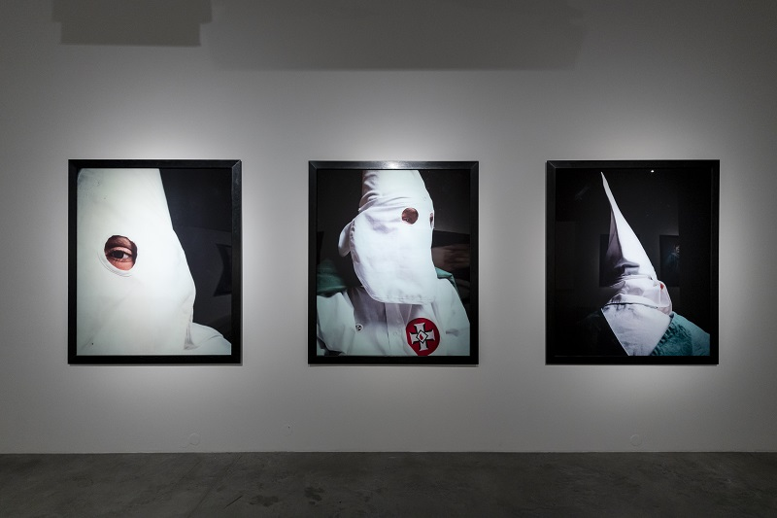
Andres Serrano’s work also does not avoid controversy in the area of racial intolerance. In his series The Klan (1990) he seeks to expose the darker aspects of this issue and raise questions about human nature and social stereotypes.
For him, as an artist of Hispanic origin, these themes are even more sensitive and personal.

Many of Serrano’s works involve bodily fluids. For example, he has used blood (sometimes menstrual blood), semen, or human breast milk in his photographs. He has also photographed subjects immersed in bodily fluids. These are mainly the series Bodily Fluids (1986-1990) and Immersions (1987–1990).

Curator: Otto M. Urban

Infamous Beauty
8. 6. 2023 – 7. 1. 2024
DOX Centre for Contemporary Art
Poupětova 1, Prague 7

The Press release and photos can be downloaded in the Press section after registration.

Author of the photos of the exhibition: Jan Slavík, ©DOX

Contact:
Karolína Kočí
E karolina.koci@dox.cz
T +420 777 870 219
www.dox.cz

