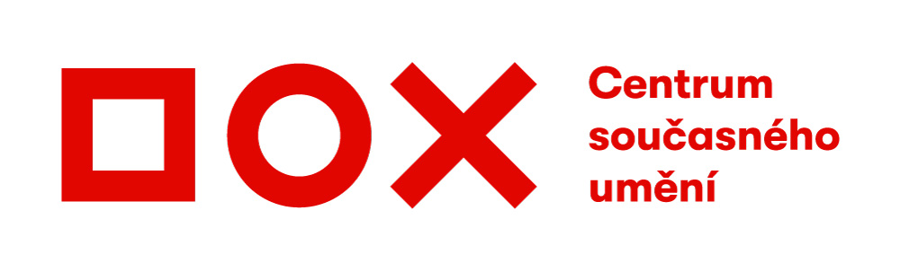

Press release / 11 June 2019
Night in the City – a unique seven-hour experience with Farm in the Cave
The Farm in the Cave International Theatre Studio, in cooperation with the DOX Centre for Contemporary Art, has prepared two unique evenings in June. Visitors will embark on a journey through the industrial architecture labyrinth of the DOX Centre for Contemporary Art to experience three exceptional performances straddling the genres of physical theatre, video, and documentary, will listen to live music and enjoy a picnic on the roof, a candlelight dinner, or twilight under the iconic Gulliver Airship. A unique seven-hour experience that won’t be repeated – that’s Night in the City.
The award-winning Farm in the Cave International Theatre Studio, under the leadership of Viliam Dočolomanský, will accompany visitors to Night in the City through a labyrinth of industrial architecture, uncommon experiences, and three exceptional performances – Informers, Together Forever! and Refuge.
“But Night in the Cave won’t be just theatre. Visitors will experience a seven-hour respite from routine stress, routine reality, and will have time to experience time in a different manner and allow themselves to be carried away by experiences that will surprise them,” says Viliam Dočolomanský.
Farm in the Cave has established itself as a modern laboratory offering performers “asylum” and the opportunity to continuously focus on self-development. They can thus not only discover new ways of expression that one-off projects or mainstream theaters cannot accommodate, but can also reassess their attitude towards themselves and others.
In recent years their work has focused on exploring “difficult“ contemporary topics. Performers and creators have carried out field research in a number of global metropolises where they worked with specific social groups and communities. Based on these direct experiences they have created emotionally strong shows and have focused on spreading awareness about the researched topics through a number of other public activities. For example, meeting and working with a group of seniors in Prague led to the Together Forever! performance, while in-depth discussions with refugees in London coalesced into the Refuge stage composition.
Night in the City is an all-round artistic experience during which visitors will experience three exceptional performances, listen to live music and enjoy a picnic on the roof, a candlelight dinner, an evening under the Airship, and an accompanying programme that will gradually be revealed throughout the evening in connection with the performances.
A night of stories, discovery, and subverting normal ways of seeing things. A night during which time flows differently. Switch off your phone, and forget what you think you know. Merge with the Night in the City. This is the challenge that lies in store for those who decide to embark on 14 and 16 June on a night-time journey through the architecture of the DOX Centre for Contemporary art in Prague’s Holešovice district.
The event is part of the Prague Quadriennale 2019. The DOX⁺ multifunction hall, which will host part of the Night in the City programme, was chosen by an international jury of the PQ among four winning projects from around the world.

Night in the City
on Friday the 14th and on Sunday the 16th of June, from 5:00 p.m. until midnight.
Admission: CZK 990 – this includes three performances, the accompanying programme, and refreshments including beverages
Tickets can be purchased via www.goout.cz

About Farm in the Cave
Farm in the Cave’s performances arise out of long-term research, focused on the transmission of human experience beyond words and the limits of ordinary understanding. Having performed in more than sixty cities on three continents, Farm in the Cave International Theatre Studio have received numerous awards, including the European Prize for New Theatrical Realities for Director Viliam Dočolomanský, Total Theatre Award, The Grand Prix Golden Laurel Wreath Award, and the Fringe First Award.
The company has established itself as a “modern laboratory” offering “asylum” to performers who are encouraged not only to work on new ways of expression, but also to constantly reassess their attitude towards themselves and others through their research work on different social topics. In recent years the work of Farm in the Cave has focused on
exploring “difficult“ topics that tend to be ignored by contemporary society. Performers and creators have carried out field research in global metropolises such as Brussels, Tokyo, Prague, and London, often gaining unprecedented access to specific social groups and communities. Directly shared experience with members of these communities led the performers to create emotionally strong shows and to spread awareness about the researched topics through a number of other public activities. Farm in the Cave’s specific approach to research works not only as a dramaturgical tool, but also as a vehicle for unexpected and mutually enriching encounters among very different social groups.

The Informers performance is based on actual, hidden criminal practices of a transnational food industry corporation, which resulted in scandalous revelations before a Swiss court in 2013. Is it possible to escape corporate influence? In the Together Forever! performance, Hana Varadzinová and Eliška Vavříková invited Prague senior citizens without any prior stage experience, and at least here they succeeded in spanning the generational divide that is all too evident in real life. Refuge, a stage composition that is somewhere between a concert and physical theatre, came about based on interviews with a community of young people in London who had experienced extreme situations while on the run.

Media contact
Michaela Šilpochová (DOX)
+420 774 222 355
michaela@dox.cz

Print-quality photos can be downloaded from: www.dox.cz/cs/press

Night in the City Partners
The City of Prague / Ministry of Culture Czech Republic / The State Cultural Fund of the Czech Republic /Institut Français de Prague / Government of Flanders „Flanders State of Art“/ Prague 7 / Arts and Theatre Institute / Prague Quadrennial

