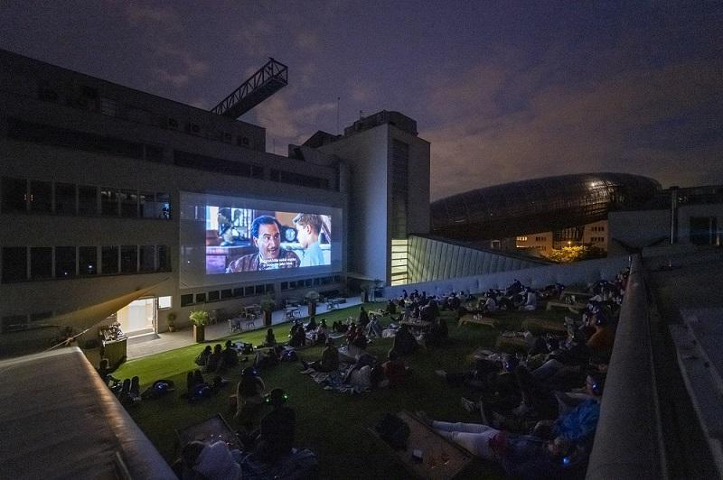**DOX Centre for Contemporary Art in Prague launches David Lynch Season**

↑ A summer cinema screening on the terrace of DOX+. Photo: Jan Slavík

**In June 2025 the DOX Centre for Contemporary Art in Prague opened the exhibition event of the year! In its main exhibition space DOX is presenting the artistic work of American cinematic icon David Lynch.**

The exhibition [**David Lynch: Up in Flames**](https://www.dox.cz/en/whats-on/david-lynch-up-in-flames) features over 400 works of art – from drawings, photographs, lithographs, woodcuts, and watercolours to short experimental and animated films created by the director. The works span all of Lynch’s creative periods, from his early days in the late 1960s all the way to 2024.

**Visitors to DOX can now expand their experience by visiting an open-air cinema on the grassy rooftop of DOX, where David Lynch’s cinematic masterpieces and also films that influenced his work will be screened throughout the summer.**

**This year the** [**DOX Centre for Contemporary Art**](https://www.dox.cz/en) **has joined forces with the** [**Ponrepo Cinema**](https://nfa.cz/en/ponrepo-cinema) **(The National Film Archive, Czech Republic), to prepare a programme of nine movie nights under the stars and in the unfathomable, mysterious, and deeply captivating universe of David Lynch.**

The first screening will take place on 2 July, and other films will follow **every Wednesday until the end of August, always at 9:30 p.m**. Each screening will include a dramaturgical introduction by an expert from the film industry. The film programme is curated by the head of the Ponrepo Cinema, David Havas.

“In the coming weeks we will be working with DOX to ensure that we walk off into the summer nights engaged in convivial conversation about the work of David Lynch, whether that means getting annoyed by someone’s indecisive analysis, laughing, feeling moved, or quietly immersing ourselves in our own thoughts. For David Lynch taught several generations of his fans that a certain element of inexplicability also brings a greater degree of openness to knowledge,” says David Havas, curator of the film programme and head of the Ponrepo Cinema.

The summer cinema will open the first week of July with a screening of the American cult classic [*The Wizard of Oz*](https://www.dox.cz/en/whats-on/the-wizard-of-oz). As David Lynch himself said: “That film is like a dream; it has enormous emotional power.”

A large outdoor screen and headphones with great sound are a given, but audiences will also enjoy a unique view of the Gulliver Airship, cold drinks, a comfortable lawn, and an unparalleled atmosphere.

**The films will be screened in the original languages with Czech subtitles.**

**For more information, see the website of the** [**DOX Summer Cinema**](https://www.dox.cz/en/whats-on/dox-summer-cinema-david-lynch-season)**.**

**DOX Summer Cinema**

**2 July – 28 August 2025**

**every Wednesday at 9:30 p.m.**

DOX Centre for Contemporary Art (DOX+ terrace)

Poupětova 3, Prague 7

**Summer Cinema Programme**

**2. 7.**

[**The Wizard of Oz**](https://www.dox.cz/en/whats-on/the-wizard-of-oz)

director: Victor Fleming, USA (1939, 101 min.)

The screening will be introduced by film critic Štěpánka Zapata and David Havas.

**9. 7.**

[**Wild at Heart**](https://www.dox.cz/en/whats-on/wild-at-heart)

director: David Lynch, USA (1990, 117 min.)

The screening will be introduced by Marie Barešová, curator of the National Film Archive.

**16. 7.**

[**Sunset Boulevard**](https://www.dox.cz/en/whats-on/sunset-boulevard)

director: Billy Wilder, USA (1950, 110 min.)

The screening will be introduced by film critic Martin Pleštil and David Havas.

**23. 7.**

[**Lost Highway**](https://www.dox.cz/en/whats-on/lost-highway)

director: David Lynch, USA (1997, 134 min.)

The screening will be introduced by film critic Martin Pleštil.

**30. 7.**

[**8½**](https://www.dox.cz/en/whats-on/8)

director: Federico Fellini, ITA/FRA (1963, 139 min.)

The screening will be introduced by Tomáš Hubáček, a film historian and critic from the National Film Archive.

**6. 8.**

[**Twin Peaks: Fire Walk with Me**](https://www.dox.cz/en/whats-on/twin-peaks-fire-walk-with-me)

director: David Lynch, USA (1992, 135 min.)

The screening will be introduced by film critic and theorist Štěpánka Zapata.

**13. 8.**

[**Lolita**](https://www.dox.cz/en/whats-on/lolita)

director: Stanley Kubrick, USA/GBR (1962, 152 min.)

The screening will be introduced by film critic and historian from the National Film Archive Tomáš Hubáček and David Havas.

**20. 8.**

[**Blue Velvet**](https://www.dox.cz/en/whats-on/blue-velvet)

director: David Lynch, USA (1986, 121 min.)

The screening will be introduced by film critic Jan Nevyjel.

**27. 8.**

[**Persona**](https://www.dox.cz/en/whats-on/persona)

director: Ingmar Bergman, SWE (1966, 83 min.)

The screening will be introduced by Marie Barešová, curator of the National Film Archive.

Tickets to the summer cinema can be purchased online, at the DOX ticket office during opening hours (Poupětova 1), and on the day of the screening from 8:00 to 9:30 p.m. at the DOX+ ticket office (Poupětova 3).

In case of inclement weather, the screening will be cancelled. Tickets will be refunded if the screening has not yet started.

The DOX+ terrace and bar will be open before the screening from 8:00 p.m.

The press release and photographs can be downloaded after registering in the [Press](https://www.dox.cz/users_area/register) section of our website.

Contact:

**Karolína Kočí**  
E [karolina.koci@dox.cz](mailto:karolina.koci@dox.cz)

T +420 777 870 219

**www.dox.cz**