A combination of literature and fine art in the Fenomeander exhibition
at DOX in Prague

The Fenomeander exhibition at the DOX Centre for Contemporary Art presents artists linked to the Meander publishing house. It features the work of fourteen contemporary artists of various generations who work primarily in the field of fine art, yet are simultaneously capable of creating book illustrations. You can visit the Fenomeander exhibition, curated by Emma Hanzlíková, until 29 August 2021.
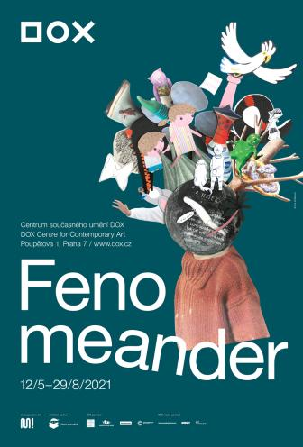
↑ The poster for the Fenomeander exhibition, featuring a collage by Eva Koťátková.

All exhibiting artists have done work for the Meander children’s publishing house, which on 15 December 2020 celebrated its quarter-century of existence during which it has published more than 333 books. “In connection with publishing, the expected focus of interest would primarily be artwork created to accompany text, nevertheless we are not exhibiting framed illustrations. Plus illustrations as such cease to function as an integrated whole outside the context of the book, which is why Fenomeander shows all polarities of this world of art combined with literature,” says exhibition curator Emma Hanzlíková.
The artwork linked to Meander thus spans three different levels. The first floor of the exhibition features books from Meander Publishers. In an installation by Zbyňek Baladrán, visitors can approach them as everyday objects that engage in a dialogue with artistically successful children’s publications from the twentieth century from various Czech publishers for whom high-quality graphic design and striking illustrations were key. As a result, they co-create a comprehensive tradition of beautiful and original children’s books that has deep roots in the Czech lands.

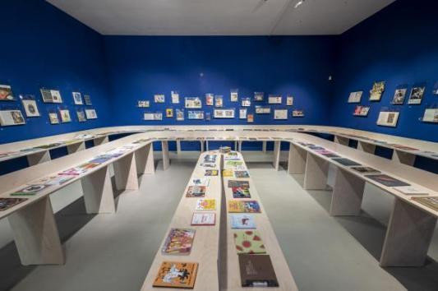
↑ Fenomeander. A glimpse of the exhibition. Photo: Jan Slavík, © DOX

On the next level, specific examples of fine art by artists capable of changing both format and medium are shown: oil paintings, a textile sculpture, objects, and installations with play elements from the literary world of children custom-created for the exhibition space. The featured artists create sophisticated works, often with dimensions greater than that of a standard book, and yet are capable of adapting to a situation where they have to condense their entire vision on a sheet of paper and work to order under the pressure of the source text.

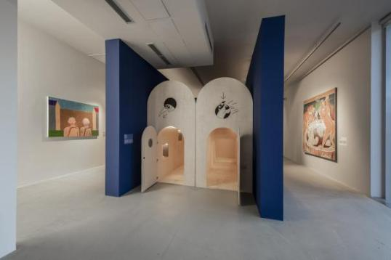
↑ Fenomeander. A glimpse of the exhibition. Photo: Jan Slavík, © DOX

Right from the start, the walls on the tower’s top floor were approached as one would a blank page in a book. Four artists – David Böhm, Jiří Černický, Jiří Franta, and Petr Nikl – created and gradually developed a universal painting, which became an illustration of the exhibition process itself, accompanied by the pandemic’s scenario, among other things. The monumental monochrome painting, stretching over three walls, was a performance in the spirit of nulla dies sine linea, and its unfinished nature encourages one to continue the story even beyond the DOX’s walls.

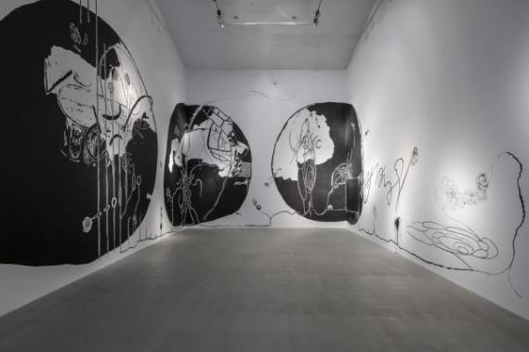
↑ Fenomeander. A glimpse of the exhibition. Photo: Jan Slavík, © DOX

The Fenomeander exhibition is part of a new, separate programming direction at the DOX Centre, which will feature projects – exhibitions, site-specific interventions, discussions with authors, and educational programmes – straddling the line between literature and visual art in the tower and the Gulliver Airship. The Literature/Art programme section will be under the creative and curatorial leadership of Michaela Šilpochová, DOX’s art director. ←

Fenomeander
from 12 May to 29 August 2021
Curator Emma Hanzlíková
Exhibiting artists David Böhm & Jiří Franta, Jiří Černický, Kristina Fingerland, Jan Hísek, Nikola Hoření, Vendula Chalánková, Eva Koťátková, Tadeáš Kotrba, Anna Neborová, Petr Nikl, Viktor Pivovarov, Jiří Sopko, Jiří Stach
Co-production Michaela Šilpochová
Architecture and installation COLL COLL and Zbyněk Baladrán
Exhibition visual design Daniel Korčák
Exhibition partner Čtení pomáhá

DOX Centre for Contemporary Art
Poupětova 1, Prague 7
Opening hours: Wed–Sun 12 noon to 6 p.m.

The press release and photos can be downloaded after registering in the Press section

Contact
Hana Janišová
DOX Centre for Contemporary Art
E hana.janisova@dox.cz

