DOX presents a summer of big cinematic stories. At the Evergreen Summer Cinema on the roof of the DOX+ hall, starting on June 30, filmgoers will be able to see 12 film adaptations of award-winning novels.

The roof of the DOX+ multifunction hall with a view of the Gulliver Airship serves as a large unconventional terrace during the day, and after sunset will turn into the Evergreen Cinema. Every Wednesday from June 30 to September 15, the DOX Centre for Contemporary Art will feature one of 12 film adaptations of award-winning novels by leading writers from around the world.
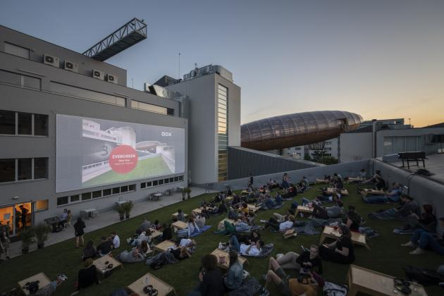
↑ The Evergreen Summer Cinema. Photo: Jan Slavík, © DOX

Last year’s opening of the Evergreen Cinema featured genre-transcending artists as part of the DOX Centre’s multi-genre concept, and this year we will offer an encounter between two areas of art – this time literature and films – within sight of the Gulliver Airship, which is devoted to the DOX Centre’s literature programme.

We will be showing movie versions of books such as the cult surrealist fantasy of Boris Vian’s Foam of the Days (June 30), the psychological drama of The Talented Mr. Ripley by Patricia Highsmith (July 14), the phenomenal Hours by Pulitzer Prize winner Michael Cunningham (July 21), the dark horror of Lighthouse by Edgar Allan Poe (July 28), the epic love story What the Day Owes the Night by the author using the pen name of Yasmina Khadra (August 4), the wartime drama Atonement by Ian McEwan (August 11), Marlen Haushofe’s mysterious The Wall (August 18), or the romantic The Remains of the Day by Nobel Prize winner Kazuo Ishiguro (September 8).

“Is the book always clearly better than the film? Quite probably, and quite probably there are also exceptions. But there is an entire number of films that are worth seeing precisely because you can’t really imagine that the amazing story you just finished reading could be filmed. Because someone else was able to imagine it. And perhaps you’ll be surprised…” says Michaela Šilpochová, the DOX Centre’s programme director.

DOX will repeat the successful silent cinema concept, with sound being transmitted to wireless headphones instead of loudspeakers, which means that the surroundings aren't bothered by noise and viewers can adjust sound levels to suit their individual preferences. As an added bonus, there will snacks, refreshing drinks, and a “cinema menu” offered by the DOX+ bistro.

“After a long, exhausting period when we spent most of our time at home and in front of computer screens, it’s hopefully finally time to unwind a bit. To lie on the grass under the stars with a view of the literary airship above DOX and allow oneself to be drawn into a big cinematic story,” says Michaela Šilpochová.

Films will be shown in their original versions with subtitles. In case of rain, the film will be shown inside the DOX+ hall.

Programme
June 30 Foam of the Days, based on the novel by Boris Vian, directed by Michel Gondry, 2013
July 7 Room, based on the novel by Emma Donoghue, directed by Lenny Abrahamson, 2015
July 14 The Talented Mr. Ripley, based on the novel by Patricia Highsmith, directed by Anthony Minghella, 1999
July 21 Hours, based on the novel by Michael Cunningham, directed by Stephen Daldry, 2002
July 28 The Lighthouse‚ based on a story by Edgar Allan Poe, directed by Robert Eggers, 2019
August 4 What the Day Owes the Night, based on the novel by Yasmina Khadra, directed by Alexandre Arcady, 2012
August 11 Atonement‚ based on the novel by Ian McEwan, directed by Joe Wright, 2007
August 18 The Wall, based on the novel by Marlen Haushofer, directed by Julian Roman Pölsler, 2012
August 25 Out Stealing Horses, based on the novel by Per Petterson, directed by Hans Petter Moland, 2019
September 1 Night Train to Lisbon, based on the novel by Pascal Mercier, directed by Bill August, 2013
September 8 The Remains of the Day, based on the novel by Kazuo Ishiguro, directed by James Ivory, 1993
September 15 The Kite Runner, based on the novel by Khaled Hosseini, directed by Marc Forster, 2007

The films The Wall and Night Train to Lisbon are being screened as part of the Das Sommerkino project – in collaboration with the Goethe-Institut, the Austrian Cultural Forum in Prague, and the Swiss Embassy.

Evergreen Summer Cinema
every Wednesday from 30 June to 15 September 2021 from 9 p.m.
the DOX⁺ hall, Poupětova 3, Prague 7
the complete programme and tickets are available on www.dox.cz

The press release and photos can be downloaded after registering in the Press section

Contact
Hana Janišová
DOX Centre for Contemporary Art
T 739 573 568
E hana.janisova@dox.cz

