Vanitas at DOX: vanity and transience
as a theme in the work of 66 artists

The DOX Centre for Contemporary Art has prepared an extensive exhibition devoted to transience. Sixty-six artists living in the Czech Republic confront the verse from Ecclesiastes: “Vanity of vanities, all is vanity!” The Vanitas exhibition, curated by Otto M. Urban, will be open until 10 October 2021.
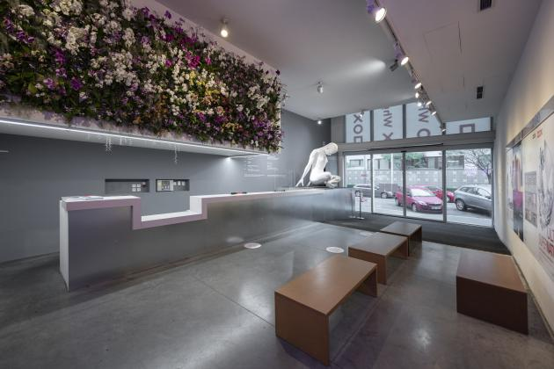
↑ “Paradise Lost”, a flower installation by Eugenio Percossi in the DOX reception area.
Photo: Jan Slavík, © DOX

Various phases of human history have differed in their relationship with death. However, as a rule, death was always a relevant topic in art and culture. Though in modern society death and dying are becoming increasingly isolated or even taboo as topics, they are and will continue to be present in art, and need to be addressed.

The words from Old Testament’s Book of Ecclesiastes that accompany the entire exhibition are among those most frequently quoted from the Bible. Suffused with scepticism and sorrow, in human toil they see but transience, emptiness, and above all, vanity. In the end all is eclipsed by death; it alone is just, it is the only measure and certainty. Vanity – vanitas – has been a frequent topic from the last Middle Ages to the present day, one that is still open to new and original approaches. Still-lives with flowers or with a skull clearly reflect the generality of their content. It is clear and comprehensible, both flowers and skeletal remains are legible symbols. Significant here is also their opposite; they symbolize opposite poles, from the beauties of life to its pain and suffering. But in a number of cases both themes are joined in one whole, where their sharp boundary is transformed into a peculiar harmony. Death becomes beautiful and life (nature) is the bearer of destruction. The aestheticization of the skull as a symbol of brilliant death is a counterpoint to the melancholy of wilting flowers, an allegory of ageing and dying.

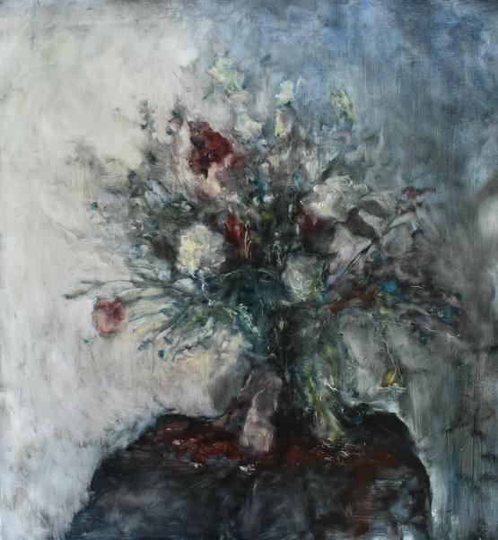
↑ Martin Mrkva: Departing I. Photo: Jan Slavík, © DOX

“The current sensitivity to death and dying is natural. Traditional certainties have been shaken, but haven’t been replaced by new ones. The artists whose works appear in the exhibition have been dealing with the topic of vanitas over the long term. This interest has been passing steadily through generations – from Matouš Háša or Epos 257 to Milan Kunc and Jan Švankmajer – genres, and various media. Hence, Vanitas features works even several decades old, while almost a third of the works were created directly for the exhibition,” says curator Otto M. Urban. Visitors will encounter paintings, drawings, prints, sculpture, photos, videos, and installations. The programme will be supplemented with flower workshops and family workshops.

“We are dedicating this exhibition to everyone who lost someone, and due to the current difficult situation, may not even have had the opportunity to say goodbye. Art is one way of trying to look death in the eye, to laugh at it, to come to terms with it, to accept it,” says Otto M. Urban in closing.

The Vanitas exhibition will be accompanied by an extensive catalogue containing texts by Tereza Matějčková, Jiřina Šiklová, Tomáš Hříbek, Jiří Přibáň, and Otto M. Urban, and literary experiments by Marie Ilyashenko and Petr Borkovec. The image section will be supplemented by a small anthology of Czech poetry on the theme of vanity. ←
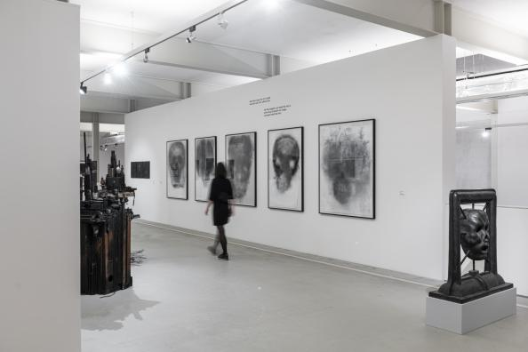
↑ Vanitas. A glimpse of the exhibition. Photo: Jan Slavík, © DOX

Vanitas
from 12 May to 10 October 2021
Curator Otto M. Urban
Exhibiting artists Barbora Balek, Josef Bolf, Erika Bornová, Veronika Bromová, David Černý, Jiří David, Jiří Georg Dokoupil, Tereza Eisnerová, EPOS 257, Lenka Falušiová, Jan Gemrot, Martin Gerboc, Václav Girsa, Matouš Háša, Siegfried Herz, Josef Hnízdil, Tomáš Honz, Monika Horčicová, Kryštof Hošek, Martin Janecký, Jakub Janovský, Petr Jedinák, Tomáš Jetela, Václav Jirásek, Josefína Jonášová, Krištof Kintera, Svatopluk Klimeš, Simona Krausová, Milan Kunc, Hynek Martinec, Jan Mikulka, Martin Mrkva, Robert V. Novák, Eugenio Percossi, Jiří Petrbok, Ivan Pinkava, Daniel Pitín, Miroslav Polách, Ondřej Přibyl, Michal Rapant, Tomáš Rasl, Lukáš Rittstein, Jaroslav Róna, Aleš Růžička, Martin Salajka, Jenny Salm, Marek Schovánek, František Skála, Vladimír Skrepl, Adéla Součková, Michal Škapa, Marek Škubal, Barbora Šlapetová, Jakub Špaňhel, Richard Štipl, Dagmar Šubrtová, František Štorm, Jan Švankmajer, Eva Švankmajerová, Mark Ther, Anna Tretiagová – Krajčová, Teri Varhol, Tomáš Vrana, Jan Vytiska, Richard Wiesner, Martin Zet
Exhibition partner Kytky od Pepy

DOX Centre for Contemporary Art
Poupětova 1, Prague 7
Opening hours: Wed–Sun 12 noon to 6 p.m.

The press release and photos can be downloaded after registering in the Press section

Contact
Hana Janišová
DOX Centre for Contemporary Art
E hana.janisova@dox.cz

