**What’s hidden beyond the glass ceiling? ART*VR festival focuses on women and showcases virtual reality’s best**

**Press Release**

*Prague 9 October 2024*

**Six days, three dozen virtual reality experiences and the opportunity to meet the creators. This is what the second edition of the ART*VR festival will bring, the main part of which will take place from 15 to 20 October at the the DOX Centre for Contemporary Art in Prague, Czech Republic. This year’s theme of the festival, which is the largest event of its kind in Central and Eastern Europe, is called Beyond the Glass Ceiling and will explore the position of women in the sphere of virtual reality. Part of the programme will continue after the main part of the festival at DOX until 17 November.**

For the second time, the creative team led by VR creator Ondřej Moravec, in collaboration with the DOX Centre for Contemporary Art in Prague, presents the ART*VR festival, which will focus on immersive creation in virtual reality.

Audiences can look forward to three programme sections consisting of projects that have received international recognition at the world’s most prestigious festivals, as well as those that will be presented in their world premiere at DOX. In all, the festival will present 15 projects in the competition section and 12 projects in the thematic section. More than 100 guests from all over the world will attend the festival.

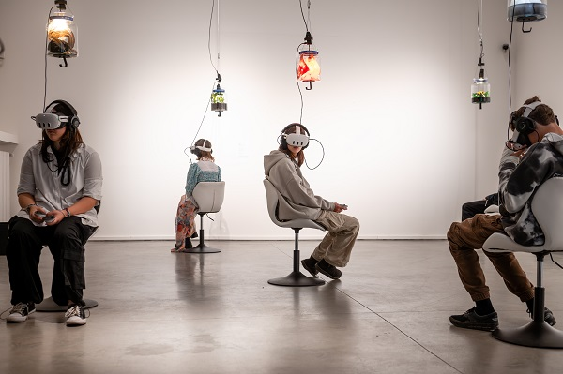

*“This year we received many interesting projects - from those that work with mixed reality format (you can see your real surroundings and digital 3D layers in the headset) to complex installations for multiple people (e.g. Otherworlds). We are delighted that the festival is growing, this year we are presenting a third more projects than last year, and nearly half of the projects in the competition will be presented in a world, international, or European premiere - which highlights the fact that creators perceive us as a prestigious festival to premiere their projects,”* said Ondřej Moravec, ART*VR Festival Director.

The festival will also include the **Zip-Scene Conference** with more than forty guests from all over the world, which will take place at DOX from 17 to 19 October. Can interactive storytelling in digital formats lead to a state of deep listening?

There will also be a **programme for primary and secondary school students**, for whom the festival has prepared a special programme focusing on mental health, the climate crisis, and the position of women in today’s society.

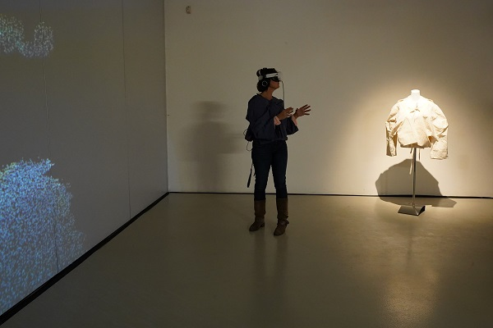

1. **International competition: Plato’s Cave and dissociative disorder**

A competitive showcase of fifteen of the most important projects of the past year will feature works that combine the latest technology with an inspiring narrative style. The festival will award four prizes: **the Grand Jury Prize, the Best Design Prize, the Best Storytelling Prize, and the Audience Award**.

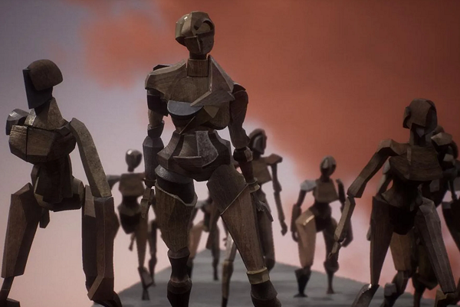

How would Plato think about the cave if he had a VR headset? Polish artists **Jowita Guja** and **Adam Żądło** asked themselves a similar question and created the project [***The Cave VR***](https://artvr.cz/en/programme/the-cave-vr)***.*** The interactive adaptation of Plato’s metaphor leads participants to further reflect on the distortions of reality around us. The project [***Turbulence: Jamais Vu***](https://artvr.cz/en/programme/turbulence-jamais-vu) enables us to dive into a world where the familiar suddenly becomes alien. In a delicate personal essay on dissociative disorder, Australian XR artist Ben Joseph Andrews gives viewers a glimpse into his world, where even reaching out for a coffee mug can be a difficult challenge.

French painter Marcel Duchamp created a cubist-futurist painting of a naked woman descending a flight of stairs. **Lilian Hess** decided to give the figure in Duchamp’s painting a different story and her [***Duchampiana***](https://artvr.cz/en/programme/shadowtime)embarks on a journey towards a free and authentic self. Into the depths of their own emotions and bodily sensations, the participants in Sarah Ticho and Niki Smit’s [***Soul Paint***](https://artvr.cz/en/programme/soul-paint) will explore and creatively express their inner reality, whatever its shape, colour or pulse, through 3D drawing.

How far can humanity go in its desire for invincibility? In [***Limbophobia***](https://artvr.cz/en/programme/limbophobia)***,*** Taiwanese XR artist **Wen-Yee Hsieh** takes us to a surreal dark city where an inevitable doom is approaching. The artist is coming to Prague for the festival and will present the project in person in an international premiere. Director and choreographer Rebecca Evans will also come to present the world premiere of her [***Hinterlands***](https://artvr.cz/en/programme/hinterlands). Extremophiles are organisms that can endure radiation or being in space. The author invites audience members on a journey in which they can penetrate the world of these creatures. The festival will also offer [***Ito Meikyu***](https://artvr.cz/en/programme/ito-meikyu), an audiovisual abstract poem in virtual reality that won the Grand Jury Prize at the Venice Film Festival in 2024.

1. **Beyond the glass ceiling: Nana Lou, the birth of a superheroine and breast cancer**

The thematic section Beyond the Glass Ceiling is dedicated to VR projects by female authors and their stories. Projects from four continents will thematically address issues related to corporeality and gendered inequalities that women face, as well as broader societal issues. The thematic section will be on display until 10 November.

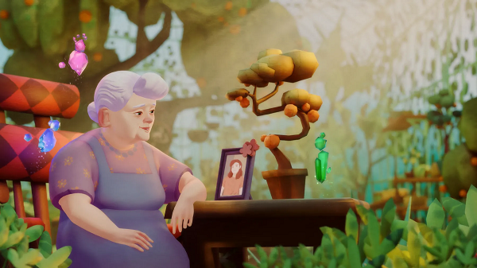

One of the projects ART*VR will offer is [***Nana Lou***](https://artvr.cz/en/programme/nana-lou), about a senior woman whose life is coming to an end. To die peacefully, she needs to deal with painful memories. Participants can use the healing power of touch to help Grandma reflect on her past mistakes and forgive herself. Creator **Isabelle Andreani** will come to Prague and personally present the project at the festival.

In [***Comfortless***](https://artvr.cz/en/programme/comfortless)***,*** **Gina Kim** presents the stories of the “comfort women of American soldiers”, who were recruited from across the country to the South Korean city of Kunsan to meet the needs of soldiers at a nearby base. Set against the backdrop of a ruined ghost town, the author uses snippets of conversations, reflections of figures in mirrors, hints, and clues to evoke the painful memory of the place and to ensure that the women’s experiences do not fall into oblivion.

The documentary project [***Mammary Mountain***](https://artvr.cz/en/programme/mammary-mountain)recounts the stories of several women and one man who have been through breast cancer. It reveals their experiences of all stages of treatment and their feelings, while also providing testimony of their confrontation with the healthcare system. One of the creators, **Tara Baoth Mooney**, will personally present the project in Prague. From a different perspective on femininity, [***MAYA: Birth of a Superhero***](https://artvr.cz/en/programme/maya-the-birth-of-a-superhero) follows the coming of age of a young girl whose life is turned upside down after the onset of her first period. The interactive project breaks down societal taboos around menstruation and explores the theme of awakening female sexuality and finding inner strength.

The topic of spontaneous abortion will be opened by the animated documentary [***HeartBeat***](https://artvr.cz/en/programme/heartbeat), whose main character decides to break the silence, share her feelings of loss and sadness, and talk about the physical experiences that are an integral part of the abortion process. Through sensitive animations, we get to know the heroine and the embryo she has to say goodbye to. One of the authors of the project **Johanna Courtney** will personally attend the festival.

The selection of the thematic section Beyond the Glass Ceiling will also include the winning immersion film of the One World Festival [***I Took a Lethal Dose of Herbs***](https://artvr.cz/en/programme/i-took-a-lethal-dose-of-herbs) inspired by a Reddit thread in which a former anti-abortion activist anonymously shared her experience of an unwanted pregnancy and the subsequent ingestion of a lethal dose of herbs. The evocative project brings the experience of postpartum psychological difficulties to life and makes the audience aware of what it is like to have intrusive, violent thoughts that are difficult to confide in anyone. American author **Yvette Granata** will personally attend the festival.

1. **Special programme: a journey through space, the fragility of home, and a musical show in mixed reality**

In the special programme until 17 November, the festival will present various artistic uses of the virtual reality medium. It offers [guided tours of VR world](https://artvr.cz/program/komentovane-prohlidky-vr-svetu)s, a music show in mixed reality format, and an [augmented reality projec](https://artvr.cz/program/stan)t unravelling the topic of homelessness.

What will humanity leave behind once it’s gone? That’s the question asked by [***Astra***](https://artvr.cz/en/programme/astra), a science fiction story that takes the audience on an exploration of unknown worlds deep in space. Eliza McNitt’s project (who will also sit on the International Competition jury) turns the airship Gulliver into a spaceship, allowing new elements to be discovered on fascinating distant planets in the search for the essence of life.



The thematic installation Beyond the Glass Ceiling will be replaced at DOX from 11 November by Ondřej Moravec’s latest project, which will transform an anonymous living room into the cosy home of a Ukrainian family in mixed reality. [***Fragile Home***](https://artvr.cz/en/programme/fragile-home), which competed at this year’s Venice Festival, will allow visitors to explore the apartment and get to know its absent inhabitants through photographs on the wall, birthday cards, or a purring cat. But the fragile essence of home is shattered by the ominous reality of war.

**For more information about the ART*VR Festival, visit** [**www.artvr.cz**](https://artvr.cz/en)**.**

[**Photos for the projects**](https://drive.google.com/drive/folders/1fCMx6UVFjVkSR8fzWNbCGw4C9t3qm4xI?usp=drive_link)

The press release and photos can be downloaded from the [Press](https://www.dox.cz/en/press) section of the DOX website after registration.

**Media contact:**

**Eva Müllerová Karolína Kočí**

[media@artvr.cz](mailto:media@artvr.cz) [karolina.koci@dox.cz](mailto:karolina.koci@dox.cz)

+420 720208552 +420 777 870 219

[**www.artvr.cz**](http://www.artvr.cz/) **www.dox.cz**