The David Lynch exhibition at DOX enters the fall season! It features concerts by Chrystabell and Xiu Xiu, and a new performance.

The Czech exhibition event of the year – the artistic work of American film wizard David Lynch – enters the fall season. The DOX Centre for Contemporary Art in Prague, the largest independent institution focused on contemporary art in the Czech Republic, is preparing an accompanying programme for the exhibition this fall, which will offer guided tours, literary events, and unique concerts. The exhibition David Lynch: Up in Flames will run until 8 February 2026.

The exhibition Up in Flames is the most extensive presentation of Davida Lynch’s artwork in the Czech Republic. The project, a DOX collaboration with the David Lynch Estate, Pace Gallery, and Item éditions, was curated by Otto M. Urban.

The main exhibition spaces at DOX feature 400 works of art, ranging from drawings, photographs, lithographs, woodcuts, and watercolours to short experimental and animated films created by the director. The works cover all of Lynch’s creative periods, from his beginnings in the late 1960s to the present day.

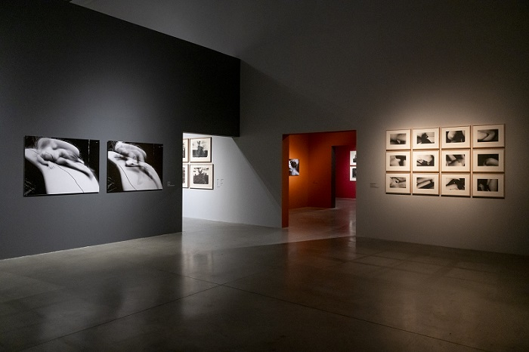

↑ The exhibition David Lynch: Up in Flames at DOX, photo: Jan Slavík, © DOX

DAVID LYNCH SEASON AT DOX

As part of the interdisciplinary approach characteristic of DOX, the exhibition is linked to other genres. Throughout its duration, the Up in Flames project also offers a wide range of accompanying programmes, focusing in particular on film, contemporary experimental music, and literature. DOX is planning an entire series of events for the fall.

CONTEMPORARY EXPERIMENTAL MUSIC CONCERTS

Chrystabell - The Spirit Lamp

American singer, musician, and actress Chrystabell is coming to Prague for the October FALL festival. This longtime muse and collaborator of David Lynch will perform live at DOX+ on October 5 with her musical tribute to David Lynch.

Chrystabell, known for her mesmerizing vocals in Lynch’s film Inland Empire and her unforgettable role as FBI agent Tammy Preston in Twin Peaks: The Return, brings her musical show Chrystabell: The Spirit Lamp, to DOX after debuting it in Cannes earlier this year.

“During our personal meeting with David Lynch at his home in Los Angeles, the name Chrystabell came up very early on. When I asked who should perform as part of the accompanying programme for the Up in Flames exhibition, Chrystabell was Lynch’s first choice. I am very happy that the discussions were successful and that her concert will take place at DOX in Prague,” explains Otto M. Urban.
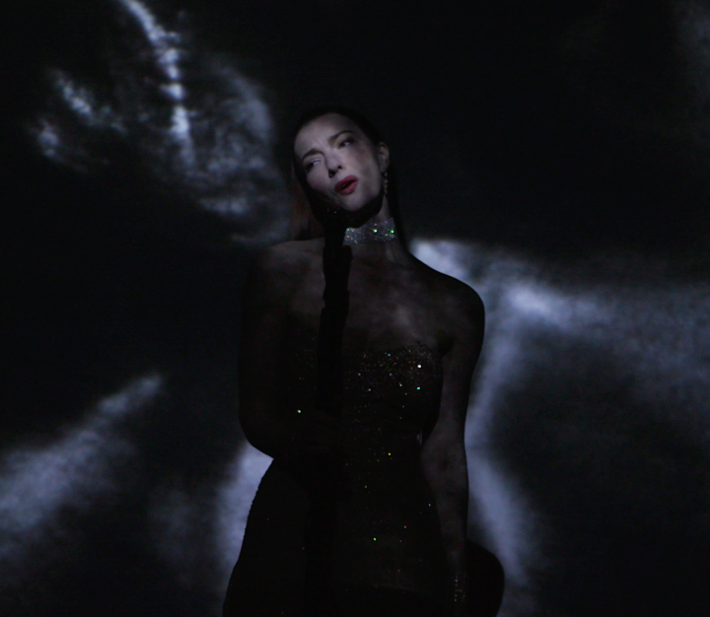
The Spirit Lamp is a special performance of songs written by David Lynch and Chrystabell, performed by Chrystabell and instrumentation by David Lynch, with stunning visuals created especially for The Spirit Lamp show by internationally renowned experimental filmmaker David Gatten.

The concert is part of the accompanying programme for the exhibition David Lynch: Up in Flames and the Festival of Art, Literature, and Education – FALL.

Chrystabell Concert - The Spirit Lamp: 5 October 2025 at 8:30 p.m.

Chrystabell – A Tribute to David Lynch

As part of the FALL Festival, fans can also meet Chrystabell on Saturday, October 4, at a special discussion in the Gulliver airship. During the programme CHRYSTABELL: A TRIBUTE TO DAVID LYNCH, Otto M. Urban will talk with the American singer about her musical collaboration with David Lynch and his bold, captivating, and unrestrained work.

Discussion: Chrystabell - Tribute to David Lynch: 4 October 2025 from 12 noon.

ERASERHEAD XIU XIU

One month later, on 5 November, the legendary cult band Xiu Xiu will perform at DOX+, bringing a unique tribute to David Lynch’s Eraserhead to Prague.

ERASERHEAD XIU XIU is a new live concert with accompanying film. It uses field recordings, instruments designed and built specifically for this concert, organs, modular synthesizers, voices, lights, electromagnetic interference, and elements of musique concrète to express the bizarre emotionality, contradictory sexuality, relentless darkness, and uniquely disturbing lunar landscape of this masterpiece of “midnight movies.”

“The ERASERHEAD XIU XIU concert will be a major event. This is already their second project based directly on Lynch’s film work, and Prague has become part of the tour where the project will take place. Before the concert at DOX+, we are also planning a moderated meeting with the band’s frontman Jamie Stewart, led by music journalist Miloš Hroch,” explains exhibition curator Otto M. Urban.

The concert is part of the accompanying programme for the exhibition David Lynch: Up in Flames.

ERASERHEAD XIU XIU concert: 5 November 2025 at 8 p.m.

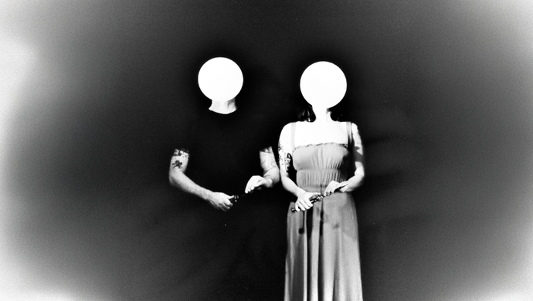

The concert is co-organized by the music association A.M.180 Collective.

PERFORMING

Farm in the Cave - All Is Good in Heaven

What happens when a gallery doesn’t close after hours, but instead begins to fill with stories of surreal characters who have lives of their own? Farm in the Cave, the resident ensemble of the DOX Centre, presents a unique evening performance All Is Good in Heaven, which
takes place in the middle of the exhibition David Lynch: Up in Flames.
Playfulness. Nostalgia. Madness. Mystery. Desire. Absurdity. Inspired by David Lynch and his courage to follow his imagination, the members of the ensemble, led by Viliam Dočolomanský, have created a performance directly in the exhibition space.
They speak through movement and music.
In the panopticon of the exhibition space, a world of strange characters awakens, characters that may seem somehow familiar to us. Visitors experience the performance “up close and personal”. They look into individual rooms and encounter mysterious, sometimes absurd beings on their journey through the universe.
The production features original music by composer Marcel Bárta, in which original compositions freely intertwine with quotations from Lynch’s work. The cast includes Hana Varadzinová, Eliška Vavříková, Gioele Coccia, Barbora Ješutová, David Králík, and Monika Částková.
All Is Good in Heaven is about the courage not to abandon your imagination.


The Farm in the Cave ensemble will present All Is Good in Heaven on five consecutive evenings in November:

16 Nov 2025, 8 p.m.
17 Nov 2025, 8 p.m.
18 Nov 2025, 8 p.m.
19 Nov 2025, 8 p.m.
20 Nov 2025, 8 p.m.

The project is produced in collaboration with the DOX Centre for Contemporary Art and the Music Is festival.

ART AND LITERATURE

David Lynch: Catching the Big Fish

During the FALL festival organised by DOX from 2 to 5 October, we are preparing a tour of the exhibition Up in Flames, which presents the artwork of one of America’s most respected film directors, David Lynch.

This unique tour of the David Lynch: Catching the Big Fish exhibition will be accompanied by readings from the new translation of Lynch’s autobiographical book Catching the Big Fish (published by Dybbuk).

The exhibition will be guided by curator OTTO M. URBAN, with readings by JIŘÍ VYORÁLEK and ANNA KAMENÍKOVÁ.

Walk through the exhibition David Lynch - Catching the Big Fish: 4 October 2025 from 10:30 a.m.

SCREENINGS

DOX Summer Cinema – David Lynch season

During the summer months, DOX, in collaboration with the Ponrepo cinema, offered summer movie nights under the stars and in the Lynchian universe. The summer cinema on the roof of DOX+ presented a total of nine screenings, which sold out well in advance. A total of 1,215 viewers attended.

In addition to David Lynch’s films, the programme also included films that strongly influenced Lynch’s work. Each screening was introduced by personalities from the world of film and visual arts. The film programme was curated by David Havas, director of Ponrepo cinema.

David Lynch series at Ponrepo cinema

Following on from the summer screenings at DOX, Ponrepo cinema will continue with a series of David Lynch screenings in the fall.

Ponrepo cinema director David Havás has selected Lynch’s cult films such as Mulholland Drive, Blue Velvet, and Lost Highway, as well as films that were decisive for Lynch’s work: Sunset Boulevard and Eight and a Half.

DOX Centre for Contemporary Art
Poupětova 1, Prague 7
Opening hours: Tue–Sun, 11 a.m. –7 p.m.

Contact
Karolína Kočí
E karolina.koci@dox.cz
T +420 777 870 219
www.dox.cz

The press release and photos can be downloaded after registration in the Press section.

