Badiucao´s exhibition opens at DOX Prague despite Chinese Embassy´s protests

The exhibition of Chinese artist and activist Badiucao is open at DOX Centre for Contemporary Art in Prague. The exhibition is the first presentation of Badiucao's work in the Czech Republic and tackles various social and political problems of contemporary China and also includes his latest works on Ukraine. Despite Prague’s Chinese Embassy’s demands that the exhibition be cancelled, the show will open in the presence of the artist on 13 May and will be on view until August 28, 2022.

↓ Xi_s going on a bear hunt, © Badiucao
Badiucao has established himself on the international stage thanks to social media, through which he spreads his message all over the world, exposing himself on the front line against every form of ideological and moral control exercised by political power, constantly challenging the Chinese government and censorship in support of the transmission of a non-plagiarized historical memory. He expresses his commitment through the creation of participatory campaigns, posters in public places, illustrations, and online activities, often constructed with a visual language that ironically evokes propaganda in a Pop vein, reproducing its graphic style, colours, and tones.

In the fall of 2021, the Chinese government tried to cancel Badiucao’s exhibition in Brescia, Italy. In Prague, the day before the opening of the Czech exhibition at the DOX Centre for Contemporary Art, the gallery was also contacted by the Chinese embassy with a request that the exhibition be cancelled.

“We are proud to present Badiucao’s work. DOX is a private and independent institution, an environment where we value our intellectual freedoms. We will certainly not respond to this or any other pressures, which we consider utterly unacceptable”, says DOX artistic director and one of the exhibition’s curators Michaela Šilpochová.
The exhibition, first conceived by curator Elettra Stamboulis, looks back over Badiucao´s oevre, considering multiple aspects of his artistic production: graphics, painted and multi-material works bearing witness to the violations of human rights, the censorship inflicted on Chinese citizens on the issue of Covid-19, the repression of dissents in Myanmar during the military coup in 2021, as well as the forced cultural assimilation of the Uyghurs and including the protests that have seen the population of Hong Kong struggle to challenge the political line of the government.

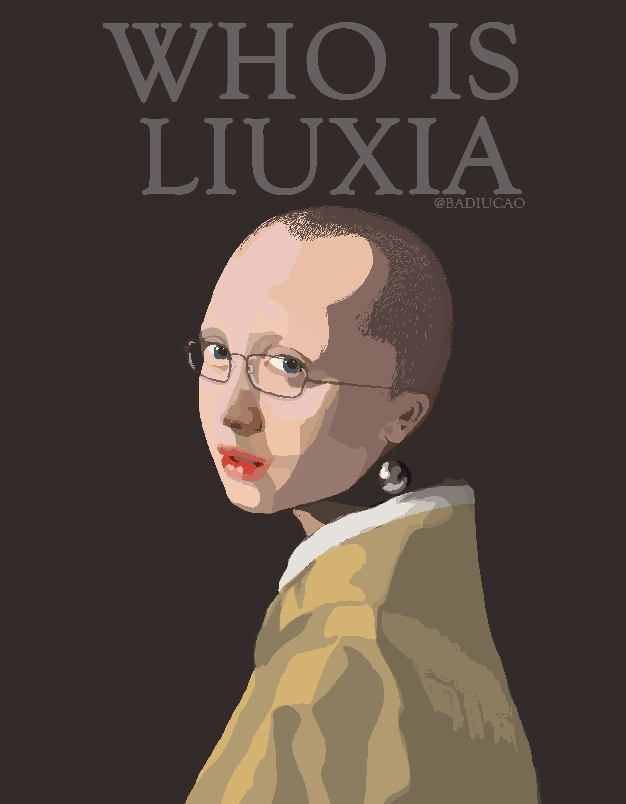
Echoes of the Czech context can be found in Badiucao’s bow to the legacy of philosopher and Nobel Peace Prize winner Liu Xiaobo, whose Charter 08, calling for political reform and democratization of Chinese society, found direct inspiration in the Czechoslovak Charter 77; the tribute to Xiaobo’s wife, poet and photographer Liu Xia, whose photographs were featured at DOX in 2014; or in a reinterpretation of one of the symbols of the recent Hong Kong protests – the Prague Lennon Wall. New works have been created for the exhibition at the DOX Centre in Prague that respond to the war in Ukraine and the disturbing relationship between China and Russia.

Who is Liu Xia, © Badiucao

Badiucao abandoned his studies to devote himself to the art of protest after he had seen a secretly filmed documentary on the Tiananmen Square massacre. In 2009, he emigrated to Melbourne, Australia, where he worked as a primary school teacher for a number of years and created his first satirical drawings under the pseudonym of Badiucao. He worked anonymously for many years, appearing at public events wearing a mask.

In 2018, he worked in Berlin as an assistant to Ai Weiwei, whom he considers his most important teacher, from both the artistic and the ideological perspectives. Compared to Banksy for his ground-breaking criticism of modern society, after the umpteenth threat against his relatives, he revealed his true identity on 4 June 2019, on the anniversary of the Tiananmen Square massacre, during the presentation of the documentary devoted to him: “China’s Artful Dissident”.
Badiucao uses all media, but his most powerful tool for spreading his message remains Twitter, which he began to use after repeated censorship in China of the microblogging website Weibo.
He has exhibited in Australia and the United States, and his works have been used by Amnesty International, Freedom House, the BBC, CNN, and China Digital Times. In 2021, Garry Kasparov, President of the Human Rights Foundation, presented him with the Vaclav Havel Prize for Creative Dissent, an award intended for artists who creatively denounce the deceptions of dictatorships.

Curators:
Elettra Stamboulis
Michaela Šilpochová (DOX)

The exhibition is organized in collaboration with Fondazione Brescia Musei.
The exhibition is held under the auspices of the Mayor of Prague Zdeněk Hřib.

The expert partner of the exhibition is SINOPSIS, a project of the non-profit organization AcaMedia z.ú., implemented in professional cooperation with the Department of Sinology, Faculty of Arts, Charles University in Prague. Its aim is to provide a regular overview of developments in China and the impact in today’s world from the perspective of Chinese, Czech, and world media and observers.

The exhibition will be on view at the DOX Centre for Contemporary Art until August 28, 2022. Opening hours: Wed-Sun from 12 to 6 p.m.

ACCOMPANYING EVENTS

15 May from 12 PM
BADIUCAO: PERFORMANCE of the WUHAN DIARY
live performance of the artist in the exhibition
In 2020, Badiucao published on his Twitter account the diaries of one of the inhabitants of Wuhan during the first lockdown. Along with Fang Fang’s journal, Badiucao's blog is the only documentary about this critical period at the beginning of the Covid 19 epidemic that has not been censored by the Chinese intelligence service. As part of the performance, Badiucao will read from the diary.

18 May
BADIUCAO: THE ART OF PROTEST
documentary film screening + discussion with the artist

5 pm – China´s Artful Dissident - screening of the documentary by film director Danny Ben-Moshe, Australia, Identity Films, 57 min.
6 pm – artist talk and discussion with the artist

21 May, 3 PM
BADIUCAO: PERFORMANCE FORGOTTEN
live performance of the artist in the exhibition
meditative performance to a series of works called Forgotten, which is dedicated to child victims of world conflicts.

Contact:
Michaela Šilpochová, E michaela@dox.cz, M +420 774 222 355, www.dox.cz

