**DOX Prague will present the exhibition**

***Up in Flames* by David Lynch**

**The exhibition *Up in Flames*, organised by the DOX Centre for Contemporary Art in Prague in collaboration with the David Lynch Estate, Pace Gallery, and Item éditions and curated by Otto M. Urban (DOX), is the first and largest presentation of David Lynch’s work in the Czech Republic to date.**

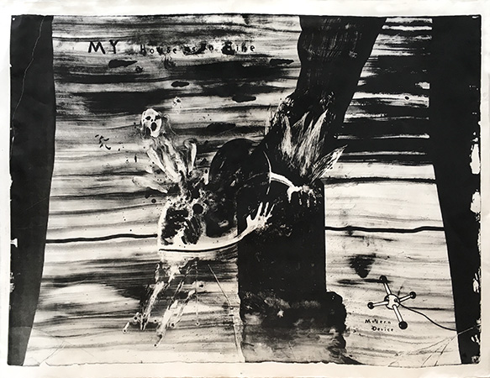

↑ David Lynch, *My House Is on Fire – Modern Device*, 2013 © The David Lynch Estate, courtesy of Item éditions Paris

The exhibition at DOX will present drawings, photographs, lithographs, and watercolours as well as short, experimental, and animated films by David Lynch. In total, there will be more than four hundred items on display, and the exhibition will introduce visitors to works from throughout the artist’s creative periods, from the 1960s to 2024.

**The exhibition *Up in Flames* focuses on Lynch’s works on paper.** The artist perceived this type of creation as an autonomous artwork that captures the delicate nuances of the human condition with all its subtleties.

“The fact that the exhibition focuses on works on paper – meaning prints, drawings, watercolours, and photographs – allowed us to present a number of pieces that have never been exhibited before. In this sense, the exhibition is representative and features all of the artist’s important works on paper, spanning from 1965 to 2024,” comments Otto M. Urban from DOX, curator of *Up in Flames*.

David Lynch studied painting at the Pennsylvania Academy of the Fine Arts. It was there that he had a vision of a moving painting, and in 1967 this vision became the basis for his first film, *Six Men Getting Sick (Six Times)*. Lynch was always working on paper, and he said that drawing helped him to capture ideas that he could later develop into paintings, films, music, or objects. In his artistic work he was fascinated by all manner of different materials and surfaces.

A major part of the exhibition consists of works on loan directly from the David Lynch Estate in Los Angeles, but the project will also include a number of works (lithographs and photographs) which he created at Item éditions in Paris. *Up in Flames* will take place in the main exhibition space of DOX and will also offer a wide range of accompanying programmes focusing in particular on film, contemporary experimental music, and literature.

Deliberations regarding the project gradually developed over many years, and an important condition for its realisation was establishing direct contact with the artist in 2024. Patrice Forest of Item éditions in Paris was instrumental in facilitating this connection.

The organisational team of the exhibition *Up in Flames* consists of Leoš Válka, Michaela Šilpochová, Jan Slavík, and Anna Bárová from DOX, Anna Skarbek and Michael T. Barile from the David Lynch Estate, and Genevieve Day from Pace Gallery. The graphic design of the exhibition and the accompanying catalogue has been entrusted to Robert V. Novák.

The exhibition *Up in Flames* is curated by Otto M. Urban, head curator of the DOX Centre for Contemporary Art in Prague. Michael T. Barile and Anna Skarbek of the David Lynch Estate and Patrice Forest of Item éditions in Paris made significant contributions to the exhibition. **Michael T. Barile and Patrice Forest will be the guests of honour at the exhibition’s opening ceremony.**

**David Lynch: Up in Flames**

**19. 6. 2025 – 8. 2. 2026**

The press release and photographs can be downloaded after registering in the [Press](https://www.dox.cz/users_area/register) section of our website.

**DOX Centre for Contemporary Art Contact**

Poupětova 1, Prague 7 **Karolína Kočí**

Open: Tue–Sun, 11:00–19:00 E [karolina.koci@dox.cz](mailto:karolina.koci@dox.cz)

T +420 777 870 219

www.dox.cz

**David Lynch**

David Lynch’s (1946–2025) prolific nearly six-decade career spanned an extensive range of artmaking, including painting, drawing, photography, printmaking, sculpture, music, and film.

He wrote and directed critically acclaimed films such as *Eraserhead* (1977), *The Elephant Man* (1980), *Blue Velvet* (1986), *Lost Highway* (1997), *Mulholland Drive* (2001), *Inland Empire* (2006), and the television series *Twin Peaks* (1990–91) and *Twin Peaks: The Return* (2017). While studying painting at the School of the Museum of Fine Arts in Boston and the Pennsylvania Academy of the Fine Arts in Philadelphia in the late 1960s, Lynch envisioned his first “moving painting”, a multidimensional composition beneath a moving projection titled *Six Men Getting Sick (Six Times)* (1967). This multimedia work marked Lynch’s first foray into video and filmmaking. His remarkable career touched on subjects of the organic body and industrial sites in various states of decay, describing a deeper human experience both beyond and within the everyday. Often depicting scenes with an eye towards surrealism and mystery, Lynch’s work balanced the porous divide between the body and the world it inhabits.

Lynch’s work has been the subject of numerous exhibitions. Retrospectives of his work include *The Air is on Fire: 40 years of Paintings, Photographs, Drawings, Experimental Films, and Sound Creations* at Fondation Cartier in Paris (2007), which then travelled to La Triennale di Milano (2008), the Ekaterina Cultural Foundation in Moscow (2009), and Gammel Strand in Copenhagen (2011); *Between Two Worlds* at QAGOMA in Brisbane, Australia (2015); *Silence and Dynamism* at the Centre of Contemporary Art in Toruń, Poland (2017–18); and *Someone is in my house* at the Bonnefanten in Maastricht, Netherlands (2018–19). In 2014, a survey of Lynch’s work entitled *The Unified Field* was presented at the Pennsylvania Academy of the Fine Arts, where the artist previously studied painting.

**Authors of the exhibition *Up in Flames***

* **Otto M. Urban** – Head curator of the DOX Centre for Contemporary Art in Prague, where he has prepared numerous exhibitions, including his latest project, *David Lynch: Up in Flames*. Since the early 1990s Urban has focused on Czech and international art from the turn of the twentieth century, especially symbolism and decadence, as well as contemporary art.
* **Michael T. Barile** – Executive assistant to David Lynch and employee at Asymmetrical Productions from 2008 to 2025. Barile is an American film producer and writer who worked on several of Lynch’s projects, including *Twin Peaks: The Return* (2017), *Twin Peaks: Missing Pieces* (2014), and *What Did Jack Do?* (2017) as well as numerous other commercials, music videos, and short films. He currently works for the David Lynch Estate.
* **Anna Skarbek** - An American visual artist and educator, Anna Skarbek began working with David Lynch as assistant art director on his 2006 film *INLAND EMPIRE*. She subsequently worked with him on commercials, music videos and experimental films, and she built and maintains the data base that inventories all of Lynch's artworks. Anna has organized fifteen national and international museum exhibitions of Lynch’s work, overseen forty gallery exhibitions, and co-edited twelve accompanying exhibition catalogues.
* **Patrice Forest** – A close friend of David Lynch and director of the Item éditions lithographic studio in Paris. In 2007 Forest initiated Lynch into the secrets of lithography during the time that Lynch was creating nearly three hundred works in the studio. Item éditions is the oldest lithographic studio in Paris, with presses used in the past by Picasso, Matisse, and Giacometti, to name just a few. The exhibition will include not only a large set of lithographs from Lynch’s production at Item éditions but also two photographic series of gelatin silver prints on Baryta paper titled *Small Stories*.