**DOX opens a large-scale exhibition of works by David Lynch: *Up in Flames***

**The DOX Centre for Contemporary Art in Prague, the Czech Republic’s largest institution dedicated to contemporary art, is launching the exhibition event of the year. In its main hall DOX will present the artistic work of American master of cinema David Lynch. The exhibition will run from 19 June 2025 to 8 February 2026.**

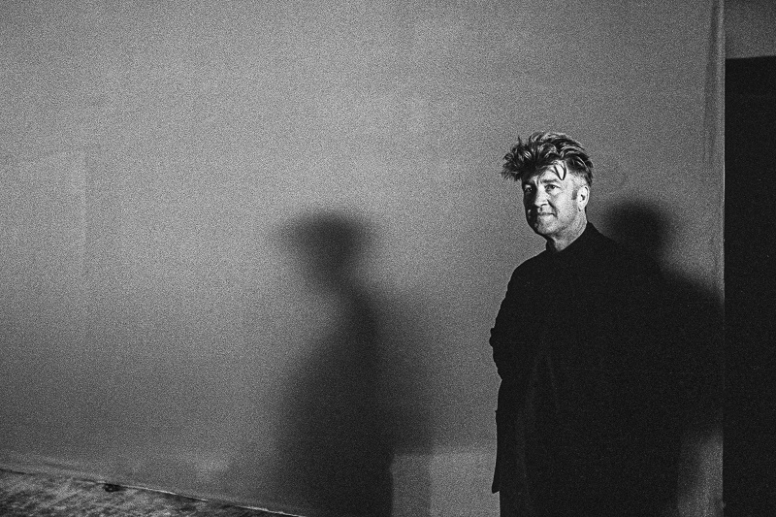

↑ David Lynch in Prague (1996), photo: Karel Cudlín, © 400ASA

**The project, on which DOX is collaborating with the David Lynch Estate, Pace Gallery, and Item éditions, is curated by Otto M. Urban. *Up in Flames* is the first presentation of David Lynch’s art in the Czech Republic.**

In the main spaces of DOX over four hundred works of art are on display – from drawings, photographs, lithographs, woodcuts, and watercolours to short experimental and animated films created by the director. The works span all of Lynch’s creative periods, from his early days in the late 1960s all the way to 2024.

“I consider it a small miracle that we are finally opening the exhibition. Without the enthusiastic cooperation of everyone involved, we could not have pulled off a project like this. Unfortunately, David Lynch, who oversaw the preparations for the exhibition from the very beginning, will not see the final result. Nevertheless, I hope that he would be satisfied with the exhibition, which I see as a tribute to a great artist and a great man,” says Otto M. Urban, the curator of the exhibition.

**How the project came to pass**

Deliberations regarding the project gradually developed over many years, and an important condition for its realisation was establishing direct contact with the artist himself. The first serious discussions about a David Lynch exhibition at DOX took place in the spring of 2024, when the David Lynch Studio (now the David Lynch Estate) and Pace Gallery joined the project. Patrice Forest of Item éditions in Paris was instrumental in facilitating this connection.

**However, the preparations were unexpectedly interrupted by the news of David Lynch’s sudden passing on 16 January.**

“David and I spoke about this show the day before he passed. He loved the images he’d seen of DOX and was looking forward to seeing his art in that space. He had confidence in Otto, and he was excited to share his work with the people of Prague. When he died, it seemed like the world stopped turning,” adds Michael T. Barile from the David Lynch Estate.

**Works on paper**

The main axis of the exhibition consists of works on paper, which Lynch considered to be autonomous artworks in their own right. He said that drawing helped him to capture ideas that he could later develop into films, paintings, or objects.

David Lynch studied painting at the Pennsylvania Academy of the Fine Arts. It was there that he had a vision of a moving painting, and in 1967 this vision became the basis for his first film, *Six Men Getting Sick (Six Times)*. Lynch drew throughout his career, and in his artistic work he was fascinated by all manner of different materials and surfaces.

A major part of the exhibition consists of works on loan directly from the David Lynch Estate in Los Angeles, but the project also includes a number of works (lithographs and photographs) which he created at Item éditions in Paris.

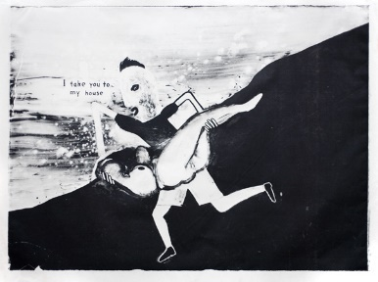**A SELECTION OF EXHIBITED WORKS**

**I Take You to My House** (2014), large-format lithograph (126 × 168 cm). This is one of five large-format lithographs created by David Lynch. Lithography suited the artist best because it allowed him to work in a very similar way to watercolour. The work contains motifs typical of Lynch: a figure in a landscape, a house, and a gun.

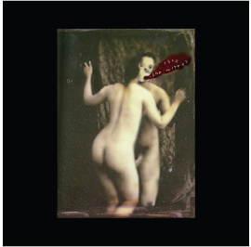

A photograph from the series **Distorted Nudes** (1999). This is one of Lynch’s most extensive series, comprising thirty-two works in which he manipulated original photographs into mutated shapes during scanning. It is a typical example of Lynch’s perception of the human body as an artistic material.

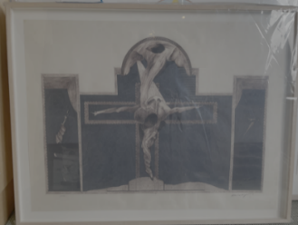

The drawing **Crucifixion** (1973) is one of the oldest works in the exhibition, created during the making of Lynch’s first film, *Eraserhead* (1977). He made signed prints of the drawing and sold them to fund the completion of the film. It is a piece that is not often exhibited, despite being one of the key examples of Lynch’s early work.

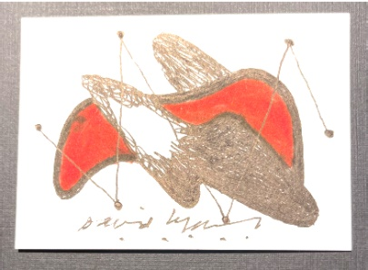Lynch created this untitled series of twenty-seven drawings in 2024, making them the most recent works in the exhibition. They feature recurring motifs typical of Lynch, but the colour palette is unusual, as he generally worked in black and white. The series is presented alongside a set of matchbook drawings from the early 1970s, which also comprises twenty-seven works.

**David Lynch season at DOX**

**As part of the interdisciplinary approach that is a hallmark of DOX, the exhibition will be connected with various other mediums.** Over the course of its duration, *Up in Flames* will also offer a wide range of accompanying events, particularly with a focus on film, contemporary experimental music, and literature.

**Performance**

The opening of *David Lynch: Up in Flames* will include a surprise performance by DOX’s resident ensemble [Farm in the Cave](https://farminthecave.com/en/). The programme, which is directed by Viliam Dočolomanský, was prepared by performers Hana Varadzinová, Eliška Vavříková, and Barbora Ješutová as well as musicians Marcel Bárta and Miloš Klápště. Lucie Špačková, Lucia Škandíková, Kateřina Jirmanová, and sound designer Eva Svobodová also collaborated.

**The performance will also serve as an invitation to the unusual November premiere of the production *BIG FISH*.** Under the direction of Viliam Dočolomanský, members of the ensemble have crafted a performance inspired by David Lynch and his courage to pursue his own inner world. They have transformed images into shapes of the body, movement, music, voice, and silence. In the panopticon of the exhibition, visitors will thus experience what they can normally only observe from afar, on a distant stage.

The performance will feature music by composer Marcel Bárta which loosely interweaves original compositions with quotations from Lynch’s work. Vocal performers Hana Varadzinová, Gioele Coccia, Monika Částková, Barbora Ješutová, David Králík, and Eliška Vavříková will perform in close proximity to visitors.

The production, which has the working title *BIG FISH*, is about the courage to dream – about the freedom to create without explanation. It will premiere on 16 November.

**Summer cinema**

Starting in July, DOX and the Ponrepo Cinema will be hosting a series of summer movie nights under the stars and in the universe of David Lynch. [**Summer cinema on the roof of DOX+**](https://www.dox.cz/en/whats-on/dox-summer-cinema-david-lynch-season) will present a total of nine screenings, and in addition to cinematic works by Lynch himself (*Wild at Heart*, *Lost Highway*, *Twin Peaks: Fire Walk with Me*, *Blue Velvet*), we will also be presenting films that strongly influenced the character of his work (*The Wizard of Oz*, *Sunset Boulevard*, *8½*, *Lolita*, *Persona*). Screenings will take place every Wednesday at 9:30 p.m., starting on 2 July. Each screening will begin with an introduction by one or more experts from the fields of film and the visual arts. The curator of the film programme is the head of the Ponrepo Cinema, David Havas.

**Literature**

As part of the literary festival [FALL](https://www.doxfall.cz/en), which DOX is organising on 2–5 October, Otto M. Urban will give a lecture on the topic of David Lynch and literature. During the festival a new Czech translation of Lynch’s [*Catchi ng the Big Fish*](https://www.dybbuk.cz/knihy/chytani-velkych-ryb-2/) will also be presented, accompanied by a programme of readings from the book, which will take place directly in the exhibition.

**Education**

DOX’s long-term conception of education is based on the idea of an art institution that responds to the issues that are shaping the world today. Building on its exhibition programme, DOX has developed its own methodology linking different artistic fields, themes, and approaches with the aim of fostering empathy, critical thinking, and other competences that are important tools for young people in the twenty-first century.

The education department at DOX has prepared two accompanying programmes for the exhibition *Up in Flames* (with more to come). [Story Exchange](https://www.dox.cz/en/programmes-for-school-groups/story-exchange-up-in-flames) uses the content of the exhibition and the Narrative 4 methodology to develop empathy through sharing stories. [Sticking Your Neck Out](https://www.dox.cz/en/programmes-for-school-groups/sticking-your-neck-out-up-in-flames) uses the work of David Lynch to bring participants closer to their own authentic expression – they become creators themselves. The programmes for school groups must be booked in advance. Several events for families will take place over the course of the exhibition, the first of which is the creative workshop [Fire and Ash](https://www.dox.cz/program/ohynek-a-popilek) on 21 June. More at [www.dox.cz](http://www.dox.cz).

**Organisational team**

**The exhibition *Up in Flames* is curated by Otto M. Urban.** The organisational team consists of Leoš Válka, Michaela Šilpochová, Jan Slavík, and Anna Bárová from DOX, Anna Skarbek and Michael T. Barile from the David Lynch Estate, and Genevieve Day from Pace Gallery.

Michael T. Barile and Anna Skarbek from the David Lynch Estate and Patrice Forest from Item éditions in Paris made significant contributions to the exhibition. **Michael T. Barile, Anna Skarbek, and Patrice Forest will be the guests of honour at the exhibition’s opening ceremony.** The graphic design of the exhibition and the accompanying catalogue was entrusted to Robert V. Novák. The music was arranged by Marcel Bárta.

**Photo by Karel Cudlín and teaser video**

The press materials for the exhibition include a unique photo of David Lynch taken on his visit to Prague in 1996. We are providing the photo to the media with the kind consent of its author, Czech documentary photographer Karel Cudlín.

A teaser video is also being created, combining Robert V. Novák’s visuals for the exhibition with a speech by David Lynch, filmed at Smecky Music Studios in Prague in 1996 while he was recording the music for *Lost Highway* (1997). The teaser is being prepared by Robert V. Novák, Filip Malásek, Michal Mocňák, Pavel Rejholec, and Marcel Bárta.

**David Lynch**

David Lynch (1946–2025) had a prolific nearly six-decade-long career, which spanned an extensive range of artmaking, including painting, drawing, photography, printmaking, sculpture, music, and film.

He wrote and directed critically acclaimed films such as *Eraserhead* (1977), *The Elephant Man* (1980), *Blue Velvet* (1986), *Lost Highway* (1997), *Mulholland Drive* (2001), *Inland Empire* (2006), and the television series *Twin Peaks* (1990–91) and *Twin Peaks: The Return* (2017). While studying painting at the School of the Museum of Fine Arts in Boston and the Pennsylvania Academy of the Fine Arts in Philadelphia in the late 1960s, Lynch envisioned his first “moving painting”, a multidimensional composition beneath a moving projection titled *Six Men Getting Sick (Six Times)* (1967). This multimedia work marked Lynch’s first foray into video and filmmaking. His remarkable career touched on subjects of the organic body and industrial sites in various states of decay, describing a deeper human experience both beyond and within the everyday. Often depicting scenes with an eye towards surrealism and mystery, Lynch’s work balanced on the porous divide between the body and the world it inhabits.

Lynch’s work has been the subject of numerous exhibitions. Retrospectives of his work include *The Air Is on Fire: 40 years of Paintings, Photographs, Drawings, Experimental Films, and Sound Creations* at Fondation Cartier in Paris (2007), which then travelled to La Triennale di Milano (2008), the Ekaterina Cultural Foundation in Moscow (2009), and Gammel Strand in Copenhagen (2011); *Between Two Worlds* at QAGOMA in Brisbane, Australia (2015); *Silence and Dynamism* at the Centre of Contemporary Art in Toruń, Poland (2017–18); and *Someone Is in My House* at the Bonnefanten in Maastricht, Netherlands (2018–19). In 2014, a survey of Lynch’s work entitled *The Unified Field* was presented at the Pennsylvania Academy of the Fine Arts, where the artist previously studied painting.

**Authors of the exhibition *Up in Flames***

* **Otto M. Urban** – Head curator of the DOX Centre for Contemporary Art in Prague, where he has prepared numerous exhibitions, including his latest project, *David Lynch: Up in Flames*. Since the early 1990s Urban has focused on Czech and international art from the turn of the twentieth century, especially symbolism and decadence, as well as contemporary art.
* **Michael T. Barile** – Executive assistant to David Lynch and employee at Asymmetrical Productions from 2008 to 2025. Barile is an American film producer and writer who worked on several of Lynch’s projects, including *Twin Peaks: The Return* (2017), *Twin Peaks: Missing Pieces* (2014), and *What Did Jack Do?* (2017) as well as numerous other commercials, music videos, and short films. He currently works for the David Lynch Estate.
* **Anna Skarbek** – An American visual artist and educator who began working with David Lynch as assistant art director on his 2006 film *INLAND EMPIRE*. She subsequently worked with him on commercials, music videos, and experimental films, and she built and maintains the database that inventories all of Lynch’s artworks. Skarbek has organised fifteen international museum exhibitions of Lynch’s work, overseen forty gallery exhibitions, and co-edited twelve accompanying exhibition catalogues.
* **Patrice Forest** – A close friend of David Lynch and director of the Item éditions lithographic studio in Paris. In 2007 Forest initiated Lynch into the secrets of lithography during the time that Lynch was creating nearly three hundred works in the studio. Item éditions is the oldest lithographic studio in Paris, with presses used in the past by Picasso, Matisse, and Giacometti, to name just a few. The exhibition will include not only a large set of lithographs from Lynch’s production at Item éditions but also two photographic series of gelatin silver prints on Baryta paper titled *Small Stories*.

**David Lynch: Up in Flames**

**19. 6. 2025 – 8. 2. 2026**

**DOX Centre for Contemporary Art Contact**

Poupětova 1, Prague 7 **Karolína Kočí**

Open: Tue–Sun, 11:00–19:00 E [karolina.koci@dox.cz](mailto:karolina.koci@dox.cz)

T +420 777 870 219

[www.dox.cz](http://www.dox.cz)

The press release and photographs can be downloaded after registering in the [Press](https://www.dox.cz/users_area/register) section of our website.