FALL 2025: THINK DANGEROUSLY

The third edition of FALL Festival of Arts, Literature and Learning at DOX Centre for Contemporary Art in Prague will focus on the theme of censorship and self-censorship in contemporary art and literature.

SAVE THE DATE FOR A FESTIVAL IN THE AIR
This October the DOX Centre for Contemporary Art will host the third year of the FALL Festival of Arts, Literature & Learning, which will once again bring prominent international writers and artists to Prague. The main part of the festival runs from Thursday to Sunday, 2–5 October in the Gulliver Airship, DOX Centre´s special venue dedicated to literature and storytelling. The programme will feature discussions with artists, readings by Czech and international authors, connections between contemporary art exhibitions and literature, interdisciplinary workshops, and events for students and families.
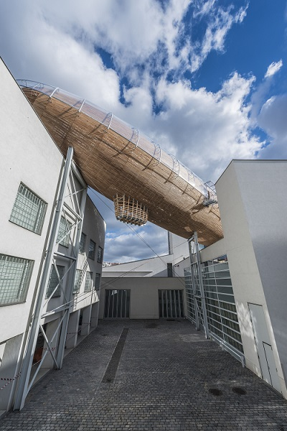
EMPATHY IN THE DIGITAL AGE
The FALL festival at the DOX Centre for Contemporary Art is a space for the thoughts and voices of writers, artists, and other creative minds from various genres and their inspiring “borderlands”. Its permanent focus is the theme of empathy in the digital age. At a time when we share more on social media than in the real world, the festival is a chance to see the world through someone else’s eyes for a moment, to step into the stories of others, to ask how art and literature affect our ability to perceive and empathise with them, and to question whether creativity, imagination, and empathy are what (for now) set us apart from our artificially intelligent future.

FALL 2025: THINK DANGEROUSLY
Each edition of the festival also has a more specific focus, and this year it will explore the issue of censorship, self-censorship, and artistic freedom in contemporary art and literature.
“For this year’s festival we have selected a theme which we find alarmingly topical. We proceed from the consideration that the world of art and literature hasn’t even had time to react to the pressures of so-called cancel culture or woke culture in recent years, and yet in some until recently still liberal countries it is already becoming subject to a different kind of censorship – one that is dangerously reminiscent of the authoritarian regimes of the past. Technology, including artificial intelligence, is of course now also playing a role. The list of ‘uncomfortable’ books is growing in many countries, and artistic institutions are finding themselves under pressure. And so we are interested to learn whether the voice of art and literature is gradually being ‘tamed’ under the onslaught of this changing environment, how artists and writers are responding to its demands, and if self-censorship is creeping into their work. We will discuss the issue of artistic freedom in the world today with writers and artists from many different countries, including Ukraine, Ireland, Slovakia, Germany, China, and Palestine. We have borrowed the deliberately ambiguous motto THINK DANGEROUSLY from Albert Camus’s famous 1957 lecture ‘Create Dangerously’. On the occasion of the FALL festival, DOX will be publishing the first-ever Czech translation of this text. With the festival guests we will discuss, among other things, what it means to think dangerously in the 2020s,” says Michaela Šilpochová, artistic director of the DOX Centre for Contemporary Art and founder and chief curator of the FALL festival.

To create today is to create dangerously. Any publication is an act, and that act exposes one to the passions of an age that forgives nothing.
Albert Camus
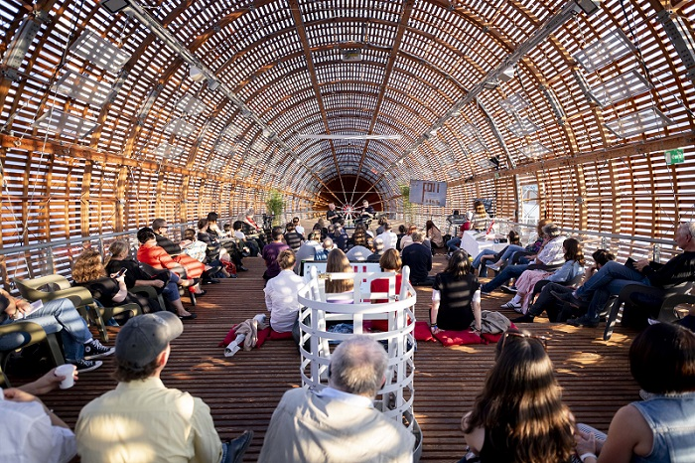

GUESTS
Over the course of several days, visitors will have the opportunity to meet Czech and international writers, artists, and other remarkable figures in the galleries of DOX and on board the Gulliver Airship. The main programme will include, for example, Booker Prize–winning Irish author Paul Lynch, who will present his most recent novel, Prophet Song (2023). The award-winning Austrian-German writer Daniel Kehlmann will be in Prague to launch the Czech translation of his latest novel, The Director (2025). Palestinian author Adania Shibli will also come to launch the Czech translation of her book Minor Detail (2017). The book was to be awarded the LiBeraturpreis at the 2023 Frankfurt Book Fair, but the organisers cancelled the award ceremony for political reasons, prompting dozens of the world’s foremost authors to speak out in Shibli’s defence.
Other guests include prominent Ukrainian author Sofia Andrukhovych, Chinese dissident artist Badiucao, and American journalist with Chinese-Taiwanese roots Melissa Chan. The programme will also feature Czech authors such as Radka Denemarková, Nina Špitálníková, Jan Němec, and Adéla Knapová.
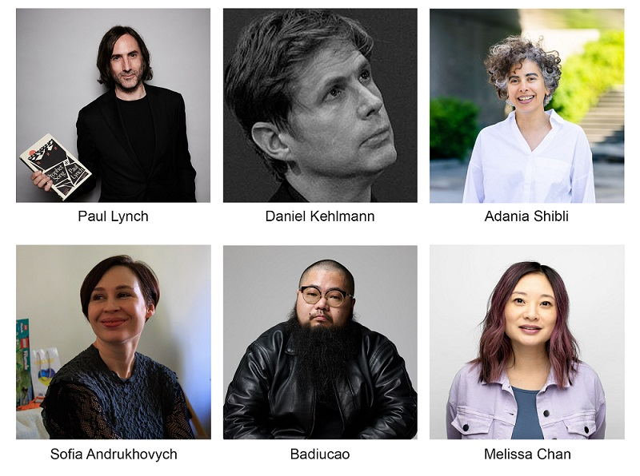

INTERNATIONAL HONORARY BOARD OF THE FALL FESTIVAL
From 2025, the FALL festival is proud to announce an international honorary board. Four prominent figures from the world of literature and culture have been invited to join the advisory body, which supports the values and long-term concept of the FALL festival.

Alberto Manguel – an internationally respected Argentine-Canadian writer, translator, essayist, and promoter of reading
Radka Denemarková – an internationally acclaimed Czech author, screenwriter, literary historian, and translator of German literature
Colum McCann – an award-winning Irish novelist and co-founder of Narrative 4, an organisation devoted to developing empathy through sharing stories
Bill Shipsey – the founder of the organisation Art for Amnesty and executive director of Art for Human Rights
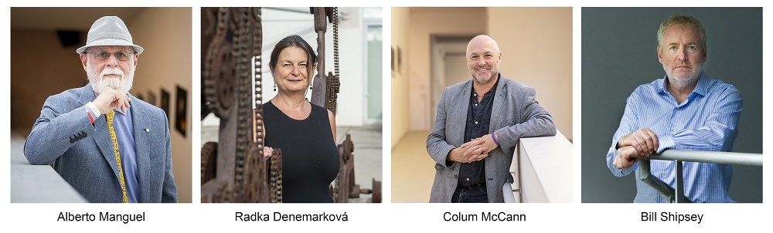

PROGRAMME
The festival will feature discussions with authors, readings, special interdisciplinary workshops led by artists and writers, guided tours of exhibitions connected with reading, concerts, and performances, all of which will take place on board the Gulliver Airship and throughout the DOX Centre for Contemporary Art. There will also be programmes for school groups and creative workshops for families. The festival naturally also includes contemporary art exhibitions, all of which have literary overlaps this year:

• David Lynch: Up in Flames
• Viktor Pivovarov: Metaphysics and Despair
• Orhan Pamuk: The Consolation of Objects

We will be announcing more guests and the festival programme during the summer.

FALL FOR SCHOOLS AND PROFESSIONALS
An important part of the festival is a series of programmes for secondary school students and teachers focused on the theme of empathy in the digital age. The festival will host special student discussions with authors and artists every weekday, with follow-up interactive workshops aimed at developing empathy. The workshops are centred around the sharing of personal stories, and they utilise the successful methodology of the international educational project Narrative 4, whose co-founder, Irish writer Colum McCann, is also a member of the honorary board of the FALL festival. As part of its multi-genre programme, DOX expands on the Narrative 4 methodology with connections to the visual arts and literature.
This year students will have the opportunity to speak with Chinese artist and political activist Badiucao, American journalist with Chinese-Taiwanese roots Melissa Chan, Ukrainian writer Sofia Andrukhovych, author Jan Němec, writer and journalist Adéla Knapová, who is currently living in war-torn Ukraine, or writer and Korean studies specialist Nina Špitálníková.
This year the festival will once again include a discussion about the Literary Critics’ Award and a professional discussion and workshop for teachers and librarians.

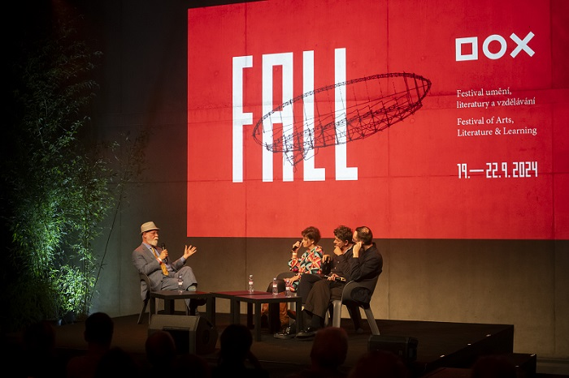
TICKETS
Early bird tickets for FALL 2025 are now available for purchase on the festival’s website doxfall.cz and at dox.cz. Tickets for the full festival are in presale for a discounted price of CZK 1200. They include admission to the programme during all four days of the festival as well as entry to all of the DOX Centre’s exhibitions, including the main exhibition David Lynch: Up in Flames.

DOX. MORE THAN JUST A GALLERY
The DOX Centre for Contemporary Art was established thanks to a private initiative that transformed a former factory in Prague’s Holešovice neighbourhood into the largest non-governmental, non-profit institution dedicated to contemporary art in the Czech Republic. Since 2008 its mission has been to foster an environment for the exploration, discussion, and artistic presentation of important social issues, with visual art, literature, music, theatre, and other disciplines enabling a critical approach to the so-called reality of the world today. The exhibition space of over three thousand square metres is complemented by the DOX+ Multifunctional Hall and the Gulliver Airship, which is the home of the FALL festival.

The festival will take place with the support of the Ministry of Culture of the Czech Republic, the City of Prague, the Abakus Foundation, and the DOX Foundation, in cooperation with Art for Human Rights and Narrative 4 as well as individual publishers and literary magazines.

FALL – Festival of Arts, Literature & Learning
2–5 October 2025
DOX Centre for Contemporary Art
Poupětova 1, Prague 7

The press release and print-quality photographs can be downloaded after registering in the Press section of the DOX Centre’s website.
Photos: Jan Slavík, © DOX
Contact
Karolína Kočí
E karolina.koci@dox.cz
T +420 777 870 219
www.dox.cz

