From the headlines to art: HIT BY NEWS at DOX explores the relationship between art and the press.

The exhibition HIT BY NEWS, which will take place at the DOX Centre for Contemporary Art in Prague from 6 March to 23 August 2026, opens up a fascinating dialogue between the worlds of art and the media. The selection of works from the Swiss collection of Annette and Peter Nobel shows how the press has shaped society and visual art over the past century – from early artistic experiments with print media to reflections on today’s media practices. Featuring nearly four hundred works by an array of prominent international artists, the exhibition presents an exceptionally comprehensive view of the phenomenon of press art – art that deals with news, headlines, newspaper print, and the very role of the media in society. Renowned curator Christoph Doswald has selected a unique collection of works for the exhibition at DOX, which shows that press art is more than just art that works with print media – it is an important visual response to a reality shaped by the news.

The public opening of the exhibition will take place on 5 March at 7:00 p.m.

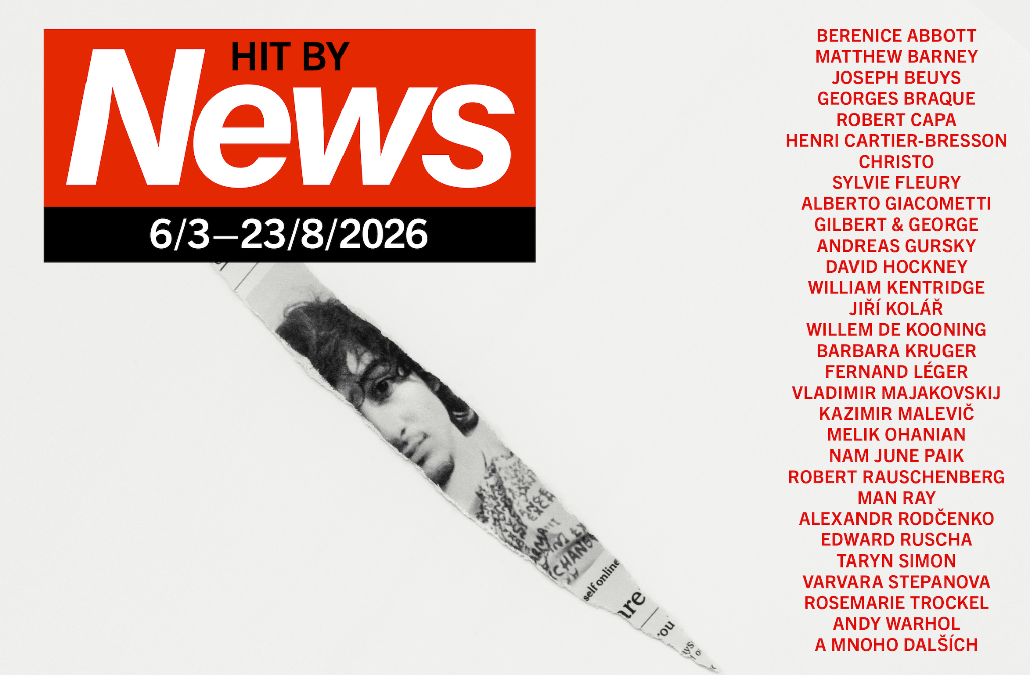

“Under the genre label of ‘press art’, the exhibition gathers together artworks that are related to the printed word and the printed image in the broadest sense – works that elevate the cheap, everyday, renewable consumer good to an expensive individual item: collages made from newsprint; paintings whose model was provided by a press image; photographs showing a magazine cover; gouaches applied to newsprint; silkscreens based on photographs of stars in celebrity magazines. The list of applications is long, the techniques diverse, the themes almost infinite – just as diverse as the reasons for the respective artistic engagement, which oscillate between admiration and criticism,” explains curator Christoph Doswald.

HIT BY NEWS will be one of two major exhibition projects at DOX this year. From March to the end of August, it will offer visitors the opportunity to explore the relationship between art and the mass media and the way in which traditional print media in particular has influenced society over the last century. The project will present works by more than two hundred artists who have dealt with the press – mainly print media – in their work. The exhibiting artists include Georges Braque, Fernand Léger, Vladimir Mayakovsky, Kazimir Malevich, Jean Arp, Joseph Beuys, Robert Capa, Man Ray, Henri Cartier-Bresson, Christo, Le Corbusier, Jiří Kolář, Barbara Kruger, Willem de Kooning, Alberto Giacometti, Robert Rauschenberg, Alexander Rodchenko, Edward Ruscha, Gilbert & George, Andreas Gursky, David Hockney, Dennis Hopper, William Kentridge, Rosemarie Trockel, Martin Kippenberger, Jannis Kounellis, Matthew Barney, and many others. The exhibition presents works exclusively from the collection of Annette and Peter Nobel.

The curatorial selection of this series of unique works from the Swiss collection of the Nobels, who have been systematically collecting press art since the 1980s and whose collection now contains over two thousand works of art focused on this dialogue, will be handled by the renowned independent curator Christoph Doswald.

“The Nobels’ collection is unique in its focus and scope, and the curatorial selection, created specifically for DOX, offers a rare opportunity to examine the relationship between art and the press from a historical perspective spanning the last century and to discover perhaps lesser-known works by world-renowned artists. At the same time, the theme of the exhibition encourages us to reflect on how the influence of digital media in recent decades has led to a significant shift in both the media landscape and the way that art responds to it. The exhibition indirectly opens up a number of related topics, such as the relationship between social media and art, collaboration

between the Czech media and artists, and the issues of media freedom, increasing attacks on journalists, and growing pressure on public media, which we are currently witnessing in many countries, including the Czech Republic. These topics will be also be reflected in the exhibition’s accompanying events and educational programmes,” says Michaela Šilpochová, the artistic director of DOX.

Christoph Doswald is a Swiss curator and university lecturer. He has curated numerous exhibitions at institutions such as Kunsthaus Graz, Villa Arson in Nice, Kunstmuseum Bern, Pasquart Biel, Museum der Moderne Salzburg, Kunstmuseum St. Gallen, the Pera Museum in Istanbul, and the Academy of Arts in Berlin. From 2001 to 2007 he was a curator at large and a member of the Comité technique at Fonds Régional d’Art Contemporain (FRAC PACA) in Marseille, where he realised various exhibitions of artists such as Ugo Rondinone, Björn Dahlem, and Maria Marshall.
From 2009 to 2020 Doswald was the chair of the city of Zurich’s public art programme, where he initiated and curated numerous projects, including ART AND THE CITY (2012), New North Zurich (2018), and commissions by Claudia Comte and Paweł Althamer at Münsterhof square.
In 2023 he co-curated the 4th Industrial Art Biennial in Croatia, subtitled Landscapes of Desire, which included more than thirty artistic projects dealing with the ambiguous context of post-Yugoslavia.
In 2022 he was appointed artistic director of ART FLOW, a growing exhibition in the Limmat Valley, north of Zurich, which features twenty-five commissioned projects by Lara Almarcegui, Michel Comte, Tobias Kaspar, Sonia Leimer, Olaf Nicolai, Karin Sander, Alec Soth, Pedro Wirz, and many others.
For almost thirty years, Doswald has been a curator and an advisor to the Press Art Collection and to the Nobel family.
In 2003 Christoph Doswald was honoured with the Swiss Art Award, a recognition from the Swiss government for his innovative work as a curator.

The Swiss collection of Annette and Peter Nobel is one of the most important private collections focusing on the relationship between art and print media. The collection, which they have been building systematically since the late 1980s, focuses primarily on so-called press art – artistic strategies that work with print media, news, photojournalism, and media language. Featuring several thousand works by prominent artists of the twentieth and twenty-first centuries, it maps the ways that art has responded to the world of media and the reality it shapes over the last century.

DOX Centre for Contemporary Art
Poupětova 1, Prague 7
Open: Tue–Sun, 11:00 a.m.–7:00 p.m.
The press release and photographs can be downloaded after registering in the Press section of our website.

Contact
Karolína Kočí
E karolina.koci@dox.cz
T +420 777 870 219
www.dox.cz

