From the headlines to the canvas – the exhibition HIT BY NEWS at DOX charts a century of the relationship between art and the media.
How much do newspapers, headlines, and media images influence our perception of the world? And how do artists respond to them? The answers to these questions and more can be found in the exhibition HIT BY NEWS at the DOX Centre for Contemporary Art, which opens up a fascinating dialogue between art and the world of the media. The project, which is based exclusively on works from the Swiss collection of Annette and Peter Nobel, shows how the press has shaped society and visual art over the past century – from early artistic experiments with print media to reflections on today’s media practices. This exceptionally comprehensive overview of the phenomenon of press art – meaning art that deals with news, headlines, newspapers, and the very role of the media in society – will feature nearly four hundred works by an array of prominent international artists.
The exhibition is curated by renowned Swiss curator Christoph Doswald, who, in collaboration with DOX, has prepared a representative cross-section of the Nobels’ collection, which they have been building since the 1980s and contains more than two thousand works. It is one of the most important specialised collections focused on the dialogue between art and the media in an international context.
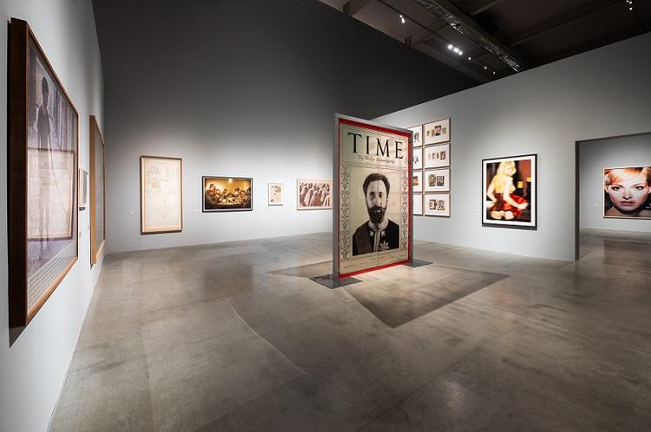
↑ The exhibition HIT BY NEWS, photo: Tomáš Cindr, © DOX

The exhibition will run from 6 March to 23 August 2026.

The public opening will take place on 5 March 2026 at 7:00 p.m.
From the avant-garde to the digital era

The exhibition HIT BY NEWS follows the development of the relationship between art and the press, from the historical avant-garde to postwar art to the present. The project presents works by more than two hundred artists, including key figures of modern and contemporary art, who have dealt with the media – mainly print media – in their work.
The exhibiting artists include Georges Braque, Fernand Léger, Vladimir Mayakovsky, Kazimir Malevich, Jean Arp, Joseph Beuys, Robert Capa, Man Ray, Henri Cartier-Bresson, Christo, Le Corbusier, Jiří Kolář, Barbara Kruger, Willem de Kooning, Alberto Giacometti, Robert Rauschenberg, Alexander Rodchenko, Edward Ruscha, Gilbert & George, Andreas Gursky, David Hockney, Dennis Hopper, William Kentridge, Rosemarie Trockel, Martin Kippenberger, Jannis Kounellis, Matthew Barney, and many others.
The broad generational and geographic scope allows us to trace how the visual aesthetics of the media and its relationship to art have shifted from the early avant-garde to the present day – from playful collages to pop art works inspired by mainstream culture to contemporary reflections on media reality.
“HIT BY NEWS tells the story of a complex but fruitful relationship: the interaction between art and mass media. The curatorial approach of the exhibition is inspired by the production process of a newspaper, which begins with an empty sheet of paper. Once covered with stories and pictures, it ends up as what we call a ‘newspaper’. Art and news are genuinely connected via this process of storytelling, which is the red thread running through the fourteen chapters of the exhibition,” explains curator Christoph Doswald.

When newspapers become art
Newsprint, photographs from the dailies, magazine covers – these common items that pass through our hands every day are transformed by artists into original works. The term “press art” refers to works which, in the broadest sense, relate to the printed word and image and which transform this common, widely distributed medium into unique artistic artifacts.
According to the curator of HIT BY NEWS, press art cannot be understood simply as art that makes use of newspapers; it is a critical and fascinated response to the reality shaped by the media. These artists are not just aesthetic experimenters but active commentators on public events. Their work reflects changes in political ideologies, the rise of popular culture, media manipulation, and fickle trust in journalism as a tool of democracy.
“Under the genre label of ‘press art’, the exhibition gathers together artworks that are related to the printed word and the printed image in the broadest sense – works that elevate the cheap, everyday, renewable consumer good to an expensive individual item: collages made from newsprint; paintings whose model was provided by a press image; photographs displaying a magazine cover; gouaches applied to newsprint; silkscreens based on photographs of stars in celebrity magazines. The list of applications is long, the techniques diverse, the themes almost infinite – just as diverse as the reasons for the respective artistic engagement, which oscillate between admiration and criticism,” adds curator Christoph Doswald.
Current themes of today
Although the exhibition focuses primarily on print media, its theme is very contemporary. The project raises the question of how the media landscape has changed in recent decades under the influence of digitisation. In an age of social media, round-the-clock news coverage, and information overload, the question of the role of the media is more relevant than ever. The project thus also indirectly explores issues such as trust in the news, media freedom, and pressure on journalists.

“The Nobels’ collection is unique in its focus and scope, and the curatorial selection, created specifically for DOX, offers a rare opportunity to examine the relationship between art and the press from a historical perspective spanning the last century and to discover perhaps lesser-known works by world-renowned artists. At the same time, the theme of the exhibition encourages us to reflect on how the influence of digital media in recent decades has led to a significant shift in both the media landscape and the way that art responds to it,” says Michaela Šilpochová, the artistic director of DOX.
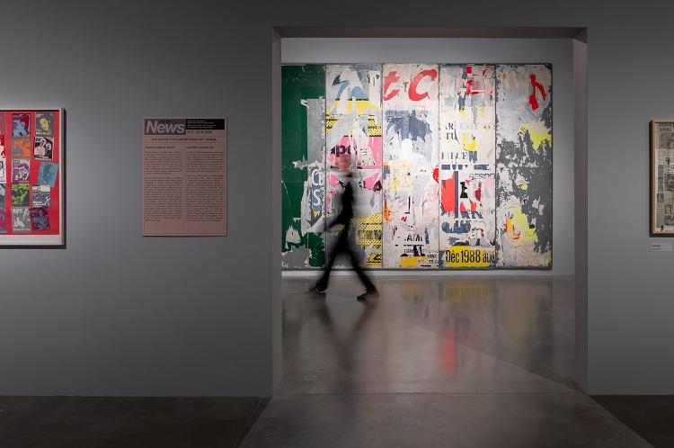
↑ The exhibition HIT BY NEWS, photo: Tomáš Cindr, © DOX

HIT BY NEWS is one of DOX’s two main exhibition projects of 2026. The expansive exhibition will be accompanied by expert debates, a series of educational programmes, and discussions focused on relevant topics such as media ethics, freedom of speech, and the relationship between art and public space.
"What led me to create the collection of press art? My fascination with printing technology played a key role, followed by the intellectual dimension, and lastly the transformation over time. However, the art of printing itself is also important. It is surprising how many artists used newspapers as the basis for their works, whether during a certain period, on a one-off or random basis, or regularly. Some even painted based on newspapers or designed them themselves. They did so quite consciously; it was their way of aesthetically coming to terms with everyday life. The symbolic world comes to life in art. These images could undoubtedly even be used to compile a kind of history of the press. […] Artistic creation using newspapers is an expression of a conscious handling of the democratic living space under the conditions of the technological age.” —Peter Nobel on his collection of press art
Expert commentary by curator Christoph Doswald on three selected works from the exhibition
Kurt Schwitters: Beware of Hot Air / Man soll nicht asen mit Phrasen
In their early days, newspapers were purely text-based media. The value of the logged information manifested itself in word collections, in libraries. But the word is also easier to manipulate, to distort, to gloss over – at least that was the case until the age of digital visual media. Man soll nicht asen mit Phrasen (Beware of Hot Air, 1930) is Kurt Schwitters’s reference to Adolf Hitler and his ambiguous claim that he, Hitler, made his living from art, not politics.

Alfredo Jaar: Newsweek
In April 1994 civil war broke out in Rwanda, developing into genocide and claiming an estimated one million lives. Despite the incredible significance of the events, the issue was only recognised and reported on by the American media at a very late stage. Alfredo Jaar impressively revealed this in his multi-part work Newsweek, in which sixteen covers of the American magazine report on trivialities such as antioxidants or the death of Jacky Kennedy Onassis. It was not until four months after the genocide began that the conflict made it onto the cover of this important American magazine.

Barbara Kruger: Untitled (Only the Unborn Have Your Right to Life)
The definitions and role models of gender, religion, ethnicity, and much more are being put to the test and are being negotiated and redefined constantly. Art and (social) media play a key role in this progressive dynamic as early indicators and amplifiers. Barbara Kruger, who earned her living as a graphic designer for women’s magazines, is one of the pioneers of a feminist art form that redefines the social role of women. Kruger collaged the phrase “Only the unborn have your right to life (1986)” onto a large red image of an embryo, addressing the US’s ambivalence on the issue of abortion.

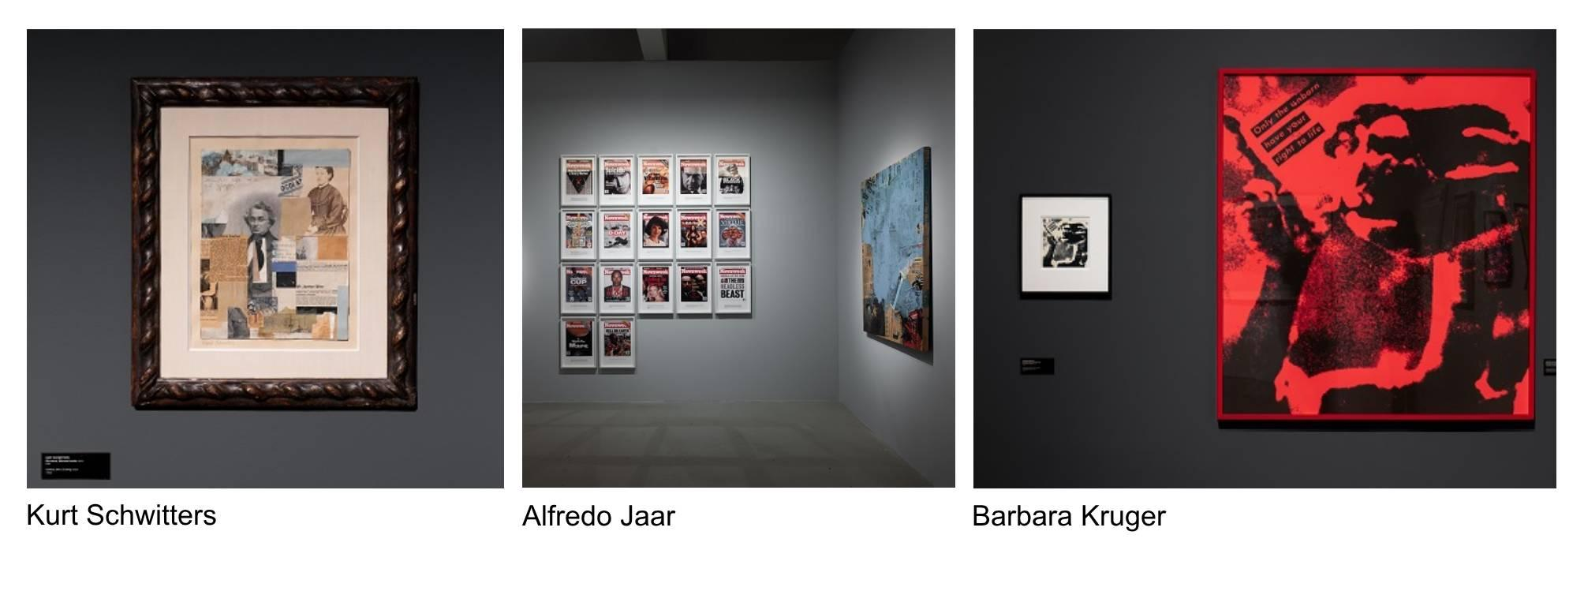

Christoph Doswald is a Swiss curator and university lecturer. He has curated numerous exhibitions at institutions such as Kunsthaus Graz, Villa Arson in Nice, Kunstmuseum Bern, Pasquart Biel, Museum der Moderne Salzburg, Kunstmuseum St. Gallen, the Pera Museum in Istanbul, and the Academy of Arts in Berlin. From 2001 to 2007 he was a curator at large and a member of the Comité technique at Fonds Régional d’Art Contemporain (FRAC PACA) in Marseille, where he realised various exhibitions of artists such as Ugo Rondinone, Björn Dahlem, and Maria Marshall.
From 2009 to 2020 Doswald was the chair of the city of Zurich’s Public Art Programme, where he initiated and curated numerous projects, including ART AND THE CITY (2012), New North Zurich (2018), and commissions by Claudia Comte and Paweł Althamer at Münsterhof square.
In 2023 he co-curated the 4th Industrial Art Biennial in Croatia, subtitled Landscapes of Desire, which included more than thirty artistic projects dealing with the ambiguous context of post-Yugoslavia.
In 2022 he was appointed artistic director of ART FLOW, a growing exhibition in the Limmat Valley, north of Zurich, which features twenty-five commissioned projects by Lara Almarcegui, Michel Comte, Tobias Kaspar, Sonia Leimer, Olaf Nicolai, Karin Sander, Alec Soth, Pedro Wirz, and many others.
For almost thirty years, Doswald has been a curator and an advisor to the Press Art Collection and to the Nobel family.
Christoph Doswald was honoured with the Swiss Art Award, a recognition from the Swiss government for his innovative work as a curator.

The Swiss collection of Annette and Peter Nobel is one of the most important private collections focusing on the relationship between art and print media. The collection, which they have been building systematically since the late 1980s, focuses primarily on so-called press art – artistic strategies that work with print media, news, photojournalism, and media language. Featuring several thousand works by prominent artists of the twentieth and twenty-first centuries, it maps the ways that art has responded to the world of media and the reality it shapes over the last century.

DOX Centre for Contemporary Art
Poupětova 1, Prague 7
Open: Tue–Sun, 11:00 a.m.–7:00 p.m.

The press release and photographs can be downloaded after registering in the Press section of our website.

Contact
Karolína Kočí
E karolina.koci@dox.cz
T +420 777 870 219
www.dox.cz

