**From ancient mythology to the paintings of Rubens and Titian to the Tesla Cybertruck.**

**Artist Hynek Martinec is opening a new exhibition called *Cyberlemon* at DOX in Prague, with the titular fruit taking centre stage.**

**P:\Doxstorage\01 VÝSTAVY\VÝSTAVY 2025\2. HYNEK MARTINEC\5. PRESS\mensi foto fo TZ\Cyberlemon, 2024. Oil on canvas, 35 x 40 cm.tifIn his first solo show in Prague since 2018, London-based artist Hynek Martinec draws together an extraordinary range of references to meditate upon the current state of human consciousness. In his new works featured in a project called *Cyberlemon*, Martinec responds to an accelerated and increasingly polarised world where art, technology, and social issues meet in unexpected and often paradoxical ways.**

In a time of fracturing societies marked by the rise of extremist ideologies and identity politics, and as AI is beginning to have profound effects on the cultural landscape, **Martinec traces a journey from the “cradle of civilisation” in the Mediterranean – the cultures of ancient Greece and the Roman Empire – to the present day, to ask: Where are we now? How did we get here?**

↑ Hynek Martinec, Cyberlemon, 2024 ©Hynek Martinec

Often labelled hyper- or photorealist, Hynek Martinec’s paintings defy such categorisation. While his painterly technique is rooted in the realist tradition, he collapses together imagery from diverse sources, creates surreal juxtapositions and distorts form and scale to craft complex images that elude simple interpretation.

In his new works, his references include ancient Greek and Roman sculpture, paintings by Rubens and Titian, and the tradition of Dutch still-lifes but also Damien Hirst’s diamond-encrusted skull, the Tesla Cybertruck, and even plastic toys (symbols of contemporary consumerism). The artist’s use of imagery from Greek and Roman classical sculpture was largely inspired by a visit to the Museo Archeologico Nazionale in Naples in 2024, a visit he has called a “wake-up call” and a reminder of the timelessness of art.

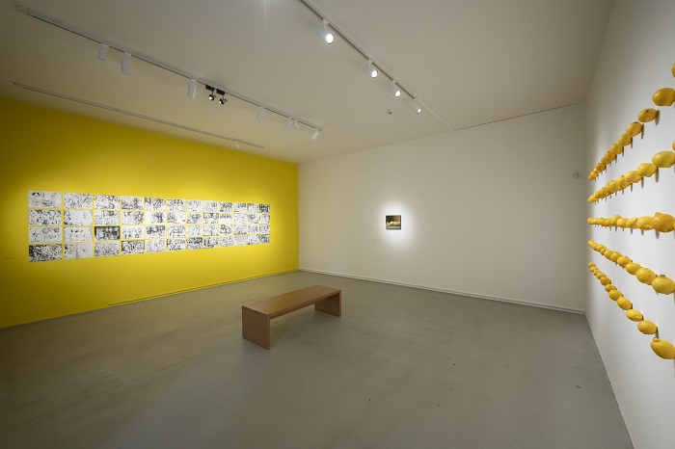

↑ Hynek Martinec, view into the Cyberlemon exhibition, 2025 , photo Jan Slavík

Running through many paintings in the exhibition is the motif of the lemon. For Martinec, who has painted lemons throughout his career, the lemon is a motif that introduces historic themes but is “neutral” in the context of today’s “culture war” debates: “I thought, why not choose some kind of extreme and pursue a motif that we feel won’t upset anyone? But if I view that motif through the lens of social media, it can take on a number of contradictory meanings. So for me, in this exhibition the lemon is a kind of guide who changes roles like an actor. The first time that we see it is in a mythological setting, the second time as an object of beauty, and the third time as a lamp by Joseph Beuys.”

“London in the last decade has become politically, socially, and culturally charged. In the visual arts, questions of identity (gender, sexuality, ethnicity, politics) have come to the fore. Martinec responds to this by trying to find a universal motif, something that cannot be reduced to the binaries of political debate. For him, this is the lemon, a commonplace object that has nonetheless been used throughout art history to represent different ideas (luxury, exoticism) and which evokes the ancient civilisations of the Mediterranean,” adds curator Ben Tufnell regarding the theme of the lemon. He continues: “It might seem surreal to focus on lemons at such a time of fractured politics, economic instability, and global conflict, but I think that for Martinec this symbol serves to remind us of the universality of culture.”

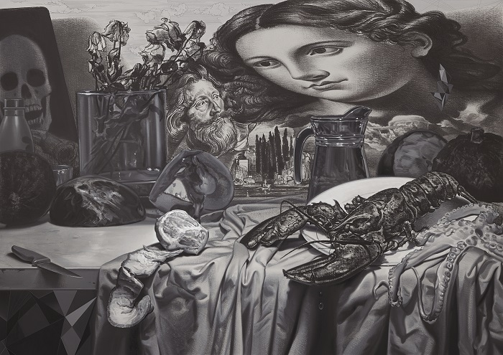

↑ Hynek Martinec, Out of Chaos, 2024 – 2025 ©Hynek Martinec

The painting that gives the exhibition its title – *Cyberlemon* (2024) – depicts a traditional still life that transforms into an array of quasi-cubist abstract planes inspired by the rectilinear lines of the Tesla Cybertruck. The hybrid “cyberlemon” thus symbolises a synthesis of the old and the new and announces Martinec’s theme.

“In the final room, a giant drawing of a burning ‘Cybertruck’ takes us back to this small painting and also reminds us of the current situation in the US and Europe and the (possibly irreconcilable) differences between ancient knowledge and technological innovation,” says curator Ben Tufnell.

Spanning three floors of the DOX tower, the exhibition project culminates on the top floor with a series of monumental site-specific wall drawings dominated by a depiction of the mythical figure of Atlas. Derived from a sculpture in the Museo Archeologico Nazionale in Naples, Martinec’s Atlas bears upon its shoulders not the globe but a giant lemon.

The artist employs a wide range of techniques, most of which can be seen in this new exhibition – from oil painting to aquatint and printmaking to installation. Moreover, a number of the works are hybrids in which Martinec explores the relationship between painting and drawing: He leaves parts of the canvas unpainted, revealing the charcoal underdrawing, and he refines some of the drawn elements in detail.

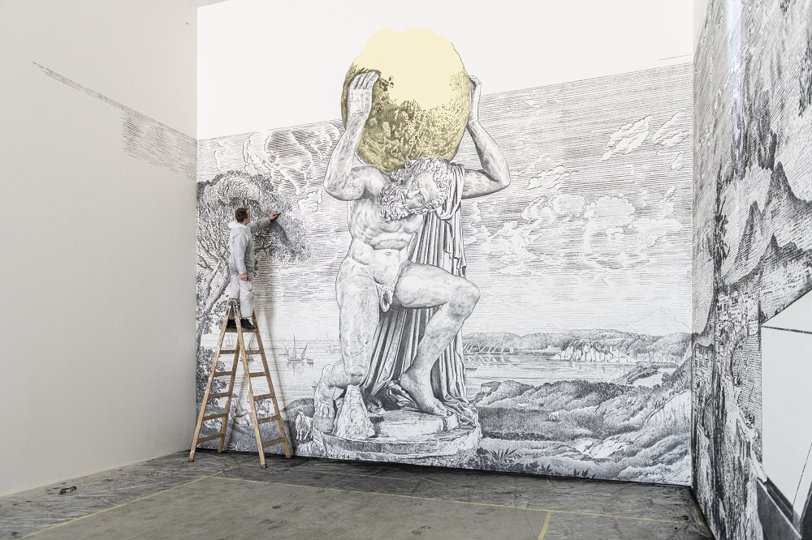Charcoal drawing is fundamental to Martinec, which he has demonstrated in the large-scale wall drawing on the top floor of the DOX tower. Over twenty-nine metres long and eight metres high, it was created on site over a period of three weeks. “For me personally, the ritual of creation is important. It is a powerful moment in which I relate to cave paintings. After all, it was coal that was the first creative material forty thousand years ago! It’s fascinating for me, as if I were in direct dialogue with a civilisation that disappeared long ago. The ephemerality of drawing is also important to me. Even if a drawing is monumental, it is essentially just dust on the wall that will one day disappear. I want to show how life is amazing when it is lived to the fullest, but there always comes a moment when everything is extinguished. Nevertheless, culture – perhaps specifically coal – will live on.”

↑ Hynek Martinec, creation of Atlas drawing at DOX, 2025 , photo Jan Slavík

As curator Ben Tufnell points out, Hynek Martinec’s *Cyberlemon* is a surreal, playful project with certain elements of absurdity, but it is realised with serious intent. For Martinec, art remains, as it was in ancient Greece, the best tool for making sense of the chaos around us.

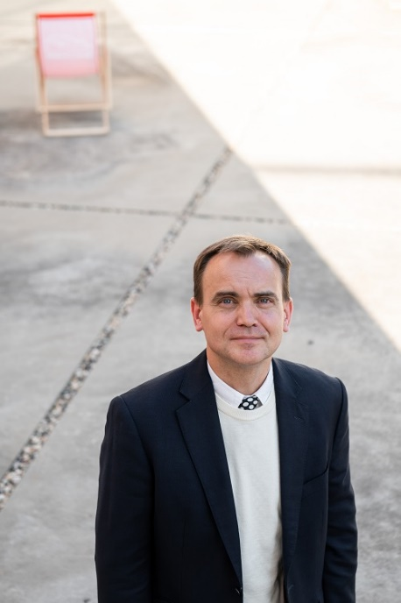**Hynek Martinec**

Hynek Martinec (b. 1980, Broumov) is a renowned Czech-British contemporary artist known for his innovative fusion of traditional techniques and conceptual or experimental approaches. His work deals with themes of time, memory, and perception, often situated at the intersection of art history, science, and philosophy. Martinec studied at the Academy of Fine Arts in Prague in the Studio of Classical Painting Techniques and also at Middlesex University in London, where he enriched his artistic practice with experimental and conceptual art. He further honed his skills at the prestigious Cooper Union in New York. Martinec currently lives in London and considers himself both Czech and British. His work is thus defined by a dual cultural context. He has exhibited extensively throughout Europe and the US. His notable solo exhibitions include *Every Minute You Are Closer to Death* at Parafin Gallery in London and *Voyage to Iceland* at the National Gallery Prague. He has also been involved in group exhibitions at renowned institutions such as the National Portrait Gallery in London and Galerie Rudolfinum and the DOX Centre for Contemporary Art in Prague. In 2024 Martinec was selected for the anthology *The Anomie Review of Contemporary British Painting 3* in recognition of his contribution to British art. His work is represented in major public and private collections, including those of the National Gallery Prague and the British Museum in London.

**Exhibition curator: Ben Tufnell**

**Hynek Martinec: Cyberlemon**

**27. 3. 2025 – 24. 8. 2025**

DOX Centre for Contemporary Art

Poupětova 1, Prague 7

The press release and high-resolution images can be downloaded after registering in the [Press Section](https://www.dox.cz/users_area/register) of our website.

**Photographs: Jan Slavík, ©DOX**

Contact

**Karolína Kočí  
PR Manager**

DOX Centre for Contemporary Art  
E [karolina.koci@dox.cz](mailto:karolina.koci@dox.cz)

T +420 777 870 219

**www.dox.cz**