I’m Here, announces Jiří David through an exhibition of paintings
at DOX
→ Among the most prominent artists on the Czech scene, Jiří David has his first solo show in the Czech Republic in over ten years
→ DOX will feature hitherto not exhibited large-format paintings created in 2018 and 2019
→ I’m Here is curated by eminent European artist Viktor Pivovarov

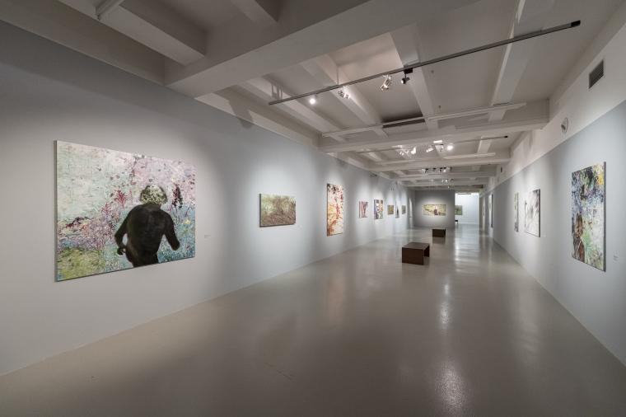
↑ Exhibition view. Photo Jan Slavík, © DOX

Jiří David, a multimedia artist and educator, who since the mid-1980s has exerted significant influence on the Czech art scene, presents his newest works, paintings both large and small, in an exhibition entitled I’m Here. He works with a rare artistic approach: a self-portrait from the rear, which he accents in the exhibition through repetition on three canvases, he immerses himself in the colourful intoxication of flowers and gardens, paints nude female bodies as well as himself, and in several paintings achieves a certain dematerialization of the physical body. The exhibition, featuring some thirty works, includes a series devoted to grass, a motif quite unique in Wester art when it comes to artistic focus.

“Jiří David paints with his typical temperament and emotional involvement, enriched by experience gained from conceptual work,” states exhibition curator Viktor Pivovarov, “and opens an old and simultaneously new world of painterly poetry and poetic painting, both for himself and for his viewers.”
“I actually never completely abandoned the medium of painting, but rather searched for its meaning, including by doubting, torturing, and tormenting it within myself. Simultaneously, I also looked for content-related contexts that made some sort of sense to me without having to ʻillustrate’ contemporary narratives, but at the same time avoiding getting bogged down in mere decorative experimentation,” says Jiří David regarding his exhibition.

Jiří David (1956), visual artist and educator, head of the Intermedia Communication studio at the Academy of Arts, Architecture and Design in Prague, working in the area of painting, object creation, photography, and video art; he is also involved in critique and journalism. While studying at the Academy of Fine Arts in Prague, he helped organize Confrontations, a series of unofficial group shows. In 1987 he and other artists of his generation founded the Tvrdohlaví [The Stubborn] group. Through his paintings, freely using signs and political symbols, he played a key role in the formation of the post-modern programme at the end of the 1980s and start of the 1990s, when he also began installing objects and writing texts dealing with the role of the artist and art in society. He participated in the Venice Biennale four times. His name became a household word in 2002 when his neon “Heart” was installed on the north tower of St. George’s Basilica at the Prague Castle. His work is present in many domestic and foreign collections. His works are currently also being shown at Thomas Erben Gallery in New York’s Chelsea district.

The exhibition is accompanied by a catalogue with texts by Jiří David and Viktor Pivovarov. I’m Here, Prague 2019, ISBN 978-80-970832-6-7.

The public can meet Jiří David in person during guided tours of the exhibition on 20 February and 12 March.

Jiří David
I’m Here
17 January – 30 March
Curator: Viktor Pivovarov

DOX Centre for Contemporary Art
The DOX Centre for Contemporary Art is a multi-functional space created thanks to a private initiative through the reconstruction of a former factory in Prague’s Holešovice district. The name DOX is derived on the Greek word doxa, which among other things means a way of perceiving things, an opinion, a conviction. DOX’s programme differs from other similar exhibition institutions (the combination of a “kunsthalle” with a multifunctional cultural centre) primarily through art projects incorporating critical reflection on current social topics and issues overlapping with other “non-artistic” areas and disciplines such as psychology, philosophy, history, sociology, political science, etc.

Where we are
Poupětova 1
Praha 7, 170 00

DOX partners
Hlavní město Praha
Nadační fond Avast
Metrostav
Ministerstvo kultury ČR

DOX media partners
Hospodářské noviny
Respekt
Art & Antiques

Print-quality photos can be downloaded from: www.dox.cz/cs/press

Contact
Michaela Šilpochová
DOX Centre for Contemporary Art
T +420 774 222 355
E michaela@dox.cz

