The KAFKAesque exhibition: today’s world through the eyes of more than 30 contemporary artists influenced by the work of Franz Kafka

The KAFKAesque exhibition at the DOX Centre for Contemporary Art in Prague, Czech Republic, presents a reflection on Kafka’s work and poetics in contemporary art. It does not offer a historical view of the writer’s work, but a view that reflects our contemporary situation with all its complexities and ambiguities. The work of more than thirty internationally renowned artists shows that Kafka’s work, with its references to existential fears and personal anxieties, is highly relevant to our times.

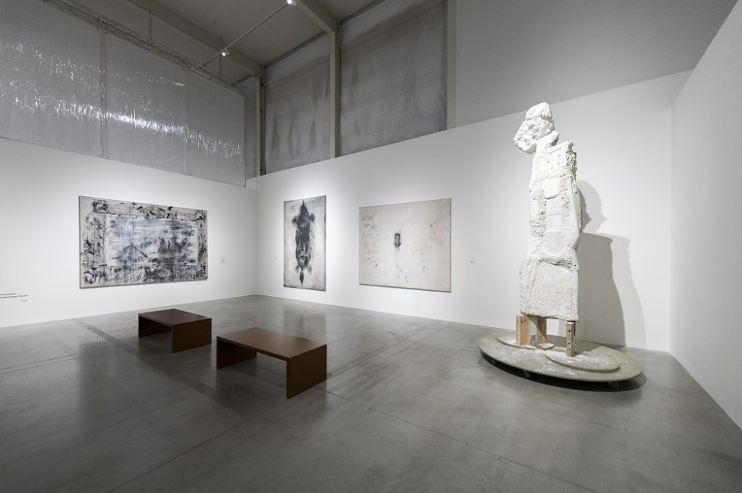
↑ View into the exhibition. Photo: Jan Slavík ©DOX

The KAFKAesque exhibition, which is being held in Franz Kafka’s hometown, Prague, on the occasion of the centenary of his death, has been planned by DOX curators for several years. The project was originally scheduled to take place in 2023 but had to be postponed due to covid. The bold concept was finally realized at the beginning of 2024, before the full celebration of the year of Franz Kafka.

Visitors to DOX can wonder through the Kafkaesque reflections of three dozen local and international artists in the extensive exhibition presented on two floors of the DOX Centre, the largest contemporary art venue in the Czech Republic. According to Otto M. Urban, one of the curators of the exhibition, the selection of artists was a challenge: “The number of artists who have dealt with Kafka in some way is enormous. We have primarily selected artists whose work has featured Kafka more indirectly, but all the more intensely. We were not interested in illustration, but in reflection. The exhibition is not meant to comprehensively map all the influences Kafka had and still has on contemporary art, but it is a certain slice, one of many possible perspectives.”

Prague-born Franz Kafka (1883-1924) is one of the key authors of the 20th-century cultural world. His German-language novels, stories and correspondence have been translated into dozens of languages, and his work and life have been the subject of numerous monographs and scholarly studies.

During his lifetime, Franz Kafka, a law student and later a long-time accident insurance clerk, published only a few works that did not meet with much acclaim. And although his work was already known to intellectual and artistic circles in the 1920s and 1930s, it was not until after the Second World War that he began to receive worldwide acclaim.
Over the following decades, Kafka’s work gradually became a cult. His influence began to extend far beyond literary and academic circles and found resonance not only in all areas of cultural production, from the visual arts to film, music, and theatre, but also outside the art world.

Gabriel García Márquez, Vladimir Nabokov, William Burroughs, Albert Camus, and Milan Kundera have all written about or analysed the work and life of Franz Kafka. He has been an inspiration for visual artists such as Francis Bacon, Andy Warhol and Louise Bourgeois, filmmakers such as Orson Welles and David Lynch, and music and theatre artists such as Philip Glass, David Bowie, Nick Cave, and the Rolling Stones. The philosophers Jean-Paul Sartre, Walter Benjamin, Hannah Arendt, and Theodor W. Adorno have all given their thoughts on Kafka. Over time, Kafka has made his way into comics, video games and even virtual reality.

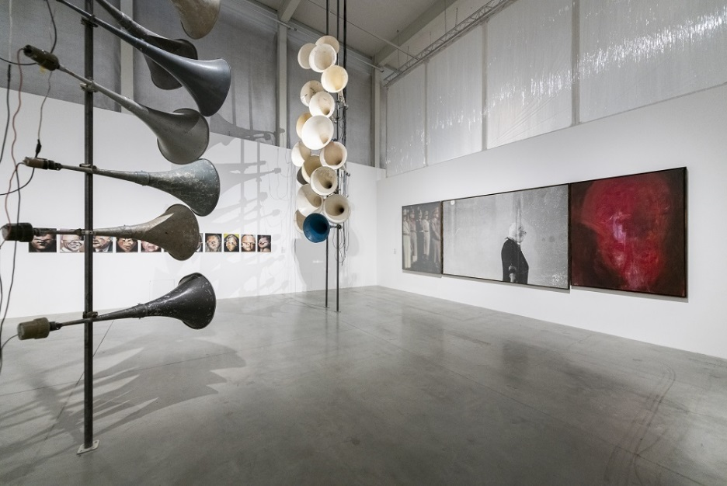
↑ View into the exhibition. Photo: Jan Slavík ©DOX

“The interest in Kafka’s work has given rise to the term ‘Kafkaesque’, which attempts to capture the essential features of Kafka's texts: the omnipresent influence of unknown authorities and apparatuses of power, and the futile efforts of those who are trapped in their arbitrary labyrinths. The incomprehensibility, bizarreness, and illogic of the situations in which the protagonists find themselves. In the words of Hannah Arendt, it is a ‘tyranny without a tyrant’ with obscure laws, confusing procedures, absurd logic, but also humour. All this is conceived outside of a specific time and space,” adds Michaela Šilpochová, co-curator of the exhibition and artistic director of DOX.

For decades, attempts to understand Kafka’s literary work and his life have presented an intellectual and often emotional challenge to scholars and readers alike, and have been the subject of much interpretation. Every age has had a need to comment on Franz Kafka and his work, and today is no different. Everyone has their Kafka.

“There is a category of professional kafkologists. There is a category of amateur kafkologists. And there is a category of astonished readers who prefer a personal touch. This is the criterion of our exhibition. The interest in the personal relationship of contemporary artists to Kafka and his world”, says DOX director and co-curator of the exhibition Leoš Válka.

The KAFKAesque exhibition does not offer a historical view of Franz Kafka’s work but presents its own “Kafkaesque” conception of the contemporary world through the works of selected artists.

Exhibiting artists: Josef Bolf, Brothers Quay, Pavel Büchler, Mat Collishaw, Vladimír Doležal, Rowynn Dumont, Martin Gerboc, Douglas Gordon, Matouš Háša, Gottfried Helnwein, Siegfried Herz, Jake and Dinos Chapman, Magdalena Jetelová, David Lynch, Volker März, Stefan Milkov, Jan van Oost, Wolfgang Pavlik, Viktor Pivovarov, Nil and Karin Romano, Jaroslav Róna, Nicola Samori, Marek Schovánek, Liou Sia, Jakub Špaňhel, Jan Švankmajer, Johan Tahon, Mark Ther, Alexander Tinei, Maciej Toporowicz
Curators: Otto M. Urban, Leoš Válka, Michaela Šilpochová
The exhibition will be accompanied by a series of events, including literary readings, film screenings and concerts.

KAFKAesque
9 February 2024 – 22 September 2024
DOX Centre for Contemporary Art
Poupětova 1, Prague 7

Press release and photos can be downloaded in the Press section after registration.

Contact:
Karolína Kočí
E karolina.koci@dox.cz
T +420 777 870 219
www.dox.cz

ARTIST STATEMENTS (selected texts):

Mat Collishaw
Franz Kafka, were he alive today, might view social media as a labyrinthine web, echoing the alienation and existential angst prevalent in his works. He could perceive these platforms as a modern-day “Metamorphosis”, transforming users into digital avatars, often losing authentic human connections. Kafka might critique how social media, like the bureaucratic absurdities in “The Trial”, entangles individuals in a toxic cycle of validation and anxiety, stripping away genuine identity in favor of a curated, often misleading, online persona.

A life-size animatronic Stag in Insilico slips, slides, and falls depending on the intensity of abuse directed at selected individuals on Twitter. Sentiment and hate-speech analysts designed bespoke software to trawl twitter to establish who is the most abused person on the platform. The software then rates the incoming tweets depending on the intensity of the abuse. A monitor at the back of the artwork displays the live twitter feed and the code engaged in determining the results. This data is fed to the mechanisms which determine the movements of the animatronic Stag.
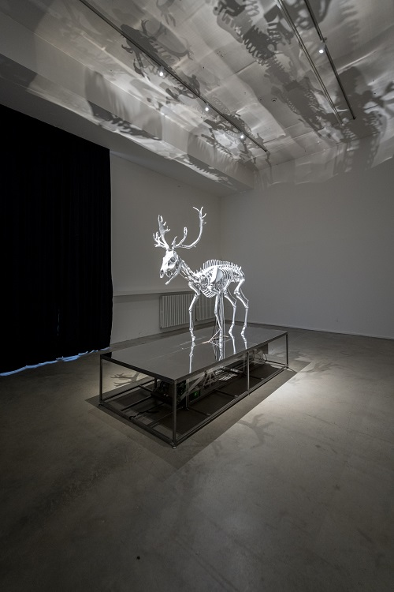
↑ Mat Collishaw, Insilico, 2023. Foto Jan Slavík ©DOX

Rowynn Dumont
Within the concealed passages of Manhattan’s convoluted veins, a forgotten valise emerges, unravelling its cryptic contents like a dream infused with the evocative essence of an enigmatic literary figure. The discovered photographs in the sunken valise serve as relics from this fantastical pilgrimage. Countenances shrouded in enigma, expressions pregnant with the ineffable, and landscapes transcending the mundane—they bear witness to Kafka’s ephemeral sojourn through the labyrinthine alleyways and boulevards of New York. The portraits within the sunken valise capture these ephemeral moments, frozen fragments that defy the linear constraints of temporal reality.

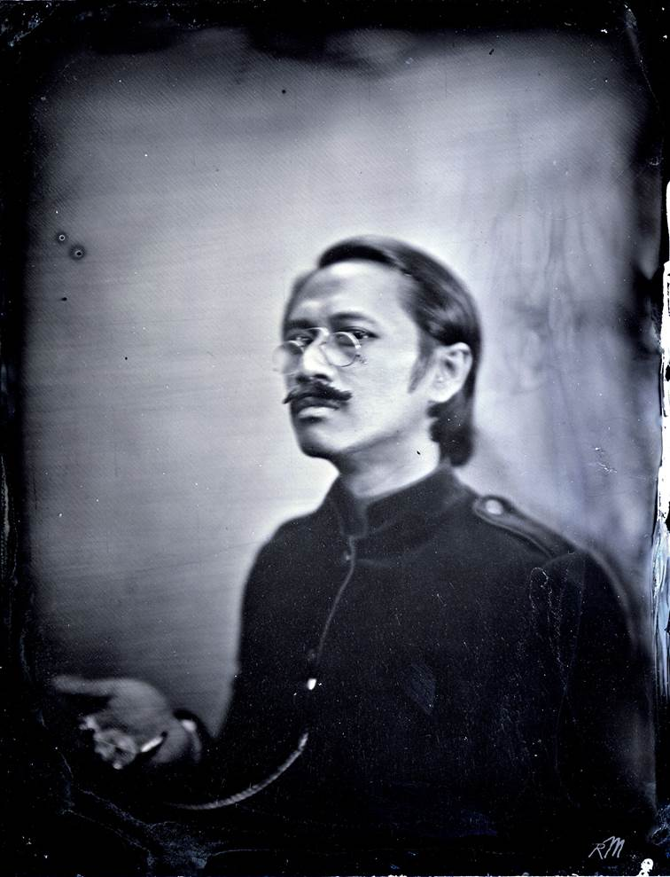
↑ Rowynn Dumont, Yakuza in Gotham, Type Portrait of Lotus Josephine, 2009–2014

Martin Gerboc
Kafka is not a surrealist but a pragmatist who discovered that the necessity of an attitude towards reality inevitably results in alienation, and that the only principle of not succumbing to the disillusionment of one’s own misunderstanding is to maintain asceticism in the form of silence. But this silence is neither resignation nor regret for one’s own unclassifiability. It is, on the contrary, the culmination of imagination beyond the limits of the imaginable. In an internment dictated by provisionality, futility, the anonymity of power, and the painful presence of fear, isolation is the only freedom. But with silence comes visions and demons. And if Artaud screams, Kafka is equally silent.
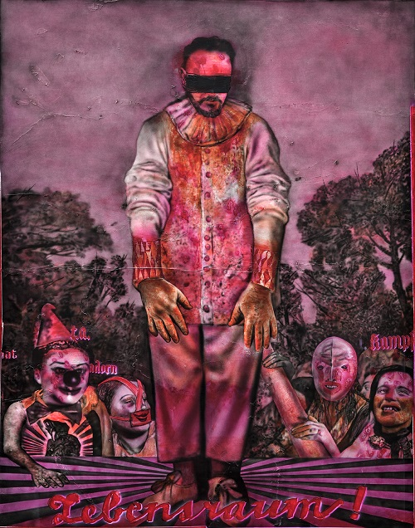
↑ Martin Gerboc, The World without Me, 2019–2020

Gottfried Helnwein
I finally got it.
Kafka is the ultimate Realist.
It took me a lifetime to fully understand that Kafka’s “Prozess” and “Das Schloss” are just painstakingly honest and sober reports of the world I live in.
All the other tales of the matrix are simply illusions.
Or dreams within dreams, as Poe put it.
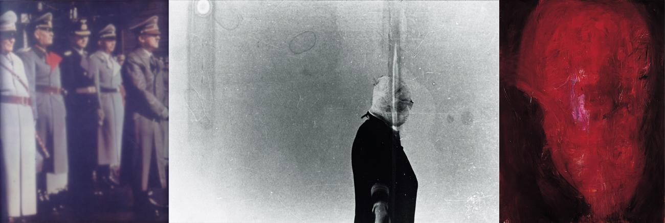
↑ Gottfried Helnwein, Der Beweis, 1986

Siegfried Herz
In the Kafkaesque exhibition, I’m dealing with Kafka’s ‘Letter to His Father’ and the portraits of his family, so it was important for me to stick to the surviving photographs, which are few and far between. Since the content of the whole letter corresponds magically with my own experience, I decided to project it into these portraits. So, I looked for a photograph whose emotional content I could most easily connect to. I chose a more unfamiliar one, in which Kafka looks somewhat “lost”. However, this was by no means an attempt to paint over the photograph, but rather to realign it, to transform it, to stretch it, to deform it, to charge it and to infuse it with blood.
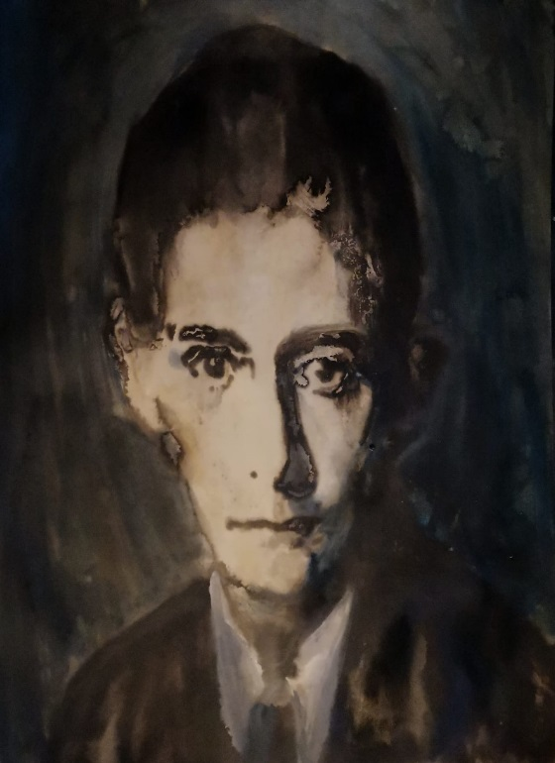
↑ Siegfried Herz, Franz Kafka, 2023

Nil and Karin Romano
Like in Kafka’s works, the protagonists in the paintings of the Romano twins are unwillingly cast into a “labyrinthus”. The lack of proportions, and the distorted and deceptive dimensionality in their paintings leave a strong impression of a directionless limbo. In the absence of space, boundaries, and directions, one would expect to find freedom of any kind of restraint in the Romanos’ paintings. However, in a Kafkaesque irony, it is precisely in the absence of boundaries that all figures seem trapped in their own bodies or lost in space.
The humanlike figures in the Romanos’ paintings go through a continuous metamorphosis which doesn’t necessarily lead them into a state of being helplessly stuck or socially alienated.

Based on their mystical twin bond that is clearly reflected in their paintings, Nil & Karin Romano show that sometimes out of a gesture, out of rituality, or out of physical intimacy, the lonely person can find comfort in rare moments of human connection that is beyond words.
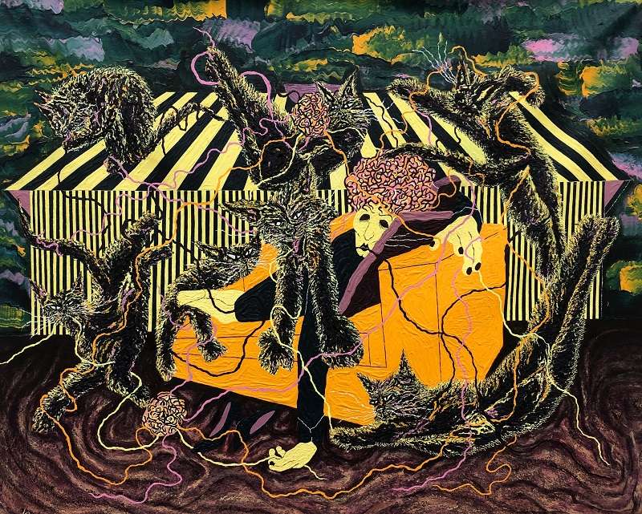
↑ Nil a Karin Romano, The Chaos Within, 2023

Jaroslav Róna
I was introduced to Franz Kafka in three waves. First as an eighteen-year-old curious about so-called “forbidden literature”. Later, as the art director for the film Amerika when I was 34 years old. I tried my hardest to break into his work in 2000, when I was 43 years old, I designed his Prague memorial, and strangely enough, I won the competition. I believed that Kafka helped me because I have a studio in the New Jewish Cemetery, where Kafka is buried, and we have been neighbours since 1980. I wanted his memorial to be the same as his poetics, that is, somewhat scary and absurdly humorous at the same time. Since then, I’ve actually been reading his texts continuously - even if only randomly, depending on my mood, when I need to filter out of the real world and into the world of strangeness, you could also say – bizarre reality. And so, Kafka appears to me from time to time in drawings and paintings, and has become a bit part of myself, which of course threatens all sensitive artists who are imbued with Prague, that cruel mistress with sharp claws dug into the heart.
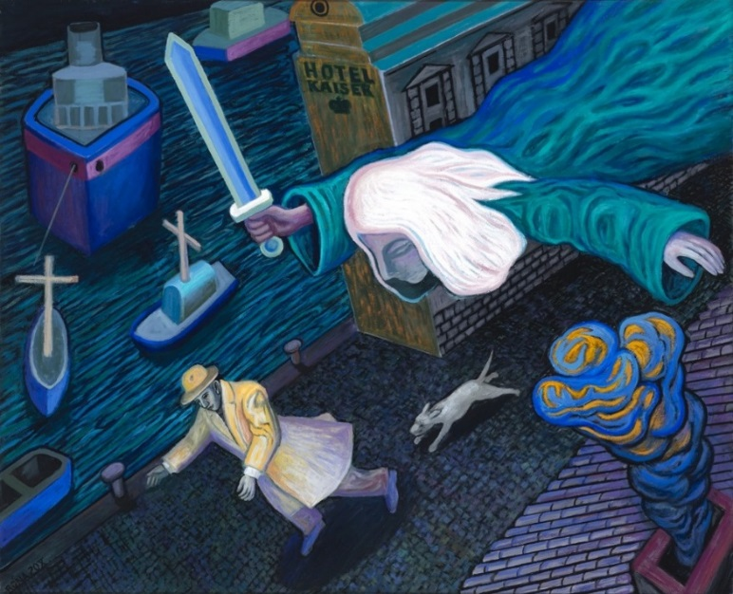
↑ Jaroslav Róna, Kafka in Trieste, 2020

Johan Tahon
In my Kafka-inspired sculptures, I aim to confront the surrealism of his life as a writer with the formal surrealism in my visual art. I was particularly touched by Kafka’s ‘Letter to His Father,’ a father who was strong and authoritarian, or everything that his vulnerable son was not. Perhaps it was this troubled relationship that led Kafka to waver between the brutal reality imposed on him by society and his private world, where he could be himself, writing at night in great solitude. Writing meant living on the edge of society for a brief moment, only to return to the social circle again and again, without being able to share what mattered to him most. This gap made Kafka fear that his work was too fragile for the mundane and too intimate to survive after his death. It is very fortunate that his world-class literature has nevertheless been preserved.
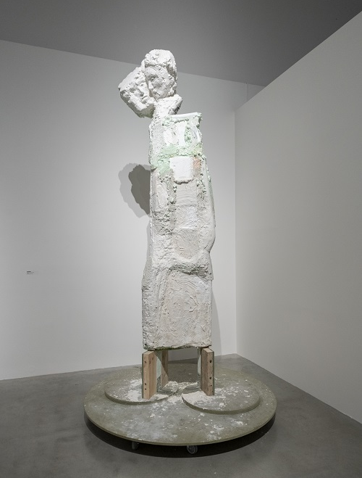
↑ Johan Tahon, Dvojitý Kafka aneb otec, 2023. Foto Jan Slavík ©DOX

Maciej Toporowicz
What resonates in me most about Kafka came to me as a synchronicity when I tried to deal with my own questions regarding life and art. There is no other artist who showed so well the failure of logical and empirical ego driven methods of quantifying human experience. His acceptance of unhappiness and isolation as a form of gift and punishment at the same time. His struggle to reconcile the demands of the inner and outer world. Those of us who stepped as artists into the path traversed before by Kafka are familiar with various degrees of possession, anxiety, and isolation. He is my hero - he sacrificed his personal life and relationships to fulfil his destiny as an artist.
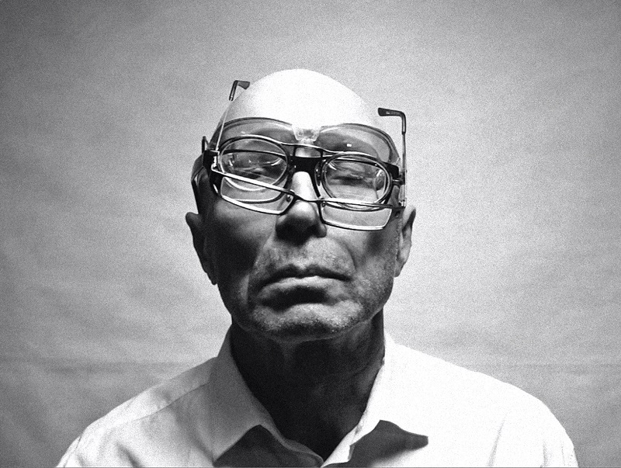
↑ Maciej Toporowicz, Metamorphosis, undated

