Viktor Karlík’s LITERATURE – sculptures and objects from the eponymous cycle exhibited for the first time in Prague DOX

In the LITERATURE exhibition, painter, graphic artist and sculptor Viktor Karlík, considered the most prominent visual artist of the so-called second generation of the Czech Underground, also co-founder and editor of prestigious cultural magazine Revolver Revue, presents sculptures, objects and actions from the his eponymous series. Visitors of the DOX Centre for Contemporary Art will have the first opportunity to see them all together in their original material form, the exhibition comes after they have been introduced in an acclaimed book.
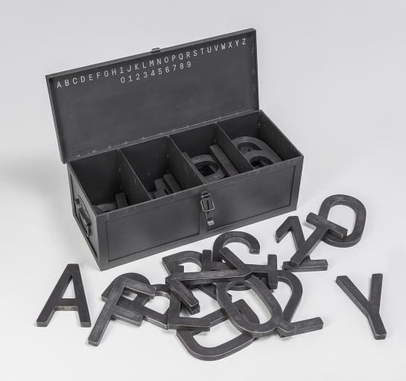
↑ Viktor Karlík: Iron ABC. 2018, iron, 22 × 65 × 27 cm. Photo Ondřej Přibyl.
“Iron ABC. When the box is filled with all the letterforms, it is impossible to lift it just with your hands. The older I get, the more I understand the meaning of prayer. When you feel the letters of the alphabet as separate three-dimensional objects, what you touch is what words are made of. Taking the letter A in your left hand and the letter Z in your right hand can mean holding the beginning and the end of the system on which our culture stands. (…)” – From Viktor Karlík’s description
Viktor Karlík’s exhibition LITERATURE brings an almost complete set of works, which he published in the book of the same name (published by Revolver Revue, 2019), nominated in the competition for the Most Beautiful Book of the Year. The exhibited spatial works were created in 2012–2019 and are complemented by the more than three-meter-long Básník building from 2021. Sculptures, reliefs, lights and other objects and events reflect Karlík’s reader’s interests, focus on specific authors and titles.

“The impetus for this series was my relationship to specific authors, their works, their repeated reading. Often also the great happiness of knowing that such good texts exist. It may have started as private monuments of some sort,” says Viktor Karlík. However, what he has created isn’t simply a respectful tribute to selected literary personalities, Karlík’s polemical and critical spirit and detailed knowledge of the given authors, their destinies and works is key to the whole project.

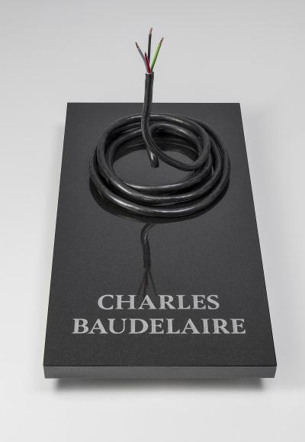
↑ Viktor Karlík: Baudelaire (tombstone). 2018, granite, electric cable, 54 × 50 × 100 cm. Photo Ondřej Přibyl.
„Charles Baudelaire. Flowers on a tombstone can be an expression of our respect for the dead. The colors of the cable’s bared ends can evoke a flower. Four internal veins, four sharp pistils. However, its coiled stem is more like a snake stetching through a hole in the granite block. We do not know how deep lies the end of the animal. (…)” – From Viktor Karlík’s description

He is reflecting on literature through iron, bronze, wood, cast iron, brass, resin, plaster, concrete and other materials. Viktor Karlík has devoted more than a hundred objects to his literary preferences, not only to individual personalities (Baudelaire, Poe, Rimbaud, Dostoevsky, Conrad, Nietzsche, Musil, Kafka, Orwell, Céline, Beckett, Gombrowicz, Sorokin, etc.), but also to movements and styles as well as to more general questions, including to several fateful moments and attributes of Czech culture.

Viktor Karlík is transforming and condensing literary content into an art form that acts on us in a way that is surprising and at the same time unpretentious and seemingly matter-of-fact. Ambiguity, irony and a Dada spirit alternate in LITERATURE with unquestionable and authoritative concepts, and the viewer remains amazed at how Karlík manages to grasp the contents and messages of such a diverse array of literary luminaries, currents and problems with such reduced three dimensional means.

Connecting words and images, the LITERATURE exhibition is in unison with one the important program lines of the DOX Centre for Contemporary Art, symbolized by its Gulliver Airship: the zones where literature and fine arts overlap. ←

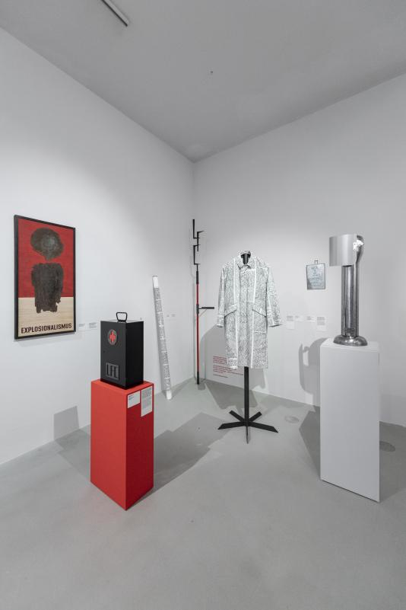
↑ A view of the exhibition. Photo Jan Slavík, © DOX
Viktor Karlík (born March, 1962 in Prague) is a visual artist, graphic designer and editor. After he graduated from Prague’s Graphic School in 1981, he worked in the depository of the Oriental Collection of the Czech National Gallery. In the years 1984–1985, he was the editor of the illegal (samizdat) series Edice Pro více; in 1985, he cofounded the illegal journal Jednou nohou / Revolver Revue, in which he has been working to this day. He was a founding member of the alternative rock group Národní třída (1982–1986). In 1989, he was one of the founders of the Independent Press Center and, subsequently, the weekly Respekt. He also works as a graphic designer and illustrator (having illustrated, among others, books by Zbyněk Hejda, Jáchym Topol, J. H. Krchovský).

By the late 1980s, he had exhibited his paintings and sculptures in private apartments and venues; the first exhibition that was officially open to the general public was held in Prague’s Junior Club at Chmelnice in May 1989. Since 1990, he has exhibited in the Czech Republic and abroad; his work is included in public collections, including the National Gallery in Prague or the Gallery of West Bohemia in Pilsen, and numerous private collections, both Czech and international.

He often arranges his work in cycles, such as the monotype series Manhole Covers, 1988–1992; found objects on plywood, 1991–1994; oil paintings Nature Morte, 1995–1996; Center–Periphery series, since 1999; linocuts Black Works, 2000–2004; serigraphs on plywood, 2001–2002; bronze sculptures and reliefs, since 2003; Typographics series, i.e. quotes or statements executed as linocuts or silk-screen printing, since 2004; Voices from the Underground, cast iron manhole covers inscribed with poems, 2013. He designed the bronze plaque commemorating the rock musician Milan “Mejla” Hlavsa (2005), the bronze award for the Jihlava documentary film festival (2006–2018) or the memorial Jan Hanč Path (inaugurated in Pilsen in 2016).

His books – such as Katalog (2001); Černé práce / Black Works (2004); Hands of Poets (2005, 2nd expanded edition 2015); Světla města / The City Lights / Les Lumières de la ville / 1990–2010 (2010), Podzemní práce (Zpětný deník) / Underground Work (Retroactive Diary) (2012) or LITERATURA/LITERATURE (2019) – offer reproductions of his paintings, drawings, sculptures etc., often accompanied by the author’s comments that range between explanatory notes, reminiscences and aphorisms.

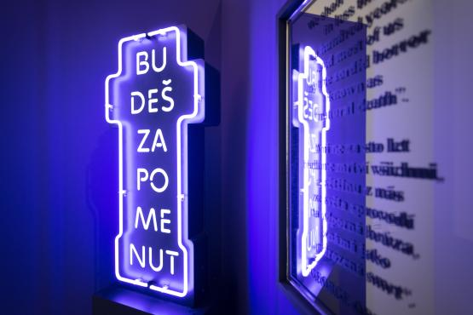
↑ A view of the exhibition. Photo Jan Slavík, © DOX

Viktor Karlík: LITERATURE
Sculptures and objects, 2012–2021
17. 9. 2021 – 9. 1. 2022

Curator: Magdalena Juříková
Exhibition design: Natálie Najbrtová
Graphic design: Josefina Karlíková

Exhibition partner: Revolver Revue

You can find the current program of the DOX Centre for Contemporary Art on the website www.dox.cz
The Press release and photographs can be downloaded after signing up in the section Press

Contact
Hana Janišová
DOX Centre for Contemporary Art
Poupětova 1, Prague 7
E hana.janisova@dox.cz

