**“Evil and poetry are incompatible,” says artist Viktor Pivovarov. DOX presents his thoughts imprinted in paintings in the exhibition *Metaphysics and Despair*.**

***Metaphysics and Despair* features the thoughts, inspiration, and insight of Viktor Pivovarov (b. 1937), a legend of the Czech art scene, which he first entered in the 1980s. The exhibition presents the artist’s works from recent years, accompanied by an album he created in 2005. All of the works are having their exhibition premiere at DOX. A total of 54 paintings, 6 drawings, and an album with 22 sheets were selected by curator Máša Pivovarová and the artist for the specific space of the DOX gallery.**

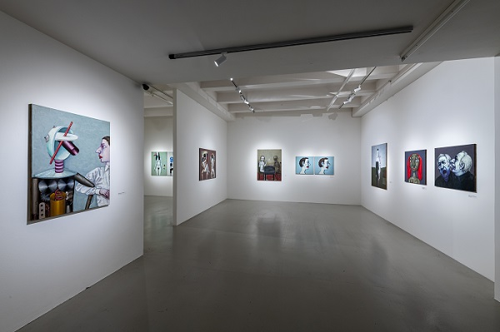

↑ Exhibition view of *Viktor Pivovarov: Metaphysics and Despair*, photo: Jan Slavík © DOX

The exhibition is introduced by the album *To the Philosopher, Letter no. 3*, for which Pivovarov used a booklet created by Daniil Kharms in 1937 (incidentally, the same year the artist himself was born) and reworked it into the specific art form of an album. As was typical of Kharms, the booklet combines absurd humour with serious themes. It deals with what happens to a person if they give in to their basest instincts.

“In the booklet Kharms elaborates on the symbolism of individual colours and deals with the processes of the rise, fall, and destruction of the human soul. Viktor Pivovarov created drawings related to Kharms’s symbolism of colours especially for the exhibition at DOX. The viewer is then led into luminous white halls where the 2024 series *Poets and Muses* is presented,” says curator Máša Pivovarová.

A large number of the exhibited paintings are from the series *Poets and Muses*, which corresponds to a period when Pivovarov was actually surrounded by muses and wrote a collection of poems. “Last March, to my great surprise, I wrote a series of poems. No, in truth, I didn’t write them. The Muse simply flew in and dictated the poems to me. Basically, every day at least one new poem was born. And then the Muse flew away. I decided to thank her for this gift, so I dedicated my series of paintings *Poets and Muses* to her. It has 45 paintings, and almost all of them are on display in the exhibition,” adds Viktor Pivovarov.

**This somewhat autobiographical series presents various forms and paths of inspiration and depicts all the possible hardships and joys associated with the creation of a work of art, be it literary or visual. With insight and specific humour, it shows how complex the birth of these uplifting metaphysical works is and what kind of mental and physical anguish it involves.**

Máša Pivovarová adds that the muse can take many forms – she does not only appear to the artist as a beautiful woman but also takes the guise of various demonic beings.

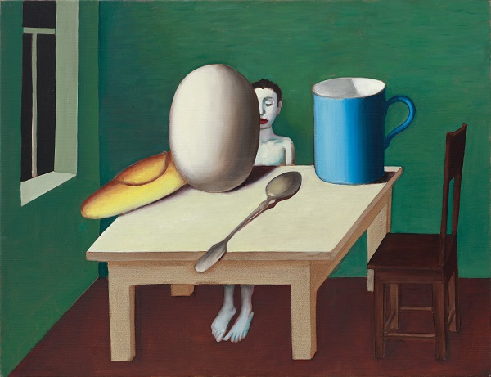

↑ Viktor Pivovarov, *Poet and Objects*, 2024 © Martin Polák

At the end of the exhibition the artist returns to Daniil Kharms. The series *Metaphysics and Despair*, from which the entire exhibition gets its title, once again portrays what happens when our basest instincts such as greed, hatred, and anger take over – it can even lead to war. The paintings include real newspaper excerpts chronicling the horrors of the war in Ukraine. It’s as if the metaphysical paintings are unrelated to the texts, begging the question of whether it is even possible to write poems or paint pictures against the backdrop of these horrific events.

“The war in Ukraine has caused enormous human suffering. I am not a political artist, but I couldn’t help but react to this sea of suffering. The 14 paintings entitled *Metaphysics and Despair* are a diary of 14 days of war. It is a chronicle of the sacrifices made during those 14 days. A chronicle of the victims cannot share the same space as a metaphysical painting. Evil and poetry are incompatible. The artist-poet has no power to stop the evil. The answer: despair,” concludes Pivovarov.

**Exhibition curator: Máša Pivovarová**

**Viktor Pivovarov (b. 14 January 1937, Moscow) studied illustration and book design at the Moscow Polygraphic Institute. Since the 1970s he has focused primarily on free creation, working in comprehensive pictorial cycles. Together with Ilya Kabakov he created the distinctive art form of the album, which combines word and image in an original way. Pivovarov also incorporates text into his pictorial cycles or sometimes creates purely textual paintings. He thus became one of the founders of the Moscow conceptualist movement.**

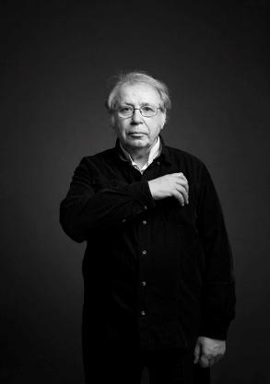**Since 1982 he has lived in Prague, where, thanks to both his wife Milena Slavická and Jindřich Chalupecký, he found himself in a similar artistic environment to that of Moscow – that is, the environment of unofficial artists. He became a member of Nová skupina (The New Group), and after the revolution, together with Adriena Šimotová, Václav Stratil, and Milena Slavická, he established and managed the gallery Pi-Pi-Art, which was located in the basement of the Topič Salon on Národní třída in Prague. He also contributed to the design and concept of the magazine *Výtvarné umění* (Fine Art).**

**He has had major solo exhibitions at Galerie Rudolfinum (1996), the National Gallery Prague (2021), the House of Arts in Brno (2022), IFA in Berlin (2001), and the Moscow Museum of Modern Art (2006 and 2011). His works are held in renowned galleries around the world (Tate in London, Centre Pompidou in Paris) as well as private collections.**

↑ Viktor Pivovarov, photo: Václav Jirásek

**Viktor Pivovarov: Metaphysics and Despair**

**15. 5. – 5. 10. 2025**

DOX Centre for Contemporary Art

Poupětova 1, Prague 7

The press release and photographs can be downloaded after registering in the [Press Section](https://www.dox.cz/users_area/register) of our website.

Contact

**Karolína Kočí**

E [karolina.koci@dox.cz](mailto:karolina.koci@dox.cz)

T +420 777 870 219