FAUST is all of us. DOX presents Radka Bodzewicz’s new painting cycle inspired by Goethe’s most famous work.
What pushes us beyond the boundaries of the possible? Is it a thirst for knowledge, love, power, or success? The desire transcend our own limitations? The FAUST exhibition at the DOX Centre for Contemporary Art presents an extensive new series of paintings by Radka Bodzewicz, inspired by one of the most significant works of world literature – Goethe’s Faust. This tale of a scholar who sells his soul to the devil serves as the starting point for the artist’s exploration of universal human archetypes and the forces that shape our decisions, ambitions, and destinies.
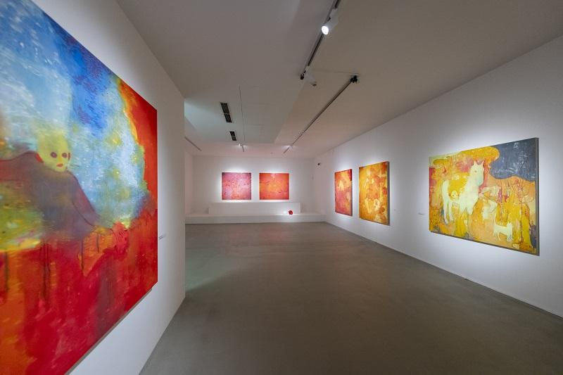
Radka Bodzewicz has long drawn inspiration from literature, philosophy, and mythology. Her previous projects have dealt with, for example, Dante’s The Divine Comedy, Milton’s Paradise Lost, or Eliade’s The Myth of the Eternal Return. She translates these canonical texts into a contemporary visual language through extensive series of paintings, in which she often combines classical techniques with technological experiments and new media.

In the exhibition FAUST, the artist turns her focus to the legendary story of a man who makes a pact with Mephistopheles in exchange for knowledge, power, and the fulfilment of his desires. For Radka Bodzewicz, however, Faust does not represent a specific literary character – rather, he is a symbol of all of us.
The artist interprets the story of Doctor Faust as an expression of the Jungian principle of the archetypes of human desire, which are the motivation, driving force, and architect of our destinies. “I primarily focus on updating literary works that I consider timeless and relevant to people’s daily lives. For me, Faust is one of those stories that speaks to people regardless of nationality, time, or place. In my opinion, it is just as relevant today as it was when it was first written,” says Radka Bodzewicz.
“The exhibition does not follow the linear narrative of the Faustian legend, nor are the individual works meant to be its illustrations. Each of the three floors of the exhibition space is dedicated to one of the story’s central characters, who represent three archetypal forces: Mephistopheles (Shadow), Margaret (Anima), and Faust (Seeker, Ego). At the same time, they can be viewed as three parts of a single psyche, perhaps our own,” explains curator Michaela Šilpochová.
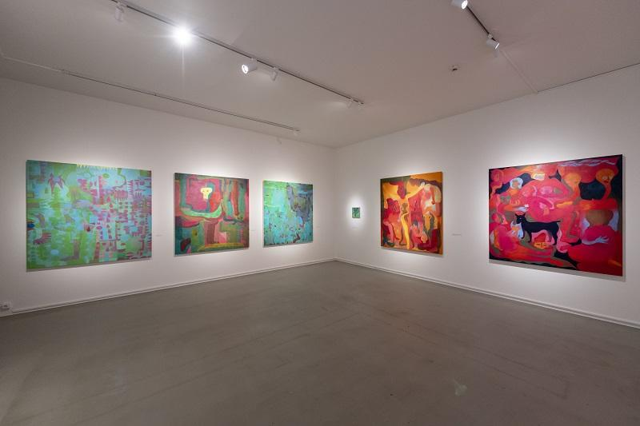
Although Radka Bodzewicz has long experimented with virtual reality, holographic imagery, and 3D printing in her work, for the FAUST exhibition she has decided to set aside most technological elements and focus her attention primarily on the painting itself, its visual power, and its dialogue with the literary source material.

“New technologies have interested me for a long time, but at the same time, they have their limitations. In the FAUST exhibition, however, these technologies are minimised as much as possible. Although I do work with 3D printing here, I’ve set everything else aside in favour of traditional painting. This time, viewers can put away their phones and let themselves be carried away by the image, the colour, the meaning, and the excerpts from the literary work,” says the artist.
The FAUST exhibition is one of Radka Bodzewicz’s most ambitious projects to date. Through twenty monumental paintings and five objects made between 2025 and 2026, she has created an evocative space in which the literary source material is transformed into an existential statement about humanity and our desires, doubts, and responsibility for our own choices.
Bodzewicz’s paintings touch on themes that are just as relevant today as they were in Goethe’s time, and she turns the Faustian motif into a metaphor for the modern human.
“In the universal conflict between good and evil, Radka Bodzewicz’s rendition of Faust embodies our own stories of an endless thirst for knowledge, love, and power and our desire to transcend the boundaries of what is possible – tales of the fatefulness and irreversibility of our own decisions, our own pacts with the devil,” adds the curator.
Curator: Michaela Šilpochová

The exhibition will run from 19 June to 8 November 2026.

RADKA BODZEWICZ (1991) studied at the Academy of Fine Arts in Prague in the studios of Vladimír Kokolia (Printmaking 2) and Jindřich Zeithamml (Sculpture 2), graduating in 2017. During her studies she participated in an exchange programme at Gray’s School of Art at Robert Gordon University in Aberdeen (2016), and in 2018 she was a finalist for the Leinemann-Stiftung für Bildung und Kunst Award. Her work is deeply influenced by her interest in literary and philosophical texts, whose themes she develops into monumental painting series while expanding classical artistic techniques through new technologies (virtual reality, holographic imagery, and 3D printing). Her work has been featured in numerous solo exhibitions in the Czech Republic and abroad.

DOX Centre for Contemporary Art
Poupětova 1, Prague 7
Open: Tue–Sun, 11:00 a.m.–7:00 p.m.

The press release and photographs can be downloaded after registering in the Press section of our website.

Photos of the exhibition: Jan Slavík

Contact
Karolína Kočí
E karolina.koci@dox.cz
T +420 777 870 219
www.dox.cz

