Mysticism, folklore, and B-horror in The Ritual of Cursed Hearts by Jan Vytiska

Part of the DOX Centre for Contemporary Art has been filled with folklore. An unusual combination? The work of painter Jan Vytiska is saturated with it. In his paintings, he remixes scenes from log-cabin interiors, shepherdesses, and the snowy foothills of the Beskid Mountains with the cruelty and symbols of B-horror films. A decadent painter combining folklore with mysticism, brutality, and philosophy. Works from the last three years are now presented in the exhibition The Ritual of Cursed Hearts.

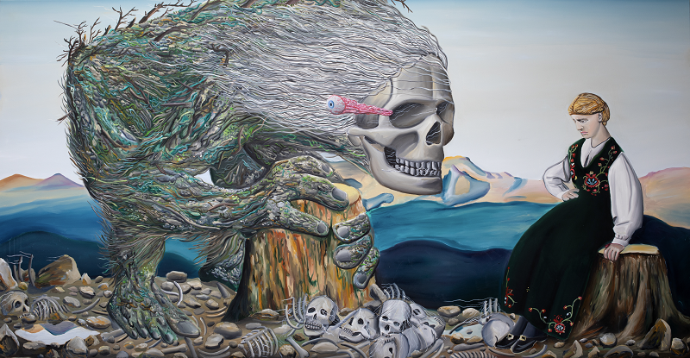
↑ Jan Vytiska, The Sadness, 2022 ©Jan Vytiska

Jan Vytiska himself finds it difficult to classify his work into a particular genre. He is attracted to postmodern magical realism, which blends real experience with illusory elements of dream, myth, folklore, and a touch of pop culture. He exaggeratedly compares his work to turbofolk, a musical genre combining Balkan folklore with synthesizers that resonated through the former Yugoslavia in the 1980s. “In general, I am a fan of folk creativity and naive art, and I am fascinated by the paganism of the Dionysian way of life to which Friedrich Nietzsche refers in his writing. Ultimately, I like how folklore changes and mutates with contemporary pop culture. But folklore is now also the stuff of the 1990s and the 2000s,” comments Jan Vytiska.
Otto M. Urban, head curator of the DOX Centre, became interested in Vytiska’s work 15 years ago. Until then, he had not encountered a similarly curious connection between folklore and pop culture either in the Czech Republic or abroad: “He was ahead of his time in taking up the subject of folklore. Moreover, he connected it with the aesthetics of B-horror films, music, and pop culture in general. His work is always instantly recognisable. I was intrigued by what’s behind it, because unless the principle he uses - that is, combining apparent opposites - has some deeper basis, it’s superficial and can only be sustained for a season or two. But Jan Vytiska is constantly moving into new territories within his subject matter, both in content and form. This makes him a unique figure not only on our scene, but also on the international one.”

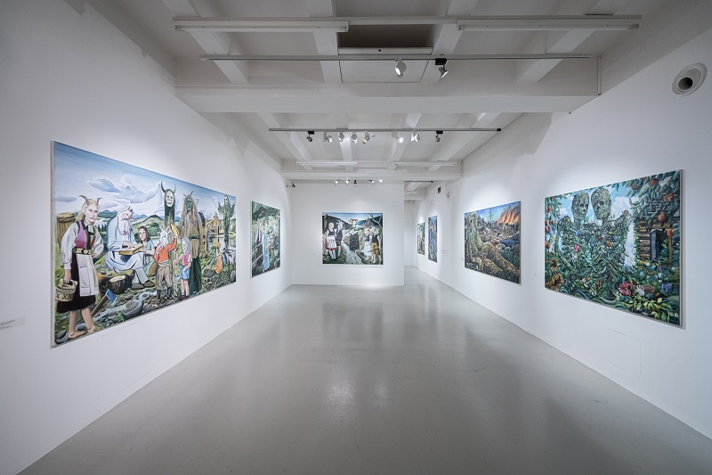
↑ A look inside the exhibition The Ritual of Cursed Hearts, photo: Jan Slavík

Thematically, Vytiska is still based on a distinctive mix of Wallachian folklore and pop culture references. This is not a return to a tried and tested theme, however, but a new take on it and an expansion of its meaning. This is not a return to a tried and tested theme, however, but a new take on it and an expansion of its meaning. Landscapes appear more and more in recent paintings, and mountain ranges or flowering meadows contrast with the scene for which they form the framework. Nevertheless, the artist continues to mix all kinds of references into his own romantic gesture.
“The most important thing for me is the story and the atmosphere that a given painting is meant to convey. Widescreen films are a big inspiration for me - I used to paint only in these formats, now I use a squarer format. I also have a collection of quirky images from the internet involving folkloric masks, interiors, and various creatures, which I call “google archaeology”. I like to listen to audiobooks while I paint. I listened to over thirty of them last year and the result is all the things I mentioned mixed together into a postmodern collage. It’s impossible to define exactly what is the exclusive and given inspiration. It’s more of a snowball formed out of one genre that then avalanches down on the small-town folks.”

Vytiska last exhibited independently in Prague six years ago. In terms of scope, the exhibition at the DOX Centre is the artist’s largest project ever. It presents almost forty large-format paintings created by the artist after he switched from acrylic to oil paint. The painter decided to take advantage of the generosity of the DOX Centre’s space, and, over the last three years, he began painting on two-metre canvases. Four of the exhibited paintings are even three-metre-long landscapes. “Together with curator Otto M. Urban, we have basically created a story dividing the exhibition into three segments. The first is a village in a valley where one should never or would never want to wander. These are group scenes of village life full of horned girls, goats, and other mythological creatures. Then we get into the interiors of the log cabins, the so-called chambers. From them, we get a glimpse of the vantage point to which we shuffle up the mountain hills until we see a monumental vista filled with death and the existential angst of being. For me, mountains produce a sort of feeling of the absolute.”
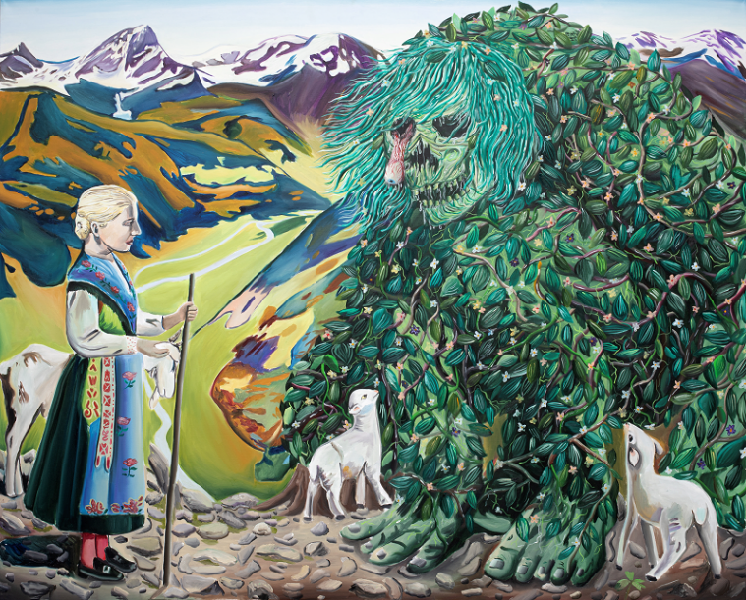
↑ Jan Vytiska, Death and Tenderness, 2022 ©Jan Vytiska
As recognisable and typical as the images of Vytiska are at first sight, their form has also been undergoing a certain development. The artist is constantly experimenting, the colours of the paintings change, and their formats have gradually expanded. In the same way, according to the curator of the exhibition, the content does not follow only one theme. “His works have several layers, and if the viewer is patient and interested enough, suddenly behind that colourful, bright surface they can discover very fundamental questions of a philosophical and social nature, a relationship to history and so on, so that suddenly what at first glance seems like a colourful joke turns out to be a very serious and thoughtful concept of perceiving the world around us. It connects the high with the low, pop culture with philosophy,” says Otto M. Urban.
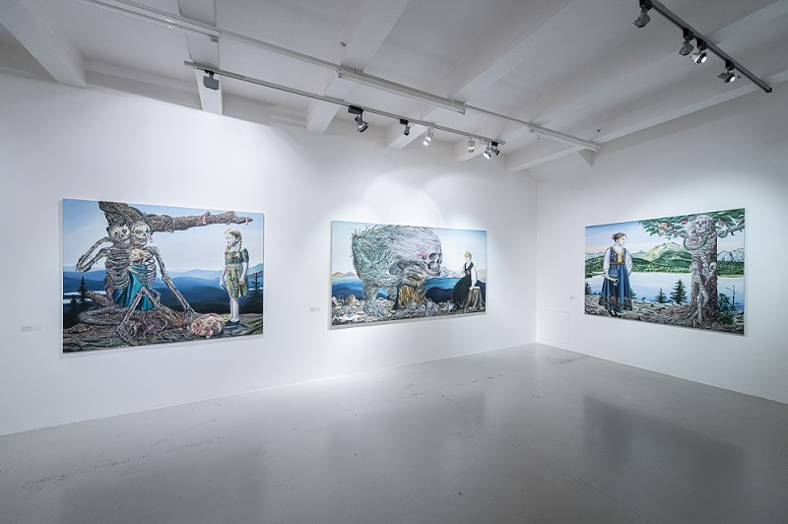
↑ A look inside the exhibition The Ritual of Cursed Hearts, photo: Jan Slavík

It may be interesting that Vytiska reflects specific folkloric creatures from Wallachia in his work. The so-called “Promise”, for example, a girl who broke a promise to her lover. After her death, she turned into a woman dressed in white, walking the mountains and luring men. “What can she do to you? At best, she’ll grab you and dance with you through the woods, through clearings, thickets, thorns, roots, potholes and stumps until there’s not a single piece of skin left on your feet without blood; at worst, she’ll beat you to death,” the artist adds. In the past, Mora has also appeared in his paintings - most often a woman who transforms into a cat or plants at night and sets out to suck blood from people’s breasts; she can also harm animals and trees. A child who is born with teeth usually becomes a Mora.

Jan Vytiska
Jan Vytiska was born in 1985 in Prague, but grew up in Rožnov pod Radhoštěm, a small town in the Vsetín district of the Zlín region, where he was influenced by west-Beskid folklore. He refers to himself as a Rožnovian. Already at the Elementary School, his artworks were characterised by a distinct brutality. However, it was not until after his university studies that he began to paint professionally. First, he studied sculpture with Jaroslav Koléšek at the Applied Arts Secondary Vocational School of Glassmaking in Valašské Meziříčí, then he studied new media with Jiří Surůvka at the University of Ostrava. Jan Vytiska drew attention to himself during his studies, he was nominated by the university for the international competition of the best graduates of art faculties StartPoint. In 2011, he won the UniCredit Bank Prague Photo Young Award for artists under 30 at the Art Prague contemporary art fair, and the following year he was selected as a finalist for the Critics’ Prize for Young Painting.
His typical and always recognizable work is based on a distinctive mix of Wallachian folklore and pop culture references. He describes his own work as a post-modern collage of folk mythology, pop culture, surrealism crossing over into magical realism with elements of B-horror. Jan Vytiska has had more than two dozen solo exhibitions, his works have appeared in the exhibition Paradise (2017) at the Trafo Gallery in Prague or in the group exhibition Folklore Is Not Dead (2021) at the Roudnice Gallery. The Ritual of Cursed Hearts at the DOX Centre for Contemporary Art is Vytiska’s largest exhibition project to date.
Curator: Otto M. Urban

The Ritual of Cursed Hearts
April 13 – Sept 10, 2023
DOX Centre for Contemporary Art
Poupětova 1, Prague 7

Press release and photos can be downloaded in the Press section after registration.

Contact:
Karolína Kočí
E karolina.koci@dox.cz
T +420 777 870 219

