Thin Skin: premiere of a movement installation by acrobat Eliška Brtnická
Suspended poles, three acrobats, live electronic music, and the breathlessness of the audience. This is a new performance by the established circus acrobat Eliška Brtnická at the DOX Centre for Contemporary Art. The title Thin Skin is based on the English term thin-skinned, which refers to hypersensitivity, but also vulnerability.
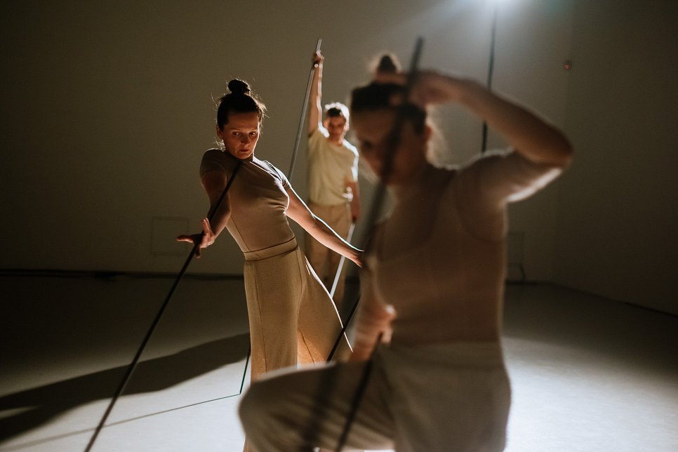

↑ Thin Skin, photo: Jan Hromádko

The author Eliška Brtnická explains the title further: “The poles answer us, we answer them. We have to be strongly connected to each other and also be in a way sensitive to the poles, because when we are not, they can bend. It’s all about the centre of gravity. The performers have to constantly be aware of how much the pole or they themselves are leaning, whether the movement is moving too far from the centre of gravity and therefore becoming unstable.”

The performances of the established circus acrobat Eliška Brtnická are characterised by techniques that are more common in contemporary foreign circus than on the domestic scene. Moreover, her work is characterised by distinctive artistic elements. In her performance Thin Skin, the artist searches for original forms of the suspended trapeze, ones that open up new possibilities for the movement of the human body, which together create a unique atmosphere and bring an intense, visual experience.

“The trapeze here is conceived more as an art object or a sculpture of some kind. It definitely has more space than the movement itself. We don't even call them trapezes anymore, they are more like long, three-metre-long poles, which are more important in the performance than we are," laughs Eliška Brtnická.

In Thin Skin, the acrobats create kinetic installations of “levitating” thin poles and human bodies. The body and the material - two elements in one space whose existence depends on each other. In the performance, three performers (Eliška Brtnická, Alžběta Tichá, Filip Zahradnický) thoroughly test their centre of gravity and the centre of gravity of the poles.

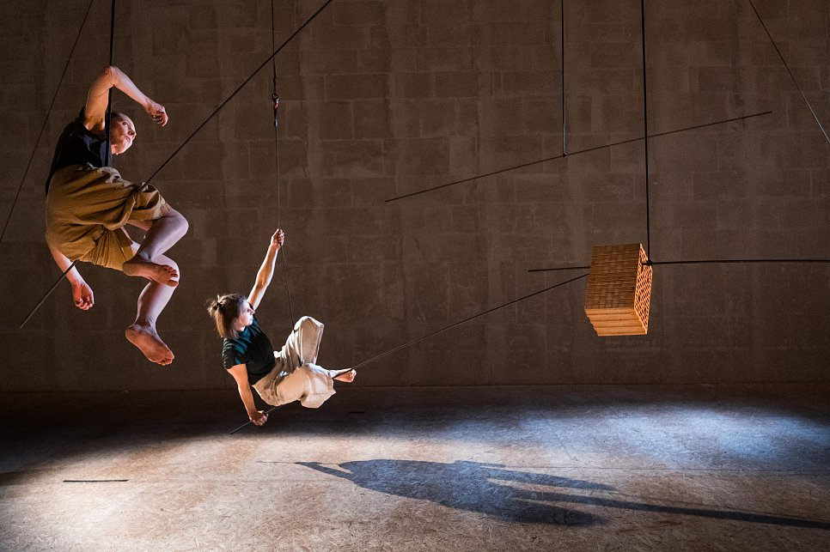
↑ Thin Skin, photo: Jan Hromádko

The author deliberately approached performers for the project whom she felt were interested in artistic research. “Alžběta is an aerial acrobat like me, and Filip is a juggler. I invited him to the project precisely because he works with different objects. Since we are prioritizing the object here, I thought it was interesting to approach someone else who is used to manipulating these objects a little differently than us acrobats.”

Viliam Dočolomanský, Program Director of Live Art at the DOX Centre, explains that DOX's performing arts dramaturgy focuses on supporting artists who have or are searching for an unmistakable scenic language, often at the intersection of different art forms or genres. “Such is the case with Thin Skin, a work at the intersection of visual installation and contemporary circus. Together with other performers, Eliška Brtnická creates fragile images that seem to flow outside of time in the precarious situation of a body at the mercy of unstable material. She does not fight, but gently and concentratedly accepts the limits of reality. She gives us the space to immerse ourselves in a meditative and unobtrusive atmosphere outside the distraction and aggression of our time. DOX, as the main co-producer of the production, will regularly present it in the impressive spaces of the gallery auditorium.”

In collaboration with the DOX Centre for Contemporary Art and in its impressive spaces, a hypnotic production was created on the border between movement installation and contemporary circus, where everything is a cruel question of time. The moving sculptures disappear as quickly as they appeared. The body imprints itself in matter, the image in the mind, time bends. Thin Skin is fragility, vulnerability, instability.

Premieres:
October 23 and 24, 2022 at 7 p.m.
DOX Centre for Contemporary Art Auditorium
Poupětova 1, Prague 7
Performers:

Eliška Brtnická is a performer, choreographer, dramaturge, and director. She graduated in Non-verbal Theatre from HAMU in Prague, where she completed her PhD studies in 2018, focusing on contemporary circus. In 2010 she founded the ensemble Cirkus Mlejn, under the name of which she creates her projects. In 2017 she completed a year-long course in circus dramaturgy at the prestigious French circus school CNAC in Châlons-en-Champagne. She has been involved in artistic research in the field of contemporary circus for a long time. She is also the dramaturge of the international festival Fun Fatale.

Alžběta Tichá is an acrobat and performer. She graduated from the Duncan Centre Dance Conservatory in Prague, where she developed her new-circus skills, especially aerial acrobatics, which she subsequently studied at Codarts University in Rotterdam. In addition to performing in international projects, she has also worked as a solo artist. She is the founder and performer of Feel the Universe Circus Company.

Filip Zahradnický is a performer and juggler. He graduated from The Academy of Modern Circus in Copenhagen. He presented his graduation show Vermilion at the Mondial du Cirque de Demain, where he won two awards. He is a member of Circus La Putyka, with whom he performed at the Berlin Chamäleon, has performed in several international projects and is also a solo artist.

Concept and direction: Eliška Brtnická
Choreography and performance: Alžběta Tichá, Filip Zahradnický, Eliška Brtnická
Sound: Stanislav Abrahám, Roman Džačár
Lighting: Martin Špetlík
Costumes: Tereza Kopecká
Set design and choice of material: Prokop Vondruška
Consultation: Ilona Jäntti, Stéphanie N’Duhirahe, Markéta Vacovská, Hana Turečková
Text documentation of the creative process: Kateřina Korychová
Photography: Jan Hromádko
Video: Kryštof Čížek
Producer: Cirkus Mlejn, z. s.
Co-producer: DOX Centre for Contemporary Art
Support: the City of Prague, Ministry of Culture of the Czech Republic
Partners: KD Mlejn, Cirqueon, Diod Jihlava, Metropolis.dk

Press release and photos can be downloaded after registration in the Press section

Download the trailer: https://vimeo.com/doxprague/thin-skin-trailer

Contact:
Karolína Kočí
PR & Media Manager
DOX Centre for Contemporary Art
E karolina.koci@dox.cz
T +420 777 870 219
www.dox.cz

