ULTRASUPERNATURAL by Barbora Šlapetová and Lukáš Rittstein: Two Worlds in a Miraculous Encounter in DOX

Since 1997, Barbora Šlapetová and Lukáš Rittstein have undertaken 11 expeditions to the remote regions of Western Papua and Papua-New Guinea. However, they did not come as researchers conducting an ethnological study but as artists. Through an artistic perspective, they sought to express the miracle of an encounter between two vastly different worlds, divided by a gap in time. For many of those last indigenous peoples, meeting them was the very first encounter with a white man. For Barbora and Lukáš, it was a unique opportunity to draw inspiration from the very souls of these prehistoric people. →

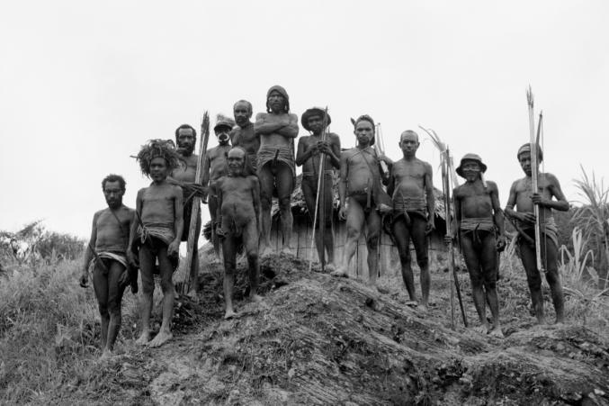
↑ Barbora Šlapetová: Hill. Photo by © Barbora Šlapetová

Ultrasupernatural in the DOX Centre is a culmination of an extremely personal project of two artists, Barbora Šlapetová and Lukáš Rittstein, spanning almost 25 years and based on actual encounters with important Papuan chieftains and tribe members from the Yali Mek and Korowai Batu tribes. Until very recently, the two tribes had lived undisturbed in the jungles of inland Western Papua, untouched by civilization, a living relic of the Stone Age.

“Over those more than twenty years, we have managed to establish a dialog with the tribespeople, and even try to fulfill some of their wishes,” says Lukáš Rittstein. „The Papuan chieftains expressed a wish to meet the greatest Czech chieftain; gain a deeper understanding of who artists are and what they do; or meet those who could fly up to the upper levels of this world, just like their tribal shamans.” And so the Stone Age chieftains met president Vaclav Havel; had their bodies transformed into artworks; and met American astronauts Leroy Chiao and Koichi Wakata.

“ULTRASUPERNATURAL may be a somewhat enigmatic title, but it puts our entire experience into a new context,” explains Barbora Šlapetová. “Ultrasupernatural is sort of a mix of the natural and the supernatural. What is (super)natural for us, may not be (super)natural to the indigenous people, and vice versa. A mobile phone, for example, is something they would find ultrasupernatural,” she adds.

The tribespeople’s jump from the prehistoric age to the twenty-first century, which has forever changed the locals’ lives, is reflected in a vast amount of artworks: Barbora’s photographs, experimental films, sketches and animations, and Lukáš’s sculptures. For the first and last time in the history of humanity, 3D digital technology met the bodies of the last prehistoric people on Earth. In autumn of 2017, Members of the Yali Mek tribe, joined by astronaut Koichi Wakata, were captured by a 3D scanner at a unique moment.

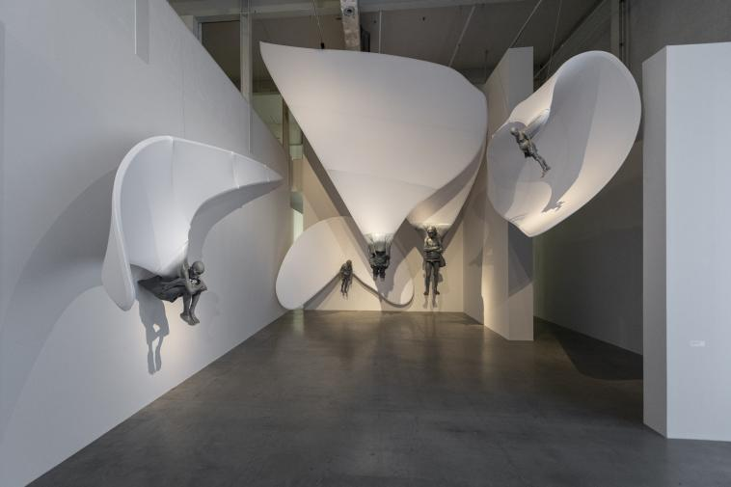
↑ Lukáš Rittstein: Pilots – The Spirit Tree. A glimpse into the exhibition. Photo by © DOX, Jan Slavík

Barbora Šlapetová a Lukáš Rittstein have collaborated with DOX for years. Shortly after the Centre’s opening, the artistic duo presented the first part of their extraordinary project, entitled Manop, The Final First (2009), followed by Everything Is Different in 2015. ←

Barbora Šlapetová (*1973) graduated from the Academy of Fine Arts in Prague in 1997. She also studied in Montreal, and in 2000 she received the prestigious DAAD stipend in Berlin. Her work includes painting, photography, drawing, film, and the written word. She represents NASA in Art projects (since 2008) and cooperates with Black Moon corporation company as a visual art agent for the Moon DNA missions.

Lukáš Rittstein (*1973) graduated from the Academy Fine Art in Prague in 1997, and has headed its sculpture studio since 2013. In 1997 he received the the Jindřich Chalupecký Award. His sculptures have been featured at the Akademie der Kunste in Berlin, at Art Beijing, at the Socrates Sculpture Park and the WTC in New York, and at a solo show at the Albertinum in Dresden. His sculptures can be found both in galleries and as public installations.

Barbora Šlapetová and Lukáš Rittstein represented the Czech Republic at the EXPO 2010 world exhibition in Shanghai, China, and at EXPO 2015 in Milan, Italy. They have also written three books about their expeditions to Papua. In Proč je noc černá (Why The Night Is Black), Nepřistupuj blíž (Do Not Come Any Closer) and Jak se dotknout nebe (How To Touch the Sky), they have recorded the accounts of the indigenous peoples, in a symbolic expedition to the depths of the souls of the last tribes untouched by civilization on this planet. Proč je noc černá won the Magnesia Litera literary award in 2005.

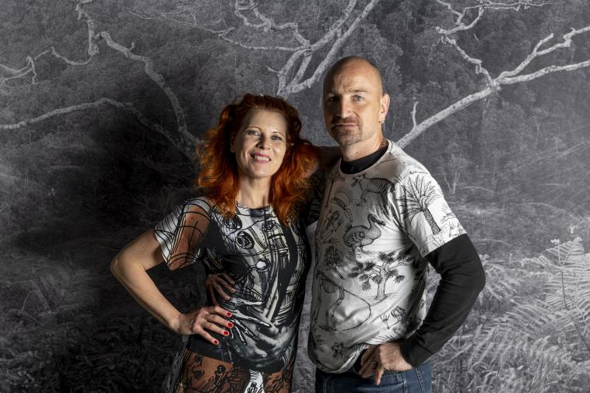
↑ Barbora Šlapetová a Lukáš Rittstein, 2020. Photo by © DOX, Jan Slavík

ULTRASUPERNATURAL
Barbora Šlapetová a Lukáš Rittstein
27. 5. – 12. 10. 2020
curators Leoš Válka, Michaela Šilpochová, Otto M. Urban

DOX Centre for Contemporary Art
Poupětova 1, Prague 7
opening hours from May 27:
Wed–Sun 12 pm to 6 pm, closed on Mondays and Tuesdays

Check out the current program at our new website: www.dox.cz
Press release and photo available for download in the Press section (registration required).

Media contact
Michaela Šilpochová
E michaela@dox.cz
T +420 774 222 355

