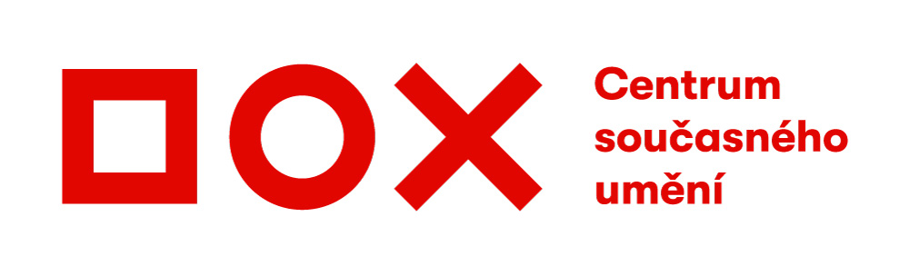

Press Release / 27 June 2019
The ART-BRUT-ALL international art show will feature 42 artists from Georgia to Iceland
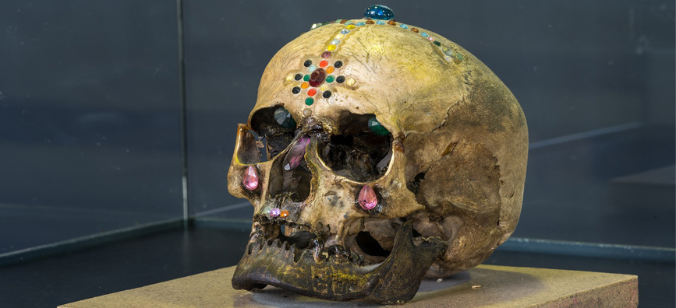

At the DOX Centre for Contemporary Art, the ART-BRUT-ALL international art show will feature the work of artists who accent principles of spontaneous artistic gestures, expressiveness, and politically-involved manifestations.
The name of the exhibition project is a play on words that refers to the Brutal Assault metal festival where it first took place, and the term art brut, which means unschooled art, art in its raw state. "Metal music can be a symbol of redneckery for some; it can also be a lifestyle, an ironic world view, or a means of escape from this world. It is a subcultural sign, connected to a certain generation and aesthetics. Metal has an unmistakable (sometimes even theatrical) visual language. It can be macho, feminist, or pathetic, and in most cases is aggressive and poetic. Metal has avoided all fads and intellectual conceits and countless trends. A pathetic attitude that is free of cynical humour and self-depreciative irony is hard to market. And this is also one of the reasons it remains authentic," says one of the curators, Pavel Forman.
Even though the exhibiting artists are mostly unschooled, they work with elementary art expression, form, and content. The essence of their artistic approach is the transformation of established visual structures – the reinterpretation of semantic or emotional profiles such as solitude, nothingness, disgust, fear, anxiety, and ecstasy, as well as the redesign of religious and essentially elemental contexts.
"In the ART-BRUT-ALL exhibition we present established names, but not mainstream ones, artists respected by university instructors. The exhibiting artists include Czech and Slovak artists as well as artists from abroad, such as Paweł Jarodzki and Krzysztof Wałaszek from Poland, Chen Qingqing from China, or Nicolai from Iceland," says the exhibition's other curator, Tomáš Koudela.
The ART-BRUT-ALL exhibition will take place at the DOX Centre from 28 June to 16 September 2019. It will include a printed catalogue, guided tours with curators Pavel Forman and Tomáš Koudela, a series of lectures, and a literary evening, because many of the exhibiting artists are also writers.

Exhibiting artists
Daniel Balabán (CZ), Kateřina Barabášová (CZ), Erik Binder (SK), Tereza Eisnerová (CZ), Pavel Forman (CZ), Martin Gerboc (SK), Xénie Hoffmeisterová (SK), Vendula Chalánková (CZ), Chen Qingqing (CN), Junichiro Ishii (JP), Paweł Jarodzki (PL), Martin Juef (DE), MK Kaehne (LT), Martin Kocourek (CZ), Tomáš Koudela (CZ), František Kowolowski (CZ), Jiří Krtička (CZ), Jiří Kuděla (CZ), Zorka Lednárová (SK), Petr Lysáček (CZ), Barbora Maštrlová (CZ), Stefan Milkov (CZ), Nicolai (IS), Jiří Petrbok (CZ), Antti Pussinen (FI), Rafani (CZ), Václav Rodek (CZ), Sadofsky and Trantina (CZ), Helena Sequens (CZ), Marek Schovánek (CZ/CAN), Paulina Skavová (CZ), Adam Stanko (CZ), Ivo Sumec (CZ), Jiří Surůvka (CZ), Marek Škubal (CZ), Ivana Štenclová (CZ), František Štorm (CZ), Niko Tschekladze (GE), Jan Vytiska (CZ), Krzysztof Walaszek (PL), Iliko Zautashvili (GE)

Accompanying programmes
25 July / 7 p.m.
A guided tour of the exhibition with its curators

19 August / 4 p.m.
A guided tour of the exhibition with its curators

7 September / 3 p.m.
A series of lectures on topics related to the ART-BRUT-ALL exhibition project. Presenters: Marek Škubal, Martin Jiroušek, Daniela Rywiková, Maria Theisen, and others.

19 September / 7 p.m.
An author reading by exhibiting artists who write as well as doing visual art. Featuring Daniel Balabán, Pavel Forman, Tomáš Koudela, František Kowolowski, and others.

Media contact
Michaela Šilpochová
michaela@dox.cz
+420 774 222 355
DOX Centre for Contemporary Art, Poupětova 1, 170 00, Prague 7
www.dox.cz

High-resolution photos are available at www.dox.cz/cs/press

Partners of the ART-BRUT-ALL exhibition: University of Ostrava, Obscure Promotion
DOX Centre partners: City of Prague, Avast Foundation, Metrostav, Ministry of Culture of the Czech Republic
DOX Centre media partners: Hospodářské noviny, RESPEKT, Art & Antiques, Xantypa

