**The international theatre ensemble Farm in the Cave will mount the production Refuge 2025, expanding on a successful project about the journey to freedom**

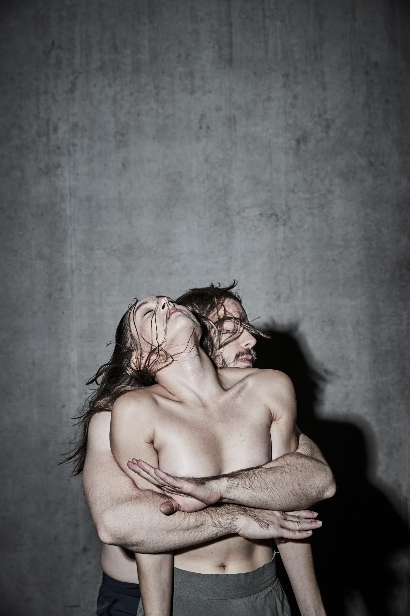

**The new production *Refuge 2025* by the international ensemble Farm in the Cave is a powerful dance theatre performance and concert in one. It is based on interviews with people who lived through limit situations during their flight to freedom. Director and choreographer Viliam Dočolomanský has transformed this pressing issue into a scenic poem. With a new form and cast, the production builds on the successful project of the same name from 2018. The premiere performances will take place on 1, 2, and 3 March at the DOX Centre for Contemporary Art.**

Three people cross paths while on the run. Bound to each other, they overcome obstacles and navigate limit situations on a difficult journey to freedom. Anxiety, courage, failure, joy, compassion. How does our world actually see the value of people who “have no territory of their own”? The production not only reflects on current events but above all portrays the human quest for self-discovery and the personal transformation of each of us.

“A situation where we have nothing – not even a place to go back to – forces us to ask: What actually is this refuge, this anchor? And where is it? Is it somewhere outside of us? And are we there for others at critical junctures? What actually is the supreme value for me? All of us have probably experienced such moments, and that’s why I believe this production has the potential to touch many people,” says director Viliam Dočolomanský.

The performers’ expressive, dynamic movements evoke an atmosphere of continuous tension, forcing the audience to remain alert. Alongside performer and singer Hana Varadzinová, a new generation of dancers – Michaela Králiková, Andrej Štepita, and David Králík – will take the stage.

The ensemble’s signature style is characterised not only by the expressiveness of the performers but also by the deep connection between the movement and the music. In this production, the music doesn’t just accompany the action – it determines it. However, the two components merge into an inseparable whole as the music was composed by the choreographer Viliam Dočolomanský himself. The powerful atmosphere created by leading jazz musicians Marcel Bárta, Štěpán Janoušek, and Jan Chalupa / Vít Halška is rounded out by the sound design of Eva Svobodová, which issues from, among other places, the loudspeakers that dominate the stage design.

Through movement and music, the work of Farm in the Cave speaks directly to the viewer’s emotions, always searching for substance and a message for us all in the topical themes that they deal with. In its more than twenty years of activity, the ensemble has developed an unmistakable scenic style, garnering them numerous awards, both in the Czech Republic and abroad.

In a new form and with a new cast, the ensemble is building on their successful 2018 production *Refuge*, which was co-produced with Tanec Praha, the DOX Centre for Contemporary Art, and the London International Festival of Theatre (LIFT). After its premiere, the new production will represent the Czech Republic at the festival of the Orbita | Spellbound National Centre for the Production of Dance in Rome.

**ABOUT THE INTERNATIONAL ENSEMBLE FARM IN THE CAVE**

The international ensemble Farm in the Cave is a pioneer of physical theatre in the Czech Republic, with original productions that respond to current events in society. The ensemble is characterised by an unmistakable expressive style combining music and movement, which it uses to reflect on contemporary issues affecting all of us. The intensity of the works is the result of a long-term creative process based on research of the themes and on the intensive expressive work of the performers.

Since 2018 Farm in the Cave has been the resident ensemble of the DOX Centre for Contemporary Art, where it also stages its other productions *Czech Hero* and *Commander*. In its more than twenty years of existence, the ensemble has received numerous Czech and international awards, including the prestigious European Prize for New Theatrical Realities won by director Viliam Dočolomanský, the only Czech laureate of this prize.

**CREATIVE TEAM:**

**Performers:** Andrej Štepita, David Králík, Michaela Králiková, Hana Varadzinová, Marcel Bárta, Štěpán Janoušek, Jan Chalupa / Vít Halška

**Concept, directing, choreography:** Viliam Dočolomanský

**Music:** Viliam Dočolomanský & Marcel Bárta, Hana Varadzinová, Vít Halška, Štěpán Janoušek

**Dramaturgy:** Jana Pilátová

**Stage design and costumes:** Lucia Škandíková, Ema Dulíková

**Lighting design:** František Fabián

**Sound design:** Eva Hamouzová

**MEDIA CONTACT:**

Eliška Seveldová

+420 606 850 981

[eseveldova@farminthecave.com](mailto:eseveldova@farminthecave.com)

[farminthecave.com](https://farminthecave.com/)

[www.facebook.com/farmavjeskyni](https://www.facebook.com/farmavjeskyni/)

[www.instagram.com/farm_in_the_cave](http://www.instagram.com/farm_in_the_cave)