FALL 2026: HOPE IS A STATE OF MIND
The fourth edition of the FALL literary festival at the DOX Centre for Contemporary Art will be about hope.
From 1 to 4 October 2026 it will welcome prominent international figures from the worlds of literature and art.

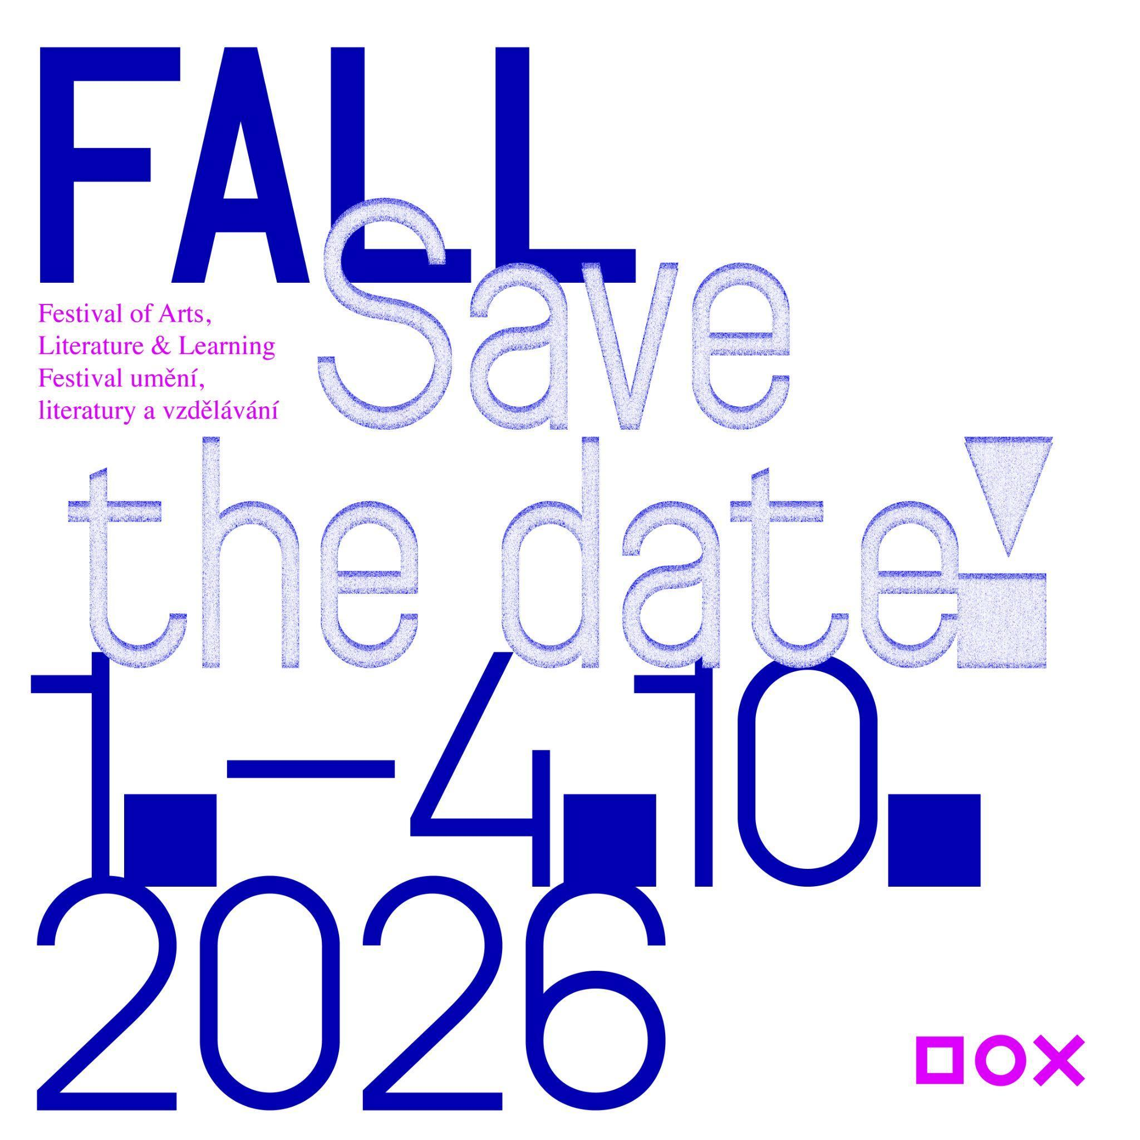

SAVE THE DATE
From Thursday to Sunday, 1–4 October 2026, the DOX Centre for Contemporary Art and its Gulliver Airship will host the fourth edition of the Festival of Arts, Literature & Learning (FALL). The main part of the festival, intended for the general public, will offer discussions, readings, encounters with Czech and foreign authors and artists, a programme connecting literature and contemporary art, and workshops for children and families. The festival also includes a programme for schools, teachers, and professionals, which will run from Tuesday, 29 September to Monday, 5 October 2026.

THE FALL FESTIVAL – EMPATHY IN THE DIGITAL AGE
The FALL festival at the DOX Centre for Contemporary Art is a space for the thoughts and voices of writers, artists, and other creative figures from various genres and their inspiring “borderlands”. Its broader long-term framework centres around the question of how literature and art can help to foster empathy – a quality that is essential in today’s digital age of algorithms and artificial intelligence.

At a time when we share more on social media than we do in the real world, the festival offers an opportunity to step into other people’s stories for a moment, to see the world through someone else’s eyes, and to ask whether creativity, imagination, and empathy are what (at least for now) set us apart from our AI-driven future.

THE THEME OF THE 2026 FALL FESTIVAL: HOPE IS A STATE OF MIND
“FALL is a place for meeting and sharing. Its permanent broader framework and the red thread running through it is the question of empathy in the digital age, meaning how literature and art can help us develop our ability to put ourselves in other peoples’ shoes – how they can bring us together. Every year, the festival has a specific thematic focus. Last year we dealt with the issue of censorship and self-censorship in literature and art, and this year we will look at where to find hope in today’s seemingly quite hopeless times. The motto of this year’s festival – HOPE IS A STATE OF MIND – comes from Václav Havel’s reflections on hope in his 1986 book Disturbing the Peace. Is hope indeed a state of mind, not of the world? Where can we find the strength to keep going in spite of everything, and how is hope connected with the currently much-discussed concept of resilience? These are questions for the guests of this year’s festival,” says Michaela Šilpochová, the festival’s founder and artistic director.
RENOWNED CZECH AND INTERNATIONAL AUTHORS
Over the course of several days, visitors to the DOX Centre and its Gulliver Airship will have the opportunity to meet prominent Czech and international authors, artists, journalists, philosophers, and other public figures.
The main programme will feature, for example, Finnish-Estonian writer Sofi Oksanen, one of the most prominent European authors of our time, whose work explores themes of memory, violence, and resilience. French writer Marie NDiaye, a winner of the Prix Goncourt who was shortlisted for this year’s International Booker Prize, will also be presenting her work. Other figures who will be in attendance include acclaimed Argentine-Canadian writer and essayist Alberto Manguel, Norwegian literary sensation Oliver Lovrenski, eminent Georgian poet and former president of the Georgian PEN Club Paata Shamugia, and Russian documentary filmmaker Pavel Talankin, co-creator of the Oscar-winning documentary Mr. Nobody Against Putin. There will also be appearances by Czech writers such as the philosopher Alice Koubová, the authors Marek Šindelka and Vratislav Maňák, and the poets Marie Iljašenko and Adam Borzič.

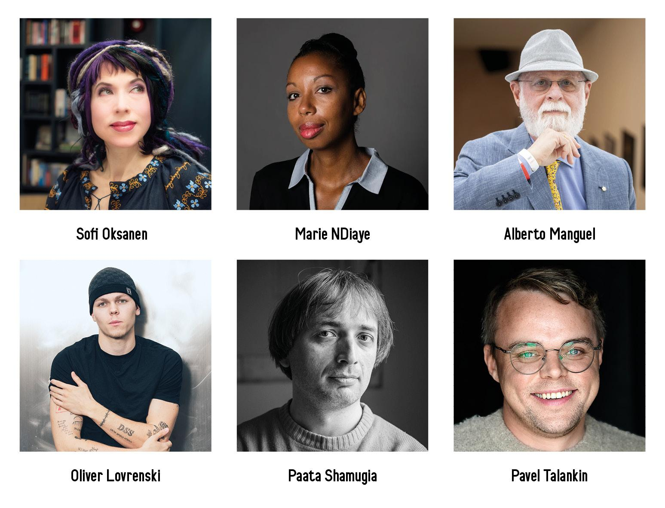
THE INTERNATIONAL HONORARY BOARD OF THE FALL FESTIVAL
FALL continues in collaboration with its international honorary board, which supports the festival’s long-term vision and values.
Alberto Manguel – an internationally respected Argentine-Canadian writer, translator, essayist, and promoter of reading
Radka Denemarková – a Czech author, screenwriter, literary historian, and translator of German literature
Colum McCann – an Irish writer and co-founder of Narrative 4, an organisation that focuses on developing empathy through sharing stories
Bill Shipsey – the founder of the organisation Art for Human Rights and a long-time activist connecting the art world and human rights
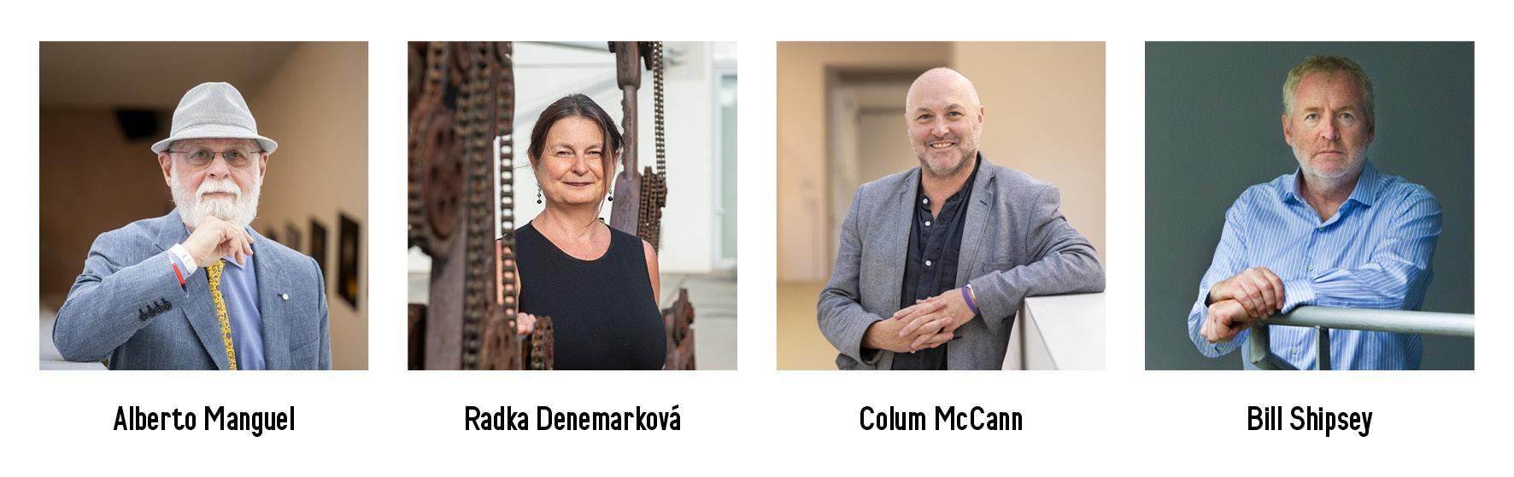

PROGRAMME
The festival programme will feature discussions with authors, readings, guided tours of exhibitions, concerts, and live performances, all of which will take place on board the Gulliver Airship and throughout the DOX Centre for Contemporary Art.
FALL will also include contemporary art exhibitions at DOX. The main autumn exhibition Argus & Medusa will be particularly closely tied to the festival’s theme, showcasing works by more than twenty prominent international artists, and its opening will take place during the festival. Other exhibitions that attendees can visit during the festival include Radka Bodzewicz: Faust and Andros, which will focus on issues of masculinity in today’s world.
We will be announcing other guests and the complete programme during the summer!
FALL FOR SCHOOLS AND SPECIALIST AUDIENCES
An important part of the FALL festival is its educational programme designed for students of secondary schools and universities as well as teachers, librarians, and anyone interested in in creative education. Each year, the festival creates a space for young people to meet with prominent writers, artists, and public figures, providing the opportunity to discuss the topics that shape the world today. The programme of this year’s festival focuses on the issues of hope and resilience as well as identity, freedom, and civic responsibility.
Every weekday during the festival there will be special student discussions with authors, followed by interactive workshops focused on developing empathy. The workshops make use of the methodology of the international educational project Narrative 4, whose co-founder, the Irish writer Colum McCann, is also a member of the honorary board of the FALL festival. DOX has long been working with this methodology and connecting it with literature, contemporary art, and creative education.
This year students can meet with, for example, the author Vratislav Maňák, who is also curating the Andros exhibition, the writer and screenwriter Marek Šindelka, the novelist Tereza D. Reichelová, and the poets Marie Iljašenko and Adam Borzič. The discussions will be complemented by experiential workshops inspired by the concept of “radical empathy”, based on sharing personal stories and seeking understanding among people with different experiences.
The educational programme will also feature a screening of the Oscar-winning documentary Mr. Nobody Against Putin, which will be followed by a discussion with its creator and protagonist, Pavel Talankin. This particular event is being organised in collaboration with the Václav Havel Library.
The programme for specialist audiences will include presentations, discussions, and workshops for teachers, librarians, and others interested in creative education. DOX has been dedicated to education since its founding, and it uses art to foster critical thinking, empathy, creativity, and civic engagement as key competencies for life in the twenty-first century.

TICKETS

Early bird tickets for FALL 2026 are now for sale on the festival’s website and at dox.cz.
Festival passes are available at a discounted price of CZK 1,200, which includes the entire programme on all four days as well as admission to all of the exhibitions at the DOX Centre taking place during the festival. Fans of FALL can also support the event by purchasing a donor ticket.

DOX – MORE THAN JUST A GALLERY

The DOX Centre for Contemporary Art was founded thanks to a private initiative which turned a former factory in Prague’s Holešovice neighbourhood into the Czech Republic’s largest private non-profit institution devoted to contemporary art. Since 2008 its mission has been to create a space for the exploration, discussion, and artistic presentation of important social issues – a place where the visual arts, literature, music, theatre, and other disciplines enable a critical approach to the so-called reality of today’s world. The exhibition space measuring 3,000 m² is complemented by the DOX+ multifunctional hall and the Gulliver Airship, which serves as the home of the FALL festival.

The festival is supported by the Ministry of Culture of the Czech Republic, Prague City Hall, the Abakus Foundation, and the DOX Foundation, and it is organised in collaboration with Art for Human Rights and Narrative 4 as well as individual publishing houses and literary magazines.

Festival of Arts, Literature & Learning
1–4 October 2026
DOX Centre for Contemporary Art
Poupětova 1, Prague 7

The press release and photographs can be downloaded after registering in the Press section of our website.
Photos: Jan Slavík, ©DOX
Contact
Karolína Kočí
E karolina.koci@dox.cz
T +420 777 870 219
www.dox.cz

