
Press Release
17 September 2026

FALL 2026: HOPE IS A STATE OF MIND
The fourth edition of the FALL literary festival at the DOX Centre for Contemporary Art will be about hope.
From 1 to 4 October 2026 it will welcome prominent international figures from the worlds of literature and art.

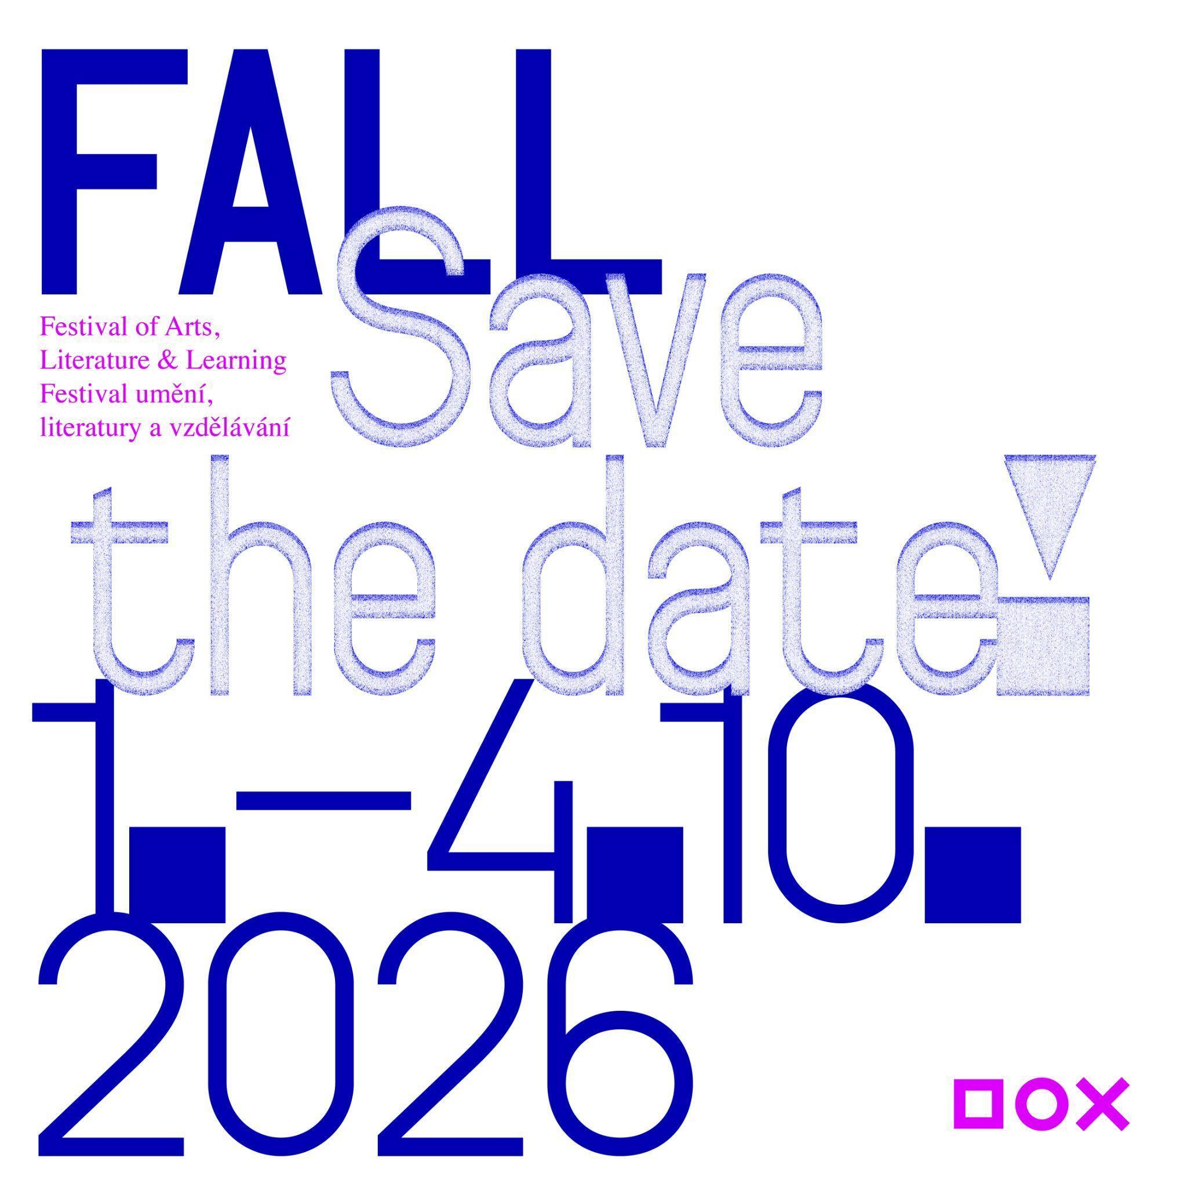

SAVE THE DATE
From Thursday to Sunday, 1–4 October 2026, the DOX Centre for Contemporary Art in Prague will host the fourth edition of the Festival of Arts, Literature & Learning (FALL). The main part of the festival, intended for the general public, will offer discussions, readings, encounters both with internationally acclaimed authors and artists and young talents, a programme connecting literature and contemporary art, and workshops for children and families. The festival also includes a programme for schools, teachers, and professionals, which will run from Tuesday, 29 September to Monday, 5 October 2026.

WHAT IS THE FALL FESTIVAL? EMPATHY IN THE DIGITAL AGE
The FALL festival at the DOX Centre for Contemporary Art is a space for the thoughts and voices of writers, artists, and other creative minds from various genres and their inspiring “borderlands”. Its broader long-term framework centres around the question of how literature and art can help to foster empathy – a quality that is essential in today’s digital age of algorithms and artificial intelligence. At a time when we share more on social media than we do in the real world, the festival offers an opportunity to step into other people’s stories for a moment, to see the world through someone else’s eyes, and to ask whether creativity, imagination, and empathy are what (at least for now) set us apart from our AI-driven future.
THE THEME OF THE 2026 FALL FESTIVAL: HOPE IS A STATE OF MIND
“FALL is a place for meeting and sharing. Its permanent broader framework and the red thread running through it is the question of empathy in the digital age, meaning how literature and art can help us develop our ability to put ourselves in other peoples’ shoes – how they can bring us together. Every year, the festival has a specific thematic focus. Last year we dealt with the issue of censorship and self-censorship in literature and art, and this year we will look at where to find hope in today’s seemingly quite hopeless times. The motto of this year’s festival – hope is a state of mind – comes from Václav Havel’s reflections on hope in his 1986 book Disturbing the Peace. Is hope a state of mind, not of the world? Where can we find the strength to keep going in spite of everything, and how is hope connected with the currently much-discussed concept of resilience? These are questions for the guests of this year’s festival,” says Michaela Šilpochová, the festival’s founder and artistic director.
RENOWNED CZECH AND INTERNATIONAL AUTHORS
Over the course of several days, visitors to the DOX Centre for Contemporary Art and its Gulliver Airship will have the opportunity to meet prominent Czech and international authors, artists, journalists, philosophers, and other public figures.
The main programme, which runs from Thursday to Sunday, 1 to 4 October, will feature, for example, the Finnish-Estonian writer Sofi Oksanen, one of the most prominent European authors of our time, whose work explores themes of memory, violence, and resilience. The French writer Marie NDiaye, a winner of the Prix Goncourt who was shortlisted for this year’s International Booker Prize, will also be presenting her work. Other figures who will be in attendance include Norwegian literary sensation Oliver Lovrenski and the eminent Georgian poet and former president of the Georgian PEN Club Paata Shamugia. You can also look forward to one of the most significant figures in contemporary Ukrainian culture, Oksana Zabuzhko, as well as the Palestinian poet and artist Ghayath Almadhoun, Turkish writer and composer Zülfü Livaneli and the Prague-based British author Missouri Williams, whose novel The Vivisectors was nominated for the 2026 Booker Prize. There will also be a discussion for students with Russian filmmaker Pavel Talankin, co-creator of the Oscar-winning documentary Mr. Nobody Against Putin. Czech and Slovak guests will include, for example, the philosopher Alice Koubová and the writers and poets Marek Šindelka, Michal Tallo, Milan M. Šimečka, Vratislav Maňák, Marek Torčík, Marie Iljašenko, and Adam Borzič.
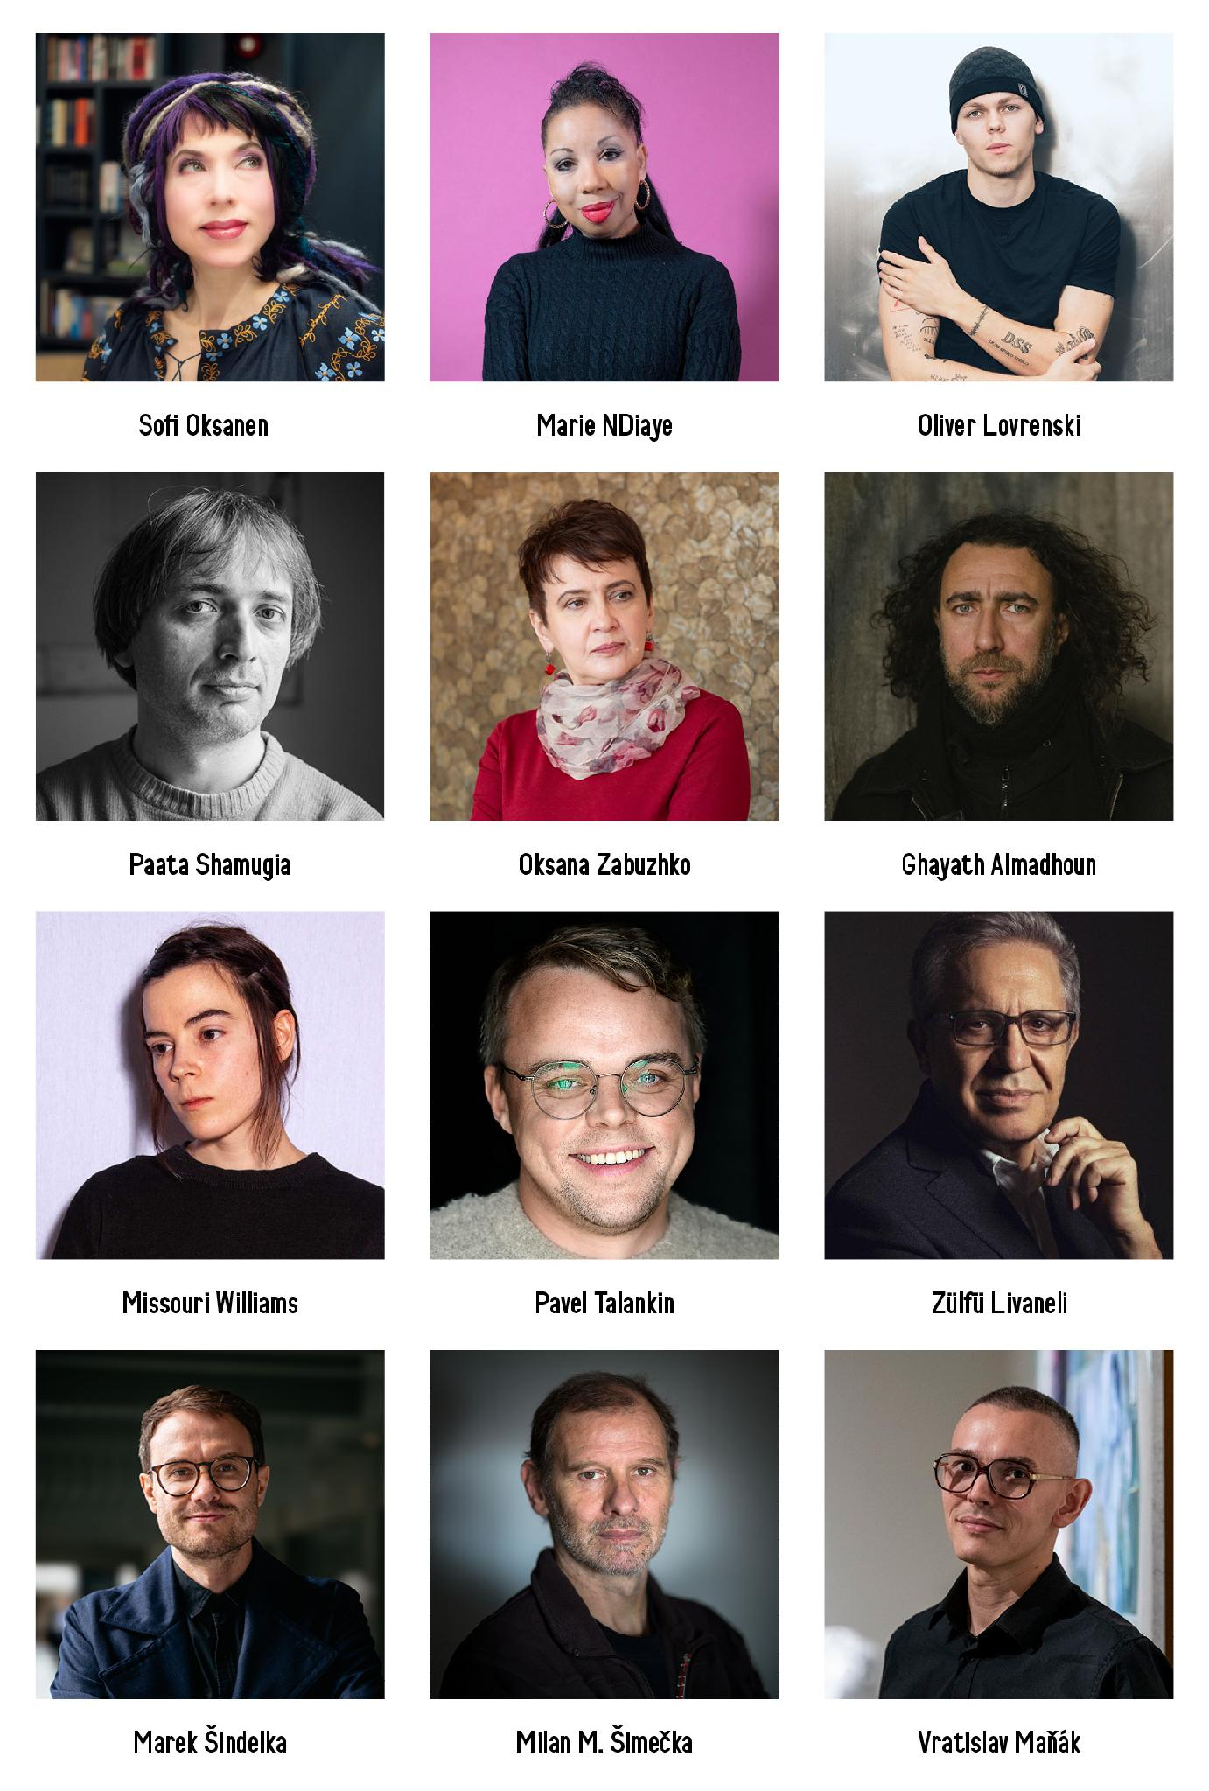

FALL IN THE AIRSHIP AND IN THE GALLERY
THURSDAY, 1 OCTOBER
The festival will open on Thursday, 1 October 2026 with a writers’ panel discussion hosted by world-renowned essayist and translator Alberto Manguel, who is also the chairman of the international honorary board of the FALL festival. The debate will feature acclaimed Finnish-Estonian author Sofi Oksanen, Prix Goncourt winner Marie NDiaye, Czech writer Marek Šindelka, and prominent Georgian poet Paata Shamugia. The discussion will be followed by the opening of DOX’s main autumn exhibition – ARGUS & MEDUSA..
The opening programme also includes an event for the younger generation: a special edition of DOXYGEN hosted by Czech writer Vratislav Maňák, who is also the curator of the ongoing exhibition ANDROS.
The main festival, which runs from Friday through Sunday, will feature discussions with authors on board the Gulliver Airship as well as inside DOX’s current exhibitions.

FRIDAY, 2 OCTOBER
On Friday, 2 October at 3:00 p.m. visitors will have the opportunity to meet with renowned Georgian poet Paata Shamugia, who will have a conversation with writer Michal Tallo about his work and also about the extraordinary situation in Georgia, where the entire cultural and civil society has been protesting in the streets for more than six hundred days against the government’s steps towards oppression.
A highlight of the Friday programme will be a discussion at 4:30 p.m. featuring young Norwegian literary sensation Oliver Lovrenski. His debut novel Back in the Day tells the story of a group of Norwegian teenagers growing up in a world full of anxiety, drugs, and hope. Published when Lovrenski was only nineteen, the book has been dubbed “Trainspotting for Gen Z”, and it quickly became a bestseller throughout Scandinavia. A Czech edition was published in 2024 by the Paseka Publishing House, translated by Václav Křenek.
At 6:00 p.m. Czech poet and translator Jitka Hanušová will discuss memory, violence, resilience, and Putin’s war on women with Finnish-Estonian writer Sofi Oksanen, one of the most prominent voices in contemporary European literature.
The Friday programme will culminate at 8:00 p.m. with an extraordinary audiovisual performance titled Cartografia Sonora Imaginária by the award-winning Portuguese ensemble Companhia de Música Teatral. Created specifically for the ARGUS & MEDUSA exhibition, it will transport the audience into imaginary landscapes of sound and images.

SATURDAY, 3 OCTOBER
The second day of the festival will begin at 10:30 a.m. with an event inside Radka Bodzewicz’s exhibition FAUST, where the artist will take part in a conversation with poet Radek Malý, author of a modern Czech translation of Goethe’s Faust.
This will be followed by a midday discussion among artists featured in the new exhibition ARGUS & MEDUSA. Martin Gerboc, John Beard, and Wolfe von Lenkiewicz will talk about how Théodore Géricault’s painting The Raft of the Medusa served as inspiration for their own works. Otto M. Urban will moderate.
The afternoon programme will take place aboard the Gulliver Airship, where at 1:30 p.m. author Marek Šindelka will discuss his novel Systémy něhy (Systems of Tenderness, 2026) with writer and editor-in-chief of Host magazine Jan Němec.
At 3:00 p.m. Oksana Zabuzhko, a prominent figure in contemporary Ukrainian literature and culture, will board the Gulliver for a conversation with poet and translator Marie Iljašenko.
A distinguished guest of this year’s festival is composer, writer, and director Zülfü Livaneli, who is considered one of the most influential Turkish authors and intellectuals of his time. At 4:30 p.m. he will discuss his work at the crossroads of music, literature, and cinema with Czech journalist Petr Vizina.
At 6:00 p.m. the Gulliver Airship will welcome aboard another extraordinary figure of world literature. French writer, playwright, and Prix Goncourt winner Marie NDiaye, whose novel The Witch was shortlisted for this year’s International Booker Prize, will offer a glimpse into her magical-realist literary universe in a conversation with Guillaume Basset.
The evening will conclude with a concert by Monika Načeva featuring a repertoire of songs in which she has set to music the poetry of Czech authors whose work was historically marginalised by official culture.

SUNDAY, 4 OCTOBER
The Sunday programme will kick off at 10:30 a.m. in the ongoing exhibition ANDROS, which explores representations of masculinity in contemporary central European art. There will be a poetry reading directly in the exhibition space featuring writer and curator of the exhibition Vratislav Maňák along with poets Sufian Massalema and Adam Borzič.
At 12:00 p.m. in the new exhibition ARGUS & MEDUSA curators Michaela Šilpochová and Otto M. Urban will meet with British artist Tom de Freston and South African artist Conrad Botes to discuss how Théodore Géricault’s famous painting The Raft of the Medusa inspired their work.
The afternoon programme will once again take visitors up into the Gulliver Airship, where at 1:30 p.m. there will be a discussion between philosopher Alice Koubová, poet and artist Michal Tallo, and journalist Milan M. Šimečka on the topic of societal resilience. The conversation will be moderated by Petr Fischer.
At 3:00 p.m. a remarkable talent and rising star of contemporary European literature will present her work for the first time in the Czech Republic aboard the Gulliver. The young British author Missouri Williams has been based in Prague in recent years, and she even used the city as the setting for her debut novel. This year her second novel was nominated for the prestigious Booker Prize. She will discuss her work with writer and poet Marek Torčík.
Palestinian poet in exile Ghayath Almadhoun will also be making an appearance at the FALL festival. At 4:30 p.m. he will present his award-winning literary work for the first time in the Czech Republic in a conversation with writer and journalist Jonáš Zbořil.
The festival will culminate at 6:00 p.m. with a discussion in honour of Václav Havel, hosted by Iranian artist Azadeh Kangarani. Her guests will include Ukrainian writer Oksana Zabuzhko, Belarusian dissident Maxim Znak, Turkish writer and composer Zülfü Livaneli, and Irish founder of the organisation Art for Human Rights Bill Shipsey.
FALL FOR KIDS
The weekend afternoons will offer four open family workshops starting at 1:30 p.m., which are free of charge for children and parents. On Saturday, 2 October at 1:30 p.m. we will also welcome a special guest – British author, poet, and playwright Kiran Millwood Hargrave, who is best known in the Czech Republic for her books for children and young adults. The author will read from her book Julia and the Shark. The book was illustrated by British artist Tom de Freston, whose work is also featured in the ARGUS & MEDUSA exhibition. The event will be hosted by Daniela Retková.
FALL FOR SCHOOLS AND SPECIALIST AUDIENCES
An important part of the FALL festival is its educational programme designed for students of secondary schools and universities as well as teachers, librarians, and anyone interested in in creative education. Each year, the festival creates a space for young people to meet with prominent writers, artists, and public figures, providing the opportunity to discuss the topics that shape the world today. The programme of this year’s festival focuses on the issues of hope and resilience as well as identity, freedom, and civic responsibility.
Every weekday during the festival there will be special student discussions with authors, followed by interactive workshops focused on developing empathy. The workshops make use of the methodology of the international educational project Narrative 4, whose co-founder, the Irish writer Colum McCann, is also a member of the honorary board of the FALL festival. DOX has long been working with this methodology and connecting it with literature, contemporary art, and creative education.
This year students can meet with, for example, the author Vratislav Maňák, who is also curating the ANDROS exhibition, the writer and screenwriter Marek Šindelka, the novelist Tereza D. Reichelová, and the poets Marie Iljašenko and Adam Borzič. The discussions will be complemented by experiential workshops inspired by the concept of “radical empathy”, based on sharing personal stories and seeking understanding among people with different experiences.
The educational programme will also feature a screening of the Oscar-winning documentary Mr. Nobody Against Putin, which will be followed by a discussion with its creator and protagonist, Pavel Talankin.
The programme for specialist audiences will include presentations, discussions, and workshops for teachers, librarians, and others interested in creative education. DOX has been dedicated to education since its founding, and it uses art to foster critical thinking, empathy, creativity, and civic engagement as key competencies for life in the twenty-first century.
THE FESTIVAL PROGRAMME INCLUDES EXHIBITIONS
FALL will also include contemporary art exhibitions at DOX. The main autumn exhibition ARGUS & MEDUSA will be particularly closely tied to the festival’s theme, showcasing works by twenty-five prominent international artists, and its opening will take place during the festival. Other exhibitions that attendees can visit during the festival include Radka Bodzewicz: FAUST and ANDROS, which focuses on issues of masculinity in today’s world.
THE INTERNATIONAL HONORARY BOARD OF THE FALL FESTIVAL
FALL continues in collaboration with its international honorary board, which supports the festival’s long-term vision and values.
Alberto Manguel – an internationally respected Argentine-Canadian writer, translator, essayist, and promoter of reading
Radka Denemarková – a Czech author, screenwriter, literary historian, and translator of German literature
Colum McCann – an Irish writer and co-founder of Narrative 4, an organisation that focuses on developing empathy through sharing stories
Bill Shipsey – the founder of the organisation Art for Human Rights and a long-time activist connecting the art world and human rights
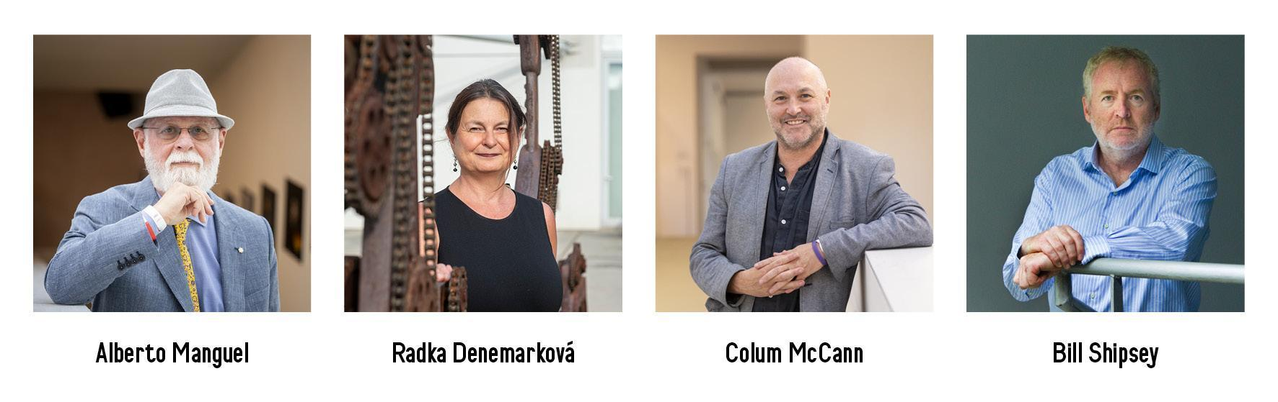

TICKETS
Various types of tickets for FALL 2026 are available for purchase on the festival website doxfall.cz and at dox.cz. Discounted prices primarily apply to festival passes and one-day passes.
Festival passes include the entire programme on all four days as well as admission to all of the exhibitions at DOX taking place during the festival, including the newly opened ARGUS & MEDUSA exhibition.
One-day passes include admission to the programme on a selected day as well as all of the exhibitions at DOX taking place during the festival, including the newly opened ARGUS & MEDUSA exhibition.
Single-entry tickets for individual events are also available for purchase.
Fans of FALL can also support the event by purchasing a donor ticket.
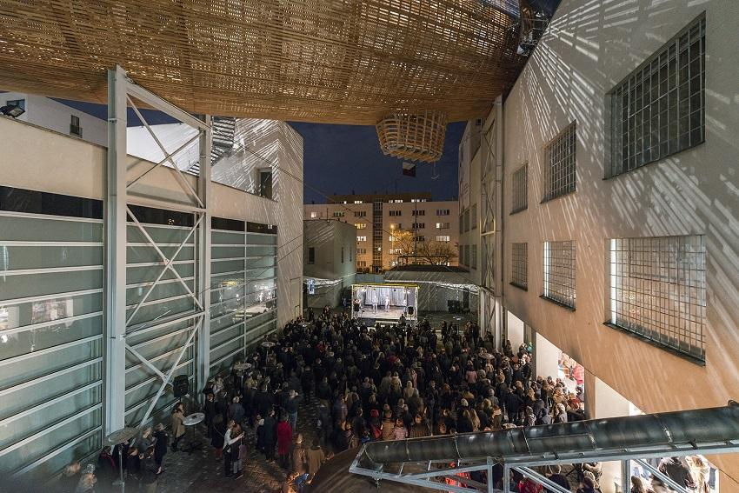

DOX – MORE THAN JUST A GALLERY

The DOX Centre for Contemporary Art was founded thanks to a private initiative which turned a former factory in Prague’s Holešovice neighbourhood into the Czech Republic’s largest private non-profit institution devoted to contemporary art. Since 2008 its mission has been to create a space for the exploration, discussion, and artistic presentation of important social issues – a place where the visual arts, literature, music, theatre, and other disciplines enable a critical approach to the so-called reality of today’s world. The exhibition space measuring 3,000 m² is complemented by the DOX+ multifunctional hall and the Gulliver Airship, which serves as the home of the FALL festival.

The festival is supported by the Ministry of Culture of the Czech Republic, Prague City Hall, the Abakus Foundation, and the DOX Foundation, and it is organised in collaboration with Art for Human Rights and Narrative 4.

The Festival of Arts, Literature & Learning
1–4 October 2026
DOX Centre for Contemporary Art
Poupětova 1, Prague 7
The press release and photographs can be downloaded after registering in the Press section of our website.
Photos: Jan Slavík, ©DOX
Contact
Karolína Kočí
E karolina.koci@dox.cz
T +420 777 870 219

