**“I like horrible things. Things that change us when we see them.” DOX opens *Broken World*, an exhibition of legendary American photographer Joel-Peter Witkin.**

**Joel-Peter Witkin, photographs and drawings, 2010–2025**

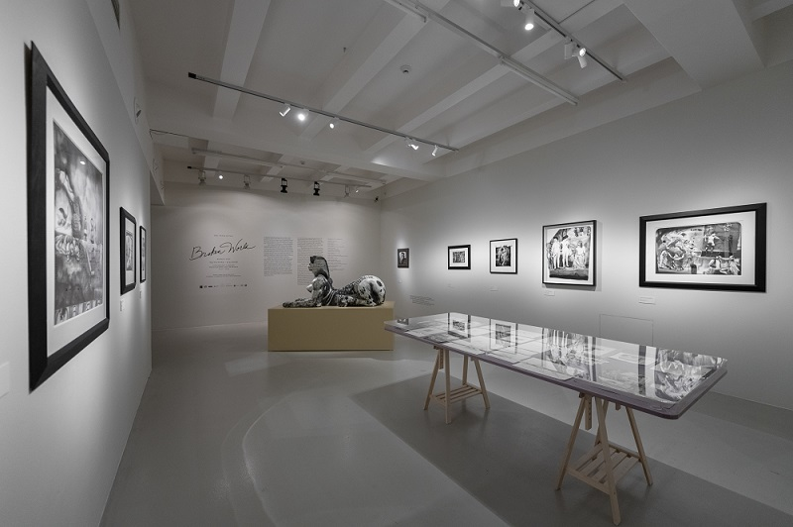

↑ The exhibition Joel-Peter Witkin: Broken World, photo: Jan Slavík, ©DOX

**For more than five decades Joel-Peter Witkin has been among the most influential artists pushing photography to the forefront of the visual arts. His staged images and meticulous work with the material of the print blur the boundaries between photography and painting, between a document and a scene. The exhibition *Broken World* at the DOX Centre for Contemporary Art presents Witkin’s photographs, preparatory drawings, and sketches, many of which are on display for the first time ever. The project maps the artist’s late period from 2010 to 2025, during which his emphasis on physicality, the sacred, and memento mori deepened and became more precise.**

“I’m a visual dramatist, and things that are pretty and beautiful like nature, I appreciate, but I don’t involve my aesthetic life with them. I like horrible things. Things that change us when we see them. I’m not a minimalist; I’m a dramatist. That’s a big factor in the subjects I choose. I make with the purpose to share and to illuminate the possibility that what is being seen is something wonderful and incredibly different. You walk away with a reverence of the subject matter.” – Joel-Peter Witkin for *Musée* (2020)

The exhibition *Broken World* offers a focused field of attention. Witkin’s late works alternate between monumental staged compositions and intimate formats. In addition to many final prints, DOX is also presenting a large number of preparatory drawings and sketches that reveal the artist’s approach and the conceptual background of the individual works.

“My photographs reflect something that comes from painting. When I was kid, instead of playing stickball, my brother and I went to museums. We thought we were in houses of beauty and wonder. We learned from the descriptions of paintings, the stories of the past. What I wanted to do with photography is to create narratives that first came about with Western painting.” – Joel-Peter Witkin for *Musée* (2020)

The drawings here function as scores for the composition as well as intimate counterparts to the photographs, revealing how the image is born even before the exposure. The drawings also provide insight into the artist’s working discipline and expand the meaning of the photographic scenes, because Witkin’s works are created in a studio following very careful preparations, as exhibition curator Otto M. Urban explains: “Each work is preceded by a series of preparatory sketches in which the artist works out the composition and the structure of the space. Only then does he create the analogue – not digital – photographs. Joel-Peter Witkin has a stage in his studio where he essentially composes living images. Each image is complemented by a painted background created specifically for that particular work. And when the artist has everything set up, he presses the shutter button perhaps twenty times, capturing small differences and minute movements. From these, say, twenty different variations, he then selects the photograph he is most satisfied with.”

Although the exhibition focuses on Witkin’s late works from 2010–2025, it opens with his iconic self-portrait with a mask from 1984, which has been newly modified this year through encaustic painting. According to Otto M. Urban, after the photograph was published, the mask that Witkin wore in it became something of a phenomenon: “The mask was worn by models in one of Alexander McQueen’s fashion shows, and David Bowie was photographed wearing the mask as well. The music video for Nine Inch Nails’ song ‘Closer’ even makes direct references to some of Witkin’s photographs, including the photo of him wearing the mask. So, the radical nature of his depictions earned him a whole host of followers and fans, even outside the field of art, in pop culture. After all, Witkin’s photographs can be found on dozens of album covers, precisely because of their aforementioned radicalism and openness.”

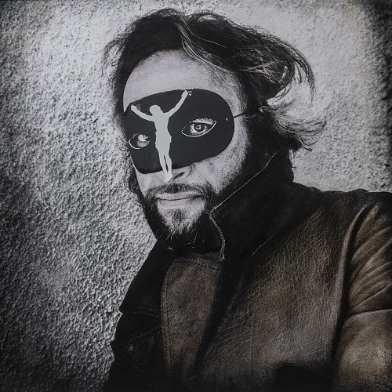

↑ Joel-Peter Witkin, Cynthia Bency-Witkin: Portrait of Joel (1984), edited (2025), photo: Jan Slavík, ©DOX

Witkin’s work cyclically returns to motifs of vanitas, metamorphosis, and the clash between the sacred and the profane. Handwritten inscriptions, glosses, and marginalia enter directly into the image; they are not embellishments but rather director’s notes. Interventions in the negatives, collage, toning, and scratches transform the time of creation into the time of reading; here light functions as a tool which draws out of the darkness even those things that we would rather overlook.

Witkin does not create spectacle. His figures, props, and vulnerable bodies are not intended for consumption but for permanence. The tension between attraction and repulsion, between the sacred and the profane, between the icon and the laboratory, transforms the gaze into an ethical act. The artist places the viewer in the role of a witness, not a voyeur. Humour and irony, precise and restrained, are not an escape but a safeguard against pathos and cynicism.

“In this context it would be good to mention that Witkin was one of David Lynch’s favourite artists. Witkin’s influence is plain to see in Lynch’s exhibition *Up in Flames* in the work *Distorted News*, where many people who are familiar with Witkin’s work see a connection without anyone even telling them anything. It was not our intention, but the fact that these two artists are meeting at DOX is very symbolic because, although they never met in person, they were aware of each other and had great respect for each other,” adds curator Otto M. Urban.

The exhibition *Broken World* offers the experience of slowing down, which restores the image’s dignity. It reminds us of Witkin’s exceptional position among the art of recent decades and shows us why his work continues to shape the way we think about the body, memory, and the meaning of images.

“Every object and person in every photograph is a world to me. I process my own film and I print my own work, which I must because the final print is the final and most clear definition of what I wanted to create.” – Joel-Peter Witkin for *Musée* (2020)

**Curator: Otto M. Urban**

**Joel-Peter Witkin** (born 1939, Brooklyn, New York) is an American photographer who lives in Albuquerque, New Mexico. His work is among the most striking examples of staged photography of the twentieth and twenty-first centuries. He is renowned for his carefully composed scenes combining themes of death, faith, physicality, sexuality, and diversity with references to the history of painting and religious iconography. A hallmark of his work is his experimentation with the photographic process, scratching and toning negatives or manually altering positives, which enhances his unique aesthetic. Witkin’s photographs are controversial, but at the same time they are appreciated for their ability to combine beauty with taboo and poetry with brutality. His works are held in the collections of major institutions, including the Museum of Modern Art in New York, the J. Paul Getty Museum in Los Angeles, the National Gallery of Art in Washington, DC, the Victoria and Albert Museum in London, and the Centre Pompidou in Paris. He has had solo exhibitions at the Museo Reina Sofía in Madrid, the Arizona State University Art Museum, and MoMA in New York, among others.

**Joel-Peter Witkin: Broken World**

**24 October 2025 – 5 April 2026**

**DOX Centre for Contemporary Art**

Poupětova 1, Prague 7

Open: Tue–Sun, 11:00 a.m.–7:00 p.m.

**Contact**

**Karolína Kočí**

E [karolina.koci@dox.cz](mailto:karolina.koci@dox.cz)

T +420 777 870 219

[www.dox.cz](http://www.dox.cz/)

The press release and photographs can be downloaded after registering in the [Press](https://www.dox.cz/en/press) section of our website.