**FESTIVAL FALL 2025 IS ABOUT TO BEGIN.  
DANGEROUS THINKING WILL BE DONE.**

**The DOX Centre for Contemporary Art presents this year’s programme and guests. Irish Booker Prize winner Paul Lynch, German-language literary star Daniel Kehlmann, Palestinian writer Adania Shibli, Chinese exile artist Badiucao, and American singer and David Lynch’s muse Chrystabell will be in attendance. Leading Spanish artist Miquel Barceló will present a new exhibition. The third year of the festival will focus on the theme of censorship and self-censorship in contemporary art and literature.**

**FALL IS IN THE AIR**

**In just a few days, at the beginning of October, the third year of the** [**Festival of Arts, Literature & Learning**](https://www.doxfall.cz/en) **will begin at the DOX Centre for Contemporary Art and its Gulliver airship.**

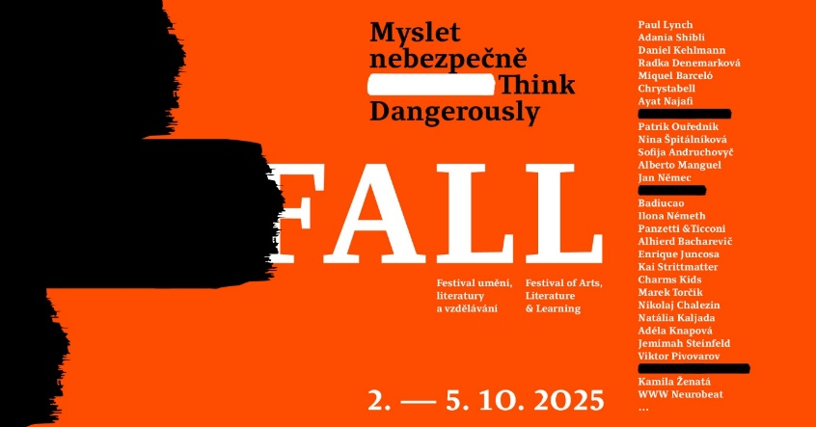

**The main part of the festival, running from Thursday 2 October to Sunday 5 October is intended for the widest possible audience. The festival also includes a programme for schools and professionals, running from 29 September to 3 October.**

**During four eventful days, the festival will offer discussions, readings by domestic and foreign authors, a combination of contemporary art exhibitions and literature, interdisciplinary workshops, and a programme for children.**

**This year the festival will feature 40 guests from 14 countries around the world whose main topic of discussion will be censorship and self-censorship in contemporary art and literature.**

**All information can be found on the festival website** [doxfall.cz](https://www.doxfall.cz/o-festivalu) **or on the** [DOX FALL](https://www.facebook.com/doxpraguefall) **Facebook page.**

**PROGRAMME**

During the festival, **discussions with authors, author readings, special interdisciplinary workshops led by artists and writers, guided tours of exhibitions combined with readings, and musical performances will take place on board the Gulliver airship and throughout the DOX premises. There will also be workshops for schools and creative workshops for families, and a brand-new exhibition on the border between art and literature will be open**.

**FESTIVAL GUESTS**

This year, the FALL festival at DOX will once again welcome several literary and artistic personalities from the Czech Republic and abroad. Local guests participating in discussions will include writers **Radka Denemarková**, **Adéla Knapová**, **Nina Špitálníková, Patrik Ouředník** and **Marek Torčík,** while workshops for the public will be led by **writer Jan Němec and visual artist Kamila Ženatá**.

# Foreign guests appearing in the main program will include Irish Booker Prize winner Paul Lynch, who will present his latest novel *Prophet Song*, a gripping dystopia about how quickly Irish democracy can turn into an authoritarian state. Acclaimed Austrian-German writer Daniel Kehlmann will come to Prague to present the Czech translation of his latest novel *Lichtspiel* (in English translation *The Director*) a Faustian-themed true story of the famous film director (born in the Czech town Roudnice nad Labem) G.W. Pabst. Palestinian author Adania Shibli, whose voice was censored at the Frankfurt Book Fair in 2023, when dozens of leading world authors spoke out in her defence, will also come to launch the first Czech translation of her book *Minor Detail*.

# Alhierd Bacharevič, a Belarusian writer living in exile, whose entire work is banned in Belarus and whose novel *Dogs of Europe* was awarded the European Prize for Understanding this spring, will speak about censorship in Belarus. He will be joined on stage by Nikolai Khalezin, founder of the Belarus Free Theatre****.****

# One of the most prominent contemporary Ukrainian authors, Sofia Andruchovyč, will present her latest novel *Amadoka* in Czech translation in a discussion with writer Jan Němec and Kharkiv-based journalist and writer Adéla Knapová.

# Chinese dissident artist Badiucao and American journalist Melissa Chan, who has Chinese-Taiwanese roots will talk about technology and artificial intelligence in the hands of censors. They will present their new graphic dystopian novel You Must Take Part in Revolution at the festival.

# French journalist and editor-in-chief of Charlie Hebdo magazine Gérard Biard has also confirmed his participation in the festival. He will talk to writer and translator Patrik Ouředník about self-censorship 10 years after the attacks on the satirical magazine’s editorial office.

# The current dramatic situation of silencing the cultural scene in Slovakia will be discussed in a dialogue with writer Radka Denemarková by artist and curator Ilona Neméth, who is also one of the prominent voices of the current protest movements Otvorená kultura (Open Culture) and Kulturný štrajk (Cultural Strike).

# Iranian film and theatre director Ayat Najafi will speak about art as an act of resistance against censorship. His film *The Sun Will Rise*, which premiered last year at the Venice Film Festival, impressively captures Iranian women’s struggle for freedom through art**.**

# This year’s partners are the international organizations Index on Censorship, Narrative 4, and Art for Human Rights. Guests will include Bill Shipsey, director of Art for Human Rights, and Jemimah Steinfeld, editor-in-chief and director of Index on Censorship.

# ****FALL - THE CONNECTION BETWEEN ART AND LITERATURE AND A NEW EXHIBITION BY MIQUEL BARCELÓ****

# **The festival also includes the programme of current exhibitions at DOX. **Painter Viktor Pivovarov** will present his latest collection of poems as part of his exhibition *Metaphysics and Despair*. David Lynch’s exhibition will feature a reading from his autobiographical book *Catching the Big Fish* and Lynch’s long-time muse, **American actress and singer Chrystabell**, will talk about Lynch’s relationship to music with **curator Otto M. Urban** in the Gulliver Airship**.** She will also bring her new music show** [Spirit Lamp](https://www.doxfall.cz/en/program/the-spirit-lamp) **to DOX, which is a tribute to David Lynch and their musical collaboration.**

**A new exhibition related to literature will also open as part of the festival.** One of the most respected contemporary Spanish artists, **Miquel Barceló, will present his artwork for the first time in the Czech Republic.** A painter and sculptor renowned for his relief paintings, bronze sculptures, ceramic works, and monumental installations, he experiments with unconventional materials while remaining anchored in the famous painting tradition and following in the footsteps of Picasso and Goya.

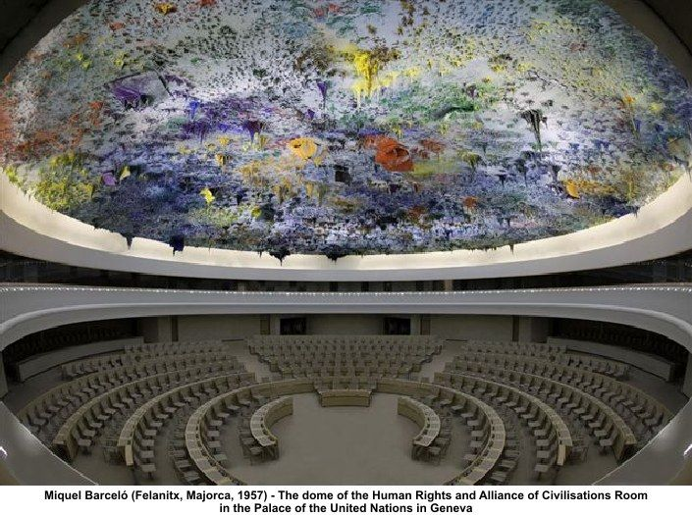**Barceló created, for example, a famous monumental installation at the UN headquarters in Geneva and large-format tapestries for Notre Dame Cathedral in Paris. This year, he was selected as one of three artists who will artistically design and complete the facade of the famous Sagrada Familia cathedral in Barcelona.** As part of the festival, DOX, with the support of the Instituto Cervantes Praga, will present his exhibition entitled [**MIQUEL BARCELÓ AND THE WRITTEN WORLDS**](https://www.dox.cz/en/whats-on/miquel-barcelo-and-the-written-worlds), which is dedicated to his intense relationship with literature. The exhibition is curated by Spanish poet **Enrique Juncosa**.

Miquel Barceló’s relationship with literature will be presented at the exhibition through paintings, sculptures, illustrations, and books on which he collaborated with a number of leading writers. On the top floor of the DOX Centre tower, visitors will have the opportunity to see the artist’s interpretation of the biblical theme of Noah’s Ark. The 4×6-meter canvas is Miquel Barceló’s largest painting to date, and this will be the first time this work has been exhibited in a gallery space (it has only been exhibited publicly once before, in a church in Salamanca, Spain).

# NIGHTFALL OR THE EVENING PROGRAM OF THE FESTIVAL

# The festival will [kick off](https://www.doxfall.cz/en/program/fall-2025-opening) on Thursday, 3 October, with a musical performance by the international music project Charms Kids, featuring Ukrainian, Czech, and Slovak musicians, as well as Italian performer Gioelle Coccia. On Friday, there will be a vernissage of a new exhibition by Miquel Barceló, on Saturday evening Italian performers Pancetti/Ticconi will present their impressive [dance show](https://www.doxfall.cz/en/panzetti-ticconi), and in the evening, there will be a [concert](https://www.doxfall.cz/en/www-neurobeat) by WWW Neurobeat, a fixture on the Czech music scene. On Sunday evening, the festival will conclude with a tribute to David Lynch by the aforementioned American singer Chrystabell.

## FESTIVAL FALL – EMPATHY IN THE DIGITAL AGE

## The FALL Festival at the [DOX Centre for Contemporary Art](https://www.dox.cz/en/press) is a space for the ideas and voices of writers, artists, and other creative personalities from various genres and their inspiring “frontiers.” Its constant focus is the theme of empathy in the digital age. At a time when we share more on social media than in the real world, the festival is an opportunity to see the world through someone else’s eyes for a moment, to enter into other people’s stories for a moment, and to ask how art and literature influence our ability to perceive and empathize with others, and whether creativity, imagination, and empathy are what (still) distinguish us from our artificially intelligent future.

**FALL 2025: THINK DANGEROUSLY**

In this context, each year has its own specific focus. This year’s edition will focus on **issues of censorship, self-censorship, and artistic freedom in contemporary art and literature**.

*“For this year, we have chosen a topic that we consider to be disturbingly topical. We are basing this on the consideration that the world of art and literature has not yet had time to respond to the pressures of so-called cancel culture or woke culture in recent years and is already becoming the subject of another form of censorship in some countries that until recently were still liberal: one that is dangerously reminiscent of the era of past authoritarian regimes. Technology, including artificial intelligence, is of course playing a new role. The number of “inconvenient” books is growing in many countries, and artistic institutions are under pressure. We will therefore be interested in how artists and writers are responding to these pressures and whether self-censorship is creeping into their work. We will discuss issues of artistic freedom in today’s world with artists from several countries, including Ukraine, Ireland, Slovakia, Belarus, Germany, China, Iran, and Palestine. We borrowed the deliberately ambiguous motto THINK DANGEROUSLY from Albert Camus’ famous 1957 speech “The Artist and His Time,” which will be published for the first time in Czech translation by Denise Molčanova as part of the DOX festival. Among other things, we will talk with festival guests about what it means to think dangerously in the 2020s,”* says Michaela Šilpochová, artistic director of the DOX Centre for Contemporary Art and founder and chief curator of the FALL festival.

***To create today is to create dangerously. Any publication is an act, and that act exposes one to the passions of an age that forgives nothing.***

***Albert Camus***

**FALL ALSO FOR SCHOOLS AND THE PROFESSIONAL PUBLIC**

An important part of the festival is a series of programmes designed for high school students and teachers focusing on the theme of **empathy in the digital age**. As part of the festival, special student discussions with authors and artists will take place every weekday from Monday, 29 September to Friday, 3 October, followed by interactive workshops focused on developing empathy. The workshops are based on sharing personal stories and use the successful methodology of the international educational project Narrative 4, whose co-founder, Irish writer Colum McCann, is also a member of the FALL festival’s honorary board. As part of its multi-genre programme, DOX is expanding the Narrative 4 methodology to include visual arts and literature.

This year, students will have the opportunity to discuss with Chinese artist and political activist **Badiucao**, American journalist with Chinese-Taiwanese roots **Melissa Chan**, writer **Jan Němec**, writer and journalist **Adéla Knapová**, who now lives in war-torn Ukraine, and writer and Koreanist **Nina Špitálníková**.

This year’s festival will also feature a professional **discussion and workshop for teachers and librarians**, as well as a discussion among literary critics as part of the Literary Criticism Award.

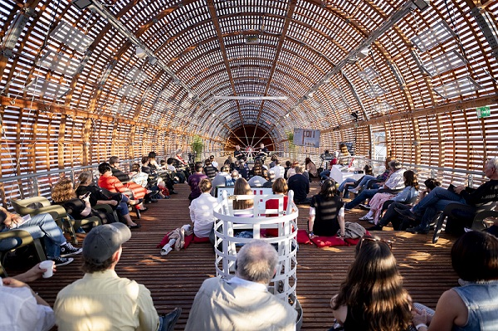

**TICKETS**

Tickets for individual events or advantageous one-day or whole-festival passes, which also include admission to all current exhibitions at DOX, are available for purchase.

* [**David Lynch: Up in Flames**](https://www.dox.cz/en/whats-on/david-lynch-up-in-flames)
* [**Viktor Pivovarov: Metaphysics and Despair**](https://www.dox.cz/en/whats-on/metaphysics-and-despair) (last day of the exhibition: October 5)
* [**Orhan Pamuk: The Consolation of Objects**](https://www.dox.cz/en/whats-on/orhan-pamuk-the-consolation-of-objects)
* [**Miquel Barceló and the Written Worlds**](https://www.dox.cz/en/whats-on/miquel-barcelo-and-the-written-worlds)

# Family workshops are FREE.

# More at [doxfall.cz](https://www.doxfall.cz/en/program/the-spirit-lamp) and [goout.cz](https://goout.net/en/)!

**FESTIVAL IN THE AIR, OR WHERE THE FESTIVAL TAKES PLACE**

The DOX Centre for Contemporary Art was created through a private initiative to renovate a former factory in Prague’s Holešovice district. It is the largest non-governmental non-profit institution focused on contemporary art in the Czech Republic. Since 2008, its mission has been to create an environment for research, discussion, and artistic presentation of important social issues, with visual arts, literature, music, theatre, and other disciplines enabling a critical approach to the so-called reality of today’s world. The exhibition space of more than 3,000 m2 is complemented by the DOX+ multifunctional hall, the Gulliver airship, the Fine Arts Archive, the Bendox bookstore, and the DOX by Qubus design store. The heart of the FALL festival is the **Gulliver** **Airship** on the roof of the DOX Centre for Contemporary Art, which was created in 2016 by renowned architect Martin Rajniš and his Huť Architektury studio and DOX director Leoš Válka.

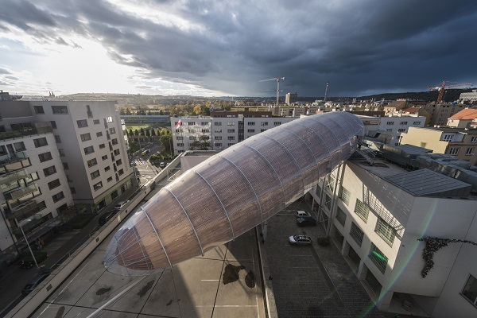

**Festival FALL**

**2 October – 5 October 2025**

DOX Centre for Contemporary Art

Poupětova 1, Prague 7

The press release and press-quality photos can be downloaded after registration on the DOX Centre website in the [Press](https://www.dox.cz/users_area/register) section.

## Photographs by: Jan Slavík, ©DOX

Contact

**Karolína Kočí**  
E [karolina.koci@dox.cz](mailto:karolina.koci@dox.cz)

T +420 777 870 219

**www.dox.cz**