The Human Body, Veins, and Roots: The Funny Games Exhibition by Moldovan Artist Alexander Tinei
Press release, 3 November 2022

The human body as the alpha and omega of the image. The author of the new exhibition Funny Games - Moldovan artist Alexander Tinei - finds inspiration in everyday life, childhood, tattoos, found photographs and their mysterious banality. Individual works, both monumental and small formats, are pieces of a grand mosaic of human life, and painting itself is his way of understanding the world and life around him. Funny Games at DOX is Tinei's biggest solo exhibition to date.

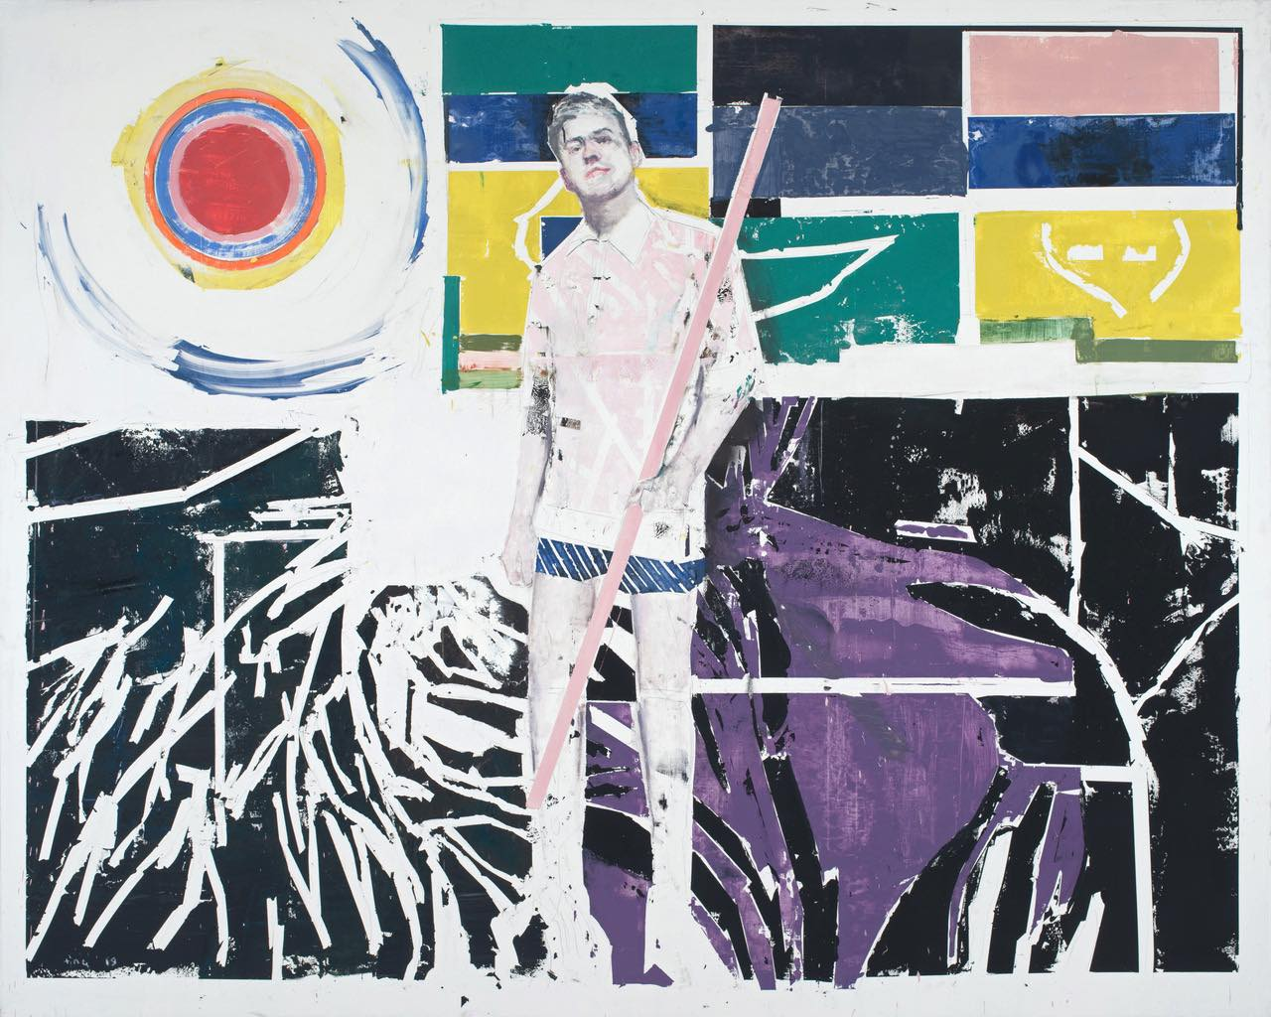
↑ Measuring the Roots ©Kunsthalle Prague

The human body has become the basic building block of Tinei’s paintings. His work has a strongly existentialist character, the figures are mostly lonely or collapsed, the surrounding atmosphere only enhances the impression, the painted and naked bodies look fragile and vulnerable. The artist’s works resemble a kind of diary entries, reflecting not only what is seen, but especially inner experience. Alexander Tinei himself says that it was only with figurative painting that his message became complete. “At the beginning of my career, I was looking for a sign of the times, an element that defines the time in which we live. I realised that our tattoos were something like graffiti in an urban development. We can't imagine urban culture without graffiti. Figurative painting gives me the opportunity to form personal ideas about myself as an artist who lives in the present.”

Tinei is constantly searching for new ways of expression and form, yet his works are recognizable at first sight. He has found and developed his own artistic language over the past two decades. He has long been consistent in the themes that interest him, repeatedly returning to the fundamental questions of the meaning of human existence, to the deepest reaches where the darkness of the unknowable and the light of the seen reign. Tinei’s paintings are a very personal statement about the world around us and the search for God in the insignificance of life.
Birds ©Robert Runták

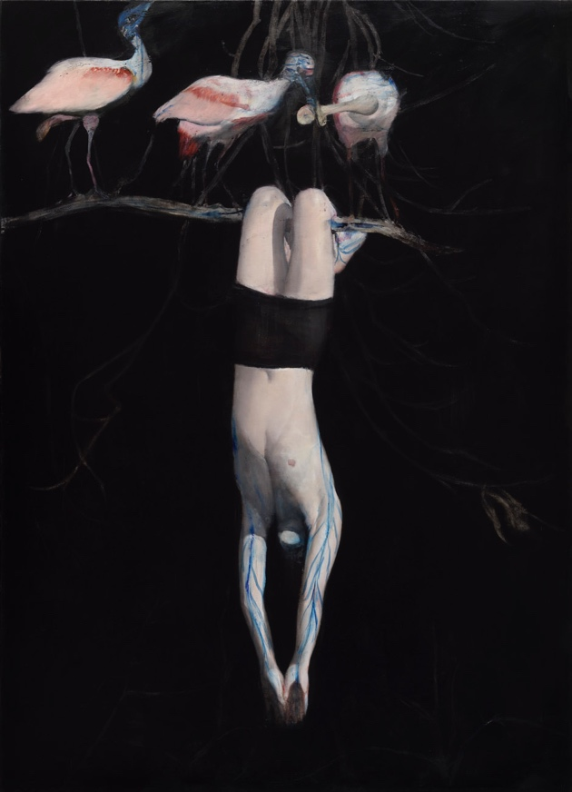
Tinei’s works are characterized by a kind of feeling of vulnerability and uncertainty. Even the figures themselves are often wounded. What is normally hidden under the skin is visible in Tinea's work, for example the structure of veins. In a way, it's a loss of protection and being thrown into a world that often confounds a person if they can't navigate it. The Funny Games exhibition is not a retrospective, but a kind of representative slice of work. The leitmotif is the surface of the body, the skin and roots, the question of identity and where I belong.
Roots are also usually hidden, but he exposes them in his paintings. Tinei himself is very religious, his work is closely linked to Christian spirituality.
(Otto M. Urban, curator of the exhibition)

It was the curator of the exhibition, Otto M. Urban, who came up with the idea of naming the exhibition after Michael Haneke’s film Funny Games (a thriller from 1997). The artist Alexander Tinei immediately agreed. “The title Funny Games is a cynical look at the crisis we are going through. I like this definition of Romanticism; in my opinion, it is a reflection of our times: at the heart of the Romantic worldview (1815-1920) is a sense of bitter conflict between man and reality, between individuality and society. The basic mood is one of sadness, loneliness, despair. Tragic disappointment at the impossibility of realising one's ideas and ideals.”
Alexander Tinei, born in 1967 in Moldova, has been one of the most important representatives of European painting for almost two decades. However, his journey onto the contemporary artistic map of Europe has not been a straightforward one. A long pilgrimage from the periphery closer to the cities, and later to Budapest, Hungary, awaited him. He was first introduced to the Czech public in 2009 at the Prague Biennial, and his participation in the group exhibition Nightfall at the Rudolfinum Gallery in 2013 also attracted attention. Reproductions of his paintings have appeared in the prestigious books Vitamin P2 (Phaidon, 2011) and Painting Now (Thames & Hudson, 2015). His work has been presented in dozens of solo and group projects. Funny Games at the DOX Centre for Contemporary Art is his largest solo exhibition to date.
* The works Mountains Are Crying Too (2017), Reading (2020) and Study for a Head (2021) are on loan from Magnus Art Gallery.

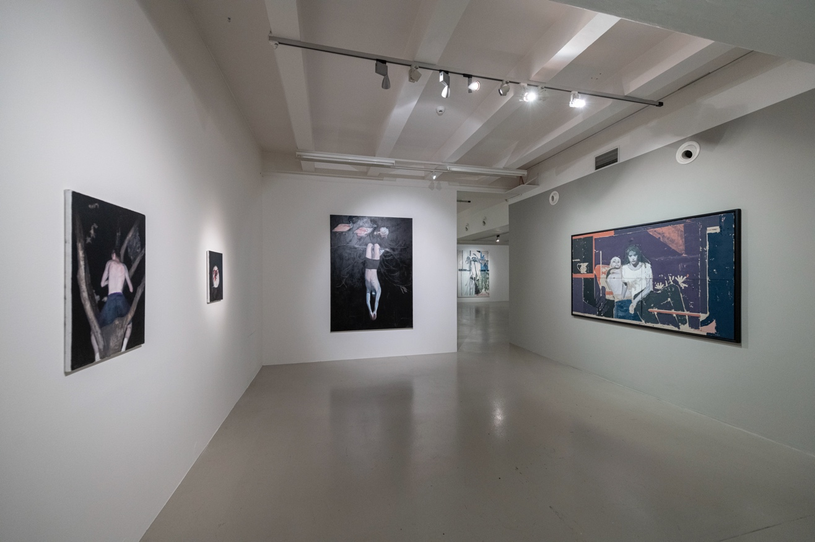
↑ view of the exhibition Funny Games, photo: Jan Slavík

Alexander Tinei studied in Moldova in the 1990s, at a time when information about art in this part of the world was often conveyed only through catalogues and books. The periphery of independent Moldova remained culturally frozen in modernism for a long time. It was only at the relatively old age of 35 that Tinei left for Budapest, where he discovered a world he had only known from reproductions. The Hungarian capital opened the door to contemporary art for him. He returned to painting, and it is fair to say that his career did not begin until he was almost 40. For Tinei, the journey from Moldavia to Budapest was therefore quite crucial.
(Otto M. Urban, curator of the exhibition Funny Games)

Alexander Tinei: Funny Games
4 Nov. 2022 – 19 Mar. 2023
DOX Centre for Contemporary Art
Poupětova 1, Prague 7

Curator: Otto M. Urban
Press release and photos can be downloaded after registration in the Press section.

Contact:
Karolína Kočí
E karolina.koci@dox.cz
T +420 777 870 219
www.dox.cz

