Japan comes to DOX: GA-I-SU-RA reveals the world of legendary Japanologist and calligrapher Petr Geisler
The DOX Centre for Contemporary Art is launching the exhibition GA-I-SU-RA, the most comprehensive presentation to date of the work of Czech Japanologist, translator, journalist, calligrapher, photographer, and educator Petr Geisler (1949–2009). The project profiles an extraordinary figure who left a unique mark on cultural relations between the Czech Republic and Japan. The exhibition took shape gradually over the course of more than fifteen years at the initiative of Ester Geislerová, who developed the project over the long term and gathered materials from the family archive, among other sources. She then invited Petr Holý, a Japanologist, theatre scholar, and former student of Petr Geisler, to help shape the project’s final form. Aňa Geislerová also contributed to the exhibition concept, bringing a personal perspective to the project alongside her sister.
“The key to the GA-I-SU-RA exhibition is an unwavering desire to present Petr Geisler as an original artist, while also giving visitors insight into his life as a whole. The layout spanning three floors was brilliantly suggested by Michaela Šilpochová and Leoš Válka from DOX, based on the vast amount of materials that Aňa and I presented to them, which I had begun collecting after my father’s death. Over the past three years, we’ve been enriching the material with the help of Japanologist Petr Holý and discovering new perspectives on my father’s work. It also took some time to decipher and translate what Dad himself, with a bit of hyperbole, called ‘scribbles’. We concluded that Petr Geisler didn’t pretend to be anything he wasn’t, he wasn’t afraid to experiment with materials, and he was a bit punk when it came to calligraphy.”
Ester Geislerová on the exhibition concept
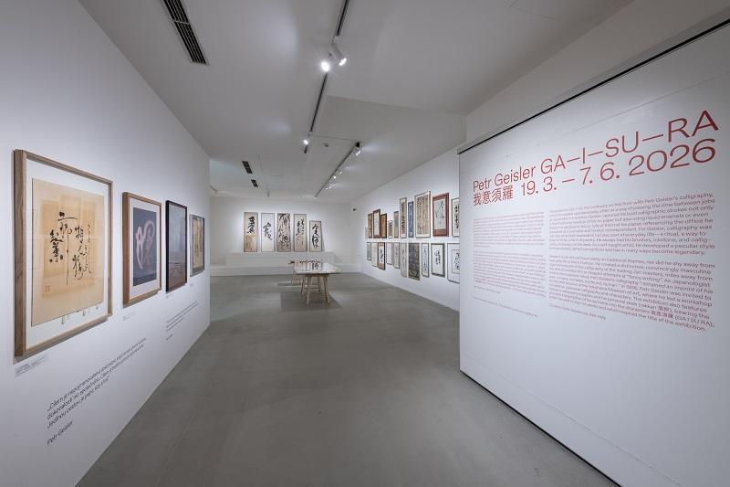
The exhibition presents Geisler’s work spanning several decades – from expressive calligraphy created spontaneously during his “idle moments” between jobs, to multiple-exposure photographs from 1980s Japan, to a monumental transcription of the Buddhist Heart Sutra which once adorned a wall in the arcade of the Metro Palace on Národní třída in Prague.
As curator Ester Geislerová describes, working on the project was also a personal journey towards a deeper understanding of her father: “I have so many memories of Dad. During my search, mixed in with all the calligraphy, notes, and e-mails, I would occasionally come across family postcards, our childhood drawings, and poems or even fairy tales that he wrote himself. My dad revealed himself to me most during the filming of the upcoming documentary Two Decilitres of Ink, when I talked about him with people who knew him for. For instance, I’ve discovered that he was a really good friend to a lot of people – and that’s nice. I’ve learned about his gentle, fragile inner world but also about his demons and ambivalence. Thanks to the photographs that I’ve been sorting through for years now, I can also see what fascinated him, how creative he was, and what a sense of humour he had. But they also give me a sense of how loving he was – and that he was loved in return.”
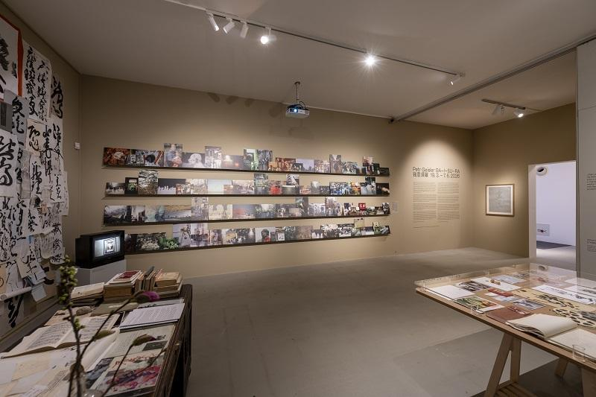
For Petr Geisler, calligraphy was much more than just an artistic discipline. It became a part of his daily life, a ritual, and a way to think. He always had a brush, ink, and inkstone at hand – whether he was working with traditional ink on paper or experimenting with liquid enamels, bleach, or unusual materials such as cardboard, plastic film, or rolls of thermal fax paper. As a self-taught artist, he developed a distinctive style that defied convention, with an energy often reminiscent of the calligraphy of the Zen masters.
Geisler worked as a foreign correspondent for the prestigious Japanese daily newspaper The Yomiuri Shimbun for over thirty years. The exhibition therefore also commemorates his work as a journalist. Visitors can see excerpts from articles he wrote in brilliant Japanese, his office environment, and testimonials from colleagues, friends, and students that shed light on Geisler’s life between two worlds – Japanese writing and Czech reality, text and image, the precision of journalism and the freedom of artistic expression.
As Japanologist and co-curator of the exhibition Petr Holý recalls, Petr Geisler was a symbol of freedom for students and colleagues alike: “Petr Geisler wasn’t just our Japanese studies teacher at Charles University; he was a symbol of freedom – and not just personal freedom but creative freedom as well. He was a Japanese scholar, educator, journalist, translator, calligrapher, and artist all in one, but he was certainly much more than that too, and as an unforgettable figure, he left an indelible mark on our academic lives and more. The key to the exhibition is therefore the man himself – Geisler, as we respectfully called him – and his unpretentious, nonchalant, and somewhat punk lifestyle, supported by his immense talent and diligence, which Ester and I have attempted to capture in the exhibition through three perspectives, as a tribute to a man who left us too soon.”
The exhibition also features authentic objects from Geisler’s personal archive: calligraphy tools, personal seals bearing the phonetic transcription of his name in kanji as 我意須羅 (GA-I-SU-RA), artefacts from his legendary office, where Japanology students attended classes in the 1990s, slides from Japan, and film recordings of student happenings. The exhibition also includes a unique installation – a reenactment of the performative project The Heart Sutra, which symbolically draws visitors into the very text of one of the most famous Buddhist sutras.
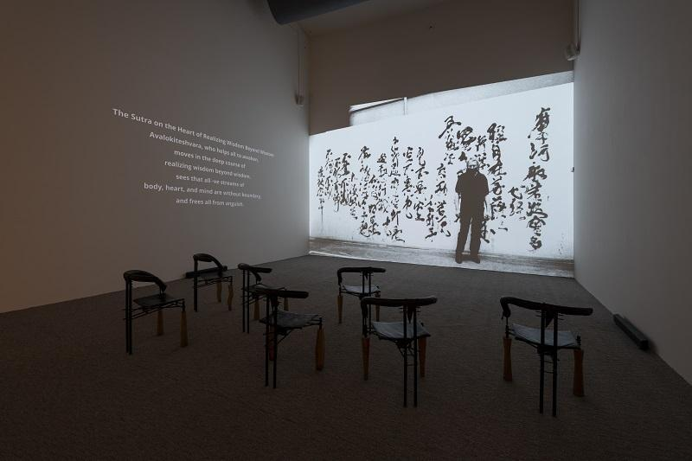
According to curator Ester Geislerová, the exhibition is structured in three interconnected levels, which together reveal various facets of Petr Geisler’s personality: “One level depicts my father’s everyday life: his work as a journalist for a Japanese newspaper, as a translator of poetry from the land of the rising sun, and as a self-taught calligrapher. Here we see his office – which looks as though he has just left – as well as a collection of striking photographs recently discovered in a suitcase in the basement and his work with multiple exposures. On the middle floor, you’ll encounter the calligrapher’s previously exhibited works – calligraphy he dedicated to his loved ones – as well as newly discovered pieces found by chance or thanks to an appeal shared on social media. And the third level is connected to the artist as a person who sought spiritual transcendence in calligraphy, which is why we can enjoy his greatest work – The Heart Sutra – in an audiovisual form.”
GA-I-SU-RA is not just an exhibition paying tribute to Petr Geisler. It is a celebration of calligraphy as a form of inner expression. It serves as a reminder that writing and beautiful script can be a natural reflection of, among other things, a pure soul.
“Dad was a mixture of a lot of contradictory elements. He had a talent for so many things, yet he didn’t attach any great importance to this. He could do anything he set his mind to – from languages to playing musical instruments to woodcarving to calligraphy – and yet he never seemed to want to make a name for himself with any of it. He was wonderful and surrounded by children and love, but even that didn’t keep him from self-destruction. Now, stepping back, I see his world and his talent organised into meaningful wholes; I see a true work of art and I see an artist. I’m proud of him, just as I am of Ester for ‘putting him together’ so beautifully for us and for herself. And I’m happy that Michaela Šilpochová saw that artist even in the chaos that GA-I-SU-RA initially seemed to be,” concludes Aňa Geislerová.
What does GA-I-SU-RA actually mean? It is the Japanese pronunciation of the name Geisler. Like Japanese calligraphers, Petr Geisler also signed his works with a seal. His surname, when transcribed into Japanese, is Gaisura. When the four kanji used to write it are translated literally, it means “my intention requires silk”.

Curators: Ester Geislerová, Petr Holý
Exhibition concept: Ester Geislerová, Aňa Geislerová

The exhibition will run from 19 March to 7 June 2026.

Petr Geisler (1949–2009) was a prominent Czech Japanologist, journalist, teacher, translator, and self-taught calligrapher. From 1967 to 1973 he attended Charles University in Prague, where he studied English as well as Japanese under the renowned Czech Japanologist, literary theorist, and philologist Miroslav Novák, whose tutelage Geisler considered to be an enormous boon to his life and a source of inspiration. From 1974 he worked as a correspondent for the Japanese daily newspaper The Yomiuri Shimbun, and from 1984 as a foreign editor. In the 1980s and 1990s he translated a number of important works of ancient Japanese poetry into Czech. His translations can be found mainly in the anthologies Zápisky z volných chvil (Notes from Leisure Time, 1984) and Bledý měsíc k ránu: milostná poezie starého Japonska (Pale Moon at Dawn: Love Poetry of Ancient Japan, 1994).
As a self-taught artist, he devoted himself to Japanese calligraphy, and even Japanese experts appreciated his works for their distinctive style and artistic quality. Geisler often mounted his works in frames that he made by hand or modified himself. His artworks have been presented in solo exhibitions in the Czech Republic and Slovakia, and they are held in the collection of the National Gallery Prague. Petr Geisler’s calligraphy also accompanied several important publications, such as Pár much a já: malý výběr z japonských haiku (A Few Flies and Me: A Small Selection of Japanese Haikus, 1996), Zlatý pavilon (The Golden Pavilion, 1998), and Cesta srdce (The Way of the Heart, 2008).
The GA-I-SU-RA exhibition was created at the initiative of and in close cooperation with Petr Geisler’s family, especially his daughters Aňa, Ester, and Lenka and his son Felix.
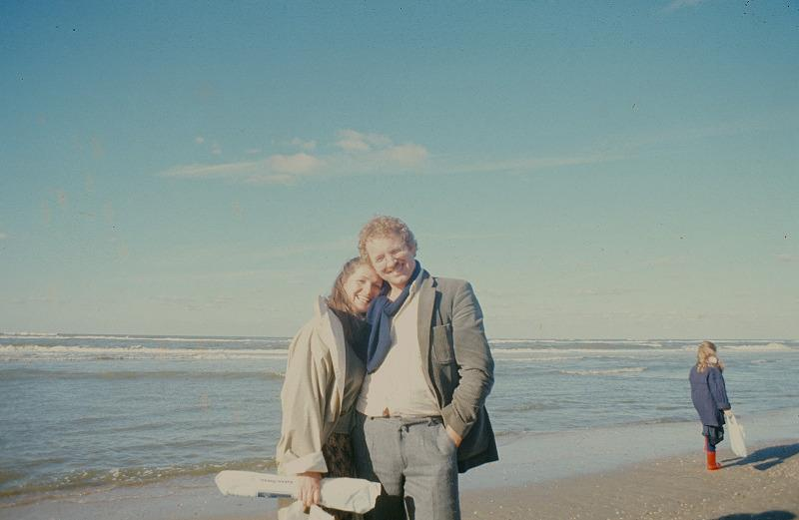
Photo from the Geisler family archive

ACCOMPANYING PROGRAMME FOR THE EXHIBITION

22 March 2026, 15:00
MOMI: Vintage & Antique Kimono Show
This showcase of kimonos from the collection of MOMI 紅絹, which focuses on traditional Japanese clothing from the end of the Taishō era and the beginning of the Shōwa period (1920s), will be led by Kumie Holý, a professional stylist who specialises in Japanese kimonos and makeup for art and film. The showcase will be followed by a workshop that will offer practical advice about wearing kimonos as everyday clothing.
https://www.dox.cz/en/whats-on/momi-vintage-antique-kimono-show

26 March 2026, 17:00
Kwaidan: Hōichi the Earless
A lecture by Japanologist Petr Holý about director Masaki Kobayashi’s renowned film Kwaidan, followed by a reading of “The Story of Mimi-Nashi-Hōichi” from Lafcadio Hearn’s book Kwaidan: Stories and Studies of Strange Things (Czech translation by Petr Holý, K-A-V-K-A, 2024) and a discussion with Aňa and Ester Geislerová.
https://www.dox.cz/en/whats-on/kwaidan-hichi-the-earless

29 April 2026, 16:00
Guided tour of the exhibition GA-I-SU-RA with Ester and Aňa Geislerová
GA-I-SU-RA is not just an exhibition paying tribute to Petr Geisler. It is a celebration of calligraphy as a form of inner expression. It serves as a reminder that writing and beautiful script have always been a natural reflection of, among other things, a pure soul. Visitors can delve deeper with a guided tour alongside Ester and Aňa Geislerová.
https://www.dox.cz/program/vystavou-ga-i-su-ra-s-ester-a-anou-geislerovymi

29 April 2026, 18:00
Launch of the catalogue for the exhibition GA-I-SU-RA / Euromedia
Join us in celebrating the launch of the GA-I-SU-RA exhibition catalogue! The core of the publication consists of reproductions of Geisler’s calligraphy, complemented by an insightful essay by distinguished Japanologist Helena Honcoopová as well as curatorial and personal contributions and the artist’s photographs from Japan.
The catalogue is published by Euromedia under the Universum imprint.
https://www.dox.cz/program/krest-katalogu-k-vystave-ga-i-su-ra

3 June 2026, 18:00
DOXYGEN: In Praise of Shadows with Moemi Yamamoto
DOXYGEN is DOX’s regular program for the younger generation under thirty – a fresh cultural emulsion, this time in the form of a guided tour and lecture by Japanese painter Moemi Yamamoto, who studied fine arts in Japan and recently graduated from AVU in Prague. The programme is inspired by the GA-I-SU-RA exhibition and the theme of interweaving Eastern and Western cultures.
https://www.dox.cz/program/doxygen-chvala-stinu-s-moemi-yamamoto

DOX Centre for Contemporary Art
Poupětova 1, Prague 7
Open: Tue–Sun, 11:00–19:00
The press release and photographs can be downloaded after registering in the Press section of our website.

Photographs of the exhibition: Jan Slavík

Contact
Karolína Kočí
E karolina.koci@dox.cz
T +420 777 870 219
www.dox.cz

