Exhibition features Vladimír Doležal´s unknown artwork

Press release

The exhibition Lost in... is a journey through the fragile and subtle work of Czech artist Vladimír Doležal. A respected restorer of medieval wall and panel paintings and at the same time an almost unknown painter - yet one of the most progressive of his generation.

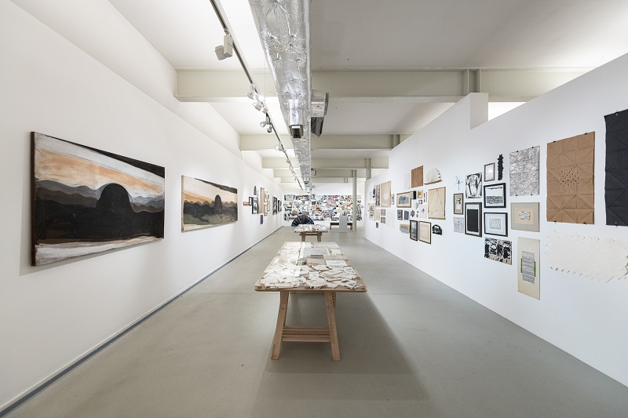
↑ a look into the exhibition Lost in …

“Discussing the work of Vladimír Doležal is like diving into a big river. Hundreds and thousands of drawings, sketches, paintings, artefacts... Layers and layers. Pleasure after pleasure. It is obvious that for Vladimír Doležal, continuous creation was a natural state,” says Leoš Válka, director of the DOX Centre and curator of the exhibition.
A cross-section of the artist's archive offers abstract and conceptual works, paintings, and drawings. The genre of the artist's book was of particular importance in his oevre. His work in this field encompasses a number of categories, from sketchbooks to interventions in existing books or other prints to spatial book objects.
Vladimír Doležal's archive can be compared to a treasure carefully preserved for decades. Creation was his life's passion. However, exhibitions and self-presentations were absent from his field of vision. That is why the unique works remained hidden from the public eye for a long time. The artist is remembered at DOX by his son Kryštof Doležal, who has been managing his father's archive for years. “He was extremely persistent in his work; he was constantly creating. Wherever he was, he was always drawing or painting or composing something. In the places where he lived and created, it was impossible to move around at all, the spaces were absolutely full. And now that we've brought his work into DOX and spread it out over this big area, I keep discovering more and more things that I've never seen before.”

The author's work is intensely permeated by his experience as a restorer and his knowledge of the European artistic tradition. "It is not a simple, first-rate work. It requires concentration and perhaps a knowledge of art history. This knowledge may be one of the keys to looking at the work and uncovering references to specific works by the old masters. Thanks to this link, the few modest lines suddenly move to a completely different level," explains Otto M. Urban, the exhibition's curator.

According to catalogue editor Lucie Rohanová, a deep understanding of the meaning of figurative images was decisive for Doležal's work. "With the figure, the artist expresses the spiritual world, what is close to man in it, as well as the unattainable. Doležal repeatedly dealt with figures in certain attitudes, with typical gestures. Again and again, he varied them, constantly rethinking the meanings that have been associated with them since time immemorial and intuitively understandable to everyone.”

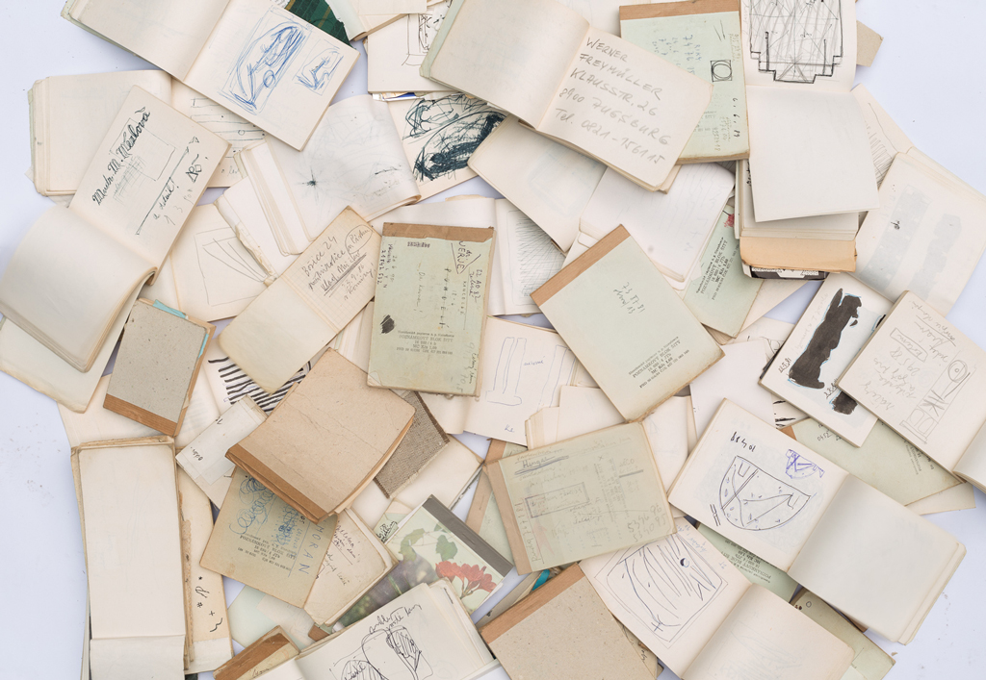
The focus of Doležal's independent abstract work was the simple line. This stream of work includes mainly the modification of various found objects - metal sheets, cardboards, posters and advertising flyers.

Doležal also worked with horizontally arranged lines in many of his author's books, a genre, with which he dealt consistently.
↑ the work of Vladimír Doležal

Given that the artist's works are in most cases undated, the creators of the exhibition decided not to follow the path of chronology. Michaela Šilpochová, Programme Director of DOX and curator of the exhibition, explains the chosen concept. “We have tried to indicate the different directions that Vladimír Doležal took in his work, specific motives he used, and also the way these motives interact across his figurative, abstract and conceptual work. For example, working with line, which transitions into landscape or even into the female body - and vice versa, or into a line in a book. We hope these links and connections will delight the attentive viewer.”

Vladimír Doležal: Lost in... creation, art, paper, inner and outer world? Maybe …

Vladimír Doležal
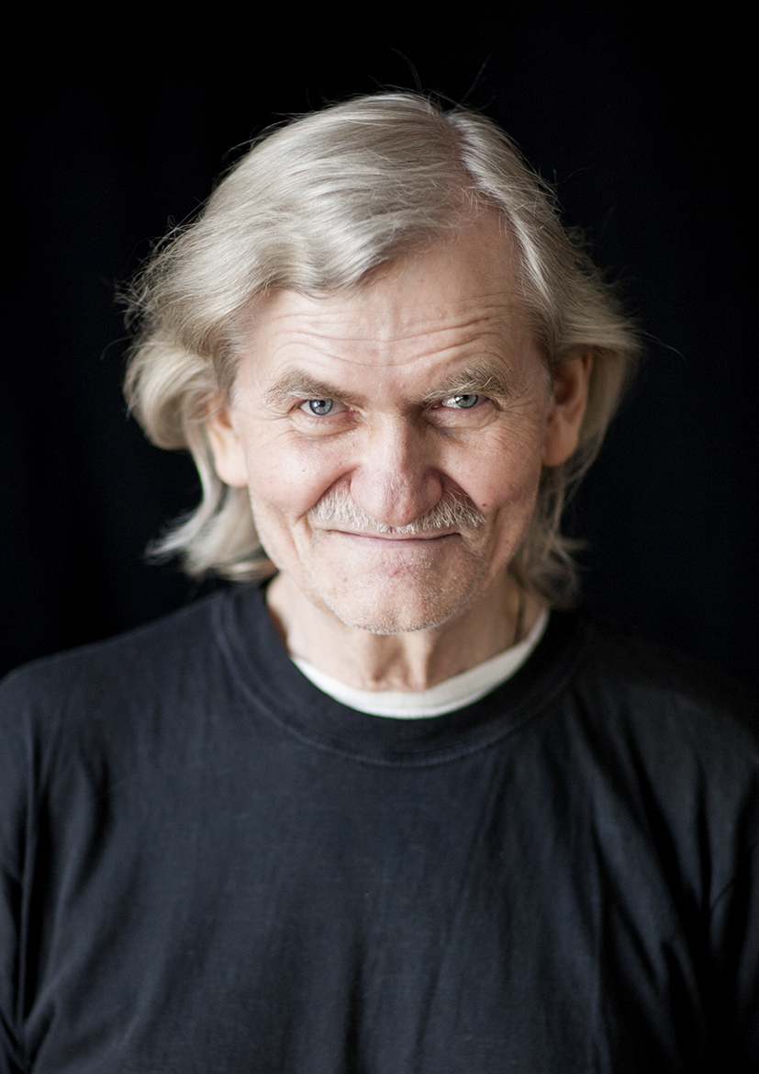
Vladimír Doležal (9 June 1946 - 3 January 2017) was born in Bratislava, where he graduated from the Secondary School of Art Industry, majoring in graphic arts, and the Academy of Fine Arts, majoring in painting and restoration. In 1969 he transferred to the Academy of Fine Arts in Prague to Prof. Bohuslav Slánský.
After graduating in 1971, his source of livelihood became restoration work. Until the end of the 1980s, he worked on the rescue of frescoes in the Most region and continuously restored frescoes in Prague's Loreta, Stary Plzenec, Židovice, Kopisty, the castle in Telč and the Church of St. Bartholomew in Hněvkovice and also hung paintings from various periods; he also specialised in polychrome sculpture.
In 1993-2000 he worked at the Academy of Fine Arts in Prague, first as an assistant at the restoration school of Prof. Karel Stretti, and since 1995 as a leading teacher of classical painting techniques.
In the 1990s he also led summer workshops at Miami University (Oxford, Ohio) on working with paper and found objects.

Accompanying programme to the exhibition Lost in …

30 Oct 2022 (4 PM)
Exhibition Lost in... with art historian Jan Rous
The guided tour will focus on the author's diaries, interventions in printed materials and spatial book objects.

1 Dec 2022 (6 PM)
The figurative versus abstract work of Vladimír Doležal
Guided tour with Lucie Rohanová.

Lost in…
13 Oct 2022 – 8 Jan 2023

Curators: Otto M. Urban, Leoš Válka, Michaela Šilpochová
Cooperation and texts: Lucie Rohanová
Exhibition design: Leoš Válka
Graphic design: Kryštof Doležal
Catalogue Editor: Lucie Rohanová
Exhibiting artists: Vladimír Doležal

The press release and photos can be downloaded after registration in the section Press

Contact
Karolína Kočí T +420 777 870 219
DOX Centre for Contemporary Art E karolina.koci@dox.cz

