**One of the most acclaimed contemporary Spanish artists is coming to the Czech Republic.**

**DOX Centre for Contemporary Art presents Miquel Barceló and the Written Worlds, an exhibition dedicated to literature**

**Miquel Barceló, one of the most acclaimed contemporary Spanish artists, is for the first time presenting his work in the Czech Republic. The painter and sculptor, celebrated for his relief paintings, bronze sculptures, ceramic works and monumental installations, experiments with unconventional materials while remaining firmly in the glorious tradition of painting, where he follows in the footsteps of Picasso and Goya.**

**Barceló has for instance created a well-known monumental installation at the United Nations Office in Geneva and large-format tapestries for Notre-Dame Cathedral in Paris, and this year he was one of three artists chosen for a competition to create a design for the monumental entrance façade of the Sagrada Família in Barcelona.**

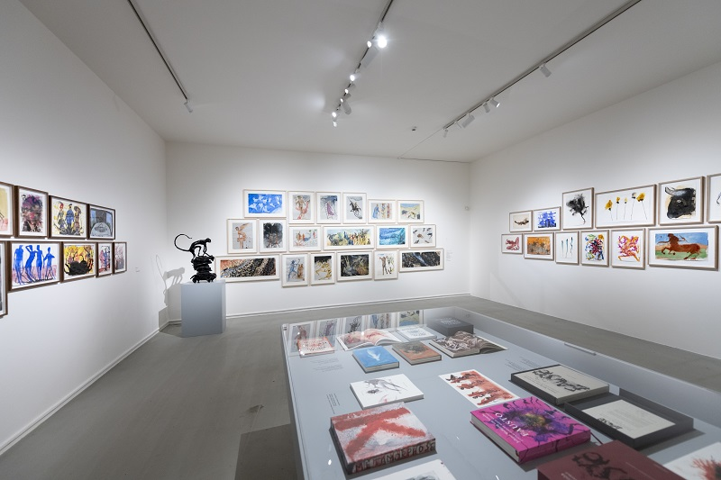**As part of the 3rd** [**FALL Festival**](https://www.doxfall.cz/en) **(Festival of Arts, Literature and Learning) DOX, supported by Instituto Cervantes Prague, presents an exhibition entitled**[**MIQUEL BARCELÓ AND THE WRITTEN WORLDS**](https://www.dox.cz/en/whats-on/miquel-barcelo-and-the-written-worlds)**, which is devoted to his relationship with literature. The exhibition’s curator is the Spanish poet Enrique Juncosa.**

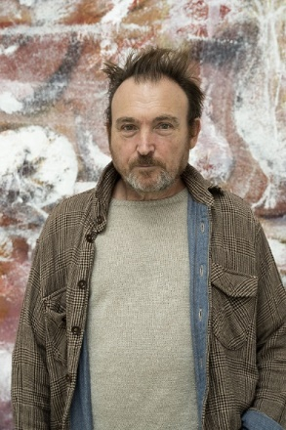Miquel Barceló (1957, Mallorca) is from a generation of Spanish artists who came to the attention of the international art scene in the 1980s and 90s, including other very well-known painters such as Juan Uslé and sculptors such as Juan Muñoz and Cristina Iglesias.

The exhibition ***Miquel Barceló and the Written Worlds*** is the artist’s first-ever presentation in the Czech Republic, focusing on his long and intense relationship with literature. This has been a recurring inspiration at various points in his career, which spans more than four decades, and it will be presented at the exhibition through paintings, ceramics, watercolours, bronzes, prints, and books.

*“As a poet and storyteller, I have had the opportunity to work with Barceló not just on artistic projects but on literary ones as well. His homes and studios are full of books, and I can say with certainty that whenever we meet we are more likely to talk about literature than painting,”* says the exhibition’s curator, the poet Enrique Juncosa. *“Over time we have also discovered that Barceló writes, and that he does so in French. Facsimiles of some of his notebooks have been published, but this is not even the tip of the iceberg, as around four hundred notebooks have been already been catalogued, although images are far more predominant in them than text. In 2024 Barceló also published a remarkable autobiographical book (…). In this book we find a list of authors, who Barceló assures us are placed in the order in which he read them. The list begins with Don Quixote.”*

When Barceló became internationally known following his participation at documenta 7 (1982) and in the Aperto section at the Venice Biennale (1984), he painted a series of monumental libraries that included self-portraits of him reading or sleeping next to empty bottles and open books. The names of the authors he admired at the time can be read on the spines of the books painted on the bookshelves.

He has also named some of his paintings after famous characters in literature such as Ahab or Hamlet, and some of his large-format still lifes refer to the works of favourite authors such as F. Scott Fitzgerald and José Lezama Lima.

Recently Barceló has illustrated special editions of classics of world literature, including Dante’s *Divine Comedy*, Goethe’s *Faust* and Kafka’s *The Metamorphosis*. When working on the illustrations for these three books, and inspired by their content, he cultivated his interest in the fantastical. *“In none of these three cases is it a question of drawing literal images, but rather of creating parallel universes. These three books have made it possible for Barceló, without him perhaps even having to think about it, to enter the world of the fantastic, something that has had a notable influence on his later paintings,”* says the curator Enrique Juncosa. A selection of Miquel Barceló’s watercolours for these classic works of literature will feature at the *Written Worlds* exhibition.

There will also be several bronze sculptures related to literary themes, as well as a series of ceramic sculptures of philosophers who are treated more expressively than realistically, and a series of portraits of famous writers made using the xylography technique.

While the earliest works at the exhibition are from the 1980s, there will also be some of Barceló’s very recent works, including still lifes with literary motifs and a series of paintings of shipwrecks named after poets who chose to take their own lives.

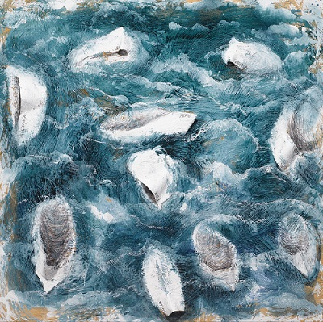According to the exhibition’s curator, Enrique Juncosa, a political subtext is immediately evident in Barceló’s shipwrecks: they allude to *“the terrible news of African immigrants drowning as day after day they try to cross the Mediterranean to reach Europe, in fragile and fatally inadequate vessels. In a way that I find hard not to call repugnant, these accidents provoke intense outbursts of hatred in certain sections of the public. In these pictures of shipwrecks, however, we also find some with precise literary references. Shipwrecks (mixed media on canvas, 2020) shows ten capsized boats on a rough sea.”*

↑ Shipwrecks (2020), photo David Bonet, © David Bonet, Miquel Barceló and AGADP

At the top of the DOX Centre’s tower visitors will be able to see the artist’s interpretation of a biblical theme. *Noah’s Ark*, a canvas measuring 4 × 6 metres, is Barceló’s largest canvas to date, and this will be the first time it is shown in a gallery (it has previously only been displayed to the public in a church in Salamanca in Spain). The painting shows various kinds of fruit and vegetables, two of each, echoing how the biblical Noah led the animals two by two into his ark.

The exhibition will be supplemented by a selection of books on which Miquel Barceló has worked with a number of prominent writers.

**Miquel Barceló and the Written Worlds**

**4. 10. 2025 – 8. 3. 2026**

**DOX Centre for Contemporary Art**

Poupětova 1, Praha 7

open: Tue–Sun, 11.00 a.m. – 7.00 p.m.

**Contact**

**Karolína Kočí**

E [karolina.koci@dox.cz](mailto:karolina.koci@dox.cz)

T +420 777 870 219

[www.dox.cz](http://www.dox.cz/)

After registration the press release and photographs can downloaded in the [Press](https://www.dox.cz/users_area/register) section.