**Turkish Nobelist Orhan Pamuk is heading to Prague’s DOX Centre for Contemporary Art to speak about his visual art.**

**On 17February 2025, the Turkish Nobel Prize-winning author will deliver a talk at the DOX Centre for Contemporary Art, where the exhibition *The Consolation of Objects* featuring Orhan Pamuk’s photographs, drawings, sketchbooks, and his famous Museum of Innocence is currently on view. On this occasion, his novel *Nights of Plague* will be released in Czech.**

While Orhan Pamuk’s literary work has been recognised all over the world, his work in the domain of the visual arts has remained unknown to the wider public.

*“Orhan Pamuk has long been interested in the relationship between word and image, as evidenced in his own artistic work, which is currently presented at DOX. On this special occasion, he will be talking about his creative process, how the visual arts impact his writing and vice versa, and also about his famous Museum of Innocence in Istanbul - probably the only museum in the world that an author conceived from the beginning as a novel and as a real museum*,” explains Michaela Šilpochová, DOX artistic director and the exhibition curator.

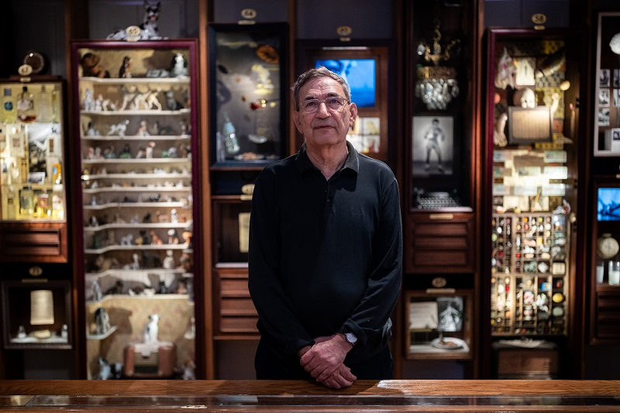  
While the Museum of Innocence, which Orhan Pamuk opened in Istanbul in 2012, forms the centre of the Prague exhibition, other artworks are on display including his photographs, drawings, notebooks and sketchbooks. In his most recent art works, Orhan Pamuk enters into an imaginary dialogue with the classical works of the old masters and modern painters from the collections of the Staatliche Kunstsammlungen Dresden and Lenbachhaus Munich, which he researched in 2022-23.

↑ Orhan Pamuk in the exhibition The Consolation of Objects, photo: Rasmus Quistgaard

The exhibition project *The Consolation of Objects* is presented in collaboration with Orhan Pamuk, the Museum of Innocence in Istanbul, Staatliche Kunstsammlungen Dresden and the Lenbachhaus Munich.   
  
Apart from the original artwork by Orhan Pamuk, the exhibition features *A House of Ink*, a poetic video portrait of the literary and visual work of Orhan Pamuk created by Turkish video artist Ali Kazma. Two documentary films about Orhan Pamuk produced by the online Louisiana Chanel are on view, kindly provided by the Louisiana Museum of Contemporary Art, Copenhagen.

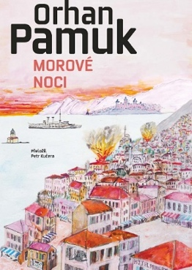The event ***Orhan Pamuk in Prague: Between Word and Image,*** *which* will take place on 17 February 2025 at the DOX Centre for Contemporary Art in Prague, will be accompanied by the launch of the Czech edition of the author’s novel *Nights of Plague*, (Argo, translated by Petr Kučera). The cover of the Czech edition features one of Orhan Pamuk’s drawings. Tickets can be obtained at [**https://www.dox.cz/en/whats-on/orhan-pamuk-in-prague-between-word-and-image**](https://www.dox.cz/en/whats-on/orhan-pamuk-in-prague-between-word-and-image)

**Orhan Pamuk** is the author of eleven novels, six non-fiction books, two books of photographs and most recently a book of illustrated notebooks chronicling his creative process. He is the winner of the 2006 Nobel Prize in Literature. In 2008, he published the novel *The Museum of Innocence*, in which he develops the themes of love, marriage, friendship and happiness in their personal and social dimensions, and in 2012 he opened the Museum of Innocence in Istanbul, which was awarded European Museum of the Year 2014. Orhan Pamuk is considered one of the greatest writers of our time. His work has been translated into more than 60 languages.

↑ Book cover of the Czech edition of Nights of Plague featuring a Orhan Pamuk’s drawing

**DISCUSSION & BOOK LAUNCH EXHIBITION**

**Orhan Pamuk in Prague: Orhan Pamuk:**

**Between Word and Image The Consolation of Objects**

**17 February 2025 21 November 2024 – 6 April 2025**

DOX+ Multifunctional Hall DOX Centre for Contemporary Art

Poupětova 3, Prague 7 Poupětova 1, Prague 7

## This press release and high-resolution images can be downloaded in the [Press](https://www.dox.cz/users_area/register) section after registration.

## Contact:

**Karolína Kočí**

E [karolina.koci@dox.cz](mailto:karolina.koci@dox.cz)

T +420 777 870 219  
DOX Centre for Contemporary Art   
[www.dox.cz](http://www.dox.cz)