Jiří Petrbok is opening up his Patient Diary at DOX.
The exhibition shows painting as both a personal confession and an identity game

What happens when an artist decides to be completely honest with himself, with no stylisation or detachment – or, in the artist’s own words, “to stick his neck out all the way”? The exhibition Patient Diary at the DOX Centre for Contemporary Art focuses on the theme of self-portraiture, presenting the artist’s work from the 1990s up to the present as an unbroken record of a changing, constantly questioned “self”. Patient Diary is an open, at times unsettling, but often ironic record of personal experiences, emotions, and shifts in identity. The result is a powerful visual statement that oscillates between a personal confession and an imaginative game.

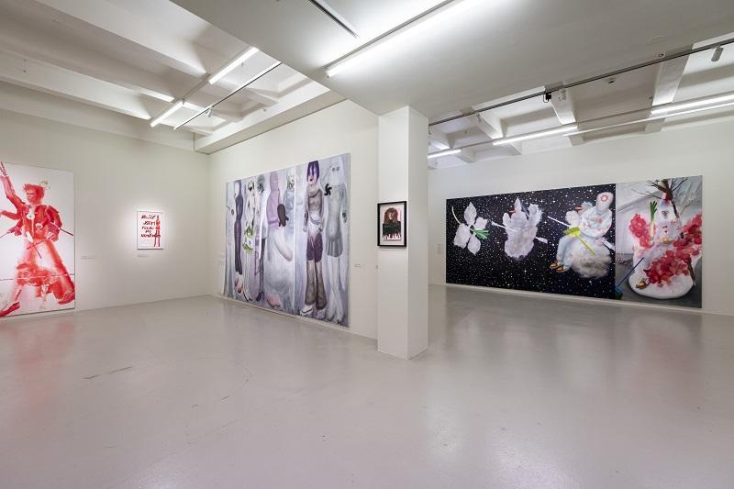

At first glance, Petrbok’s paintings appear playful, sometimes almost grotesque, at other times disturbing. They often feature figures, masks, strange beings, or references to motifs from art history as well as pop culture. Upon closer inspection, however, it becomes clear that this is a much more personal statement. In his work, the artist repeatedly returns to himself – not as a realistic portrait but rather as a shifting figure who hides, changes form, or disintegrates.

For Petrbok, the self-portrait does not serve to affirm or stabilise identity but instead becomes a space of transformation, disguise, irony, and defence. In his paintings the subject appears as a hybrid, a role, a symbol, or a body subjected to the pressures of the surrounding world. “You could say I’ve been working on self-portraits for a long time – partly due to a lack of models. I went to a vocational secondary school, where I trained to become locksmith, so when I was preparing for the entrance exams for the Academy of Fine Arts, I drew myself. But it was never a self-portrait in the traditional sense. I see myself more as a medium that absorbs everything around me and transforms it into an image. The presence of my own likeness in the paintings is also related to the fact that I wouldn’t allow myself to defile anyone other than myself – in that, I had complete freedom.”
The exhibition is not organised chronologically like a traditional retrospective. Paintings from different periods, placed side by side, form a whole that is more like a diary – full of returns, repetitions, and a range of emotions. “Patient Diary comes across as chaotic in places, and it repeatedly returns to certain themes, often after long intervals. We didn’t want to create a banal retrospective, which is precisely why we chose the theme of the self-portrait – a motif that has appeared in Petrbok’s works since the early 1990s. While preparing the exhibition, we delved deep into the artist’s archive and discovered a number of works that had never been exhibited before or had last been shown decades ago. From this collection, we selected a body of work that best captures the key aspects of his oeuvre: self-presentation, the search for identity, introspection, and considerable self-deprecation, at times with comic exaggeration,” explains curator Otto M. Urban.
The title of the exhibition does not refer to illness but rather to the broader experiences of a person who is subject to the influence of institutions, social expectations, symbols, and their own body. Here the “patient” is someone upon whom the world weighs heavily yet also one keeps a personal record so as not to become a mere case. The title Patient Diary is no accident. Petrbok himself interprets it with a certain degree of hyperbole and irony: “The viewer might be thinking it, so I’d rather just go ahead and say it for them.”
Petrbok’s visual diary intertwines pain, the grotesque, humour, and anxiety, presenting identity as a process spanning decades – fragile, ambiguous, and never fully complete. According to curator Otto M. Urban, Petrbok’s work is characterised by its depiction of people in extreme situations: “Petrbok portrays himself in the most intense emotional states, ranging from euphoria to the deepest lows. From the outset, it is clear that this is exceptionally sophisticated painting, both in terms of technique and in its distinctive, largely conceptual consideration.”
Here a self-portrait is not just a depiction of a face but a way of looking inward – sometimes directly, at other times through a mask or another identity: “Petrbok’s work blends references to the high painting of the fifteenth and sixteenth centuries, including the Renaissance masters, with elements of pop culture – from comics characters like Ferda the Ant to Futurama to graffiti and smiley face motifs. This creates a unique and distinctly personal visual ensemble,” adds Otto M. Urban.

Extreme openness plays an important role in Petrbok’s work. The artist is not afraid to push the boundaries of intimacy and draw on his own experiences, both physical and psychological: “I’ve realised that my work leans towards very personal, even psychological or archetypal images. This approach has always appealed to me. I respect conceptual art, but personally, it has never fulfilled me. During my studies, I focused on abstraction, which eventually ceased to interest me so much that I destroyed most of those works. Therefore, at a time when a strongly conceptual approach was predominant, I decided to go in the opposite direction: toward a radically personal, even extremely personal expression. Some of the works are also based on intense inner experiences, perhaps similar to art therapy – and that’s fine with me. Right at a time when a lot of people tended to avoid expressing their personalities in their work, I decided to take the opposite path – to stick my neck out all the way.”

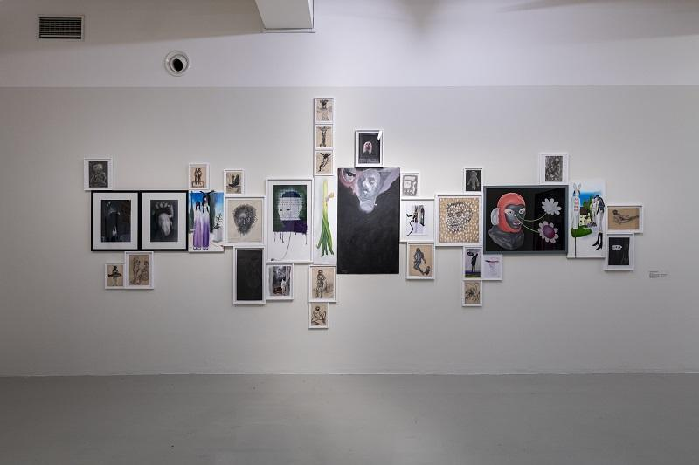

The exhibition traces how this principle is reflected in various periods of the artist’s work: from early paintings of physical and existential transformation to motifs of masks, protective suits, and fragmented figures to works in which family, institutions, public space, and language increasingly enter into the self-portrait. Petrbok’s work, however, does not speak of a “true self” that can be revealed once and for all. Rather, it presents identity as a fluid set of roles, defence mechanisms, gestures, and reactions, shaped by external pressures and internal experience.
Patient Diary is thus not an intimate confession in the traditional sense but an urgent portrait of a person who, in the space between vulnerability and self-deprecation, is trying to maintain his own coherence.
The exhibition runs from 24 April to 16 August 2026.

Jiří Petrbok
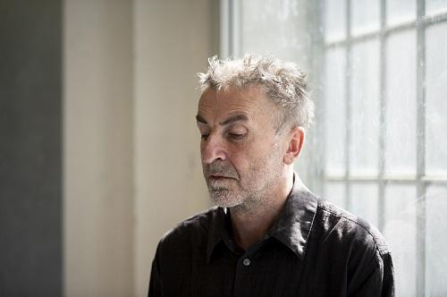
Jiří Petrbok (*1962) is one of the most striking figures of the contemporary painting scene as well as a respected teacher who has influenced generations of emerging artists. He graduated from the Academy of Fine Arts in Prague, where he studied in the studios of Radomír Kolář and Jiří Sopko between 1984 and 1991. He subsequently worked as an assistant in Jitka Svobodová’s drawing studio, which he went on to lead from 1995 to 2023. The central theme of his work is the human being and their external and internal transformations. By combining various techniques – from drawing to painting to collage – he creates dynamic, often provocative images with melancholic and decadent undertones. Through his academic background, he also has an affinity for black humour and the grotesque. He intertwines these elements with existential and social themes such as death, faith, politics, and the mental state of the individual. He considers himself an observer rather than a politically engaged artist. His works thus do not represent an objective commentary on the era but rather a subjective, introspective record of its emotions and atmosphere. Jiří Petrbok’s work is regularly exhibited in the Czech Republic and abroad. It is sought after by private collectors and also held in public collections such as the National Gallery Prague, the Prague City Gallery, and the Gallery of the Central Bohemian Region.

DOX Centre for Contemporary Art
Poupětova 1, Prague 7
Open: Tue–Sun, 11:00–19:00
The press release and photographs can be downloaded after registering in the Press section of our website.

Photographs from the exhibition: Jan Slavík

Contact
Karolína Kočí
E karolina.koci@dox.cz
T +420 777 870 219
www.dox.cz

