DOX presents ARGUS & MEDUSA, or On Hope in Dark Times
How can we weather crises when hope shrinks to a tiny speck on the horizon? The exhibition ARGUS & MEDUSA at the DOX Centre for Contemporary Art revisits one of the most powerful works in art history – Théodore Géricault’s The Raft of the Medusa, created in 1818–1819. The monumental painting, which now hangs in the Louvre in Paris, has never ceased to fascinate artists, writers, composers, and other creative minds. It shows how this iconic work continues to inspire contemporary visual artists, not only with its monumentality, groundbreaking theme, and masterful execution but above all with its epic portrayal of humanity struck by a sudden catastrophe – humanity caught in a moment between hope and despair.
ARGUS & MEDUSA will open during the fourth edition of the FALL Festival of Arts, Literature & Learning, which will take place at DOX from 1 to 4 October 2026. The theme of this year’s festival, HOPE IS A STATE OF MIND, resonates strongly with the exhibition. The guests of the festival – who include leading figures of world literature as well as artists featured in the ARGUS & MEDUSA exhibition – will discuss where we can find hope in today’s seemingly hopeless times, how this relates to the currently much-discussed concept of resilience, and what helps us keep going in spite of everything.
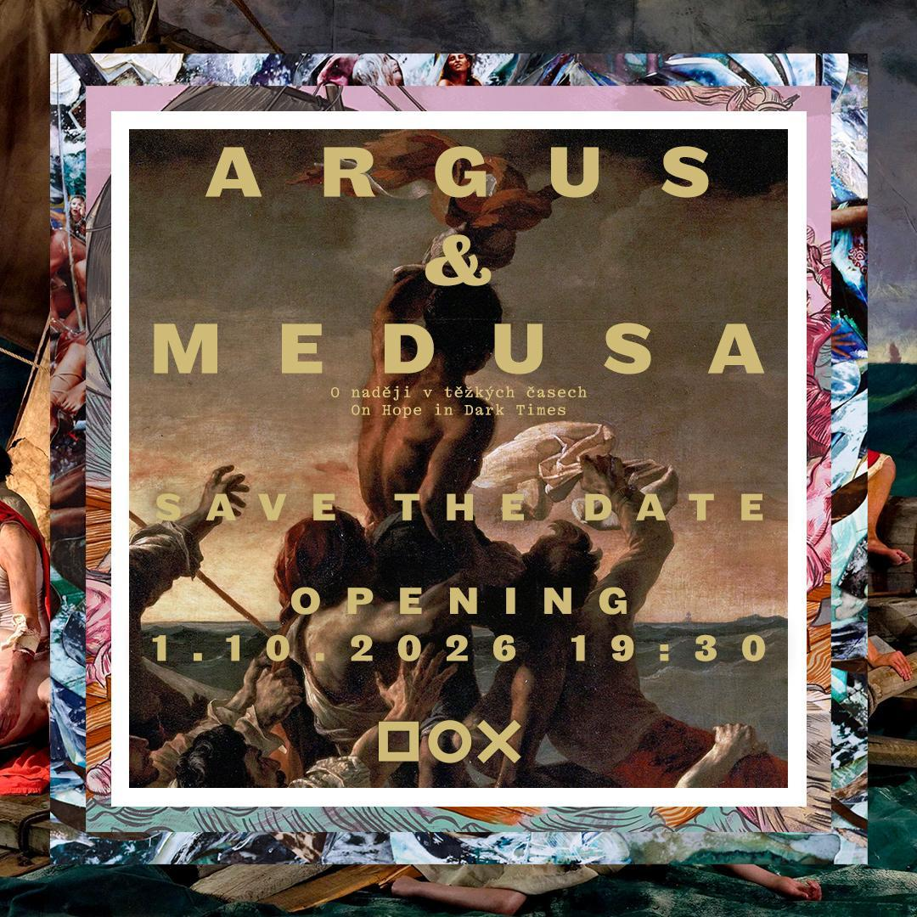

ARGUS & MEDUSA – BETWEEN HOPE AND DESPAIR
In 1819 the young French artist Théodore Géricault completed a monumental painting that forever secured his place in art history. In it he depicted a real-life tragedy that was considered to be one of the greatest maritime disasters of all time. When the French frigate Méduse was shipwrecked off the coast of West Africa in 1816, 147 members of its crew, for whom there was no room aboard the ship’s lifeboats, found themselves on a makeshift raft without sufficient supplies. They were abandoned by the lifeboats as well as the captain, leaving them at the mercy of the elements. After thirteen days of despair, violence, and cannibalism, a mere fifteen of them survived. For his artistic rendition of the event, Géricault decided to depict the moment of humanity wavering between hope and despair, as English novelist Julian Barnes famously showed in his story “Shipwreck”. When the castaways on the raft spot the rescue ship Argus on the distant horizon, it is still just a tiny dot, and it is unclear whether salvation is approaching or receding.
“Géricault’s painting The Raft of the Medusa has inspired – and continues to inspire – artists, writers, poets, composers, and performers across generations and continents. It is fascinating how many contemporary artists have felt the need to revisit this work. Our exhibition presents a selection of the many existing contemporary reinterpretations of this famous painting. Each of the artists in this exhibition has rendered The Raft of the Medusa in their own artistic language, translating the motif of the raft into a metaphor for the contemporary world and its calamities – from wars, pandemics, and migration crises to the breakdown of the social order, the loss of meaning, and even personal traumas. Yet they also emphasise hope, resilience, and the human species’ ability to survive, thanks above all to empathy, compassion, and solidarity. Their works convey the message that we are all on the raft of the Medusa and this is our story too. And so they actually pose the question: how will we ourselves cope with crises and catastrophes when hope seems to be nothing more than an uncertain speck on the horizon?” says the main curator of the exhibition, Michaela Šilpochová.
The exhibition ARGUS & MEDUSA at the DOX Centre for Contemporary Art will feature works by twenty-five prominent international artists from Europe, Africa, Australia, Canada, and Asia.
The exhibition features the works of the following artists: Pierre-Désiré Guillemet & Étienne Antoine Eugène Ronjat (Théodore Géricault), Kader Attia, Banksy, Miquel Barceló, John Beard, Conrad Botes, Sylvie Choisnel, Tom de Freston, Martin Gerboc, Adad Hannah, Hu Jieming, Nikita Kadan, Monika & Bohuš Kubinský, David LaChapelle, Wolfe von Lenkiewicz, Paul McCarthy, Karol Radziszewski, Marek Schovánek, Elfie Semotan, Jakub Špaňhel, Jason deCaires Taylor, Bill Viola, Joel-Peter Witkin
The exhibition will also feature a special presentation of Julian Barnes’s literary work “Shipwreck”.
A catalogue accompanying the exhibition with texts by Alberto Manguel, Julian Barnes, Marie NDiaye, Tom Stoppard and the artists will be published in November 2026.

Author and curator of the exhibition: Michaela Šilpochová
Collaborating curators: Leoš Válka, Otto M. Urban
The works in this exhibition are kindly on loan from: Amiens, Musée de Picardie; Catherina and Michael Roets; Collection Baudoin Lebon, Paris; Collection Conrad Botes; Collection of the Dalloul Art Foundation, Beirut, Lebanon; David LaChapelle Studio; Equinox Gallery; Galerie Poggi, Paris; Hu Jieming and ShanghART Gallery; Justyna Dąbrowska-Bień; Louisiana Museum of Modern Art, Humlebaek, Denmark; Paul McCarthy and Hauser & Wirth; Paul and Paula Smith; Pierre-François Ouellette art contemporain; Studio Semotan; Youxiantang Collection; Zeina Itaoui; the exhibiting artists; and private collectors

The exhibition opening will take place on 1 October as part of the opening ceremony for the fourth edition of the annual FALL Festival of Arts, Literature & Learning, the theme of which is HOPE IS A STATE OF MIND and whose guests will include leading figures of world literature as well as artists featured in ARGUS & MEDUSA.
The exhibition will run from 2 October 2026 to 4 April 2027.
An exhibition catalogue is in the works.

DOX Centre for Contemporary Art
Poupětova 1, Prague 7
Open: Tuesday–Sunday, 11:00–19:00
The press release and photographs can be downloaded after registering in the Press section of our website.

Contact
Karolína Kočí
E karolina.koci@dox.cz
T +420 777 870 219
www.dox.cz

