Let the body speak! DOX presents an original performance by Alžběta Tichá at the bpm of the human body.

How can we allow the audience to not only see and hear a performance but also experience what the artist on stage is feeling? What does the body sound like in moments of tension, calm, or emotional exhaustion? Alžběta Tichá asked herself these questions while creating the visceral production Frekvence, which combines a physical performance with technology that monitors her bodily functions in real time. The artist’s heartbeat becomes both the dramaturgy and scenography of the show, in which her inner sensations are transformed into a unique experience for the audience. The premiere will be presented at the DOX Centre for Contemporary Art on 11 and 12 February, with repeat performances planned for April 2026.
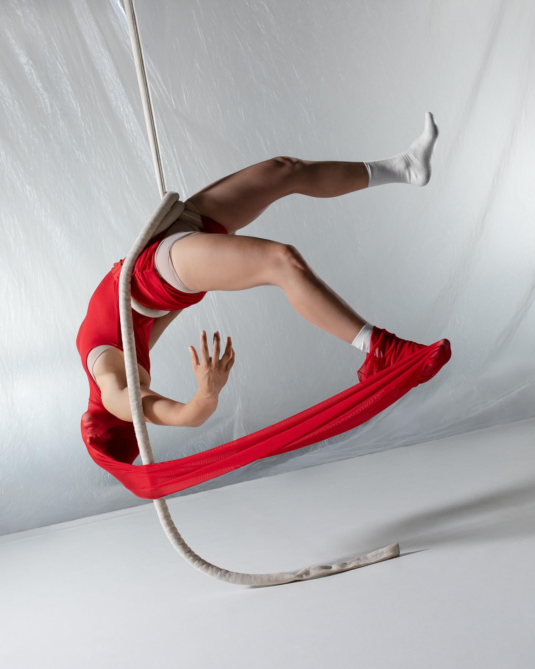
In the intimate acrobatic solo show Frekvence, performer Alžběta Tichá uses technology that monitors her bodily functions, which she and her team developed specifically for this work. The entire minimalistic yet visually captivating performance is thus carried along at the bpm of the human heart. During the performance, the artist’s heartbeat is transcribed into original sound and lighting components in real time – both during acrobatic scenes on a suspended rope and in calmer moments. The entire scene that unfolds before the audience thus reflects the performer’s actual physical and mental state at that very moment.

No two performances of Frekvence will be the same. The production thus paints an intimate and dynamic portrait of human perception and emotions.

“I wanted to try creating a performance where I would be completely alone on stage – an original work in which I could explore what my own artistic language actually is and whether I have one at all. At the same time, I have long been interested in how it would be possible to give the audience an idea of what it’s like for an artist on stage, because I’ve always felt that there is a gulf between us,” says Alžběta Tichá, who has been working on the production for the last four years. “The performance wouldn’t have been possible without my close friendship with Jakub Mirovský, whom I’ve known since childhood, when we used to juggle together. He then went abroad to study technology and game development, while I pursued a career in the performing arts. As adults, we met again and wanted to connect our two worlds,” adds Tichá.

The project reveals the often invisible physical effects and internal reactions of the body during a performance. It explores the complex relationship between body, mind, and technology, providing an intense and stimulating experience for both the audience and the artist herself.

What does it look like when we feel nothing at all? When everything is frozen and emotions stagnate? What about when we experience an extreme physical and emotional roller coaster and have no idea how it will all end? Is there a difference between what we see and what is actually happening inside our bodies? The theme of the performance is based on the artist’s personal experiences, and so the audience not only gets a glimpse of her inner world but also experiences it together with her.

Alžběta Tichá developed Frekvence as part of her studies at the International Circus Centre for Artistic Research in Spain, and it was subsequently selected as one of the twelve most interesting contemporary circus projects by the renowned European platform circusnext.

PREMIERE: 11 and 12 February 2026 at 8:00 p.m.
REPRISES: April 2026

Presentation at the DOX Centre for Contemporary Art
The basic dramaturgical direction of the performing arts programme at DOX is the long-term support of original works by established contemporary artists whose practice is marked by an authentic and unmistakable scenic style, often at the intersection of genres, with an emphasis on physicality, musicality, and a distinctive expressive urgency. These are works that aspire to longevity, further development, and an international reach.

DOX is presenting Alžběta Tichá’s work as part of its programme supporting established Czech performers with an original scenic language. “In her solo performance Frekvence, Alžbeta Tichá does not seek to hide behind acrobatics or form. She comes as she is – with her body and heart in real time. She explores her own limits and stays in touch with what is actually going on inside her, inviting us to perceive it too – even if it is uncomfortable. She doesn’t want to just entertain us. Her production goes beyond what we normally expect from an acrobatic or contemporary circus performance. It aims to authentically convey fragility, fatigue, and tension as they arise – directly, without filters and without certainties. Not as a gesture but as an urgent reminder that being alive means being present – and vulnerable,” explains Viliam Dočolomanský, programme director for the performing arts at DOX.

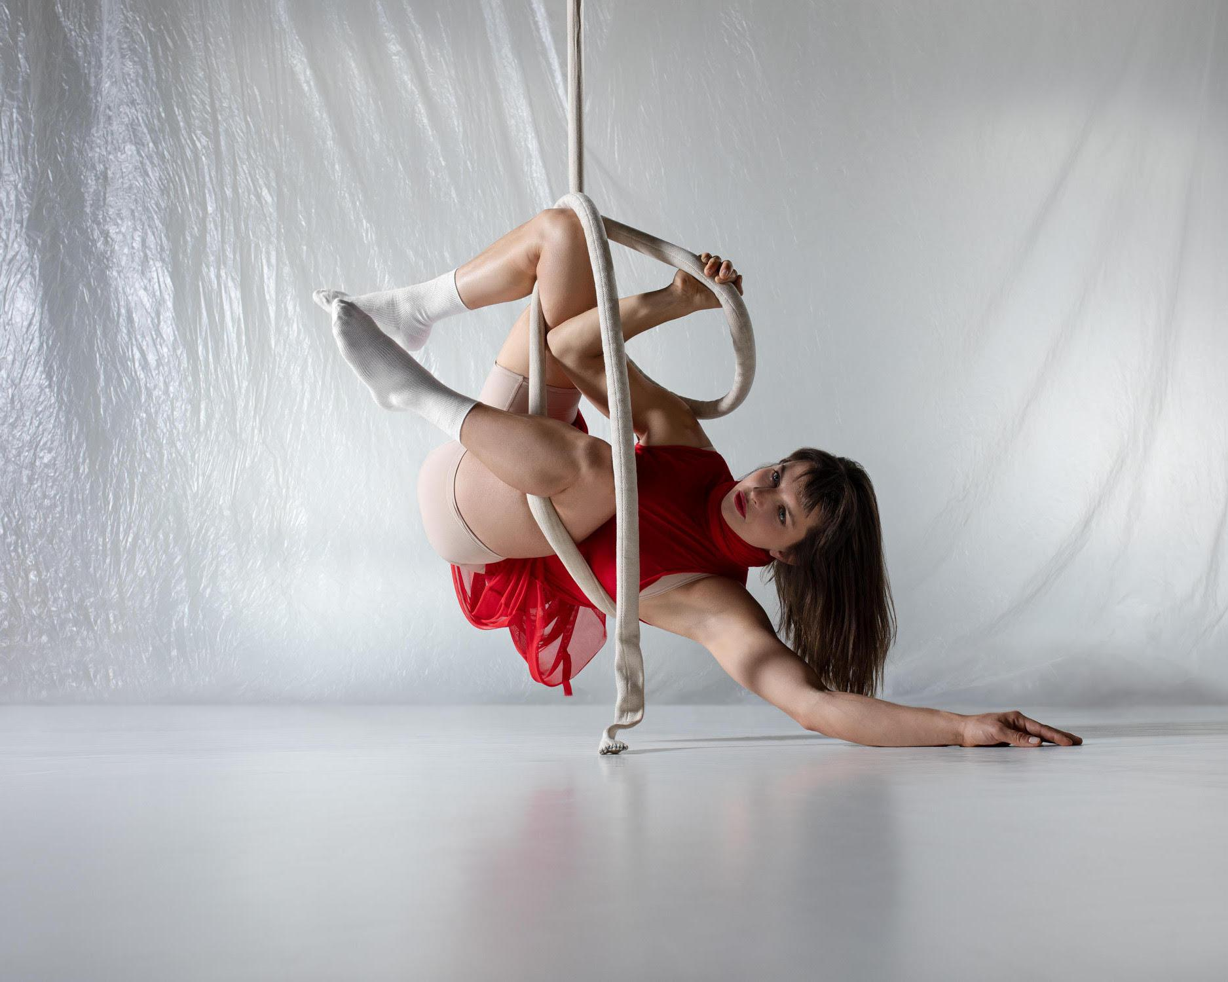
Photo: SHOTBY.US

Collaboration
The project was developed through close interdisciplinary collaboration. Director Roberto Magro contributed to the dramaturgical form and overall structure of the production, and the artist worked in continuous dialogue and reflection with Ondřej Holba and Jiřina Krásová.

The following individuals also played a key role in shaping the production’s final form:
- Jakub Mirovský – technology development
- Simone Thiere & Jan Sedláček – music / sound design
- Jonatán Vnouček – lighting design
- Mariana Stránská – costume
- Szilárd Boráros – stage design
- Jonáš Tichý – rigging

Each discipline became an equal part of the final work and influenced the dramaturgy
of the production.

Technology
The production uses technology from the fields of IT, music, and stage design (Bluetooth, OSC, MIDI, DMX). The biometric data is captured using Polar Verity Sense and H10 sensors, processed in the software Chataigne, and converted in real time into light, sound, and visual changes on stage. The technological system is divided into three parts: the sensors, the control brain, and the stage. The result is a living, data-driven scenic organism.

About the Artist
Alžběta Tichá is a Czech circus performer, author, and lecturer. Her work explores the body in the present moment, its limits, physical strain, and the relationship to space, objects, and the audience. She loves movement, heights, and adrenaline, and she primarily focuses on aerial acrobatics on a vertical rope, which she studied in the Netherlands at Codarts Rotterdam (2020), before which she studied dance at the Duncan Centre Conservatory in Prague (2014). In 2023 she participated in the programme of the International Circus Centre for Artistic Research in Spain. She is a co-founder of the Feel the Universe Circus Company, with which she performs at cultural events around the country, as well as the platform Tichá malina and the Prague Aerial Convention. She collaborates artistically with, among others, Eliška Brtnická (on the performances THIN SKIN and Chimney). In the past she has worked with established theatre authors and directors such as Matěj Forman, Radim Vizváry, Francesco Sgró, Daniel Gulko, Robert Magr, and others. In addition to her creative work, she also dedicates herself to education, sharing movement practice, and rock climbing.

DOX Centre for Contemporary Art
Poupětova 1, Prague 7
Open: Tue–Sun, 11:00 a.m.–7:00 p.m.
The press release and photographs can be downloaded after registering in the Press section of our website.

Contact
Karolína Kočí
E karolina.koci@dox.cz
T +420 777 870 219
www.dox.cz

