2026 at DOX: A Year Full of Art

In 2025 DOX celebrated seventeen years of its existence. It once again presented a genre-spanning programme combining the visual arts, performance art, music, literature, and education and recorded its highest attendance since the COVID-19 pandemic – almost 122,000 visitors. The key project of the year was the exhibition David Lynch: Up in Flames, which attracted extraordinary attention from both the public and the media. Over the course of the year, DOX presented 9 exhibition projects, over 40 concerts and theatre performances, a series of summer film screenings, and 817 educational programmes for the public, schools, and families. Three major festivals also formed an essential part of the programme: the FALL literary festival, attended by prominent authors from the Czech Republic and abroad; ART*VR, the most extensive showcase of virtual reality films in central and eastern Europe; and FUK, the largest festival of creative learning in the Czech Republic. DOX is also preparing an ambitious and packed programme for 2026.

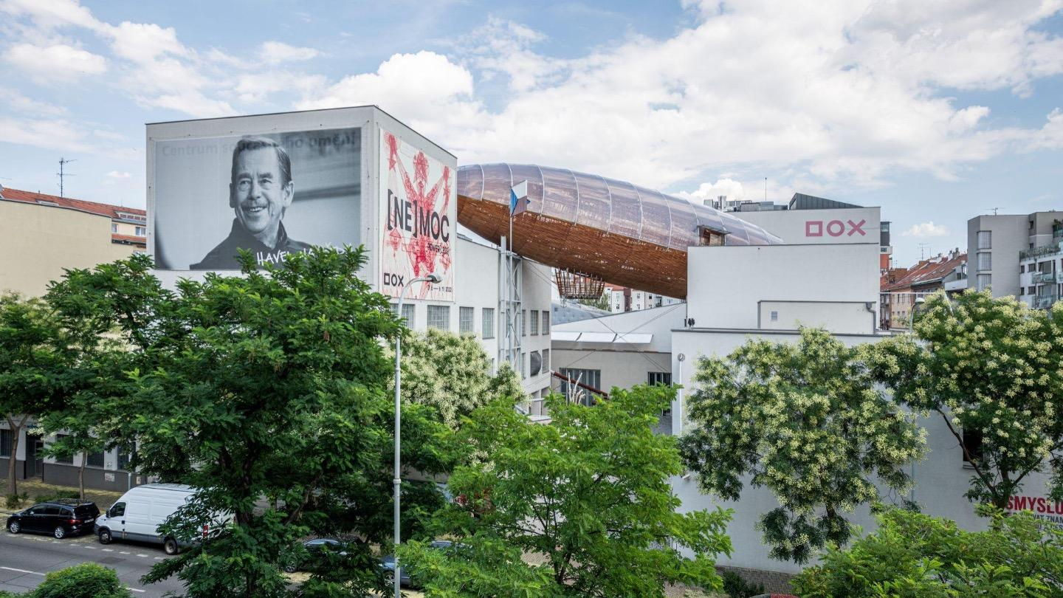

EXHIBITIONS IN 2026

HIT BY NEWS
6 March – 23 August 2026
For its main exhibition project this year, DOX is preparing HIT BY NEWS, which will run from March until the end of August. It focuses on the relationship between art and the mass media and the way in which the traditional press in particular has influenced society over the last century. The project will present artworks by several hundred artists who have worked or continue to work with print media in their creative practice. The exhibiting artists include Georges Braque, Fernand Léger, Vladimir Mayakovsky, Kazimir Malevich, Jean Arp, Joseph Beuys, Robert Capa, Man Ray, Henri Cartier-Bresson, Christo, Le Corbusier, Willem de Kooning, Alberto Giacometti, Robert Rauschenberg, Alexander Rodchenko, Edward Ruscha, Gilbert & George, Andreas Gursky, David Hockney, Dennis Hopper, William Kentridge, Martin Kippenberger, Jannis Kounellis, Matthew Barney, and others. The exhibition features an array of unique works selected by the renowned independent curator Christoph Doswald from the Swiss collection of Peter and Annette Nobel, who have been systematically collecting “press art” since the 1980s and whose collection now contains over two thousand works focused on this dialogue. The exhibition opening will take place on 5 March.

Petr Geisler: GA-I-SU-RA
19 March – 7 June 2026
In March DOX will also be launching the exhibition GA-I-SU-RA, which pays tribute to the work of the Czech Japanologist, translator, journalist, calligrapher, photographer, and teacher Petr Geisler (1949–2009), who made a wholly unique and distinctive contribution to the development of relations between the Czech Republic (formerly Czechoslovakia) and Japan.
The exhibition will present Geisler’s lifetime oeuvre in the most comprehensive form to date – from his expressive calligraphy, which he wrote spontaneously during his free time between jobs, to photographic multiple exposures from Japan in the 1980s, to the monumental inscription of the Buddhist heart sutra that once adorned a wall in the passage of the Palác Metro building on Národní třída in Prague. Ester Geislerová, who is curating the exhibition together with Petr Holý, and Aňa Geislerová, who is collaborating on the conceptual design, are significantly involved in the project.

Jiří Petrbok: Patient Diary
24 April – 16 August 2026
In April DOX will open an exhibition of works by the renowned painter Jiří Petrbok (1962), which are united by the theme of self-portraiture. Petrbok’s self-portraits are characterised by striking expressivity and narrative ambivalence, with the artist often stylising himself into grotesque, sometimes even disturbing figures. He works with the deformation of the body and face as a means of introspection, where physical transformation serves as a metaphor for psychological tension. His self-portraits regularly oscillate between the personal and the universally symbolic, revealing not only the artist’s subjective identity but also broader themes of vulnerability, fear, and irony. The exhibition is curated by Otto M. Urban.

Radka Bodzewicz: FAUST
19 June – 8 November 2026
In June we will host a solo exhibition of Radka Bodzewicz (1991), an acclaimed Czech artist of the younger generation. In collaboration with curator Michaela Šilpochová, she is preparing a new project for the DOX tower that focuses on combining painting with literary themes. Literary inspiration is typical of Bodzewicz’s work (for example, in the series Lost Paradise and The Divine Comedy). This year at DOX the artist will present a series of completely new works on the theme of Faust.

David Tibet: Under the Skin of Angels
October 2026 – March 2027
This autumn visitors can look forward to the exhibition Under the Skin of Angels, which will present the work of the legendary English musician and poet David Tibet (1960) for the first time in the Czech Republic. Tibet, the leading figure of the musical project Current 93, is one of the most influential artists working at the intersection of music, literature, and visual art in recent decades. Since the 1980s he has been developing a distinctive mystical-apocalyptic poetics that blends Christian iconography, gnostic motifs, and personal visions. His visual art – drawings, paintings, and manuscript illuminations – has a characteristic, childishly naive yet disturbing style, often inspired by his texts and dreamlike imagery. Tibet is also a translator and an author of poetry collections and memoirs, and through his record label Durtro he has made significant contributions to the documentation and dissemination of experimental music and literature, influencing an entire subculture. He is known for his extensive collaborations with artists from the worlds of music (e.g., Nick Cave, Rose McDowall, Marc Almond) and literature (e.g., Thomas Ligotti). Curated by Otto M. Urban, this will be Tibet’s most extensive exhibition to date.

THE ARGUS AND THE MEDUSA
1 October 2026 – 11 April 2027
For October DOX is preparing the exhibition project THE ARGUS AND THE MEDUSA, which poses the question of how and why one of the most famous paintings in modern art history – The Raft of the Medusa (1819) by the French painter Théodore Géricault, which was inspired by a real catastrophe and which caused a sensation in its time – continues to fascinate artists across continents, centuries, and artistic genres and has even inspired some contemporary writers. This is one of the reasons why the exhibition will be loosely connected to the autumn literary festival FALL. The exhibition is curated by Michaela Šilpochová in collaboration with Leoš Válka and Otto M. Urban.

LITERATURE: THE FALL FESTIVAL IN THE GULLIVER AIRSHIP
The flagship of DOX’s literary programme is the Festival of Art, Literature, and Learning (FALL), whose programming and curation are under purview of its founder, DOX’s artistic director Michaela Šilpochová. For the fourth time already, DOX will bring Czech and international writers and artists to Prague and present their work in discussions, author readings inside exhibitions, guided tours, and other formats.

The broader long-term framework of the festival is the theme of empathy in the digital age, because literature is one of the tools for developing empathy. That is why, in addition to the four-day public section – this year running from 1 to 4 October – the festival also has a five-day educational section for schools and professionals (from 29 September to 5 October), focused on interactive programmes that strengthen empathy through sharing stories.

The home of the festival – which in 2025 hosted more than 40 guests and attracted over 2,500 visitors – is the Gulliver Airship. This year it will once again welcome aboard numerous literary figures from the Czech Republic and abroad. The motto of this year’s edition is HOPE IS A STATE OF MIND (a quote from Václav Havel in tribute to what would have been his 90th birthday), and the theme of the festival will be hope and resilience in times of disaster.

This spring the Gulliver Airship will also christen its own Poetrymat, where visitors will be able to turn a crank and listen to poems and literary texts by Czech and international writers inspired by the poetics of airships and air travel, right on board the Gulliver.

EDUCATION AT DOX IN 2026
Education has been an integral part of the DOX Centre’s programme since the very beginning. The diversity of contemporary art and its changing themes make it possible to reach a wide range of target groups, with activities for the youngest children (BABYDOX), family workshops, intergenerational programmes, and events for seniors.
Of the more than eight hundred events held over the past year, the largest share were educational programmes aimed at students and teachers at all levels of schooling. In light of the direction society is heading, there is a growing need to develop critical thinking, empathy, creativity, and, on a personal level, the ability to understand contemporary art and, through it, oneself. DOX currently offers approximately twenty educational programmes centred around the themes of VISUAL, MEDIA, AND DIGITAL LITERACY, ACTIVE CITIZENSHIP, and DEVELOPING EMPATHY AND CREATIVITY.
This year we are once again preparing new workshops to go with upcoming exhibitions. The HIT BY NEWS exhibition in particular is eagerly anticipated – and not only in connection with media education. We will also explore issues such as individualism and human autonomy through Jiří Petrbok’s exhibition devoted to self-portraiture.
In May 2026 curators Karolína Voleská, Tereza Dvořáková, and Jiří Raiterman will present the fourth instalment of the long-term project POINT OF VIEW, this time with the theme of Resilience. Like the previous themes, resilience is an issue/concept that was requested by students. Moreover, the topic of resilience falls somewhere between the much-discussed concept of well-being and the capacity for resistance that young people still often display.
DOX is placing increasing emphasis on the participation of young people, among other things through the programme Looking for Balance and the new DOXYGEN format, in which university students co-create a programme for audiences aged 16–26 (who do not typically visit contemporary art spaces).
In 2026 we will once again be part of the Festival of Art and Creativity in Education (FUK), which will take place 2–15 November. The festival is intended for teachers, parents, and children as well as cultural professionals and experts in the field. In addition to creative learning, an important theme of the sixth edition of the festival will be “the entrepreneurial spirit”, with the 150th anniversary of the birth of Tomáš Baťa playing a role.
We are also looking forward to the semi-final round of the artistic platform Do you have a knack for art?. Throughout the year DOX will participate in a number of other educational conferences, workshops, and programmes for educators. The main event of the autumn will be the educational section of the FALL festival.

PERFORMANCES: THEATRE, MUSIC, DANCE

The performing arts programme of the DOX Centre for Contemporary Art, led by Viliam Dočolomanský, has become an integral part of the institution’s overall programming. In addition to its exhibitions, DOX is systematically establishing itself as a venue for contemporary performing arts, with no restrictions on genre. Physical theatre, dance, music, drama, performance art, and interdisciplinary projects are staged in both the theatrical and non-theatrical spaces of the DOX Centre.
The basic dramaturgical direction of the performing arts programme at DOX is the long-term support of original works by established contemporary artists whose practice is marked by an authentic and unmistakable scenic style, often at the intersection of genres, with an emphasis on physicality, musicality, and a distinctive expressive urgency. DOX positions itself as a place of continuity – productions are not staged as one-offs but are systematically reprised, developed, and maintained in long-term contact with the audience.
At the same time, DOX’s performing arts programme is designed as an open platform for dialogue between original productions created at the institution and works by prominent international figures and ensembles from the fields of music, dance, and theatre, presented in collaboration with partner festivals.
The programme for 2026 focuses on the themes of changing interpersonal relationships, identity, loneliness, and digital existence in the age of technology and artificial intelligence. These motifs are not handled in an illustrative way but rather through the body, physical experience, and direct encounters between the performers and the audience – with an emphasis on authenticity and being present “here and now”.

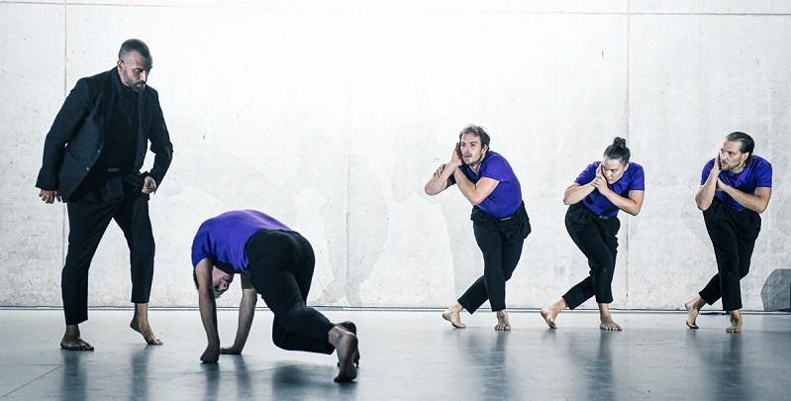

A Selection of Performances in 2026

NEW VOICES / WORKS BY ESTABLISHED PERFORMERS
In 2026 DOX will regularly present new works by prominent Czech performers who work across the genres of physical theatre, acrobatics, dance, and performance art.

Alžběta Tichá – Frequency (premieres in February 2026)
Alžběta Tichá, a prominent figure of contemporary movement and circus arts, has long been combining hanging acrobatics, dance, physical theatre, and technology. Her solo performance Frequency is an intimate physical statement about the relationship between the body, the mind, and technology. The performer’s heartbeat, recorded in real time, becomes part of the sound and light composition and an equal partner on stage. The production, which straddles the line between physical theatre and a performative concert, explores the theme of having the courage to expose oneself to the gaze of others without protective theatrical stylisation and seeks direct, authentic contact with the audience.

Andrej Štepita – Site and Self (premieres in May 2026)
Slovak performer and creator Andrej Štepita, a long-time member of the ensemble Farm in the Cave and initiator of the Tanečno festival, is developing an intimate project reflecting the tension between physical presence and digital existence. Site and Self explores digital loneliness, mediated relationships, and the question of how the human body and its memory relate to virtual worlds, algorithms, and digital “companions”. Here the body functions as a site of resistance to algorithmisation – as a bearer of memory, vulnerability, and personal experience.

Viktor Černický – PLI (reprises of the production)
Viktor Černický works at the intersection of dance, physical theatre, circus, and the visual arts, and the internationally acclaimed production PLI is one of his most striking projects. This minimalist physical study of balance, endurance, and working with space has been performed at many prestigious venues around the world, including the Théâtre de la Ville in Paris. The repeat performances at DOX highlight the production’s exceptional intimate form, which has not yet been sufficiently reflected in the Czech context.

THE WORK OF DOX’S IN-HOUSE ENSEMBLE FARM IN THE CAVE
The international ensemble Farm in the Cave is one of the key pillars of DOX’s performing arts programme. They are pioneers of an original style of physical theatre which has long reflected current social phenomena and systematically transcended the boundaries of individual genres.
The company has represented the Czech Republic in more than sixty cities on three continents and received a number of prestigious awards (the European Prize for New Theatrical Realities, the Total Theatre Award, the Fringe First Award, the Alfréd Radok Award).
In addition to staging productions, Farm in the Cave is involved in educational, community, and film projects. In 2026 it will present large-format productions at DOX+, an immersive project in the exhibition spaces, as well as intimate formats.
In 2026 the ensemble will stage a trio of striking productions that combine physical theatre, live music, and powerful social commentary. The immersive project All Is Good in Heaven (January 2026), created in dialogue with the exhibition David Lynch: Up in Flames, will transform the gallery after closing time into a live performance space where the audience themselves will shape the course of the experience. Using a precise physical score and minimalist scenography, the movement satire Czech Hero (January 2026) reflects on manipulation, disinformation, and the polarisation of society with both perspective and urgency. The updated production Refuge 2025 (June 2026) offers a timely and intense statement on displacement, the loss of security, and a world in constant motion.

CONCERTS AND PERFORMANCES FROM DOX’S FESTIVAL PARTNERS
DOX has long collaborated with leading domestic and international festivals, creating an open programming ecosystem in which Czech works meet with top international productions.

Prague Spring / Prague Offspring (May 2026)
DOX is the main venue for the platform Prague Offspring, which focuses on the latest trends in contemporary music. Offspring at DOX acts as a curatorial laboratory, combining concerts, world premieres, discussions, and educational formats.
In 2026 you can look forward to performances by Unsuk Chin, Miroslav Srnka, Ondřej Adámek, and Michal Nejtek, among others. The resident ensemble is Ensemble Modern, which will present world premieres, iconic works of the twentieth and twenty-first centuries, open rehearsals, discussions, and masterclasses at DOX+.

Other Festival Partners
DOX also collaborates with the festivals Prague Sounds, Prague Crossroads, and the Prague German-Language Theatre Festival, which bring to the programme noteworthy concerts and performances by Czech and foreign artists.

PARTNER ENSEMBLES OF CONTEMPORARY CLASSICAL MUSIC AT THE DOX CENTRE
The performing arts programme collaborates with ensembles focused on contemporary and interdisciplinary work. This approach expands the programming with a distinctive musical dimension and enables the presentation of Czech premieres and exceptional performance projects.

BERG Orchestra
In 2026 the BERG Orchestra will present two major projects at DOX+:
- WHATSPOP | … reflections of pop culture (March 2026)
The Czech premiere of WhatsPop (2022) by French composer Aurélien Dumont combines contemporary music with pop culture and literature. The distinctive vocal section and lively dialogue between the performers and guest speaker open the concert up to the contemporary social context. The composer will attend the premiere in person.
- LICHTENBERG FIGURES (December 2026)
The Czech premiere of the audiovisual work Lichtenberg Figures RELOADED by Austrian composer and performer Eva Reiter combines voice, a musical ensemble, electronics, video, and lighting design. The composition, which straddles the line between a concert and performance art, will be performed by the BERG Orchestra, with Eva Reiter as a soloist.

Ostrava Center for New Music
The Ostrava Center for New Music, associated with Petr Kotík, is a key partner of DOX’s music programme and an internationally renowned institution focused on experimental music of the twentieth and twenty-first centuries. Its main orchestra is Ostravská banda, an international ensemble specialising in contemporary and avant-garde music.

“For DOX, the year 2026 can be described as a consistent continuation of what has long been the essence of this institution: an open space where artistic genres naturally intersect and where contemporary art enters into a lively dialogue with topics that are transforming our world in real time. At the same time, it is important that DOX remains a space that dares to take unexpected turns – putting the viewer into situations where they are momentarily unsure of what exactly they are looking at, and this is precisely what truly draws them into an artwork. In 2026 it will therefore be worthwhile to continue emphasising conceptual work, a sensitivity to the space, and collaboration arising from direct contact with artists and their backgrounds. The aim is for each project at DOX to take on its own specific form and clear purpose – and sometimes even a subtle moment of surprise that opens up new interpretations and pushes expectations a step further,” adds curator Otto M. Urban.

DOX Programme Team
Leoš Válka – director, curator
Michaela Šilpochová – artistic director, curator, founder of the FALL literary festival
Otto M. Urban – head curator
Viliam Dočolomanský – programme director for the performing arts
Jiří Raiterman – head of educational programmes

DOX Centre for Contemporary Art
Poupětova 1, Prague 7
Open: Tue–Sun, 11:00 a.m.–7:00 p.m.
The press release and photographs can be downloaded after registering in the Press section of our website.

Contact
Karolína Kočí
E karolina.koci@dox.cz
T +420 777 870 219
www.dox.cz

