Press Release / 29 November 2018

TATA 30JS

The popular music group Tata Bojs is looking back at 30 years of their existence
Covering over 500 m² of the DOX Centre, the exhibition links their music in a unique manner with equally significant visuals, primarily represented by the work of one of the group’s founders, Milan Cais, who is also the author of the exhibition concept. This is the first project of such scope and specific form to merge music and art in the Czech Republic. The accompanying programme will include three concerts by Tata Bojs in the DOX⁺ multifunction hall.

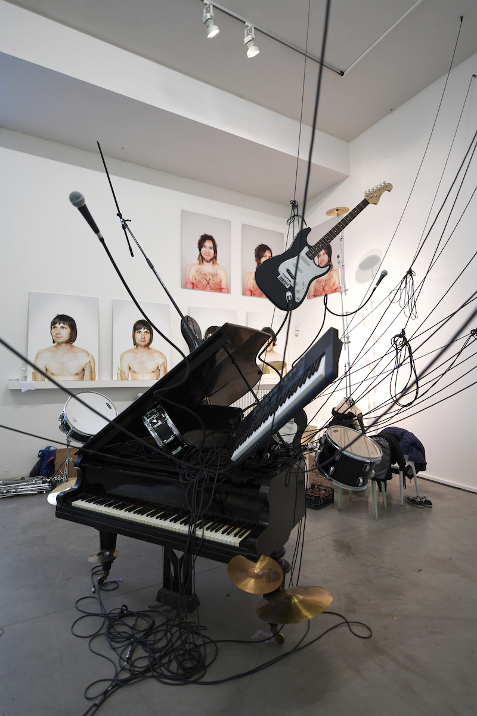
A number of new works were created especially for the exhibition, reflecting the band’s history from a contemporary perspective. According to Milan Cais, who created most of them, equally important was how they were installed at the DOX Centre:
“Due to its architecture, DOX is a very specific gallery space. It has lots of nooks and crannies and forces one to come up with a “customized” exhibition. I had thought everything out relatively well beforehand, but the exhibition’s final appearance kept changing slightly during the course of installation. The DOX Centre is an inspiring space and I think that we succeeded in assembling a quite varied and rich exhibition that will allow people to ether the visual and musical world of Tata Bojs for a while.”
The basic idea of the entire exhibition is looking back at the past through the optics of the present. In the exhibition, the group’s activities from its founding at the end of the 1980s until now are reconstructed using the language of contemporary art. The exhibition is split into ten chapters, each reflecting a certain time period. Past moments are incorporated into newly created statues, multimedia objects, and installations.
Milan Cais adds: “Looking back is always a bit dangerous. There’s usually a fair bit of sentimentality involved. The past is a trap, as one of our songs goes, but we like being on the edge. Above all, we tried to create an entertaining, contemporary, and varied exhibition full of new installations that can also work on their own. The fact that alongside them visitors can watch the history of a band is a nice bonus.”
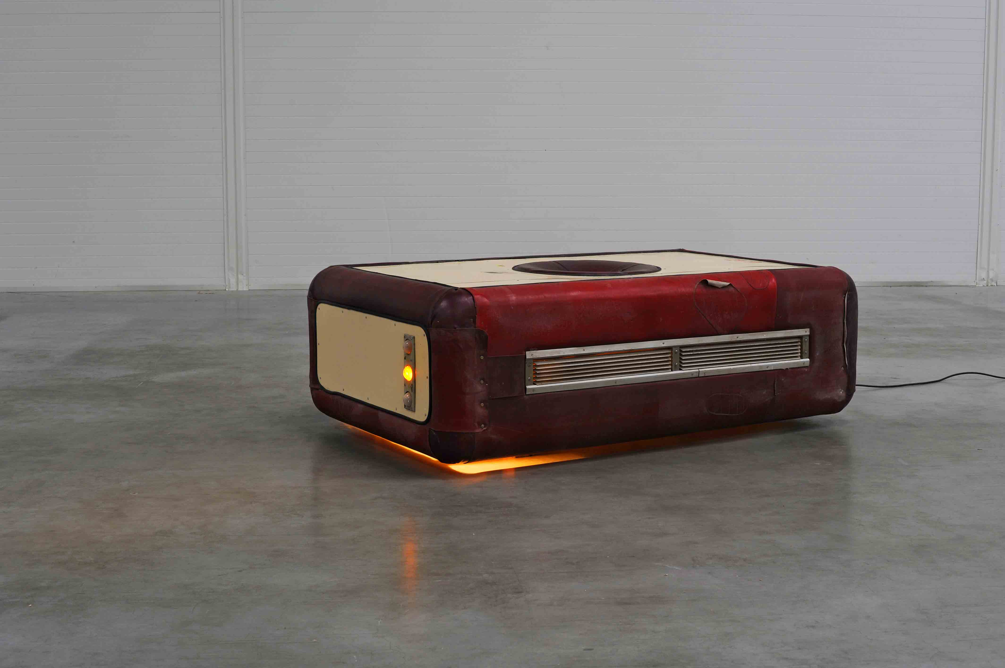
Each of the nine albums the group issued from 1988 to 2018 has its own separate space. The exhibited works always represent a symbolic intersection of the album’s main visual idea, its concept, and the circumstances under which it came about, or simply just thematically and temporally refer to the period when individual albums were recorded. For example, their evidently most conceptually and artistically comprehensive project, Nanoalbum, Nanobook, and Nanotour, is given broad representation at DOX, including original drawings and 3D visualizations by Cais, an impressive sound installation, and newly-created large-format paintings and glass sculptures. The latter were designed by Milan Cais and created by master glassmaker Martin Janecký, and show all of the main figures of the story.

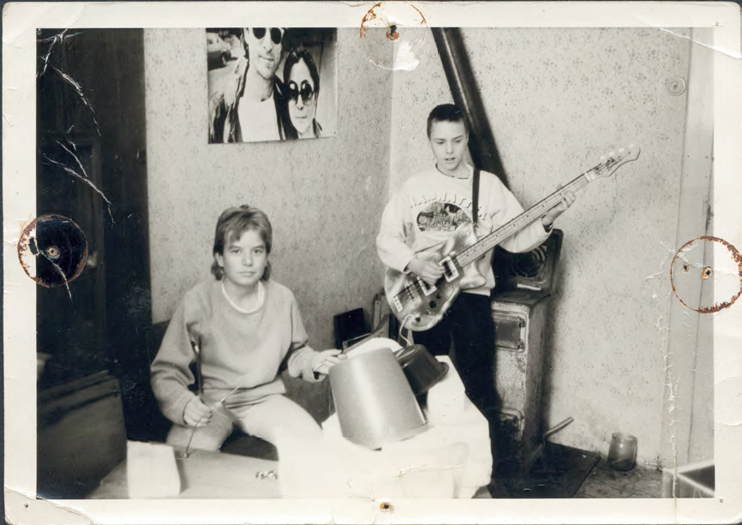
Period materials – photos, album covers, or concert recordings – as well as painstakingly reconstructed spaces and environments in which the musicians created their music lend the individual phases of Tata Bojs’ work an authentic atmosphere. “We wanted to give people the opportunity to experience the cramped environment of our first rehearsal space, so we reconstructed the basement in Hanspaulka including all details, according to period photos,” adds Milan Cais.

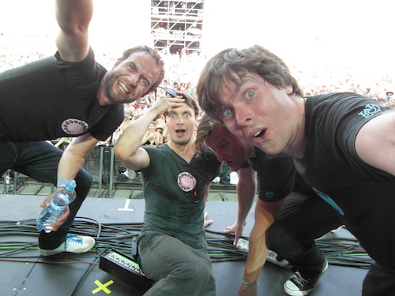
The exhibition also includes a unique series of post-concert self-portraits by Mardoša, the band’s bass player and co-founder, which he started taking in 1999. Since then over five hundred authentic images have been taken of the band with the audience, of which their author says: “I spontaneously began taking these band self-portraits in 1999, and I spontaneously haven’t stopped to this day. On the contrary, while at first I just took a picture once in a while, today it’s become an unavoidable ritual at the end of perhaps all of our concerts. We rarely look really good in the photos; we’re flushed, sweaty, tired and have funny expressions, but the key ingredients are there – emotions and atmosphere. Sometimes the photos are even in focus. But they’re not selfies, because those didn’t exist yet in 1999!”
An interactive installation reproducing a real recording studio was also created for the exhibition, in which visitors can try out what it’s like to be at a mixing board, and in the case of roughly ten songs can change the relative levels of the instruments, in short to remix the song as they’d like. Another interesting feature for visitors is virtual reality, where in various environments and at various points in time they can experience a live version of one song during four various phases of the band’s musical maturity. “That which isn’t possible in our reality is possible in its virtual version. In one case visitors can literally see what’s on our plate, and in another they’re with us in the bathroom,” say Tata Bojs, laughing.
The exhibition also benefitted from the creative advice of actor, scriptwriter, and MC Ondřej Cihlář, a member of the Vosto5 Theatre troupe, who after carefully listening to all Tata Bojs CDs, provided the initial ideas for several installations.
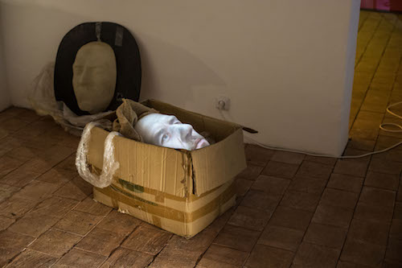
On the occasion of the band’s thirtieth anniversary, at the start of 2019 a roughly 300-page book will be published, appropriately entitled TATALOG, which will also contain all of the works from the exhibition. The band arranged its publication with Bigg Boss publishers, and the graphics were done by Marek Pistora and the renowned Studio Najbrt. The book will be published in a limited edition of 1500, and Tata Bojs will launch it at “unplugged” concerts that will be part of the exhibition’s accompanying programme.

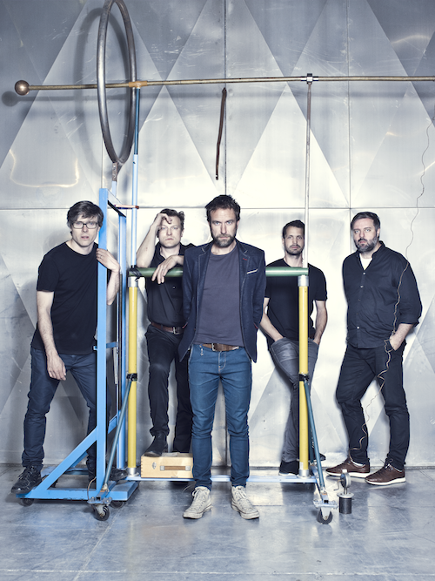
Tata Bojs is a household name in the Czech Republic: at the end of the 1980s they started out as schoolboys from Hanspaulka with no shortage of originality and humour, and quickly gained widespread popularity. In 2000 they signed a recording contract with Warner Music, and today they issue their recordings under the legendary Czech Supraphon brand. During the course of their career they have received nine Anděl [Angel] awards from the Czech Academy of Popular Music and a number of other awards, including gold records for their albums Ležatá osmička and A/B. On the occasion of the exhibition Supraphon will issue a re-mastered version of Nanoalbum on vinyl as a double LP. The Tata Bojs’ music is closely linked to other artistic genres: fine art, literature, film, and surprisingly also ballet. The groups will endeavour to gradually present these during the course of the exhibition’s rich accompanying programme.

Exhibition concept: MgA. Milan Cais

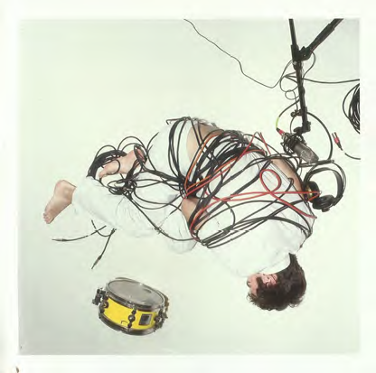
Milan Cais (1974) is a Czech visual artist and musician. In 1988 he and his childhood friend Mardoša founded Tata Bojs. He composes the band’s music and lyrics, sings, plays the drums, and creates visuals. He graduated from Václav Hollar Art High School and the Academy of Fine Art in Prague.

Accompanying programme:
10 Dec at 8:00 p.m. TATA BOJS - XXX (electric concert with stage set)
11 Dec at 8:00 p.m. TATA BOJS - XXX (electric concert with stage set)
12 Dec at 8:00 p.m. TATA BOJS - XXX (electric concert with stage set)
13 Dec at 7:00 p.m. guided tour of the exhibition
17 Jan at 7:00 p.m. guided tour of the exhibition
20 Jan at 5:00 p.m. and 8:00 p.m. TATA BOJS + DEKKADANCERS - NANOPICTURE
(Nanoalbum live and ballet)
27 Jan at 8:00 p.m. TATA BOJS unplugged + TATALOG book launch
28 Jan at 8:00 p.m. TATA BOJS unplugged + TATALOG book launch
7 Feb at 7:00 p.m. guided tour of the exhibition
23 Feb at 8:00 p.m. TATA BOJS and kamakamakamarádi (TB and friends)
24 Feb at 8:00 p.m. TATA BOJS and kamakamakamarádi (TB and friends)
3 Mar at 4:00 p.m. guided tour of the exhibition

Concert tickets can be purchased from the Ticketstream website.
The exhibition will be available for viewing at the DOX Centre from 30 November 2018 to 4 March 2019.
Print quality photos can be downloaded at: www.dox.cz/cs/press
Media contact
Jan Machonin
+420 774716814
machonin@dox.cz

DOX Centre for Contemporary Art
Poupětova 1, 170 00, Prague 7
www.dox.cz

Lukáš Kadeřábek, SUPRAPHON a.s.
Tel: +420 776 317 179
lukas.kaderabek@supraphon.cz

Project organized by: DOX Centre for Contemporary Art
Project co-organized by: Supraphon
DOX Centre partners: City of Prague, Avast Foundation, Metrostav, Ministry of Culture of the CR, Premiant City Tour s.r.o.
DOX Centre media partners: Hospodářské noviny, RESPEKT, Art & Antiques, Xantypa

